- 選擇題：請將答案畫記於答案卡。 同時請於卡上畫記班級、座號。
- 聽力測驗 10%
（一）看圖辨義：每題請聽錄音機所播出的題目和A、B、C三個選項後，選出與所看到的圖畫最相符的答案（每題播放一次）。
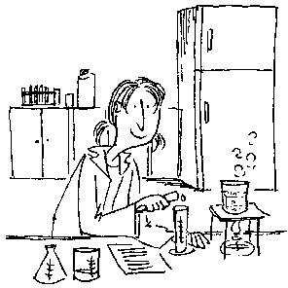
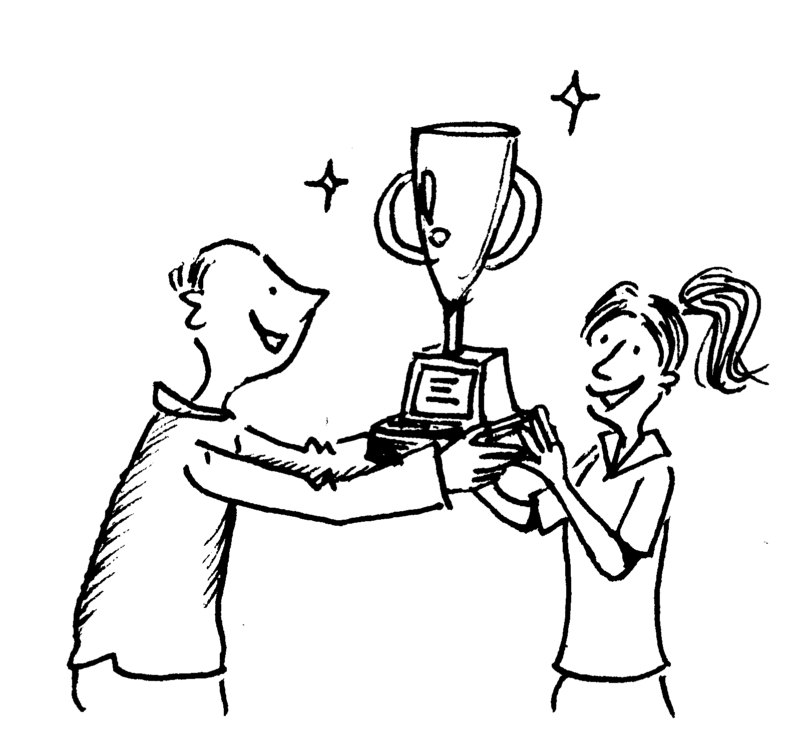

1. ______ 2_______
（二）問答：每題請聽錄音機所播出的英語句子，再從試題上A、B、C三個選項中，選出一個最適合的回答或回應。
( ) 3. (A) I’ve known you for so long.
(B) I don’t like you much, either.
(C) I feel the same way about you.
( ) 4. (A) I love reading that story, too.
(B) Sorry, I forgot to bring the key with me this morning.
(C) I think great imagination will be the key.
( ) 5. (A) I’m sorry, but I already have a girlfriend.
(B) I didn’t know you are in a relationship.
(C) I don’t think of it as a special occasion.
( ) 6. (A) I want to be a scientist.
(B) I should give it a try.
(C) I don’t think that will work.
( ) 7. (A) I’m sure you won’t fail it.
(B) In fact, I made it, too.
(C) Believe it or not, I passed.
(三) 簡短對話：
每題請聽錄音機所播出的一段對話和相關問題，再從試題上A、B、C三個選項中，選出一個最適合的答案。

( ) 8. (A) The shoe factory has closed and the workers have lost their jobs.
(B) The number of workers in the shoe factory is increasing.
(C) There are now fewer workers in the shoe factory.
( ) 9. (A) It was because he didn’t like romantic movies.
(B) It was because his girlfriend hadn’t seen it yet.
(C) It was because he had already seen it.
( ) 10. (A) The man’s grandmother is still alive.
(B) The man’s grandmother died.
(C) The man’s grandmother is feeling better.

- 克漏字 10%
My grandmother is very smart. She knows _11__ magic by using household items. For example, to _12__ a price tag, she simply heats it with a hair dryer. When people finish drinking their tea, the tea bags are often thrown away because they seem _13__ good for nothing. However, used tea bags are a great help __14__ my grandmother. She would put a few used tea bags in the refrigerator to keep odors away. __15__ my grandmother’s useful tricks, solving daily problems is a lot of fun.
11 | (A) how could she perform |  | (B) how to perform
 | (C) she to perform |  | (D) she how to perform
12 | (A) sip | (B) absorb | (C) remove | (D) soak
13 | (A) to being | (B) to be | (C) being | (D) been
14 | (A) by | (B) of | (C) to | (D) from
15 | (A) With | (B) For | (C) From | (D) On
Doing housework sometimes gives people a headache. However, white vinegar(白醋) can make _16__ easier to keep a clean home environment. __17__ there is an odor in your room, you can leave a bowl of white vinegar in the room overnight. Your room will smell __18__ better the next morning. When it comes to cleaning, white vinegar is useful _19__ because it can help prevent ants _20__ into the house. As you can see, white vinegar can not only be used in cooking but also solve a lot of daily problems.
16 | (A) X | (B) that | (C) to | (D) it
17 | (A) Although | (B) If | (C) In addition | (D) Ever since
18 | (A) more | (B) such | (C) a lot | (D) a lot of
19 | (A) as well | (B) instead | (C) in addition | (D) for free
20 | (A) for coming | (B) from coming | (C) to come | (D) to coming
- 文法選擇 30%
21 | Wendy is thinking about which dress _____ to the party.
 | (A) wearing |  | (B) does she wear
 | (C) can she wear |  | (D) to wear
22 | Catherine ________ like cats very much. She always takes pictures of cats.
 | (A) seemed | (B) seems that | (C) seems to | (D) seems
23 | Alice seems ____ rich because she drives a very expensive car.
 | (A) being | (B) be | (C) is | (D) to be
24 | Iris didn’t know this city very well. She had no idea where______.
 | (A) going | (B) to go | (C) has gone | (D) be gone
25 | You can borrow my bike _____you can return it to me tomorrow morning.
 | (A) as far as | (B) as though | (C) as long as | (D) as if
26 | The washing machine ______ to be broken, so Abby had it repaired by her husband.
 | (A) seemed | (B) is seemed | (C) has seemed | (D) was seemed
27 | I can’t remember where ____.
 | (A) Ms. Chen lives |  | (B) does Ms. Chen live
 | (C) lives Ms. Chen |  | (D) is Ms. Chen live
28 | ____ a good command(能力) of language, you can go anywhere around the world.
 | (A) Without | (B) About | (C) With | (D) From
29 | After the rain, the trees and the flowers in the forest come ______.
 | (A) lived | (B) lives | (C) live | (D) alive
30 | In come circumstances, children can choose to study at home. (選同義詞)
 | (A) actions | (B) suggestions | (C) conditions | (D) questions
31 | Vegetables will ____ longer if you put them in the refrigerator.
 | (A) absorb | (B) last | (C) remove | (D) prevent
32 | A ______ should follow the traffic rules when he or she ______.
 | (A) drive ; drive | (B) driver ; drive | (C)driver ; drives | (D) drive ; driver
33 | The weather seems ____ very terrible today.
 | (A) to be | (B) is | (C) be | (D) that
34 | Carina is thinking about ___ for the dinner.
 | (A) what she to eat |  | (B) what she is going to eat
 | (C) is she going to eat what |  | (D) what is she going to eat
35 | A _____ can ______ liquid(液體), solid(固體), or gas(氣體).
 | (A) contain ; contain |  | (B) container ; container
 | (C) container ; contains |  | (D) container ; contain
- 對話 10%
36 David: Oh, no! The cookies went soft again.
Benny: ______ They may help.
David: Really? Let me try it next time.
(A) I’ll follow your suggestions later. | (B) Maybe you can get some sugar cubes.
(C) It is a good way to solve the problem. | (D) What should I prepare?
37 Susan: I didn’t sleep well last night because of the mosquitoes(蚊子).
Joanna: ______.
Susan: I see. I’ll give it a try.
(A) Mosquitoes usually make loud noise at night.
(B) You should stay home and don’t go outside.
(C) Prepare some food for mosquitoes and flies.
(D) Just burn some dried citrus peel to keep them away.
38 Annie: I can’t stand the bad smell from the refrigerator. What can I do?
Kellly: ____
Annie: Thank you for the suggestion. I’ll give it a try.
(A) Refrigerators always have bad smell. (B) The stains on it are so ugly.
(C) Used tea bags may be a good choice for you (D) I just bought a new refrigerator.
39 Vincent: Why don’t you throw away those old newspapers?
Yvonne: ____
(A) Really? I’ll try it later.
(B) They make the windows look ugly.
(C) They are good for nothing.
(D) I can clean the windows with the newspapers.
40 Josh: I asked Sarah out for a dinner on Valentine’s Day.
Olivia: And then? Did she say yes?
Josh: ____
Olivia: I’m sorry to hear that.
(A) She knows a very nice restaurant. | (B) I think I’m very special to her.
(C) She said she is in a relationship. | (D) She didn’t like the restaurant.
- 閱讀測驗 10% (每題2分)
Grape Power
The microwave is a very convenient kitchen appliance. Almost every family has one. Actually, it can be used not only for cooking. It is also a useful tool for experiments. Here is a cool trick that can be done by only using a microwave and a grape.
First,cut a grape almost in half. Leave a small piece of grape peel connecting the two halves. Next, gently pull the two halves apart a little bit. Then, simply heat them in the microwave at full power for about 10 seconds. Boom! Check out those bright sparks from the grape!
Isn’t it amazing that a small grape has so much power? In fact, it’s all about science. At first, the electricity passes through the grape peel “bridge”. When the skin breaks, the electricity has to jump across the air, and that produces big bright sparks.
This is an interesting and surprising experiment, but it is also a little dangerous. The grape will contain extremely hot juice after the experiment, so people should be careful when they do the trick. As long as the experiment is done in the right and safe way, it should be a very good example to prove that science can be fun and easy.
Vocabulary
1. microwave微波爐 | 7. boom 轟隆隆地響
2. appliance 器具 | 8. spark 火光
3. experiment 實驗 | 9. amazing 令人驚訝的
4. connect 連接 | 10. electricity 電力
5. gently 輕柔地 | 11. produce 生產；製造
6. pull …apart 拉開… | 12. prove 證明

43. Which of the following steps(步驟) in the grape experiment is NOT true?
(A) Carefully pull the pieces of the grape apart a bit.
(B) Heat the grape in the microwave for 10 seconds.
(C) Cut a grape into three pieces.
(D) Check out the bright sparks from th grape.

44. In the experiment, the bright sparks are produced by
(A) the air
(B) the grape peel
(C) the grape juice
(D) the electricity

45. According to the passage, why is the grape experiment dangerous?
(A) The grape peel may become a “bridge”
(B) The grape juice may be very hot
(C) The grape may lose its power
(D) The microwave may be broken.

46.According to the passage, the grape experiment is a good example to show that ___.
(A) electricity is dangerous
(B) every family needs a microwave
(C) science can be easy
(D) grapes are good for human body.

47.We can possibly(可能) read this passage in a ___.
(A) cook book
(B) health magazine
(C) comic book
(D) science magazine

請務必填寫考卷右上角的班級、姓名、座號，未寫扣5分。
- 非選擇題 (請作答於右半頁作答區)
- 文義字彙 12% (每題2分)
1. Please make sure the c_______r is clean before you put the cookies in it.
2. Kevin and Lydia seem to have a happy marriage(婚姻) on the s_____e, but actually they fight very often at home.
3. There was an o_______t on the table, but it was too dark for me to tell(分辨) what it was.
4. Julia drank a cup of coffee to p____t herself from falling asleep at work.
5. The mother r_______ed all the desks and chairs from the room so that her kids could play safely.
6. The New Year’s Eve firework(煙火) will l______t for about 200 seconds.

VII填空式翻譯 11% (請注意動詞變化；每題1分)
1. 持續的降雨以經侵蝕了這座橋，因此在橋上行走很危險。
The constant reain has _________ _________ __________ the bridge, so it’s dangerous to walk on it.。

2. 為了保持健康，我建議你甩掉(去除)你的壞習慣。
To be healthy, I suggest that you _____ ____ _____your bad habits.

3. 如果你想要開啟一段友誼，一個微笑或許能奏效。
If you want to start a friendship, a smile may ______ _______ _______.

4. 臭豆腐聞起來很奇怪，但事實上，豆腐嘗起來很美味。
Stinky tofu smells strange, but _____ ______, it tastes great.

VIII單字片語選填(選出最符合句意的單字或片語，並填入代號) 每題1分，7%
(A) occasions | (B) imagination | (C) romantic
(D) awful | (E) broke her heart | (F) is about to
(G) escaped

- 文義字彙 12%
1 | __________________ | 2 | __________________ | 3 | __________________
4 | __________________ | 5 | __________________ | 6 | ___________________

- 填空式翻譯 11% (每格只填一個字)
1
2
3
4

VIII單字片語選填(選出最符合句意的單字或片語，並填入代號) 每題1分，7%
1. In order to get away from the war, some people ____ to other countries.
為了遠離戰爭，一些人逃到其它國家。
2. The weather was so ______ that nobody wanted to go outside.
天氣太糟了以至於沒有人想到外面去。
3. The sudden death of Lisa’s favorite writer ______.
Lisa心愛的歌手突然離世令她傷心透頂。
4 In Chinese culture, white candles are only used on special _____.
在中華文化，白蠟燭只在特定場合使用。
5. The school bell______ring, so please go back to your seat.
學校鐘聲快響了，請回到你的座位。
6. It’s _____ to take a walk by sea with someone you love.
與你相愛的人在海邊散步是很浪漫的。
7. Teresa always has lots of _____, so she has many ideas for many things.
Teresa總是有很多想像力，所以她對很多事有很多想法。

