市立新北高工106學年度第2學期第3次段考試題 |  |  |  |  |  |  |  | 班級 |  | 座號 |  | 成  績
科 目 | 英文 | 使用答案卡及答案卷 |  | 年級 | 2 | 科別 | 機鑄電模汽圖資訊 | 姓名 |  |  |  | 成  績

請將以下選擇題答案劃記於答案卡上(否則不予計分);並劃上座號, 未劃座號者酌扣總分15分
- Listening Comprehension (10%)
Ａ．Pictures: ２％
  1. ______ |   2. ______
Ｂ．Choose the best response to each question or statement. ３％
- (A) It’s the trendiest tablet!
(B) I’m just sending a LINE message.
(C) It’s all Greek to me!
- (A) I think Google is the best.
(B) Jeremy Lin is the most influential player.
(C) I’m currently combining two words.
- (A) There’s a discount if you pay in cash.
(B) My imagination is running wild.
(C) They are too plain looking.
C. Short Conversations (3%)
- (A) The dictionary he used was too old.
(B) He copied words from an online dictionary.
(C) He made too many typing mistakes.
- (A) She will be a participant in a study.
(B) She is trying to get a new job.
(C) She is trying to encourage her students.
- (A) It’s finished.
(B) She quit the project.
(C) She needs to try doing it again.
D. Short Talk (2%)
Listen to the talk. Then choose the best answer to each question.

(A) (B) (C)
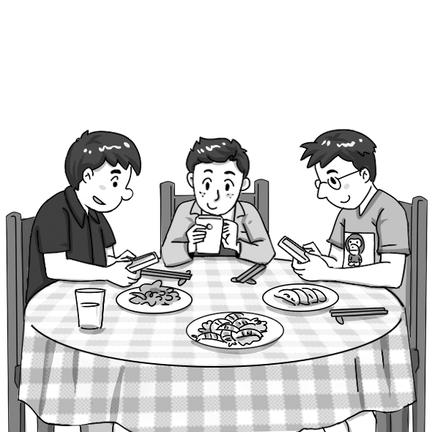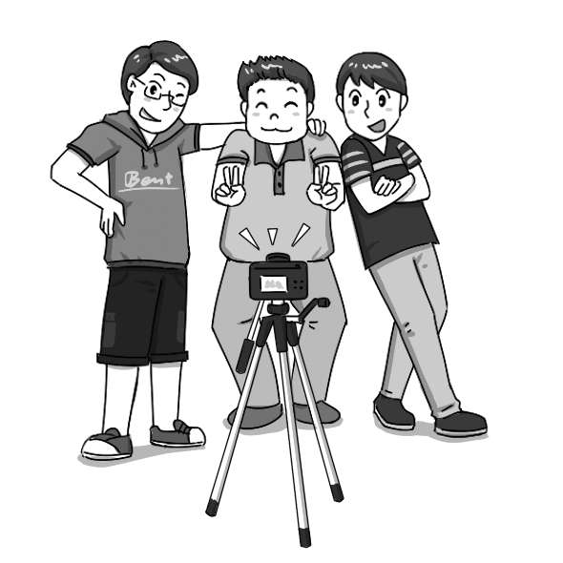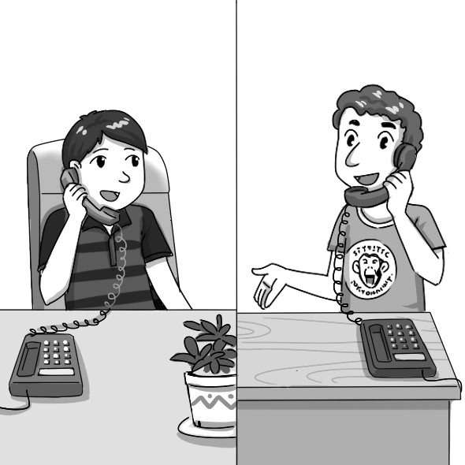

(A) (B) (C)
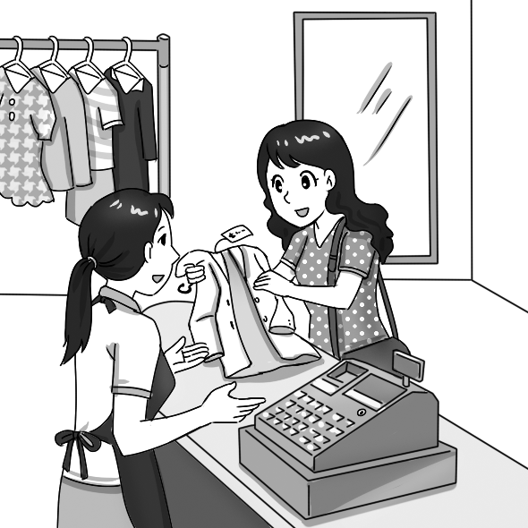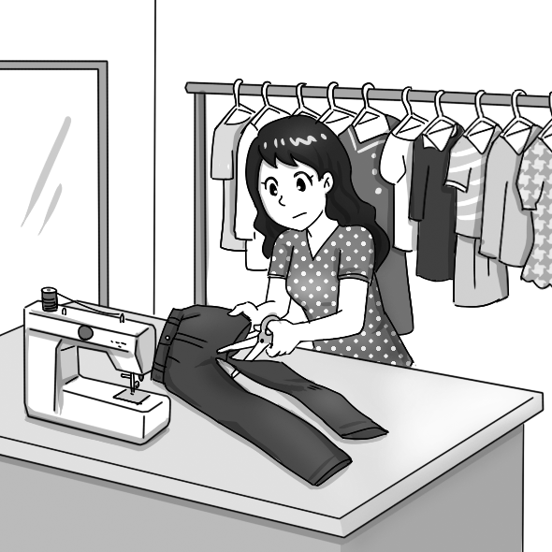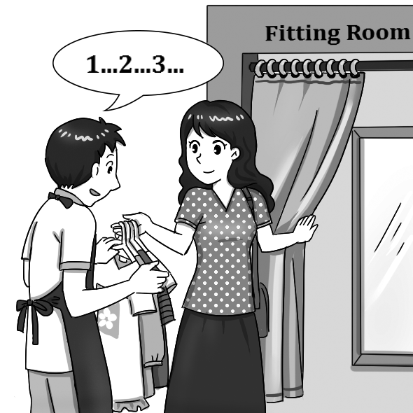

- Vocabulary and Synonyms (30%)
（ ）11.I really enjoyed the play, especially the _____. The things the performers said were so witty.
(A) dialogues (B) interests (C) websites (D) alternatives

（ ）12.Last month, fifty couples, who were married for fifty years and more, _____ their golden anniversary in the city hall.
(A) contributed (B) confirmed (C) celebrated (D) combined

（ ）13.One of the _____ of watching TV is that you can get a lot of information in a short time.
(A) devices (B) visitors (C) attendants (D) advantages

（ ）14.The science teacher brought the students to the lab where they could perform _____.
(A) experiments (B) experiences (C) guesses (D) effects

（ ）15.The athlete’s long-distance run through the Sahara Desert was a(n) _____ achievement.
(A) impressive (B) regular (C) accurate (D) foreign

（ ）16.The police are facing the difficult _____ of finding the murderer.
(A) impression (B) experiment (C) motivation (D) task

（ ）17.Allen keeps in _____ touch with his old classmates. He meets with them every month.
(A) casual (B) certain (C) regular (D) adventurous

（ ）18.If you want to make a delicious chocolate cake, it is important to be _____ when you measure the ingredients.
(A) mature (B) effective (C) various (D) accurate

（ ）19.Due to ill health, Susan had no _____ but to drop out of school and be hospitalized.
(A) alternative (B) dialogue (C) significance (D) tourism

（ ）20.For more _____ tourists, there are trips into the jungle with a tour guide.
(A) regular (B) constant (C) adventurous (D) responsible
（ ）21.According to studies, drinking one or two glasses of wine a week during pregnancy can have an impact on the baby’s brain.
(A) excuse (B) agreement (C) option (D) influence

（ ）22.Mike is a machine operator. His life in the factory is so dull that he often sings to entertain himself.
(A) uninteresting (B) professional (C) challenging (D) charming

（ ）23.All we have to do is carry out a simple test, and then we’ll know if this product contains harmful substances.
(A) defend (B) encounter (C) conduct (D) generate

（ ）24.Stanley stormed into my office and requested to know what was going on.
(A) demanded (B) generated (C) modified (D) alerted

（ ）25.Warned by our dog barking at the window in the dead of night, Dad got up to check what was going on.
(A) Alerted (B) Issued (C) Generated (D) Combined

- Grammar (20%)
（ ）26.Some of the passengers narrowly escaped death from the crash, but the fate of _____ remains a mystery.
(A) the rest (B) the variety (C) the number (D) the quantity

（ ）27.Although Ms. Chen is not a rich person, _____ she donates regularly to charities.
(A) so (B) but (C) or (D) ×

（ ）28.It is due to his great perseverance (堅持不懈) _____ Peter has been promoted.
(A) as (B) that (C) what (D) how

（ ）29.To pass the exam this Friday, all Jack has to do _____ study as hard as he can.
(A) is (B) was (C) has been (D) will

（ ）30._____ me for example. I practice yoga to relieve my stress.
(A) Take (B) Took (C) To take (D) Taking

（ ）31._____ installing this application, users can monitor another person’s mobile phone activities.
(A) At (B) In (C) With (D) By

（ ）32.No one is surprised to find that May is as _____ as her sister.
(A) beautiful (B) beauty (C) beautifully (D) beautify

（ ）33.The child is still learning to eat _____ chopsticks.
(A) for (B) by (C) through (D) with

（ ）34.Before Copernicus (哥白尼) proposed his theory, many people in Europe _____ the Earth was the center of the universe.
(A) do believe (B) did believe (C) have believed (D) believed to

（ ）35.Since there are no roads that lead to the village on the top of the mountain, much of the food is delivered to that area by helicopter _____ by truck.
(A) because of (B) or (C) instead of (D) apart from

- Cloze (20%)
If this dialogue is all 36_____ to you, or if you think it 37_____ typos, read on! Closely associated 38_____ technology and the Internet, “OMG” (oh my God), “LOL” (laughing out loud), and “google” are known 39_____ e-words. “OMG” and “LOL” are abbreviations of frequently 40_____ phrases.
( )36(A) Russian (B) Greek (C) German (D) Japanese
( )37(A) is full of (B) is filled of (C) is full with (D) is filled by
( )38(A) for (B) to (C) as (D) with
( )39(A) to (B) of (C) as (D) for
( )40(A) using (B) use (C) be used (D) used

People who like using 41_____ devices to socialize often use these words, because they are quick and easy to type. 42_____ “google,” despite starting off as a noun, it has been modified to be used as a verb. Google is such a powerful search engine that people now may 43_____ “Let me google that” 44_____ “Let me search 45_____ that.” That’s why the verb “google” now appears in the dictionary.
( )41(A) alert (B) alive (C) technological (D) major
( )42(A) Because of (B) Due to (C) In spite of (D) As for
( )43(A) be said (B) said (C) saying (D) say
( )44(A) instead of (B) except for (C) despite (D) but
( )45(A) to (B) for (C) with (D) on
- Dialogue (10%)
（ ）46.Philips: What’s up? You look so happy.
Sean: The girl I met on Facebook yesterday wants to be my girlfriend.
Philips: I don’t mean to be a wet blanket, but you should be careful. _____
(A) Online dating scams happen all the time.
(B) You haven’t heard from her for a long time.
(C) She added you as a friend just two weeks ago.
(D) There are plenty of more fish in the sea.

（ ）47.Clerk: Good evening, sir. May I help you?
Jeff: No, thanks. _____
Clerk: Take your time. If you need any help, please let me know.
(A) I’m looking for a pair of shorts. (B) I am not in a hurry.
(C) I’m just looking around. (D) I’m sorry to hear that.

（ ）48.Jane: Are you available tonight? Would you like to go to the Dream Mall with me?
Judy: Sure! _____
Jane: You bet. That’s why I’m inviting you to go with me.
(A) I’ll have an English test tomorrow. (B) They are closed on weekends.
(C) The sale is still on, isn’t it? (D) My history report is due.

（ ）49.Paulina: Look who I found on Facebook—my future husband!
Janice: _____ You just met the guy and don’t know anything about him.
Paulina: OK, I’ll be more careful.
(A) Are you certain he is your Mr. Right? (B) That’s something you’ll never know.
(C) This post is unbelievable. (D) I have never heard of it before.

（ ）50.Ann: The dress is nice, but it’s a little too small. Do you have it in a bigger size?
Clerk: Let me take a look for you. Oh, here you go.
Ann: _____
Clerk: Sure, this way please.
(A) But I don’t have any credit card with me. (B) Can you shorten it for me?
(C) May I use the fitting room to try it on? (D) I am not sure. Let me think about it.

VI. Reading Comprehension (10%)
Online chatting is a recent phenomenon that provides our society with a new way of interaction. In the past people had to meet others in person, so blind dates* and face-to-face friendships were the norm*. That made it easier for people to really get to know each other because they could spend quality time understanding others. Friendship also seemed stronger and tighter; friends might spend an entire day hanging out in a department store or hiking in the mountains.
However, such trends have gradually changed with the shift of time. Today people are more likely to talk to those they do not know and make friends with strangers in a faraway place through just the click of a button. This has expedited* the friendship process; men and women seem to be able to find their Mr./Mrs. Right faster than ever before. But this change is not without problems. It is often argued that modern friendships and relationships do not last long and tend to be more vulnerable to many things because they are based on abstract feelings on the Internet and social networking websites, as opposed to real interaction.
*blind date n. 兩個陌生人第一次約會 *norm n. [C] 常規 *expedite vt. 加速
( )51.What is the main idea of this passage?
(A) The Internet has helped people find their Mr./Mrs. Right faster than before.
(B) Friendships nowadays are more likely to break up than in the past.
(C) The new way of meeting friends is popular among youngsters.
(D) Experts are concerned about the problems brought by the changes in how we make friends.
( )52.What is the purpose of this passage?
(A) To experiment with a phenomenon. (B) To influence a phenomenon.
(C) To change a phenomenon. (D) To describe a phenomenon.
( )53.Which of the following statements is true?
(A) People nowadays only talk to friends face-to-face.
(B) In the past, it was difficult for people to make friends with each other.
(C) Modern friendships tend to come and go quickly.
(D) People in the past liked to hang out in the Internet cafés
( )54.What does “modern friendships… tend to be more vulnerable to many things” mean?
(A) Friendships are hard to define. (B) Friendships are tighter than before.
(C) Friendships are easily influenced. (D) Friendships are more complicated.
( )55.What may be the genre (文體) of this passage?
(A) An advertisement. (B) A newspaper article. (C) A poem. (D) A short story.

