請在電腦答案卡上劃上座號，並將選擇題答案劃卡作答,共50題，劃記不清者，扣總分
5分! 祝同學能有好成績，加油!!
一 、Listening Comprehension Test聽力測驗 (共10題: 10%) /@1
第一部分：看圖辨義(2%)
試卷上該題有一張圖片，請聽一個和該題相關的問題，與(A)、(B)、(C)三個英語敘述後，選一個與所看到圖片最相符的答案。
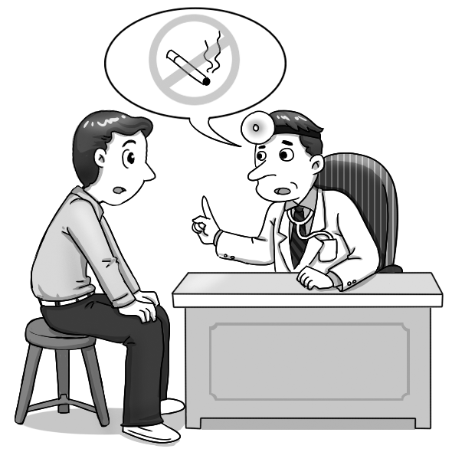  1. ______ | 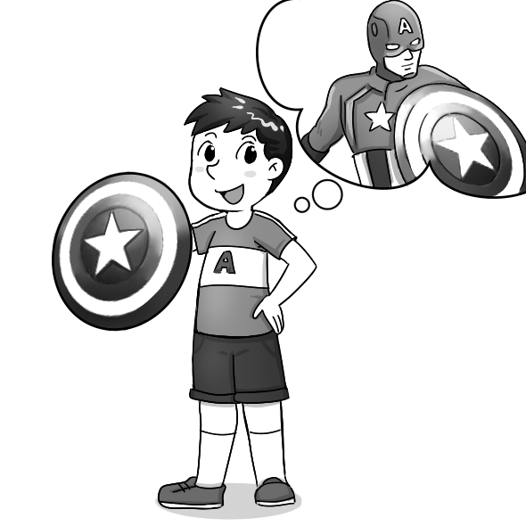  2. ______
第二部分：問答(3%)
每題會播出一個問句或直述句，聽後請由試卷上(A)、(B)、(C)三個選項中，選出一個最適合的回答或回應。
- (A) He violated some of the rules.
(B) He was fired by the manager.
(C) He knows how to use the equipment.
- (A) He received several injections from a scientist.
(B) He had great physical strength.
(C) He protected his people from harm in World War II.
- (A) I might travel around the world.
(B) I would turn into an ugly frog.
(C) I would be known for my unique voice.
第三部分：簡短對話(3%)
每題會播出一段對話及一個相關的問題，聽後請由試卷上(A)、(B)、(C)三個選項中，選出一個最適合的回答。
- (A) He’s a customer and wants to complain.
(B) He’s a manager and wants to be transferred.
(C) He’s an intern and wants to call in sick.
- (A) To a park to play baseball.
(B) To a restaurant to have dinner.
(C) To her house to do some homework.
- (A) A coffee club.
(B) A cosplay club.
(C) A music club.
第四部分：短文聽解(2%)
每題有三個圖片選項。請聽題目，並選出一個最適當的圖片。
9. (A) (B) (C)
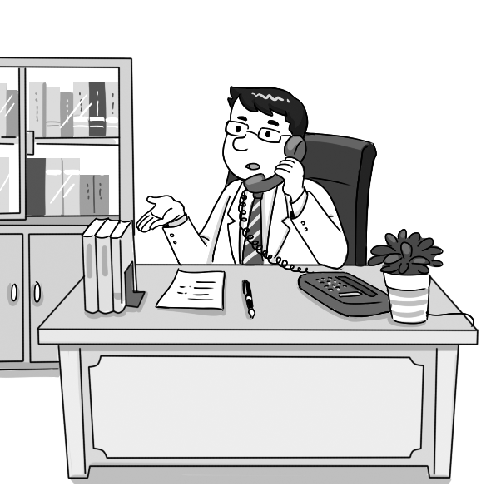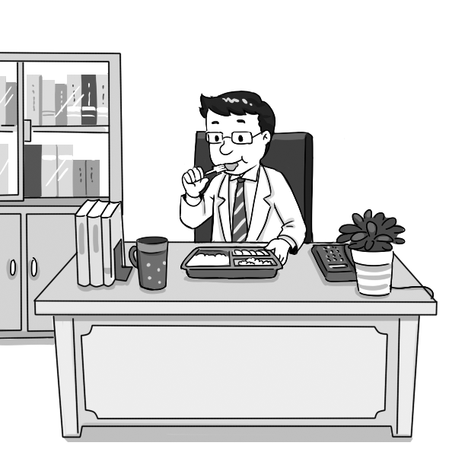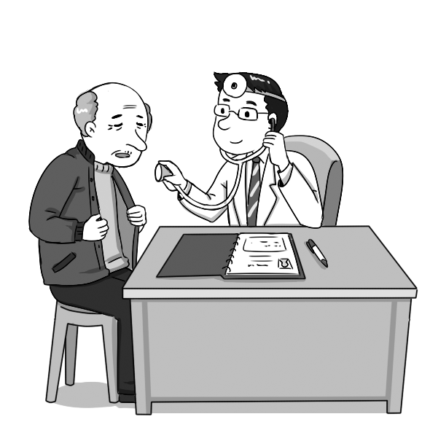
10. (A) (B) (C)
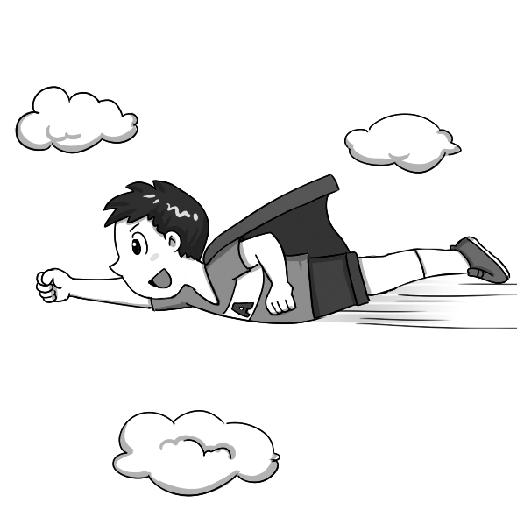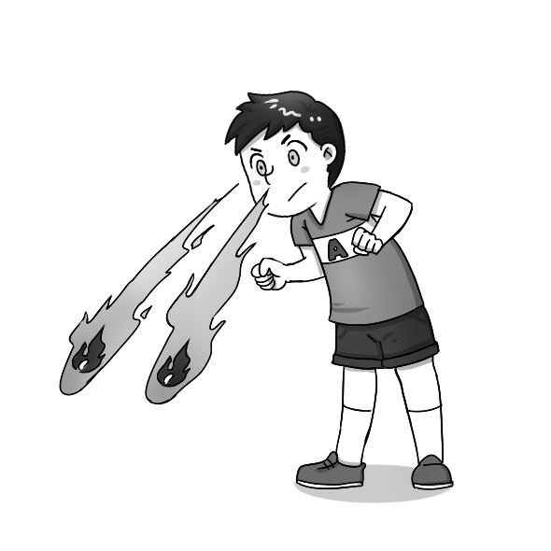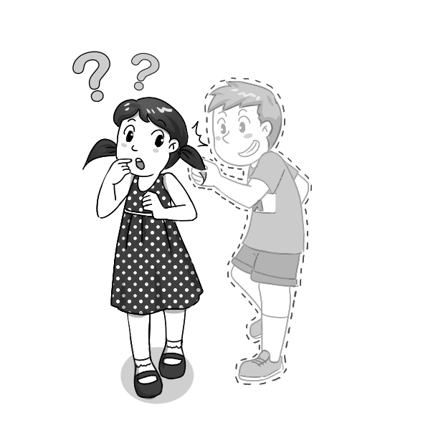
- 文意字彙選擇 10% (11-20題)/@1
11. research shows that losing a lot of weight in a short period of time may cause
serious health problems.
(A) Unbreakable (B) Medical (C) Visible (D) Natural
12. The new office is with the latest computers and other machines.
(A) equipped (B) satisfied (C) pleased (D) combined
13. Some people believe that a power caused the ships to disappear into the sea in this area.
(A) superstitious (B) successful (C) supernatural (D) superior
14. Germs are ________ to the naked eye. Even though your hands look clean, you still need to wash them before eating.
(A) impossible (B) imaginable (C) impatient (D) invisible
15. The floor shook and the ceiling lamp ________ back and forth when the earthquake struck.
(A) swam (B) swung (C) sang (D) swore
16. Language and math classes are basic requirements in high school.
(A) abilities (B) necessities (C) communities (D) societies
17. This conservative school has loosened its restrictions on students’ hairstyle and clothing.
(A) suggestions (B) preventions (C) frustrations (D) limitations
18. The soldier used a shield to defend himself from the enemy’s attack.
(A) struggle (B) protect (C) restrict (D) employ
19. The homeowner employs five people to take care of his garden.
(A) requests (B) retires (C) hires (D) advises
20. Jeffery’s piano performance was so extraordinary that the audience stood up and clapped for more than three minutes.
(A) incredible (B) potential (C) usual (D) general
三、文法選擇 10% (21-30題) /@1
21. The doctor suggested that Daniel _____ any junk food.
(A) didn’t eat (B) not eat (C) not to eat (D) eats no
22. Jason’s father insists that Jason _____ for at least thirty minutes a day to stay healthy.
(A) exercises (B) will exercise (C) exercise (D) to exercise
23. My boss required that the work _____ before he returned from Kaohsiung.
(A) did (B) do (C) be done (D) had done
24. Scientists find it important _____ action to save our environment.
(A) will take (B) take (C) taking (D) to take
25. If I _____ you, I would put youth to good use, such as experiencing a lot.
(A) was (B) were (C) would be (D) am
26. Social networking sites make _____ simple for people to keep in touch with friends.
(A) we (B) us (C) this (D) it
27. If Dad _____ how much money I spent on this cellphone, he would hit the ceiling.
(A) knew (B) knows (C) had known (D) has known
28. I consider it important for high school students _____ enough sleep.
(A) getting (B) get (C) to get (D) got
29. The boy was hooked up to more medical equipment than I .
(A) never saw (B) had ever seen (C) was seeing (D) has seen
30. If I _____ a dictionary with me, I _____ the vocabulary for you.
(A) had; would check (B) had; checked (C) have; check (D) have; would check
四、會話10% (31-35題) /@2
31. Nick: Hello, this is Nick calling. May I speak to Ms. Stacy, please?
Matt: Sorry. Her line is busy.
(A) Could you please take a message? (B) Please stand in line.
(C) Would you like to leave a message? (D) I can’t wait for you.
32. Rene: Hello, this is Rene calling.
Jamie: I’m afraid not. She won’t be home until 9 p.m.
(A) Could you forward my message? (B) Could you call again later?
(C) How may I help you? (D) Is Sophie available now?
33. Stella: I’m not feeling well.
Emma: Don’t worry. I’ll tell the boss. Take care.
(A) I’m having a good time. (B) I won’t make it today.
我今天無法上班。
(C) I can’t wait. (D) I’ve heard a lot about it.
34. Boss: What happened to Patty? She’s been absent for three days.
Sherry: She fell off her bike and broke her legs.
Boss: I see.
(A) That’s a deal. (B) Leave me alone.
(C) How about eating out? (D) I’m sorry to hear that.
35. Jack: I’m heading to the movie theater. Would you like to join me?
George:
(A) No, these tickets belong to me. (B) Sounds great. I’ll stay here.
(C) Why? I am not in a hurry! (D) I’d love to, but I have a meeting in ten minutes.
五、綜合測驗 20% (36-45題) /@2
Katie enjoyed her restaurant job more than the jobs she 36 before. She especially liked the weekly visit to the children’s hospital 37 behalf of the restaurant. 38 she did so, she felt happy. Although she was advised that she 39 the child patients, she was happy enough that she could make them smile for at least a short while.
One day, Katie heard a weak voice 40 her during her hospital visit. She turned around and saw a little kid with all kinds of machines 41 to his little body. “I’m Billy,” said the boy excitedly. “I like you and can’t wait 42 you a hug!”
Upon 43 this, Katie’s heart melted. She really wanted to hold the kid even though this would get her 44 . She was struggling inside. She needed this job, but she didn’t know
____45___ no? When Billy opened his arms, Katie broke the rule, leaned forward, and hugged him tightly.
36. (A) has (B) had (C) has had (D) had had
37. (A) at (B) on (C) in (D) over
38. (A) However (B) Whatever (C) Whenever (D) Wherever
39. (A) not to touch (B) not touch (C) couldn’t touch (D) didn’t touch
40. (A) to call (B) called (C) calling (D) had called
41. (A) turned down (B) was about (C) hooked up (D) made up
42. (A) for giving (B) give (C) to give (D) gave
43. (A) hear (B) to hear (C) hearing (D) heard
44. (A) fire (B) fired (C) to fire (D) firing
45. (A) what she said (B) what to say (C) how she said (D) how to say
六、閱讀測驗10% (46-50題) /@2
Many people around world were astonished by the news that comedian and actor Robin Williams had died at his home in Tiburon, California on August 11, 2014. His spokesman later said that Williams has been suffering from severe depression for months, and this was quite possibly the cause of his suicide. On hearing of William’s death, many celebrities and ordinary people expressed their sadness on social media.
Williams pursued a career as an actor in his early twenties. He started as a stand-up comedian in San Francisco and Los Angeles in the mid-1970s. Because of his excellent improvisational skills, brilliant wit, and limitless energy, he soon acquired a good reputation and landed the role of Mork in the American sitcom Mork & Mindy (莫克與明蒂, 1978-82). Then Williams went on to show his talent in film and achieved great things. He earned Oscar nomination for his performances in Good Morning, Vietnam (早安越南, 1987), Dead Poets Socitey (春風化雨, 1989), The Fisher King (奇幻城市, 1991), and Patch Adams (心靈點滴, 1998). In 1997, he finally won an Oscar for Best Supporting Actor for his performance as Dr. Sean Maguire in Good Will Hunting (心靈捕手). He has also won numerous other awards throughout his career, including three Emmy Awards, six Golden Globe Awards, two Screen Actors Guild Awards, and four Grammy Awards.
William’s performances touched and inspired many lives. He has been called “the most unique mind on the planet. “Although he has left us, he will live on forever in our minds and in his performances captured on film.

* celebrities 名人 * stand-up comedian 單人脫口秀喜劇演員 * improvisational 即興的
* reputation 名聲 * American sitcom 美國情境 * nomination 提名
46. What is the passage mainly about?
(A) An introduction of some awards about films and TV shows.
(B) A brief introduction to the life of Robin Williams.
(C) News of the death of Robin Williams.
(D) An investigation into Robin Williams’s suicide.
47. According to the passage, which of the following is most likely to be the reason for Robin
Williams’s death?
(A) Severe depression. (B) Alcohol addition.
(C) A chronic disease. (D) Drug abuse.
48. Which of the following may NOT be the reason that Williams got the role of Mork?
(A) He has excellent performance skills.
(B) He was always energetic.
(C) He was quick and clever.
(D) He had won three Emmy Awards.
49. For which movie did Robin Williams win an Oscar?
(A) Good Morning, Vietnam (B) Patch Adams
(C) Good Will Hunting (D) Dead Poets Society
50. According to the passage, which of the following statements about Robin Williams is NOT
true?
- He began his career as an actor by acting in a TV show.
- He has been viewed as the most unique mind in the world.
- He won six Golden Globe Awards.
- He passed away at his home on August 11, 2014.

七、字彙及翻譯填充 (手寫題) 30% (共15格)/@2
1. Don’t hide your e ns. Sometimes crying and laughing might be good for your health.
2. Parents all want to provide their children with a happy c d.
3. This animal protection o n always speaks up for the rights of stray dogs.
4. Mr. Jones expressed deep r t for what he had said to Mrs. Jones. He tried to ask for her forgiveness.
5. The t e of the novel is love and peace. It talks about a Japanese soldier who fell in love with a Chinese woman during the war.
6. Katy Perry’s latest album is scheduled for r e next month.
7. Michael Jordan, who has won ten scoring titles, is a l y NBA player.
8. Studies have shown that women live longer than men on a e.
9-10. Bill Gates and Steve Jobs have both (m) made a (d) difference in the field of high technology.
Bill Gates與Steve Jobs都對高科技領域有很大的影響。
11-12. Jane (c) her love of Barbie dolls ________ adolescence. Besides playing with
them, she even dressed like them!
Jane對芭比娃娃的愛延續到了青春期。除了玩芭比，她連穿著打扮都像芭比。
13-15. Because my co-worker was on (d) duty , she (t) turned down our
invitation to watch the movie Ant-Man.
因為我同事要值班，所以她拒絕了我們邀她去看《蟻人》這部電影。

*請同學務必將手寫部分填寫在A4答案卷上，
並寫上班級、座號、姓名，否則不予計分!

