新北市立新北高工106學年度第2學期第二次段考試題 |  |  |  |  |  |  | 班級 |  | 座號 |  | 備註 | 需附答案卡:D
科目 | 英文 | 年級 | 二 | 科別 | 機鑄汽模圖資電訊 |  | 姓名 |  |  |  | 備註 | 需附答案卡:D
I.聽力測驗 (10%)  A. Pictures 看圖辨義(2%)  Listen to the questions. Then choose the best answer according to each picture.  B. Best Response 最佳回應句(3%)  Choose the best response to each question or statement.  ______ 3. (A) No, my bag is at home.  (B) Yes, this bag belongs to me.  (C) Yes, I used it to carry some fruit.  ______ 4. (A) It assists me to get my shoes.  (B) It has a keen sense of smell.  (C) It likes to eat chemicals.  ______ 5. (A) You can exchange them for a key chain.  (B) Here are your free stickers!  (C) That comes to 120 dollars.  II.對話(10%)  ( )11. Quarantine Officer: _______________  Patty: No, sir. I’m carrying nothing but clothes.  Quarantine Officer: OK, you can go. Thank you.  (A) Do you have anything to declare?  (B) Would you like some more food?  (C) Do you like beef jerky?  (D) What is that in your baggage?  ( )12. Reporter: Hello, what’s your name?  Protester: My name is Emma.  Reporter: __________________  Protester: Yes. I am here to speak for the animals.  (A) Are you afraid of animals?  (B) How many people are here?  (C) Are you here to protest against animal testing?  (D) What do you say about the animal shelters?  ( )13. Zoo Keeper: You look like you are having a good time with the kangaroos.  Child: Yeah, I do! I notice that they are sensitve when someone is getting close to them.  Zoo Keeper: Good observation! _______________  Child: Thank you.  (A) You need to feed them more.  (B) You’re really good with animals.  (C) You take such good care of them.  (D) You’re going to learn how to take care of them.  ( )14. Mary: How much are these pants?  Sales: Three thousand dollars.  Mary: Wow, that’s too expensive. ________________  Sales: I’m sorry, these pants are on sale and the tag price is 40% off the regular price already.  (A) A size four shirt, please. (B) Is there any discount?  (C) Do you take a rain check? (D) I would like a refund, please.  ( )15. Cashier: Your total is NT $699.  Customer: _________________  Cashier: Yes, Ma’am. Then that’s NT $599.  Customer: Do you take credit card?  Cashier: Sure.  ( )28. A blender is very useful for making milkshakes and other drinks.  (A) appealing (B) functional (C) educational (D) defensive  ( )29. A model’s job is to make a product exciting and appealing so the public  will want to buy it.  (A) negative (B) extensive (C) attractive (D) inactive  ( )30. After four attempts, Mike finally passed his driving test and started to  drive happily to work right away.  (A) obviously (B) apparently (C) immediately (D) eventually  V.克漏字(10%)  This was how the situation went that day. It must __31__ about three o’clock in the morning when I was suddenly woken up by something pushing me. Half awake, I realized __32__ it was my dog, Malachi, pawing(用腳爪拍、打) at me.  “What’s wrong, Malachi?” I asked, still half __33__. “Is there someone in the house?” __34__ barking, Malachi jumped off the bed and fetched(取來) my pills. I’m nearly sixty and often get very low blood sugar, so there’s some medicine I have to take regularly. If I don’t, the condition could be fatal.  In a flash, Malachi returned and I quickly took a few pills. Somehow, he had sensed that I was in danger and that I had to take the medicine __35__. It turned out that Malachi __36__ my life!  When I told the doctor __37__ had happened the next day, he wasn’t surprised at all. “Dogs have an amazing sense __38__ smell, Maria,” he said. “They are able to __39__ diseases in plants and trees and, with proper training, can even discover __40__ problems in human beings.”  Thank you, Malachi. I owe you my life!  ( )31. (A) be (B) been (C) have been (D) has been  ( )32. (A) that (B) if (C) how (D) who  ( )33. (A) sleep (B) asleep (C) sleeper (D) slept  ( )34. (A) Instead of (B) Because of (C) By means of (D) With regard to  ( )35. (A) long after (B) at once (C) one day (D) now that  ( )42. What is “social media marketing?”  (A) It is a kind of marketing which advertises products on Facebook or  Twitter.  (B) It is a kind of shoe brand you can get on YouTube.  (C) It is a kind of pencil you can exchange stickers for.  (D) It is a kind of strategy that makes you pay more for Nike shoes.  ( )43. According to the passage, which of the following statements is NOT true?  (A) Nowadays you can see many advertisements on social networking websites.  (B) One of the benefits of advertising through social media is brand awareness.  (C) Nike, New Balance, and Adidas are not getting any business by using  strategies.  (D) The advertisement on Facebook is meant to encourage you to spend money  on certain products.  ( )44. What is an example of “customer loyalty?”  (A) A customer buys jogging shoes made by Nike and other brands.  (B) A customer clicks on the advertisements on social networking websites.  (C) A customer visits one particular shop only.  (D) A customer chooses to buy the cheapest pencils offered by a company.  ( )45. What does the term “must-have” in the third paragraph refer to?  (A) The Nike shoe brand. (B) Customer loyalty.  (C) Pentel and Plus. (D) Social media marketing.  VII.字彙及翻譯填充30%(單字2%*10；片語1%*10)  1. The government p_________es the understanding of AIDS in order to prevent teenagers from being infected  2. On Mother’s Day, department stores offer lots of t_________g gifts to make  customers spend more.  3. Danny p___________ed this precious stamp at a flea market. It cost him 200 dollars. |  |  |  |  |  | - Short Conversations 簡短會話(3%)  Listen to the conversations. Then answer the questions.  ______ 6. (A) Order food in the restaurant.  (B) It waits for her outside.  (C) It guides her around.  ______ 7. (A) He smelled something suspicious.  (B) He had a restricted item.  (C) He got a reward.  ______ 8. (A) No, because there’s no promotion on it.  (B) No, because they don’t need it.  (C) Yes, because it’s 40% off.  D. Short Talk 短文(2%)  Listen to the talk. Then choose the best answer to each question.  9. ________  (A) (B) (C)    10. _______  (A) (B) (C)  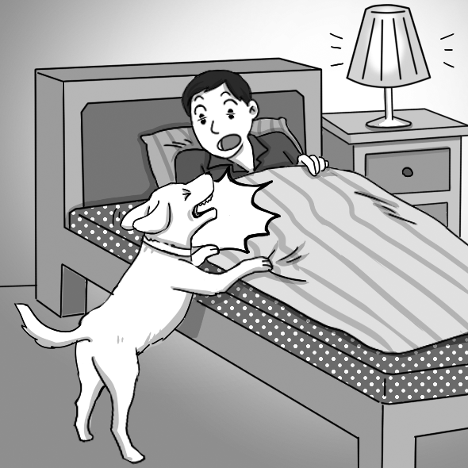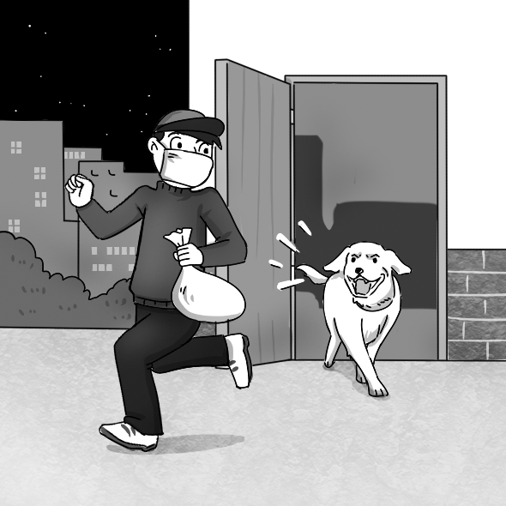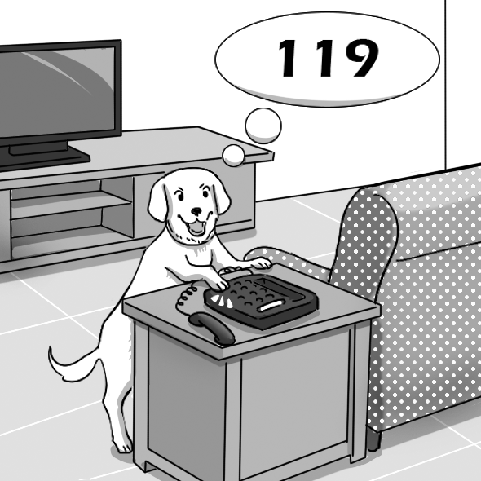  (A) I don’t have cash. (B) Do you need a bag?  (C) I have these coupons. (D) May I use the shopping cart?  III.文法選擇(20%)  ( )16. I couldn’t find my key last night. I _____ it somewhere.  (A) must have left (B) may leave (C) can leave (D) am able to leave  ( )17. Joseph has eaten three sandwiches already. Now he is eating another one.  He must _____ so hungry.  (A) be (B) is being (C) is (D) has been  ( )18. Jerry asked his girlfriend _____ marry him.  (A) would she (B) she would (C) if she would (D) would she if  ( )19. The fans didn’t know _____ the singer had taken this flight or not.  (A) where (B) how (C) what (D) whether  ( )20. _____ along the beach, I thought of my childhood.  (A) Walk (B) Walked (C) Walking (D) To walk  ( )21. _____ by her boss, Sarah was pleased and decided to work harder.  (A) To praise (B) Praising (C) Praised (D) Being praise  ( )22. _____ where the new restaurant was, we used Google Maps to search for it.  (A) Not knowing (B) Knowing not (C) No to know (D) Has not known  ( )23. _____ confident Ben became, _____ he cared about having to be perfect.  (A) The much; the little (B) The more; the less  (C) The much; the less (D) The more; the little  ( )24. The cat’s ability to see in the dark is much better than _____ of humans.  (A) one (B) those (C) it (D) that  ( )25. _____ their spectacular sense of smell, dogs can detect hidden drugs.  (A) Have (B) Owned (C) Into (D) With  IV.同義字(10%)  ( )26. The chef shares his unique cooking skills on this program.  (A) benefits (B) sections (C) weapons (D) techniques  ( )27. When we are in need, our parents always assist us.  (A) ask (B) aid (C) aim (D) allow  ( )36. (A) had saved (B) save (C) has saved (D) saves  ( )37. (A) where (B) why (C) what (D) which  ( )38. (A) on (B) in (C) at (D) of  ( )39. (A) finds (B) find (C) found (D) finding  ( )40. (A) health-relating (B) health-related (C) relating-health  (D) related-health  VI.閱讀測驗(10%)  Many businesses are now advertising through social networking websites such as Facebook and Twitter. This is called “social media marketing,” and many people believe that Facebook is the greatest marketing tool because it has over a billion users worldwide.  Two of the many benefits of advertising on social media are raising brand awareness(意識) and increasing customer loyalty. Brand awareness has to do with how much a potential(有潛力的) consumer associates the brand with the product he or she wishes to buy. For example, if you want to get a nice pair of jogging shoes, the shoe brands that first come to mind are probably Nike, New Balance, and Adidas. As for customer loyalty, it has to do with how or why a consumer chooses to stick to one particular product or go to one particular shop only. One of the examples would be someone who always buys stationery(文具) made by Pentel or Plus.  A business report points out that social media marketing has become a “must-have” when it comes to promoting products. So next time you notice an advertisement while visiting Facebook or other social networking websites, don’t forget that this is one of the ways companies are promoting their products.  ( )41. What is the passage mainly about?  (A) What kind of jogging shoes you should have.  (B) A strategy companies use to advertise their products.  (C) The idea of staying loyal to one particular fashion brand.  (D) How Facebook users are marketing their products.  4. The v__________ms of the earthquake were still waiting for medicine, food and other supplies.  5. You may take a____________e of our free shipping service if your purchase comes to 500 dollars or more.  6. On my trip to Canada, I e__________red an old friend at the airport.  7. It is almost impossible to p___________t when an earthquake will happen.  8. Because the country had been hit by many natural d__________rs, the people there needed international assistance.  9. Gina is s____________e to fashion. She always knows what the latest trends are.  10. Lisa is a volunteer in an animal shelter. She never expects a r__________d for her services.  11-12.在前門正上方大型又色彩明亮的看板比較有可能吸引人們的目光。  A huge, bright-colored sign right above the front door is more (l)________ to (c)________ people’s eye.  13-14.在UNIQLO關門前二十分鐘，Mandy掃視了有著各式各樣顏色的毛衣，考慮著要買哪一件。  Twenty minutes before UNIQLO was closed, Mandy (g)________ at the sweaters that came ___________ various colors, thinking about which one to buy.  15-16.結果是我們球隊贏得冠軍。  It (t)_________ _________ that our team won the championship.  17-18.因為除夕夜交通壅塞，我們去聽演唱會遲到了。  We were late for the concert (d)________ _________ the heavy traffic on Chinese New Year’s Eve.  19-20.整體上來說，每天運動30分鐘對你是有益的。  (O)________the ________, exercising for 30 minutes every day is good for you.  *請同學將手寫部分填寫於答案卷上，否則不予計分，謝謝!  
  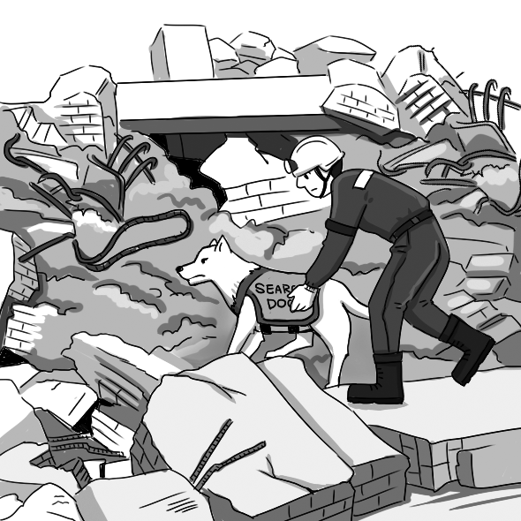 | 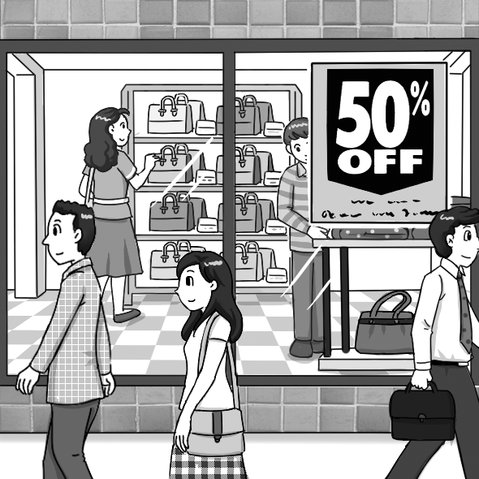
  1. ______ | 2. ______

