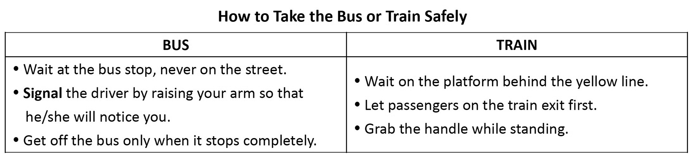 ( ) 1.According to the table, which of the signs may appear at a train station?
(A)  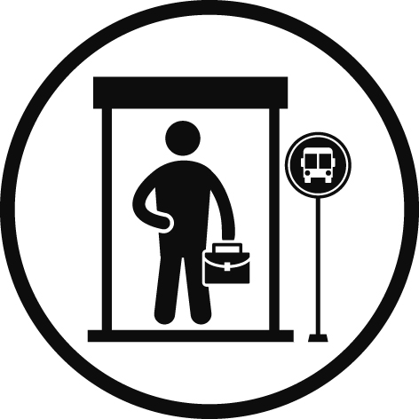 | (B)  
(C)   | (D)  
( ) 2. According to the table, what does “signal” mean?
(A) Making your feelings known to others.
(B) Showing that something will happen.
(C) Giving information to others with action.
(D) Choosing something that you like.
The Statue of Liberty is one of the most famous monuments in the world, but how much do you really know about her? For more insight into this famous tourist sight, below are some interesting facts about her.
For starters, even her name is not real. Her full name is actually “Liberty Enlightening the World,” with “Statue of Liberty” serving only as a nickname. Secondly, nobody really knows who her face is modeled after. Some believe she was based on the mother of the artist, Frederic Auguste Bartholdi. Others wonder if it might have been his brother’s face, as Bartholdi spent much time caring for him in his later years. Lastly, we all know how tall she is, but did you know she wears a pair of size 879 shoes? Or that she weighs 225 tons? Her shoe size, coupled with her waist of 35 feet, means she is a giant! Be sure to read up on the history of Lady Liberty the next time you have a chance to visit this iconic statue.
( ) 3. What is this passage mainly about?
(A) Fun facts about the Statue of Liberty.
(B) The importance of the Statue of Liberty.
(C) The measurements of the Statue of Liberty.
(D) The creator of the Statue of Liberty.
( ) 4. Which of the following is NOT true?
(A) The Statue of Liberty’s shoe size is 879.
(B) The Statue of Liberty’s face is modeled after a giant.
(C) “Statue of Liberty” is just a nickname.
(D) The Statue of Liberty is 225 tons in weight.
( ) 5. What does the word “insight” mean?
(A) A careful action. (B) A quickly delivered box.
(C) A clear understanding. (D) A good sense of smell.
Carbon dioxide (CO2) is good at holding in heat from the Sun, and even a small increase of the gas in the atmosphere can cause Earth to get even warmer. Carbon capture, usage and storage (CCUS) is about different technologies that can keep CO2 produced by factories and power plants from causing global warming. The idea is simple, and there are only a few main steps in the process. The first step is about trapping carbon emissions from factory chimneys. For instance, a filter can be placed in the chimney, so that the carbon is trapped and it cannot go out into the atmosphere. Then, the gas is piped to places where it can be stored or used. If stored underground, it cannot contribute to the climate crisis. If used, for instance, it can help grow greenhouse plants or make soda drinks.
While CCUS projects can clearly benefit the environment, these projects are not straightforward as there are many issues to be dealt with, such as maintaining the storage site, which have slowed start-ups of CCUS projects worldwide. Thus, with only a few CCUS projects operating now, there still aren’t enough to seriously help with the world’s carbon emissions. Early forerunners in this technology are the US, Canada, and Norway. The good news is that CCUS has now gained momentum in other countries, where 30 new projects have begun in the past three years. The International Energy Agency says there must be many more to keep carbon emissions from heating the world too much.
( ) 6. What is the purpose of this article?
(A) It advises us against CCUS. (B) It informs us about CCUS.
(C) It introduces new CCUS projects. (D) It shows CCUS impact on technology.
( ) 7. What is the process of CCUS?
(A) To use the CO₂ , and then store it in greenhouse plants.
(B) To pipe the CO₂ , and then trap it to cause the climate crisis.
(C) To store the CO₂ underground, and then pipe it to the chimneys.
(D) To trap the CO₂ , and then either keep it or use it.
( )8. Why is carbon dioxide put underground?
(A) To limit global warming. (B) To light up greenhouses.
(C) To worsen climate change. (D) To cool down soda drinks.
( )9. Which of the following is closest in meaning to “momentum” in paragraph 2?
(A) decrease (B) wealth (C) progress (D) fortune
( )10. What can be concluded from paragraph 2?
(A) CCUS will be stopped from now on to save money.
(B) The number of countries using CCUS may increase.
(C) CCUS benefits problems such as storage site maintenance.
(D) There are enough CCUS projects to stop heating the world.
When you think of the sharing economy, services like Uber or Airbnb probably come to your mind. The truth is that sharing economy goes much deeper than that.
Nowadays, people share almost everything. For many dog keepers, they often feel guilty and anxious when leaving dogs home alone. If they turn to private pet sitters, they have to face the financial pressure. Now, here’s DogVacay. Using this website, keepers can find a nearby host for taking care of their dogs when they are away from home. Compared with a pet boarding kennel*, DogVacay offers dogs a better environment at a lower price.
What if you want to rent a car without going to a car rental company? Turo provides an app that allows you to find a rental car in your neighborhood. To rent yours out, all you need is the navigation system* in the car. Through the system, the exact position of the car can be found, protecting the safety of drivers and renters alike. And what if you need to have something done around your house, your office, or anywhere else? Try Taskrabbit. It’s a website where you can hire people to do jobs, provide immediate helps, or even deliver goods. The sharing economy has no limit.
* pet boarding kennel (n.) 寵物寄宿 *navigation system (n.) 導航系統
( )11.What is the best title for this passage?
(A) Navigation System: A Must for Renting a Car
(B) Uber or Airbnb: The Beginning of Sharing Economy
(C) Some New Faces of Sharing Economy
(D) Sharing Economy: To Share or Not to Share?
( )12.According to the passage, which of the following statements is correct?
(A) DogVacay recommends dogs be put in a doghouse instead of boarding kennel.
(B) Turo is an app that can assist you in finding a nearby car to rent.
(C) TaskRabbit helps students with their difficult homework.
(D) Sharing economy can only be applied in certain fields, such as tourism industry.
( )13. You are going to take a business trip. However, no one can take care of your puppy.
In this case, ________ may be the best option for you.
(A) Taskrabbit (B) Turo (C) Airbnb (D) DogVacay
( )14. What can be inferred from the last sentence “The sharing economy has no limit.”?
(A) The idea of the sharing economy can be related to many jobs.
(B) There is no requirement for people to work in Taskrabbit.
(C) To know the sharing economy more, we need to be involved in it now.
(D) The government should set limits on the use of sharing economy.
( )15. How does the author feel about sharing economy?
(A) Upset. (B) Negative. (C) Positive. (D) Worried.
We are living in an environment filled with chemicals, many of which are dangerous to our health, such as plasticizer*. It is true that what we eat does affect us physically. But what about mentally? Does the food we consume have a direct connection with our emotions?
The nutrients* we take in from various kinds of food serve different functions in our bodies. For example, fruits and vegetables help produce hormones that make us stay calm. On the other hand, proteins make us become more alert*. Nevertheless, junk food consists of very few nutrients that will do us good. With its high fat, sugar, and salt content, junk food may do great harm to our health. Eating too much junk food may result in tiredness, stress, and depression*. What’s worse, an ingredient in junk food, called trans fat*, is especially harmful for our bodies.
Trans fats are a type of substance often found in junk food. According to several studies from Spain and the UK, trans fats seem to directly linked to depression. Although doctors and nutritionists haven’t figured out why trans fats have something to do with depression, it seems that they reduce the production of serotonin— a chemical that is believed to make us happy. If our body doesn’t have sufficient serotonin, we may have huge negative swings.
On the whole, eat wisely. Stay away from junk food and embrace healthy food. Eat more healthily, and you will be happier. After all, you are the master of your own body, so you should treat it well. Be careful about what you eat because the consequences of eating junk food could be long-lasting.
*plasticizer (n.) 塑化劑*nutrient (n.) 營養素 *alert (adj.) 警覺的* trans fat (n.) 反式脂肪 *depression (n.) 憂鬱
( ) 16. Which of the following is the best title of the passage?
(A) Hormones: What Makes Girls Different from Boys
(B) Junk Food and Negative Mood Swings
(C) Modern Nutrition
(D) Essential Nutrients for the Body
( ) 17. Do the foods that we eat affect us mentally?
(A) No, they only affect us physically. (B) Yes, but only for certain people.
(C) Yes, they can have major effects. (D) Yes, but only minor effects.
( ) 18. According to the reading, which of the following statements is true?
(A) Plasticizer is beneficial to our bodies.
(B) The nutrients in vegetables and fruits can make us more alert.
(C) Protein can make us calm.
(D) We can’t get many nutrients from junk food.
( ) 19. Based on the article, which of the following people is MOST LIKELY to suffer from
depression due to his/her eating habit?
(A) Jane, who is a vegetarian, doesn’t eat anything containing meat.
(B) Jack, who is a student, eats a lot of fast food in his daily lives.
(C) George, who is a teacher, eats fruits after each meal.
(D) Vicky, who is a gym trainer, consumes a lot of protein after each workout.
( ) 20. Which piece of advice is NOT given in the article?
(A) Avoid eating junk food. (B) Exercise more.
(C) Watch what you eat. (D) Treat your body well.

