一、文意字彙 34%
- The woman could ________ sleep with so much noise in the room.
(A) barely (B) meanwhile (C) shortly (D) similarly
- Please turn your phone to mute ________ during the meeting.
(A) captain (B) mode (C) captain (D) spray
- The teenager told us about his ________ with different kinds of insects.
(A) celebrity (B) technology (C) organizer (D) fascination
- Recently, Lisa has been trying to ________ her father to buy her a new laptop.
(A) persuade (B) interview (C) deliver (D) dare
- If you keep eating so much junk food and refuse to exercise, your weight will certainly
________.
(A) increase (B) seek (C) suggest (D) present
- The food at this restaurant is really________; no wonder few customers go back to eat a second time.
(A) public (B) horrible (C) principal (D) wonderful
- When it comes to global warming, humans are the ones to ________.
(A) blame (B) distract (C) spray (D) propose
- In order to protect its citizens, the government spends huge sums of money on national ________.
(A) defense (B) horror (C) ceremony (D) observation
- My boss totally accepted my suggestion and kept nodding to ________ his full agreement. (A) deny (B) excuse (C) forget (D) indicate
- Learning from one’s mistakes and never giving up are just two of the ________ rules of
achieving success.
(A) hurtful (B) delightful (C) fundamental (D) industrial
- The boss encouraged her new manager to take complete ____________ of the project
instead of relying on suggestions from more experienced coworkers.
(A) fiction (B) interview (C) equality (D) control
- Once this new tunnel is completed next year, it will greatly ________ the time it takes to
reach the village in the mountains.
(A) distract (B) shorten (C) blame (D) propose
- If the bridge has only four pillars (橋墩) instead of five, it will ________ the whole
structure.
(A) pursue (B) weaken (C) sacrifice (D) afford
14. The doctor visited several times during the night to track my dad’s progress.
(A) upload (B) establish (C) monitor (D) fascinate
15. The terrible smell of the rotten eggs made Janet feel like throwing up.
(A) hurtful (B) principal (C) limited (D) horrible
16. Sean is about to deliver a speech ________, so he is very nervous now.
(A) on purpose (B) in public (C) no longer (D) at least
17. Leo really wants to buy a new smartphone, but he has some challenges. ________, he needs
to save enough money to buy one.
(A) At least (B) For a start (C) On purpose (D) On average

二、語法選擇 30 %
18. The doctor suggested that Owen ________ less and ________ more to lose weight.
(A) eats; exercises (B) eat; exercise (C) ate; exercised (D) eating; exercising
19. Betty’s grandparents live in a small village ________ there are only about 500 people.
(A) which (B) where (C) that (D) when
20. The dog ________ around in the yard belongs to Helen.
(A) running (B) runs (C) ran (D) run
21. ________ book you are going to pick on the shelf, I believe you will enjoy it.
(A) Whichever (B) Whoever (C) Wherever (D) Whenever
22. James never leaves his children ________ on their own in the pool.
(A) played (B) to play (C) playing (D) play
23. No matter ________ tired my father is after work, he always reads us bedtime stories.
(A) when (B) where (C) what (D) how
24. We have been working too hard. It is about time that we ________ on vacation.
(A) go (B) went (C) are going (D) can go
25. Rosa felt happy ________ hearing Zack praising her in public.
(A) as soon as (B) because (C) since (D) upon
26. The ceremony will begin as soon as everyone ________ ready.
(A) is (B) will be (C) was (D) would be
27. The noise from the street vendors made ________ hard for Simon to work on his project.
(A) this (B) its (C) it (D) that

28. The actress didn’t become famous ________.
(A) when a popular film (B) because the popular film
(C) until she starred in a popular film (D) she starred in a popular film
29. Many people love to have pets. Some have dogs, others have cats, and ________ have birds.
(A) another (B) still another (C) others (D) still others
30. Lisa stood under the tree, ________ for her friends.
(A) wait (B) waited (C) waits (D) waiting
31. The orphan（孤兒）wants to know ________ his parents are still alive. He misses them so
much.
(A) where (B) why (C) if (D) when
32. The teacher was explaining ________ to do the experiment correctly.
(A) how (B) what (C) who (D) which

三、克漏字(綜合測驗) 20%
(1)
Auggie was a young boy who grew up in Manhattan. He was born ____33____ a problem: His face was seriously deformed. Despite having had many surgeries, his face still caused people to look away. That’s why Auggie was homeschooled ____34____the age of ten. ____35____, after he turned ten, his parents put him in a regular school. As he had expected, it was not easy to ____36____ at his new school. He didn’t know if he would ever make a friend. Several students even made fun of him. Yet, soon enough, one boy named Jack was willing to ____37____ with him. Over time, Jack and Auggie became great friends.
33. (A) in (B) with (C) over (D) at
34. (A) when (B) because (C) until (D) for
35. (A) However (B) Therefore (C) Besides (D) Additionally
36. (A) come with (B) end up (C) head for (D) fit in
37.(A) lead to (B) pass away (C) set up (D) hang out

(2)
Every day, millions of people ride long-distance trains. ____38____ the length of these journeys, passengers sometimes need to eat. That’s why many trains have a kitchen car (車廂), which is like a regular kitchen. The chefs have to get used to ____39____their balance while cooking. There is also a dining car where train workers provide passengers ____40____ the meals. Needless to say, the type of food they make depends on the country. But the food that ____41____ is usually a little saltier than usual. This is because trains are very noisy and bumpy, so diners don’t pay as much attention to the food. As a result, the food can seem ____42____ salty than it really is. Having a meal on a train can be a really interesting experience, so give it a try if you ever get a chance!
38. (A) Because (B) Since (C) Due to (D) In spite of
39. (A) be kept (B) kept (C) keep (D) keeping
40. (A) for (B) with (C) in (D) over
41. (A) serves (B) served (C) has served (D) is served
42. (A) less (B) more (C) much (D) least

四、對話 6%
43. Ruby: Do you know what happened to John?
Lily: No. What happened?
Ruby: Well, his father passed away in a car accident.
Lily: ____________ How can this happen to him? He must feel very sad now.
Ruby: I think so, too. Maybe we should try our best to comfort him.
(A) Good luck! (B) Just relax. (C) No way! (D) Leave me alone.
44. Waiter: Hello! Are you ready to order?
Customer: I have no idea. ____________
Waiter: You can choose from this page. These are our best-sellers.
(A) I’ll be back soon. (B) What would you like to drink?
(C) It’s nice to meet you. (D) What do you recommend?
45. Daniel: Do you know who the actor Leonardo DiCaprio is?
Peggy: Of course! I have watched all of his movies! I love him!
Daniel: What do you know about him?
Peggy: Well, I only know he is handsome and good at acting.
Daniel: In fact, he is also very concerned about the environment. He often urges people to
protect the environment!
Peggy: Wow! He is not only a great actor but also a role model!
Daniel: ____________ I think we can learn a lot from him.
(A) Take a wild guess. (B) That’s not the point.
(C) Don’t mention it. (D) I couldn’t agree more.
五、閱測 10%
(1)
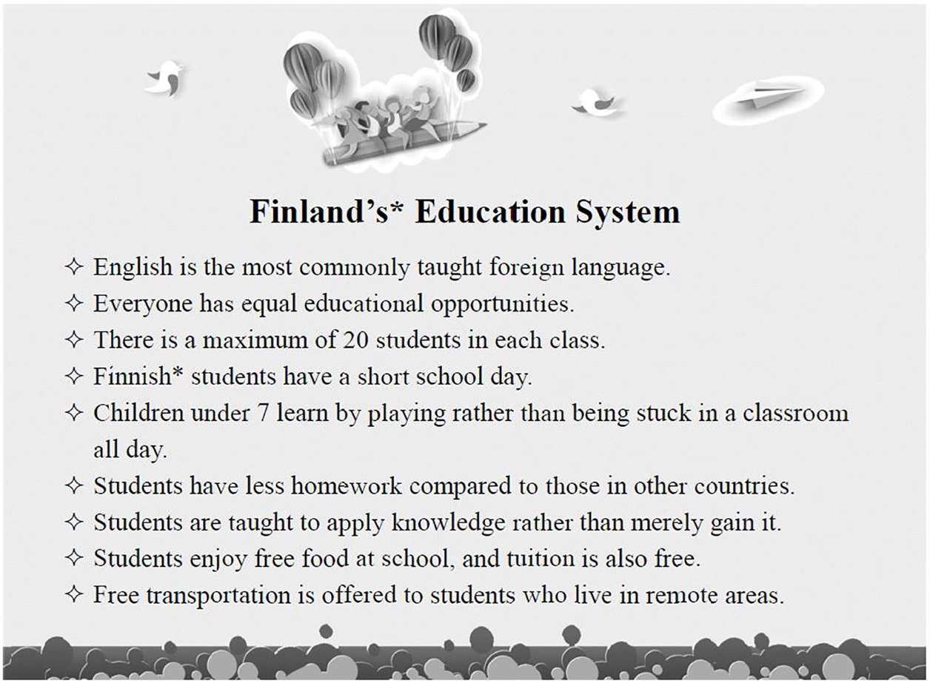
＊Finland n. 芬蘭 ＊Finnish adj. 芬蘭的
46. Which of the following is NOT true about Finland’s education system?
(A) Most Finnish students’ second language is English.
(B) Students don’t have to pay for food at school.
(C) It is impossible to have 22 students in a class.
(D) Local students have no homework at all.
47. Based on the list above, what can we infer about Finnish students?
(A) They are all used to learning in very large classes.
(B) They mostly prefer foreign teachers to local ones.
(C) They don’t have to worry about how much they should spend on the transportation to
school.
(D) They spend more time at school than students in other countries.

(2)
Traveling in an aircraft is dangerous. Extreme weather, engine failure, and acts of terror, can all lead to disaster. Even the safest flights hold threats for passengers. Due to the lack of moisture inside the cabin, for example, you’re 100 times more likely to catch a cold during a flight than you are on the ground. With germs* spreading very quickly in the dry cabin conditions, a single cough or sneeze can infect several passengers at once!
In addition, harmful bacteria often survive inside aircraft cabins for days despite cleaning. Frequently touched surfaces like toilet doors and cup holders, therefore, pose a serious threat to passengers. This is especially true for flights serving food, since passengers might swallow dangerous surface germs with their in-flight meals. And, don’t be so sure you can trust the meals themselves either! Airplane coffee and tea often aren’t brewed* at high enough temperatures to kill all the bacteria in the water, and meal packs must pass through many hands before finally arriving on your tray* table.
Proper flight safety therefore isn’t just about wearing a seatbelt. Take extra care in the air, or you might get sick!
*germ n. [usually pl.] 細菌 *brew vt. 煮 *tray n. [C] 托盤
48. What is the best title for this passage?
(A) Air Quality in an Aircraft Cabin Matters (B) How In-flight Meals are Processed
(C) The Invisible Killer in the Air (D) Threats that Germs can Hold
49. How can harmful germs get into passengers, according to the passage?
(A) Through windows and walls in the aircraft cabin.
(B) Through surfaces often touched by others.
(C) Through insects crawling in the aircraft cabin.
(D) Through passengers’ carry-on luggage.
50 . Which of the following statements is NOT true about this passage?
(A) Traveling in the air could be dangerous for many reasons.
(B) You are more likely to get ill in the air than on the ground.
(C) Even though the cabin is cleaned, bacteria can still survive for days.
(D) Wearing a seatbelt can decrease the chance of getting sick in the air.

