- 請將答案畫記在電腦答案卡上，同時畫記班級和座號，未畫者，酌扣總分5分!

I素養題
Read the label below and answer the questions that follow.
Drug Facts

Uses
Temporarily relieves these symptoms
- sneezing | - runny nose | - watery, itchy eyes

Warnings
Ask a doctor before use if you have
- glaucoma
- breathing problems
When using this product
- you may get drowsy | - avoid alcoholic drinks
- be careful when driving a motor vehicle or operating machinery
If pregnant or breastfeeding, ask a doctor before use.

Directions
Adults and children 12 years and over | Take 2 tablets every 4 to 6 hours;  not more than 12 tablets in 24 hours
Children under 12 years | Ask a doctor

Other information
Store in a cool, dry place

（ ）1.Which part should you check to find out how to take the medicine?
(A) Uses | (B) Warnings
(C) Other information | (D) Directions
（ ）2.Which effect should you be aware of if you want to take the medicine?
(A) You may feel sleepy and cannot think clearly.
(B) You may feel cool and have dry skin.
(C) You may have watery eyes and a runny nose.
(D) You may have itchy eyes and cannot breathe well.

（ ）3.According to the label, which of the following is true?
(A) Adults should take the medicine with alcoholic drinks.
(B) A 13-year-old child can take ten tablets in a day.
(C) A patient can take two tablets every six hours to treat glaucoma.
(D) A 30-year-old pregnant woman should take the medicine without asking a doctor.

.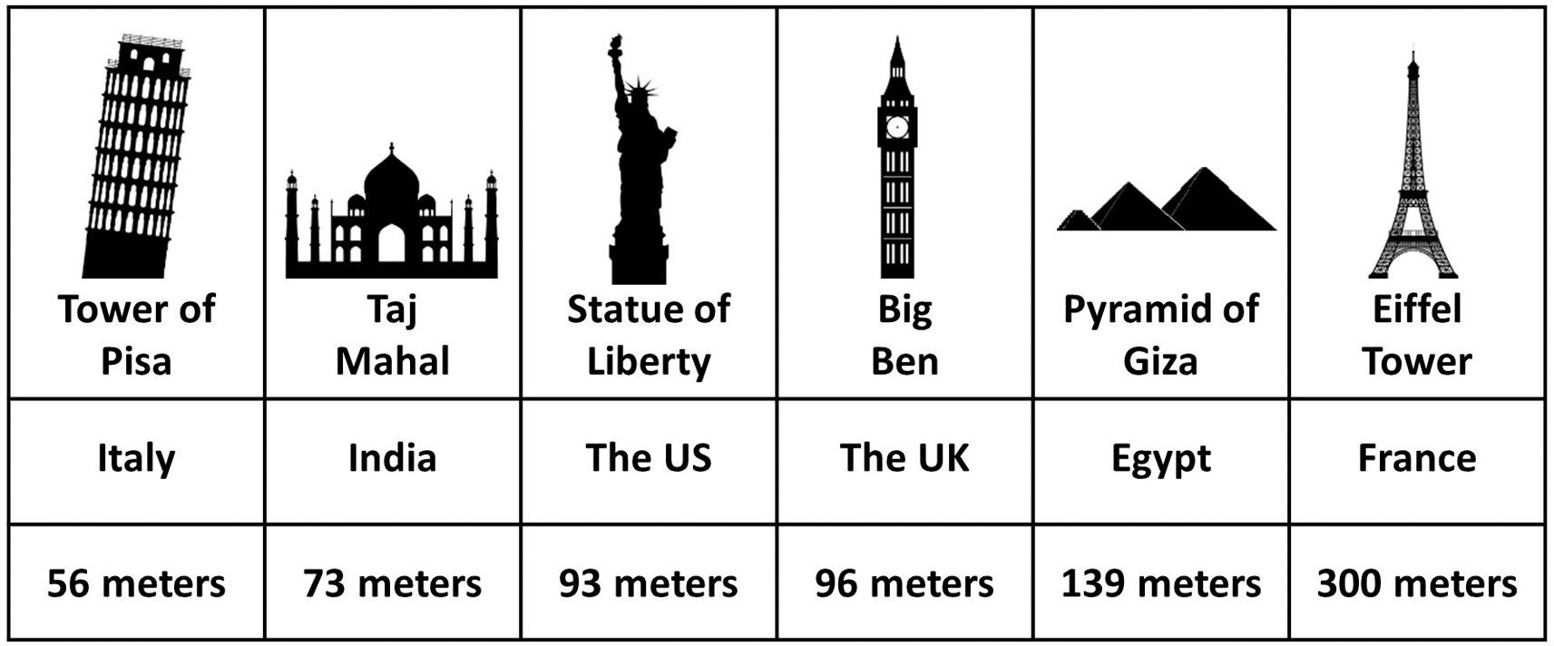

（ ）4. What is the difference in height between the Indian and Egyptian landmarks mentioned above?
(A) 139 meters. (B) 73 meters. (C) 212 meters. (D) 66 meters.
（ ）5. According to the table, how many of the landmarks are taller than the Statue of Liberty? (A) Two. (B) Three. (C) Four. (D) None.
（ ）6.According to the table, which of the following statements is true?
(A) The Eiffel Tower is taller than the four shortest landmarks added together. (B) The British and American landmarks are the closest in height.
(C) The pyramid is taller than all the other landmarks
(D) Four of these landmarks are in Europe.

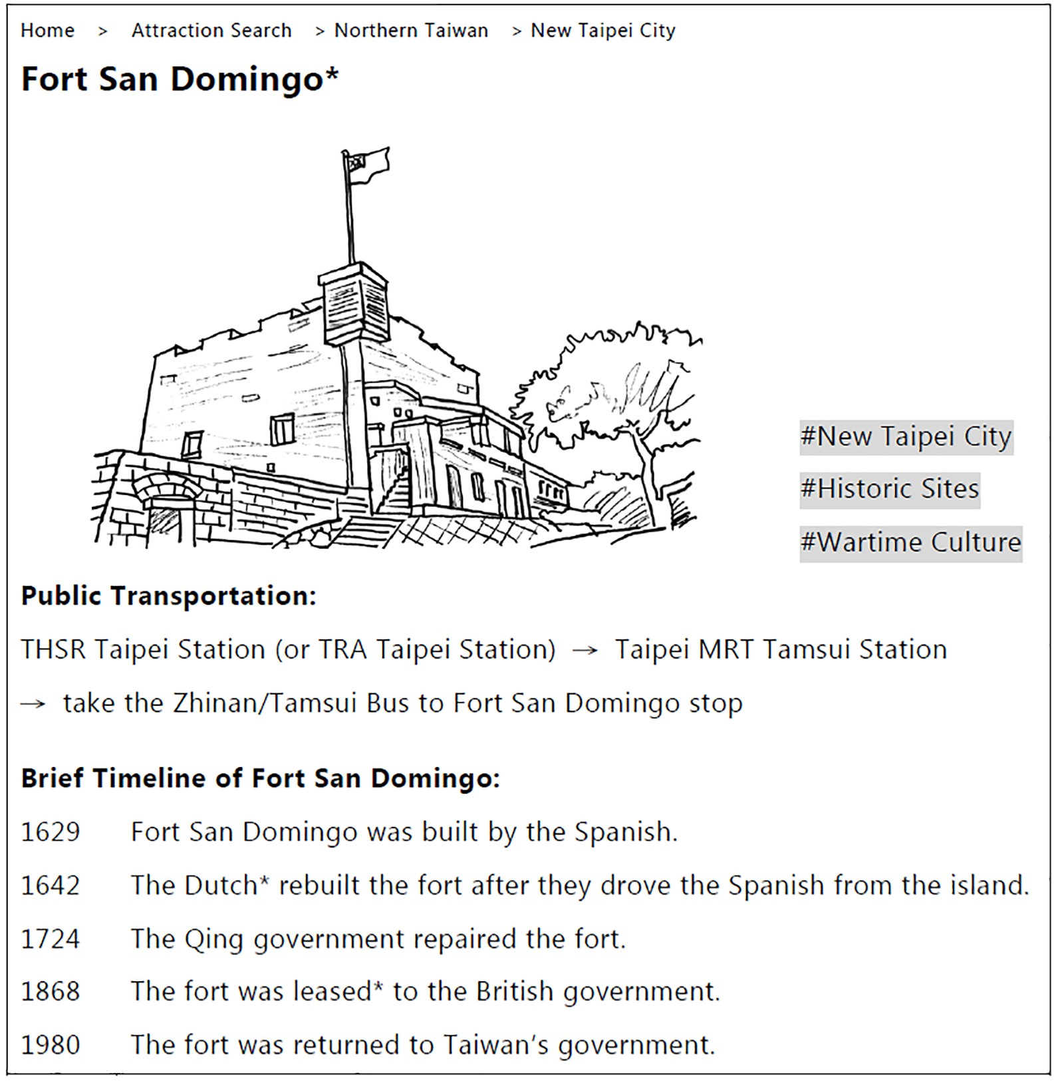
*Fort San Domingo 淡水紅毛城（聖多明哥城） *Dutch 荷蘭人 *lease vt. 租用
（ ）7. Where can this post be seen? (A) A tour website. (B) New Taipei City’s Hall. (C) A tea café in London. (D) A Qing Dynasty painting.
（ ）8. Which of the following countries did NOT occupy or use Fort San Domingo? (A) Holland. (B) Spain. (C) The United Kingdom. (D) Korea.

.

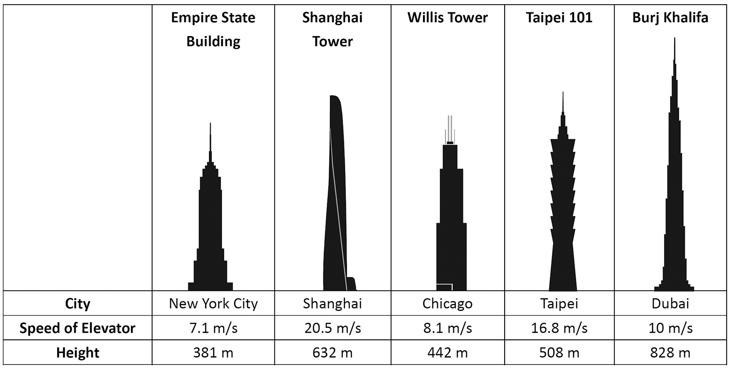

（ ）9. Which of the following buildings is the tallest?
(A) Taipei 101. (B) The Burj Khalifa.
(C) The Empire State Building. (D) The Shanghai Tower
.
（ ）10. Which of the following about the buildings’ elevators is true?
(A) The Shanghai Tower has the fastest elevator among the five buildings.
(B) The elevator of Taipei 101 is faster than that of Shanghai Tower.
(C) The elevator of the Shanghai Tower is slower than that of the Burj Khalifa.
(D) The elevator of Taipei 101 is just as fast as that of the Empire State Building.
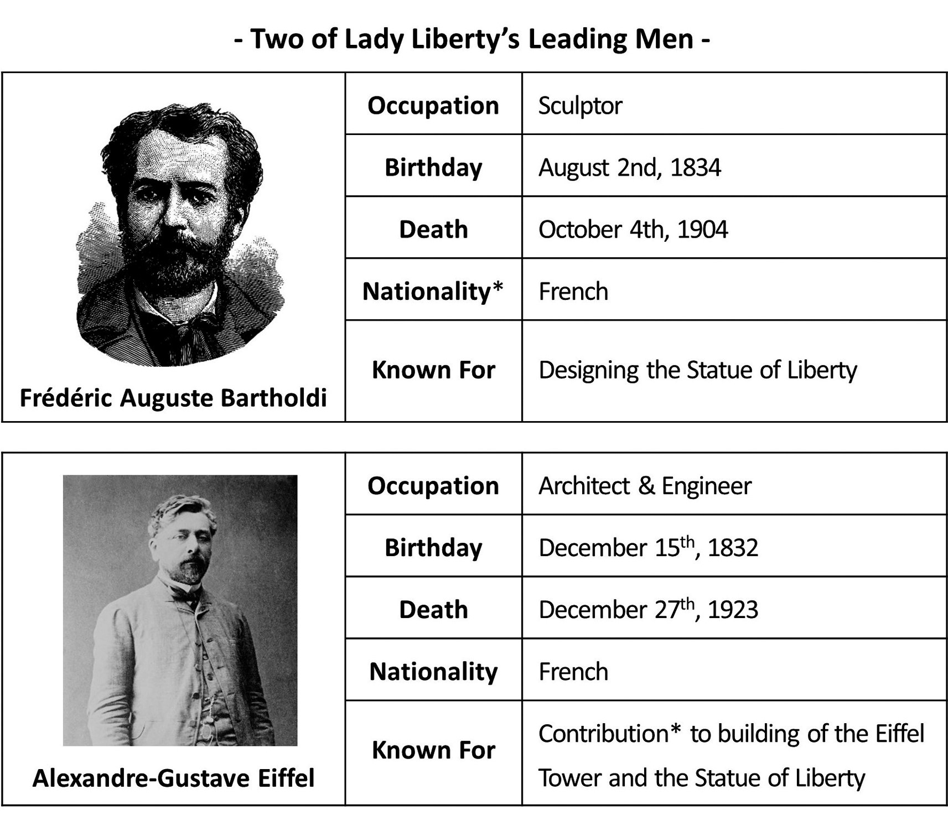
*nationality n. [U] 國籍 *contribution n. [sing.] 貢獻
（ ）11. According to the information above, what did these two men have in common? (A) They shared the same occupation. (B) They both worked on the Eiffel Tower. (C) They were both citizens of France. (D) They were both born in winter.
（ ）12. Bartholdi contacted Eiffel in 1881, asking him to assist in building the Statue of Liberty. How old was Eiffel at the time? (A) 47 (B) 55 (C) Almost fifty. (D) Over fifty.
（ ）13. Which of these two famous Frenchmen enjoyed a longer life? (A) Not enough information is given. (B) Eiffel (C) Bartholdi (D) Neither lived very long.
II閱讀測驗
- Last month, I visited Matsu. Matsu is a group of small islands named after Mazu, the goddess of the sea. These islands are in the Taiwan Strait*. First, I caught the Taima ferry from Keelung Harbor. A few hours later, I arrived on Dongyin, the most eastern of the Matsu islands. Rather than explore on foot, I rented a scooter. Riding a scooter saved me a lot of time. It also allowed me to take in all the sights quickly. Matsu has beautiful cliffs*, cool caves, and a lighthouse.
The next morning, I took another ferry to Nangan. I also rode a scooter around this island, stopping to look at Beihai Tunnel. Finally, I came upon* the giant statue of Mazu herself. This statue is over 25 meters high! In just three days, I saw the best Matsu had to offer. I definitely recommend going there!
*the Taiwan Strait 臺灣海峽 *cliff n. [C] 懸崖 *come upon 偶然發現
（ ）14. What is the best title for this passage?
(A)The History of Beihai Tunnel (B) Mazu, the Goddess of the Sea
(C) An Island in the Pacific Ocean (D) An Unforgettable Trip to Matsu
（ ）15. Which of the following sights is NOT mentioned in the passage?
(A) Cliffs. (B) Caves. (C) A lighthouse. (D) A temple.
（ ）16. What is the author’s attitude toward visiting Matsu?
(A) Bitter. (B) Uneasy. (C) Positive. (D) Angry.
- Technology is continuously changing the sports industry for the better. Electronic devices known as sensors can detect changes and provide instant information about the health and movements of the athlete. Technology has changed the way some athletes train by live tracking the athlete’s performances, perfecting the athlete’s movements, and preventing sports injuries.
Using sensors worn by the athlete, sports trainers can measure and track performance in real time. Nearly everything about the athlete can be measured, from breathing and heart rate, to sweat and temperature. The real-time information can help the trainer determine what aspects each athlete needs to focus on more. During practice, the trainer can read the data and decide when it’s time to rest, stretch or train harder. In the past, however, the practice session would be recorded, and the athlete’s performance would be judged later after the practice.

ˉ
（ ）17. What is the passage mainly about?
(A) Tracking the performance of trainers.
(B) Preventing the damage of technological tools.
(C) Perfecting the body movements of trainers.
(D) Training athletes with technological tools.
ˉ
（ ）18. Which is closest in meaning to the phrase “live tracking” in paragraph 1?
(A) Checking an activity after it is over.
(B) Following an activity before it happens.
(C) Discussing an activity that may happen.
(D) Observing an activity when it is taking place.
ˉ
（ ）19. According to the passage, how has technology changed sports training?
(A) The athlete and the trainer can have a healthy diet.
(B) The trainer can find out at once how the athlete performs during practice.
(C) The trainer can understand the athlete’s performance only after practice.
(D) The athlete and the trainer can stop during practice.
ˉ
（ ）20. In the writer’s opinion, what is the best benefit of using technology in sports
training?
(A) Watching a performance. | (B) Avoiding sports injuries.
(C) Recording the sports practice. | (D) Making the movements perfect.
ˉ

