<第一部份: 選擇題>
I. 生字片語選填 (20分，每題2分) ※ 選出最符合句意的單詞或片語，並將代號劃記答案卡上。(請忽略大小寫)
- attitude (B) positive (C) hint (D) invitation (E) message

(i)
1. The ending of the story gave a : The sequel (續集) will be coming soon.
2. My sister left a for me to come home early.
3. The dinner with David is a experience. I will like to go again.
4. It is okay if you are not very smart, but your toward learning is very important. .
5. I have not received (收到) Amy’s to attend her birthday party.
(ii)
6. Alice is sick, but she _ to take the medicine.
- refuse (B) get along (C) mention (D) to his surprise (E) confuse
7. Diana __ the lunch date (午餐約會) with our boss, but I forgot it.
8. These math questions are too difficult for me. They _ me a lot.
9. , Peter didn’t get a good grade on the history test today.
10. The neighbors pretty well. They help each another take care of the pets.

II. 文法選擇 (26分，每題2分) 根據句意，選出最適當的答案。
( ) 11. My dad keeps videos to me on LINE.
(A) send (B) sends (C) sent (D) sending
( ) 12. Rebecca ______ a lot of water yesterday.
(A) will drink (B) drinks (C) drank (D) drinking
( ) 13. Hurry up! The class is going to ______ in two minutes.
(A) began (B) begin (C) beginning (D) begins
( ) 14. Andy ______ Amy very much, but she doesn’t know about it.
(A) love (B) loving (C) loves (D) to love

( ) 15.With Lisa’s help, everything well.
(A) go (B) goes (C) went (D) going
( ) 16. Joe just to walk me home after our date.
(A) to offer (B) offered (C) offer (D) offering
( ) 17. I was so when he finally asked me out.
(A) exciting (B) excite (C) excited (D) excitedly
( ) 18. Please Jack’s email as soon as you can. He wants to know your answer.
(A) replying (B) reply (C) reply to (D) replied
( ) 19. Larry to the Taipei Game Show yesterday.
(A) go (B) goes (C) went (D) gone
( ) 20. Ann was bored the conversation and wanted to leave.
(A) at (B) with (C) on (D) for
( ) 21. I can’t tell my rabbit is happy or not.
(A) if (B) but (C) after (D) before
※ 22-23選出與句中劃底線的字詞意義最相近的答案。
( ) 22. Emily hinted that she forgot to bring her homework.
(A) waited (B) implied (C) touched (D) welcomed
( ) 23. Paul turned down my offer of help. He finished the work all by himself.
(A) started (B) threw (C) refused (D) studied
III. 對話 (12分，每題3分)
( ) 24. Logan: Emma, you’re very special to me. Do you feel the same way about me?
Emma: Umm...sorry, .
Logan: That’s OK. Bad luck on me today.
(A) I want to be your girlfriend
(B) I’m in a relationship
(C) it was a perfect date
(D) I’m really into you
( ) 25. A: I love you.
B: I know, but ________. I still don’t know much about love.
(A) I am too young
(B) we are in a relationship
(C) I feel the same way about you
(D) you are so special to me
( ) 26. A: I fell in love with Mia at first sight.
B: Wow, ________
(A) what’s up?
(B) I had a perfect date.
(C) what’s wrong?
(D) I don’t know you are into her.
( ) 27. Olivia: What’s wrong with you and Paul?
Cathy:
Olivia: Really? I thought he would never leave you.
(A) I thought she is seeing you.
(B) I am in love with him.
(C) They’ll get back together soon.
(D) He just broke up with me yesterday.
IV. 綜合測驗 (10分，每題2分)
(A) Tom and I met on the Internet. We really got 28 with each other. When he asked me out for a dinner, I happily said “Yes.” Tom was a nice guy, but I was too nervous to 29 on a conversation with him. After dinner, we took a walk in the park. I felt better 30 Tim walked me home. After that day, I 31 for Tim to ask me out again, but nothing happened. 32 I do anything wrong?

( ) 28. (A) out (B) over (C) off (D) along
( ) 29. (A) carry (B) put (C) turn (D) go
( ) 30. (A) so (B) but (C) before (D) because
( ) 31. (A) waited (B) waits (C) waiting (D) will wait
( ) 32. (A) Does (B) Don’t (C) Did (D) Done

V. 閱讀測驗 (10分，每題5分)
(A) 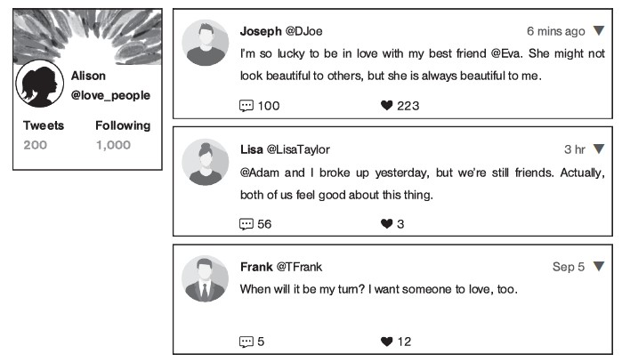
rude 無禮的
( ) 33. According to the pictures, which of the following is NOT true?
(A) Joseph and Eva are good friends.
(B) Lisa feels good about breaking up.
(C) Frank wants to be in a relationship.
(D) Adam and Alison broke up yesterday.
( ) 34. Who is more likely to be in a relationship?
(A) Frank.
(B) Adam.
(C) Eva.
(D) Lisa.

非選題部分:
I. 英翻中:(15分，每題3分)

 | 英文 | 中文
(範例) | teacher | 老師
1 | feelings
2 | refuse
3 | accept
4 | nervous
5 | conversation
II. 重組句子 (15分，每題3分) 重組字詞，以寫出完整的句子。請加上適當的標點符號。
1. you / will wait / I / for
→
2. the window / The kids / yesterday / broke
→
3. come to the office / The boss / next Monday / will not
→
4. Nick’s new shoes / Many people / like
_________________________________________________________
5. 我昨天晚上傳送訊息給Rita。

