- 選擇題：請將答案畫記於答案卡。 同時請於卡上畫記班級、座號。
第一部分：看圖辨義(3%) 未畫座號扣5分
說明：每題請聽錄音機所播出的題目和選項後，選出與所看到的圖畫最相符的答案。
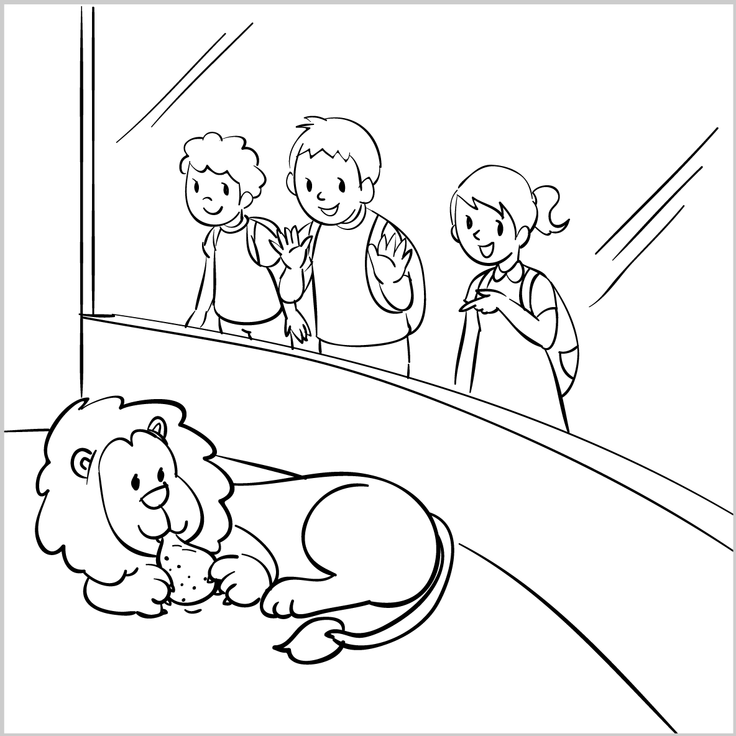  1. ______ | 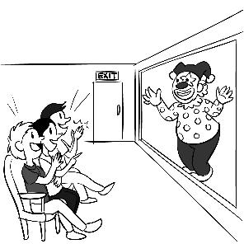  2. _____
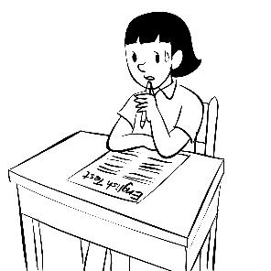 3_____
第二部分：問答(7%) 說明：每題請聽錄音機所播出的英語句子，再從試題上各選項中，選出一個最適合的回答或回應。
( )4. (A) Fine, thanks.
(B) Nice to meet you, Mary.
(C) Well, goodbye, Mary.
( )5. (A) Hello, good morning.
(B) How’s it going?
(C) OK. Goodbye then.
( )6. (A) See you! (B) I’m great, thanks. (C) How are you?
( )7. (A) Yes, we have to introduce ourselves. (B) Yes, we need to get off here.
(C) No, we’re not in the comfort zone.
( )8. (A) Please call me back. (B) I’ll see you tomorrow.
(C) Really? Can I go with you?
( )9. (A) As long as you finish your homework.
(B) No, basketball is no longer interesting to me.
(C) At first, I didn’t know you played that well.
( )10. (A) Nice to meet you. (B) Yes, I’m going, too. (C) Pretty good, and you?

I. 單字選擇(選出與句中劃底線的字詞意義最相近的答案)6% (每題1分)
( )11 | The teacher hinted that a famous writer will come to our school next week.
 | (A) waited | (B) touched
 | (C) implied | (D) welcomed
( )12 | It’s a pity that David missed the chance to ask the girl out.
 | (A) result | (B) shame
 | (C) cause | (D) offer
( )13 | The lack(缺乏) of sleep might cause you health problem.
 | (A) in addition | (B) go out
 | (C) lead to | (D) result from
( )14 | Laura’s silly pictures on the Instagram received many “likes” from her friends.
 | (A) caused | (B) occurred
 | (C) got | (D) accepted
( )15 | The hotel offered a free breakfast to its guests.
 | (A) provided | (B) accepted
 | (C) replied | (D) realized
( )16 | Don’t reply to the call. The number looks strange.
 | (A) refuse (B) respond | (C) mention (D) confuse
II克漏字選擇10%(每題2分)
It is said that men are from Mars(火星) while women are from Venus(金星). No wonder boys usually complain that girls are 17 to understand, and girls think boys are rude and careless. However, is it really true? Perhaps everything 18 well if there is more communication between the two. For example, a boy might get upset when a girl 19 his offer to walk her home. Then, he would worry about the girl’s 20 toward him. In fact, the girl may have
feelings 21 him, but she just thinks it is too much for the first date.
( ) 17. (A) fantastic (B) positive (C) single (D) hard
( ) 18. (A) go (B) went (C) will go (D) gone
( ) 19. (A) makes into (B) breaks into (C) takes off (D) turns down
( ) 20. (A) crush (B) attitude (C) interview (D) conversation
( ) 21. (A) for (B) by (C) with (D) at
III. 文法選擇 24% (每題2分)
( )22 | The two sisters _____ on the volleyball team three years ago.
 | (A) are |  |  | (B) will be
 | (C) were |  |  | (D) was
( )23 | I __ going to ___ my grandparents next month.
 | (A) was ; visit |  | (B) will ; visit
 | (C) am ; visited |  | (D) am ; visit
( )24 | Vincent never ___ asleep in English class.
 | (A) fell | (B) falling |  | (C) falls | (D) fall
( )25 | Silvia and I ___ hotpot last Sunday.
 | (A) have | (B) had |  | (C) were having | (D) has
( )26 | The department store ____ at 10:30 every day.
 | (A) is opening | (B) open |  | (C) opened | (D) opens
( )27 | After the actress ___ successful, she ___ a lot of money to her high school.
 | - became ; donated |  |  | - becomes ; donates
 | (C) becoming ; donating |  |  | (D) will become ; will donate
( )28 | Kevin kept _____ on the cellphone in math class yesterday.
 | (A) played (B) playing |  |  | (C) plays (D) was playing
( )29 | The baby _____ with the toy car and was asleep.
 | (A) gets bored (B) got bored |  |  | (C) will get bored (D) get bored
( )30 | Joseph ___ so nervous when the girl ___ to him during the date.
 | (A) feels ; talked | (B) felt ; talks |  | (C) felt ; talked | (D) feeling ; talking
( )31 | Jimmy asked to ___ the girl home, but she ____ no to him.
 | (A) walk ; said | (B) walked ; said |  | (C) walks ; says (D) walking ; said
( )32 | I ____ it would rain today, so I ___ an umbrella with me.
 | (A) think ; bring | (B) think ; brought |  | (C) thought ; brought (D) thought ; bring
( )33 | Vicky ___ up with Patrick, so she __ not in a relationship now.
 | (A) breaks ; is | (B) broke ; is |  | (C) broke ; was (D) breaking ; is
IV. 對話選擇 10% (每題2分)
( )34 A: Ben, I really like you. ________
B: I’m sorry. I’m seeing Diana now.
(A) Why do you like me?
(B) When did you break up with your girlfriend?
(C) Will you be my boyfriend?
(D) I am in a relationship.
一言為定。
( )35 A: Mark cheated on me.
B: Don’t be sad. There are still many good men out there.
A: I know, so ________.
(A) we went out on a date. (B) I broke up with him.
(C) we got back together. (D) we were seeing each other.
( )36 A: I fell in love with Michelle at first sight.
B: Wow, ________
(A) I had a perfect date.
(B) what’s up?
(C) I don’t know you are into her.
(D) what’s wrong?
( )37 Annie: Adam asked me out yesterday. What should I do?
Joan: ________
Annie: I’m not sure about that.
(A) How should I reply to him? (B) Why do you say so?
(C) Do you have feelings for him? (D) Did you have a good time?

( )38 Vincent: I fell in love with that girl with straight hair in Class 106.
Andy: Great. ________
Vincent: No, I can’t think of a good way to ask her out. I need your help.
(A) Did you have a crush on her? (B) Did you go out on a date?
(C) Did you get along well online? (D) Did you get back together?

V. 閱讀測驗 10% (每題2分)
Martin had a terrible day yesterday. It was the day of his vacation to Spain but it was a nightmare. He left the house at 10 o'clock in the morning and caught a taxi to the airport.

Martin went to the check-in with his luggage. When the man who worked for the airline asked
for his passport, Martin became very upset. Where was his passport? Martin realized he didn't
have his passport with him. What a disaster!

He jumped back into the taxi and told the driver to take him home. The driver drove quickly and Martin arrived back at his house in twenty minutes.

He ran into the house and went into his bedroom. He found his passport on the bedside table
and left the house again. But the taxi wasn't there! Where was the taxi!

Martin jumped up and down angrily. "I don't believe it. The taxi left!" he shouted. He ran down
the street and looked for another taxi.

After a few minutes, Martin found another taxi and told the driver to take him to the airport as quickly as possible. The traffic on the roads was very bad and, unfortunately, Martin's taxi
arrived at the airport late. His plane left for Spain at 11.30 and Martin missed it. He was very sad
and went to speak to the airline. They promised to get him a seat on an evening flight and Martin went home on another taxi to wait.

39 Where was Martin going on vacation?
(A). France
(B). Canada
(C). Spain
(D). the U.S.
40 How did Martin get to the airport?
(A). He went by the MRT.
(B). He went by bus.
(C). He went by train
(D). He went by taxi.

41 Why did Martin arrive late at the airport?
(A). He had a car accident.
(B). The traffic was bad.
(C). He was stopped by the police.
(D). The taxi broke down.

42 When did Martin realize that he didn’t have his passport?
(A). Before he left the hoiuse.
(B). On the taxi.
(C). At the check-in desk.
(D). When he got on another taxi.

43 Why did Martin jump up and down angrily?
(A). The taxi driver drove too slowly.
(B). He couldn’t find his plane ticket.
(C). He left his passport at home.
(D). The taxi driver left.

- 非選擇題 (請作答於右邊空格答案欄)
A. 文義字彙 8% (請注意動詞變化；每題2分)
1. My mom left a m e for me to buy milk home.
2. My parents’ a e toward my girlfriend is very important to me.
3. Howard t ls abroad with his family twice a year.
4. Jeff is not an o y child. He entered his high school at 11.

B. 填空式翻譯18 % (請注意動詞變化；每題2分)
1. 短暫休息之後，Jeff 將繼續他的清掃工作。
After a short break, Jeff will c________ o____ his cleaning.

2. Steve 一向準時。讓我們驚訝的是，他今天早上上學遲到了。
Seve is always on time. T__ o____ s_____ , he was late for school this morning.

3. John昨晚熬夜念書。因此，他在上課的時候打瞌睡。
John stayed up late to study last night. A____ a r_____ , he was nodding off during the class.

4. Carrie昨天在夜市碰見她的英文老師。
Carrie c________ a_________ her English teacher at the night market yesterday.

請務必填寫考卷右上角的班級、姓名、座號，未寫扣5分。
A. 文義字彙 8% (請注意名詞複數變化；每題2分)
1 | __________________ | 2 | __________________
3 | __________________ | 4 | __________________

B. 填空式翻譯 18% (請注意動詞變化與大小寫；每格2分；每格只填一個單字)
1
2
3
4

C. 單字片語選填(選出最符合句意的單字或片語，並填入代號) 每題1分，4%
(A) gave away | (B)make a difference
(C) In addition | (D) turned down

( )1. A pet can ____ to lonely person.
( )2. Jessica can speak Japanese and English. ______, she knows a little Hakka.
( )3. Emma _________ her Prince Charming’s proposal(求婚) last week.
( )4. The singer ____ signed CDs to her fans to express her thanks.

