閱讀測驗 100% (共20題；每題5分)
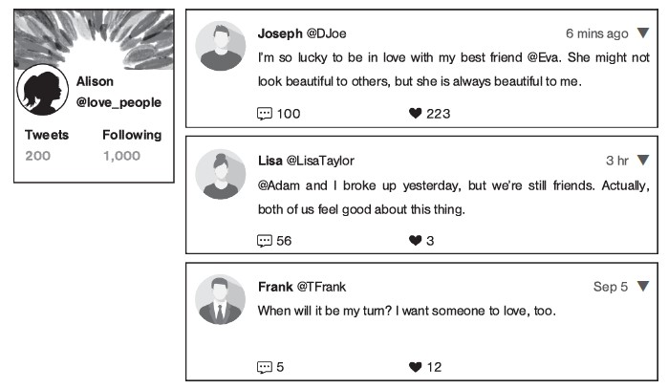
rude 無禮的
1. According to the pictures, which of the following is NOT true?
(A) Joseph and Eva are good friends.
(B) Lisa feels good about breaking up.
(C) Frank wants to be in a relationship.
(D) Adam and Alison broke up yesterday.

2. Who is more likely to be in a relationship?
(A) Frank. (B) Adam.
(C) Eva. (D) Lisa.

(B) There are four main types of attachment style for close relationships. The first one is secure attachment. People with this type feel good about both their needs and others’ needs. People with the second type may keep asking their partners’ feelings toward them. This is because they are afraid to lose the relationship. People with the third type only feel good about themselves, so they always try to be alone. The last type of people is both afraid of being alone and being too close to someone. Which type of attachment style do you think you belong to?
attachment style 依附型態 secure 安全的 partner 伴侶

3. The passage is mainly about ________.
(A) blood types (B) good friends
(C) wonderful feelings (D) close relationships

4. According to the passage, people with the ________ type feel good about their needs.
(A) first (B) second (C) third (D) fourth

5. Why do people with the third type always try to be alone?
( A) They feel bored with other people.
(B) They only feel good about themselves.
(C) They are afraid to lose the relationship.
(D) They are afraid to be too close to someone.

Are you dreaming about falling in love with a foreigner? You might want to know dating habits in different countries first! In Turkey, people usually go out for “ice cream” when they go on dates. Can you believe it? The kind of ice cream might help you find the perfect match! In Mexico, a man learns to be a perfect date by watching soap operas because women there are so crazy about them.
In most countries, men ask women for the first date, but in Australia, women often ask men instead. Men and women share costs on the first date in most countries, but in Brazil and Mexico, men always pay. Lastly, in many countries, people do not talk about topics such as money and past dates, but in Russia, you can talk about anything.
match 配偶 soap opera 偶像劇 instead 反而

6. This passage mainly talks about _____.
(A) places to meet foreigners and make friends
(B) different dating habits around the world
(C) a good restaurant for a perfect wedding
(D) ways to find your love in other countries
7. According to the passage, who may come from Mexico?
(A) David. As a man, he always paid on the dates.
(B) Maria. She asked a handsome guy out on a date.
(C) Paul. He always shared costs with his girlfriend.
(D) Kelly. She went out for ice cream to find her match.

8. Which of the following is NOT true?
(A) In Brazil, women do not pay on the first date; men do.
(B) In Australia, women often ask men out for the first date.
(C) People in Russia do not talk about money on their dates.
(D) People from different countries have different dating habits.

Voluntary work is becoming more and more popular. People do it for many reasons. By doing it, some people feel good about themselves. Others like to meet new people and make friends. And sometimes, they even find love.
Singles are now looking for their love by helping other people. Volunteers from different areas get together and do voluntary work for children’s homes or hospitals. They spend a lot of time together and have the same hope to change other people’s life in a good way. These friendships are often strong and close, and sometimes, good friends can become couples. You might not find your true love so soon by just doing voluntary work. However, you will surely make good friends and feel good about yourself!
voluntary 志願的 friendship 友誼

9. What is the purpose of this passage?
(A) To show the life of poor children.
(B) To explain friendships among young children.
(C) To help people find their true love.
(D) To ask more people to do voluntary work.

10. People do voluntary work for many reasons. Which of the following is NOT one of them?
(A) They can meet new friends.
(B) They can learn useful skills.
(C) Some of them can find love.
(D) They feel good about themselves.

11. According to the passage, which of the following about volunteers is NOT true?
(A) Volunteers help people in the hospitals.
(B) Volunteers spend a lot of time together.
(C) Volunteers all come from the same areas.
(D) Volunteers’ friendships are strong and close.

Lowering Stress
Many people feel that life today is more stressful than it was in the past. It seems that we have more responsibilities than we did before. Children have lots of homework and tests, and often attend extra classes after school. Many parents not only have to work and take care of their children, but must also cook, clean and look after the home. And life is also becoming much more expensive. This means that many people have to work even harder just to make ends meet. However, there are a number of ways to lower the rising pressure that people are feeling today.
According to French philosopher Montesquieu(孟德斯鳩), “I have never known any distress that an hour’s reading did not relieve.” Clearly for him, and for many people, sitting down with a good book is a great way to relax. Or better yet, try relaxing in a warm bath while you read. Warm water will soothe aching muscles and prepare your body for a good night’s sleep. If reading in a bath is not your cup of tea, you could try listening to soft music. It can be very stress relieving to turn down the lights and listen to some gentle classical music while you lie on the sofa. Stress relief does not always have to be quiet and relaxing, though. Exercise has been proven to reduce stress and help people sleep better. Therefore, the next time you feel tense, try going for a bike ride or heading to your local swimming pool,
Life will likely always be quite stressful at times. That is why it it important for everyone to figure out how to best deal with the pressure that we face.
lower降低 stress壓力 responsibility責任 look after照顧
make ends meet收支平衡 soothe緩和 relieving舒緩的
figure out思考 deal with處理
12. The purpose(目的) of the reading is to ____.
(A). warn readers of the dangers of stress
(B). inform告知 readers why they may suffer from stress
(C). tell readers how to deal with stress
(D) inform readers of the benefits(好處) of reading and exercising

13. According to the reading, one reason why many people suffer from(受..所苦) stress is because ______
(A). people have fewer responsibilities today.
(B). they don’t have enough close friends
(C). their children cannot cook or clean
(D). they spend a lot of time working

14. Which of the following methods(方法) of stress relief is Not mentioned in the reading?
(A). listening to music
(B). riding a bike
(C). having a massage
(D). reading a book

15. The phrase “ not your cup of tea” means that?
(A). you do not like something
(B). you enjoy something very much
(C). you have never tried something
(D). you do not understand something

(A) When you are very close to someone, to just be friends or to be more than friends can be difficult to decide. The best way to judge is to understand the differences between friendships and romantic relationships. This way, you can know if becoming partners is the best choice for you.
The differences between a romantic relationship and a friendship include these ideas:
√ Commitments: A successful romantic relationship needs two people to put their time and energy into it.
√ Same goals: Great partners should have similar life goals to keep going on.
√ Influence and interdependence: People need to accept that their partners will change them, and to understand that their life will be influenced by each other’s.
If two people can’t accept these differences, it will be better for them to just stay close friends.
commitment 承諾 interdependence 互相依賴
( B ) 16. What is the best title for this passage?
(A) Tips to Meet a Right Person in Your Life
(B) Staying Friends or Being Partners
(C) Never Falling in Love with Your Best Friend
(D) Life with Your Partner

( C ) 17. If two people ________, it is possible that they are in a romantic relationship.
(A) rely on their parents to get advice
(B) have similar choices for food
(C) are willing to share time with each other
(D) know how much he or she earns a year

(B) Can a breakup be avoided? Of course. Psychologists think that a breakup is often recognized by four signs in a relationship. In order to stop a breakup from happening, couples should be aware of these four signs. Finding fault with each other is the first one. Second, the couple begin to treat each other without respect and no longer care about the other person’s feelings. The third is that two people start feeling they cannot trust each other anymore. Finally, giving the silent treatment to your partner and stopping your communication definitely mean something goes wrong in the relationship.
However, there are three things that can fix these problems: appreciating each other, spending time together, and looking on the bright side. That is, treasure your partner. Remember what made you decide to be together at first.
psychologist 心理學家 communication 溝通 appreciate 感激
( C ) 18. The passage mainly tells people how to ________.
(A) treat their partners
(B) deal with a breakup
(C) avoid a breakup
(D) end up a relationship
( B ) 19. The word “fix” in the second paragraph is closest in meaning to “________.”
(A) dig
(B) solve
(C) show
(D) suffer
( C ) 20. According to the passage, what advice can avoid a possible breakup?
(A) Treating your partner without respect.
(B) Spending time with your friends instead of your partner.
(C) Showing appreciation to your partner's care for you.
(D) Keeping silent when your partner asks you questions.

