<第一部份: 選擇題>
- 生字片語選填 (40分，每題2分) ※選出最符合句意的單詞或片語，並將代號劃記答案卡上。
- energy (B) characteristics (C) illegal

(i)
1. Positive thinking is one of the important __ ____ of a successful leader.
2. The man was caught by the police after he did something ___________.
3. After a tiring day, everyone had no more _______ to wash the clothes.
(ii)
- technology (B) attention (C) relationship
4. Amy has a close ____________ with her father. She always tells him everything in school.
5. The new _____________, such as smartphone and the Internet, makes our life easier.
6. The pretty girl caught my ____________ on the first day of school.

(iii)

- looked for (B) In fact (C) Thanks to

7. the young man, my grandfather was saved in the car accident and sent to the hospital.
8. Josh was hungry, so he something to eat.
9. English is so difficult. ________, I don’t have any interest in it.
※10-20 請選出適當字彙或是與句中劃底線的字詞意義最相近的答案。
( ) 10. You can send an instant message to me. I will reply to you soon.
(A) immediate (B) important (C) interesting
( ) 11. The foreign teacher spent his whole life helping students in Taiwan.
(A) ready (B) round (C) entire
( ) 12. As your teacher, I am certain that you will pass the test.
(A) common (B) polite (C) sure
( ) 13. The parents were very worried because their child was missing.
(A) lost (B) front (C) easy
( ) 14. Joyce makes use of the time in school to learn something new and useful.
(A) takes advantage of (B) leads to (C) ends up
( ) 15. Tom opened his wallet looking for his student card.
- in search of (B) serving as (C) rather than
( ) 16. Nowadays, robots can do much work like _.
(A) humans (B) relations (C) senses
( ) 17. The man sold and was caught by the police.
(A) guides (B) drugs (C) characteristics
( ) 18. Sandy tried to her mind on her studies. (A) train (B) miss (C) focus
( ) 19. The news of Bryant's death quickly, and soon everyone knew it.
(A) spread (B) achieved (C) discussed
( ) 20. Henry’s beautiful painting was ___ by the teacher on the wall.
(A) posted (B) guided (C) ended

II. 文法選擇 (20分，每題2分) 根據句意，選出最適當的答案。
( ) 21. He looks 18, but fact, he is already 26.
(A) at (B) on (C) in
( ) 22. John became excited after he the drugs.
(A) take (B) took (C) is taking
( ) 23. The detection dog’s job is out illegal things.
(A) find (B) found (C) to find
( ) 24. Smartphones can not only make calls but ______ photos.
(A) also take (B) also taking (C) be taking
( ) 25. I bought a wallet ______ my father on his birthday.
(A) × (B) to (C) for
( ) 26. Not only Amy but also her two brothers ______ in the hospital.
(A) work (B) works (C) working
( ) 27. Betty and Jim went ______ together, but only Betty reached the top.
(A) to hiking (B) hiking (C) hike
( ) 28. first Brian’s song was not popular, but it suddenly turned into a hit through the movie.
(A) At (B) In (C) On
( ) 29. Mandy’s father ______ her a red envelope on Chinese New Year.
(A) ran (B) gave (C) wanted
( ) 30. Thanks Mark’s help, she finished the final paper.
(A) to (B) with (C) for

IV.對話: 10% 請依對話內容，選出最適合的答案。
( ) 31. Judy: Wow! This puppy is so cute and furry.
Bob: Yeah, his name is “Lucky.” He's friendly and easy to look after.
Judy: Great!
Bob: Sure. Please fill out these forms.
(A) He just came here yesterday.
(B) You need to feed him every day.
(C) I'll take him home.
( ) 32. Monica: Hey! I saw your video on YouTube. You have a beautiful voice.
Sean: Thanks.
(A) I prefer acting to singing.
(B) You really made my day.
(C) You're welcome!
( ) 33. Shirley:
Alex: Thanks. I'm still learning about cooking.
(A) Have a nice day!
(B) When can I eat my lunch?
(C) What a great meal!
( ) 34. Tina: Nice haircut, Eric! I like it.
Eric: I think so, too.
(A) That's very kind of you.
(B) Don't be so lazy.
(C) I can't wait to go with you.
( ) 35. A: ________
B: Twice a day is okay. Cats don’t eat much.
(A) How often should I feed my cat?
(B) Where can I find the cat?
(C) What should I feed my cat?

V.綜合測驗 (20分，每題2分)
(A) Dogs are humans' best friends. 36 first, dogs and humans went hunting together. Now, they are 37 humans' best friends, but also great helpers to many people. Here are some examples. Some dogs 38 as detection dogs. They help the police find drugs. 39 dogs help find people after earthquakes. There are still other jobs for dogs. They are trained to read traffic lights and follow voice orders. Actually, their job is 40 the blind.
( )36. (A) On (B) Of (C) At
( )37. (A) not only (B) as (C) of
( )38. (A) cause (B) serve (C) do
( )39. (A) Because (B) Other (C) However
( )40. (A) helps (B) to helping (C) to help

(B) Dogs are great helpers in different places. At the airport, dogs help the police find 41 things such as fresh fruits, meat, and living animals from other countries. In a fallen house, dogs often help 42 for the people. Actually, dogs with different 43 have different jobs. For example, Bacon, a guide dog, always pays attention to his owner’s voice orders. He 44 to help the blind. He was chosen 45 many of other dogs to do his job!
pay attention to 注意
調
查
局
的
警
探
調
查
局
的
警
探
panda 熊
貓
difficulty 困
難邦
調
查
局
的
警
探
panda 熊
貓
difficulty 困
難
( ) 41. (A) likely (B) illegal (C) nervous
( ) 42. (A) look (B) beat (C) shock
( ) 43. (A) senses (B) travel (C) characteristics
( ) 44. (A) teaches (B) taught (C) was taught
( ) 45. (A) of (B) for (C) from

V. 素養題及閱讀測驗 (10分，每題2分)
※ 根據以上海報，選出最適當的答案。
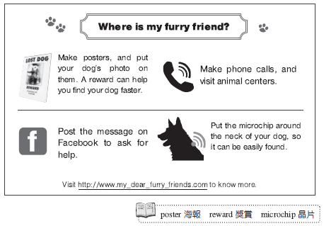
poster 海報 reward 獎賞 microchip 晶片
( ) 46. You may probably see this poster in .
(A) a big bank (B) an animal hospital
(C) a movie theater (D) a department store
( ) 47. Where should the microchip be put?
(A) On Facebook. (B) On the pictures of the poster.
(C) At the animal center. (D) Around the neck of your dog.
( ) 48. Which way to find lost dog is NOT mentioned?
(A) Post the message on Facebook.
(B) Call and visit the animal centers.
(C) Go to the police station immediately.
(D) Make posters with your dog's photo.

(A) My name is Daniel. I really want to keep a pet dog, but my mom said “no.” She doesn’t like furry dogs, and she thinks that dogs are hard to take care of. I want my mom to know more about dogs, so I took some notes about two different kinds of dogs—Labrador and German Shepherd—for her.
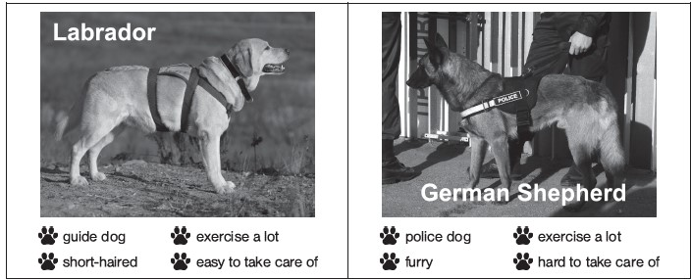
( ) 49. Why did Daniel make the notes?
(A) Because he wanted his mom to know more about dogs.
(B) Because his teacher asked him to do so as homework.
(C) Because they are good for both the dogs’ and the owners’ health.
(D) Because he needed to do a report about different kinds of dogs.
( ) 50. Daniel’s mom agrees to adopt Labrador but refuses to adopt German Shepherd. What might be the reason?
(A) Because it is shorthaired.
(B) Because it is a police dog.
(C) Because it exercises a lot.
(D) Because it is hard to take care of.

- 換頁另有試題

<第二部分: 非選題>
※ 此大題請直接在試題紙上作答，確定試題紙上均寫明班級座號姓名
無名氏扣10分
- 重組句子 (15分，每題5分) 重組字詞，以寫出完整的句子。請加上適當的標點符號。
- can / but also sing / My brother / not only dance
→
- loves / Not only Brad / the English song / but Angela
→
3. a doll from Japan / bought / My dad / me
→

