市立新北高工 109 學年度 第一學期 高一閱讀 |  |  |  |  |  |  |  |  | 班級 |  |  | 座號 |  | 成  績
科目 | 英文閱讀 | 出題教師 | 林筱雯 |  | 審題教師 | 張哲瑋 | 年級 | 1 |  |  | 姓名 |  |  | 成  績
(1) My name is Daniel. I really want to keep a pet dog, but my mom said “no.” She doesn’t like furry dogs, and she thinks that dogs are hard to take care of. I want my mom to know more about dogs, so I took some notes about two different kinds of dogs—Labrador and German Shepherd—for her.  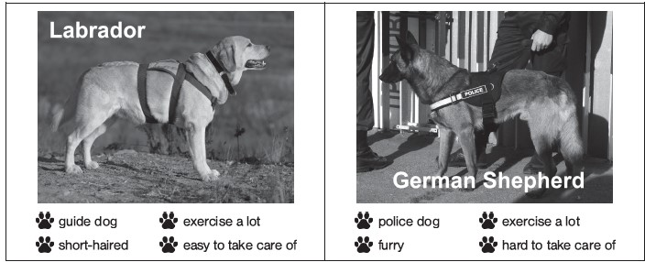  ( ) 1. Why did Daniel make the notes?  (A) Because they are good for both the dogs’ and the owners’ health.  (B) Because his teacher asked him to do so as homework.  (C) Because he wanted his mom to know more about dogs.  (D) Because he needed to do a report about different kinds of dogs.  ( ) 2. Daniel’s mom agrees to adopt Labrador but refuses to adopt German Shepherd. What  might be the reason?  (A) Because it is shorthaired. (B) Because it is hard to take care of.  (C) Because it exercises a lot. (D) Because it is a police dog.  ( ) 3. What word has the closest meaning to guide ?  (A) to lead (B) to prevent (C) to run away (D) to fight  (2) Dogs often help people. There is no doubt about it. Some dogs help blind people move around cities. Other dogs help people by keeping them safe. However, do these dogs really enjoy helping people? In a news story from National Geographic, people studied these dogs. They want to know the feelings of these dogs toward their jobs. The result is positive. The dogs don’t feel sad or bad when they are doing the work, but they do like some activities more than other activities. |  |  |  |  |  |  |  |  | For example, dogs like to be talked to or played with when they are helping children in a hospital. They don’t like to be drawn or brushed by children that much. It is good news to know about the good feelings of our furry friends toward helping people. We would not want them to feel bad.  ( ) 4. Which of the following is the best title for the passage?  (A) How About a Guide Dog? (B) How to Take Care of Your Dog  (C) Do Dogs Love to Help People ? (D) Dogs Around the World  ( ) 5. What does the word “them” mean in the passage?  (A) blind people (B) cats (C) children (D) dogs  ( ) 6. According to the passage, dogs do many things for people. Which is NOT mentioned?  (A) Making old people happy. (B) Playing with kids.  (C) Guiding the blind. (D) Drawing with kids.  ( )7. What word has the closest meaning to keeping them safe?  (A) protect (B) kill (C) hurt (D)prefer  (3)  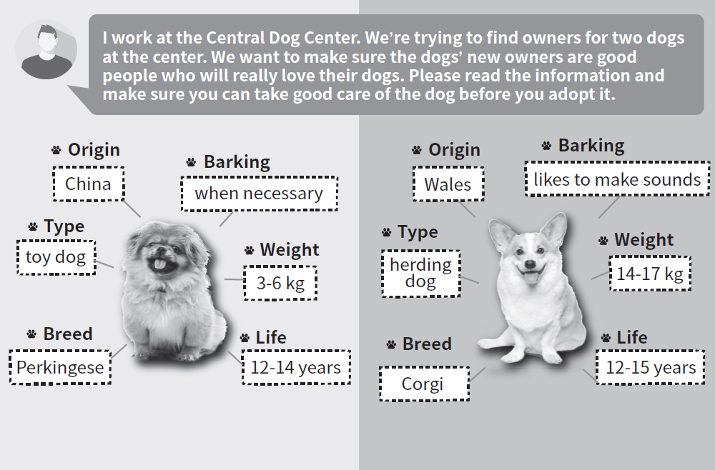  ( ) 8. What is the purpose of the post?  (A) To find new workers for the center. (B) To sell the dogs at good prices.  (C) To tell Pekingese from Corgi. (D) To find the best owners for dogs. 共3頁第1頁
市立新北高工 109學年度 第一學期 高一閱讀 |  |  |  |  |  |  |  |  | 班級 |  |  | 座號 |  | 成  績
科目 | 英文 | 出題教師 | 林筱雯 |  | 審題教師 | 張哲瑋 | 年級 | 1 |  |  | 姓名 |  |  | 成  績
( ) 9. According to the post above, which statement is true?  (A) Corgi is much heavier than Pekingese. (B) Pekingese barks more than Corgi.  (C) The origins of these two dogs are the same. (D) Pekingese can live longer than Corgi.  ( ) 10. What word has the closest meaning to adopt a dog?  (A) to keep (B) to prevent (C) to get rid of (D) to treat  (4) Thinking of buying a dog? Stop right there! Why not adopt a dog instead of buying one? Actually, there are hundreds of dogs waiting to be adopted. Many of the dogs that are found on the streets in New Taipei City are brought to us. We look after them until they have new home. Animal doctors will take good care of the dogs and also make them have examinations they need. There’s just one thing missing in their lives—new owners who will love them. Come to us, The Sanctuary, and find the dog that is right for you. For more information, visit our website: thesanctuarytaiwan.org. There are some pictures of our dogs and also our contact information, such as the phone number and address. In addition, you can read our successful adoption stories there. Perhaps the next one will be about you and your lovely new dog!  sanctuary 收容所 website 網路 contact information 聯絡資訊  ( ) 11. How do the dogs appear at the center?  (A) They are sold by some pet shops. (B) They are brought from foreign countries.  (C) They are donated to the center. (D) They are brought there from the streets.  ( ) 12. Which of the following is NOT on the website?  (A) Dogs’ pictures. (B) The contact information.  (C) Owners’ pictures. (D) The adoption stories.  ( ) 13. According to the passage, which statement is NOT true?  (A) There are only a few dogs waiting for their new owners.  (B) There are some lovely adoption stories on the website.  (C) The dogs are taken good care of and receive needed examinations.  (D) If a person is thinking about buying a dog, he’d better adopt one.  ( ) 14. What has the closest meaning to instead of  - in addition to (B) rather than (C) in order to (D) besides  ( )15. What do the dogs “not” have in their lives?  (A) Volunteers (B) Trainers (C) Doctors (D) New owners who will love them |  |  |  |  |  |  |  |  | (5) When you think of service dogs, what do you think of? In the past, service dogs were trained to lead blind people across the street. Nowadays, service dogs are becoming more popular and offering more services for people with different kinds of problems. Today, service dogs are trained to sense their owners' blood sugar levels. They alert people when their blood sugar levels are too low or too high. Some dogs are trained to “hear” for the hard of hearing people.They alert them when there are certain sounds like doorbell. Other dogs offer comfort to sad people. In addition, some dogs are even trained to get medicine or help when people's seizure attacks. (癲癇)Because of our furry friends' help, people are able to live a better life.  ( ) 16. What is the main idea of the passage?  (A) We should adopt a pet instead of buying one. (B) Healthy food is good for your dog's health.  (C) Different dogs have different jobs to do. (D) Service dogs offer many services for people.  ( ) 17. Service dogs can do many things. Which of the following is NOT mentioned?  (A) Growing vegetables. (B) Offering comfort.  (C) Getting medicine. (D) Sensing blood sugar levels.  ( ) 18. Service dogs help many people. What kind of people is NOT mentioned?  (A). The blind. (B) The sad people. (C) The police.(D) The hard of hearing people.  ( ) 19. What word has the closest meaning to offer?  (A) provide (B) prevent (C) present (D) turn down  ( ) 20. What advantage do people have because of the service dogs?  (A) Take more medicine. (B) The blood sugar level is higher.  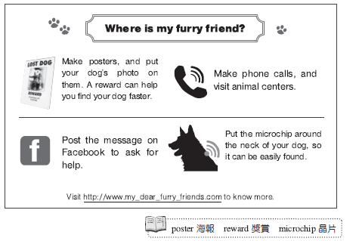  (C) Live a better life. (D) Have more seizure attacks  (6) 共3頁第2頁
市立新北高工 109學年度 第一學期 高一閱讀 |  |  |  |  |  |  |  |  | 班級 |  |  | 座號 |  | 成  績
科目 | 英 文 | 出題教師 | 林筱雯 | 審題教師 |  | 張哲瑋 | 年級 | 1 |  |  | 姓名 |  |  | 成  績
poster 海報 microchip 晶片  ( ) 21. You may probably see this poster in .  (A) a big bank (B) a department store  (C) a movie theater (D) an animal hospital  ( )22. Where should the microchip be put?  (A) On Facebook. (B) On the pictures of the poster.  (C) Around the neck of your dog. (D) At the animal center.  ( ) 23. Which way to find lost dog is NOT mentioned?  (A) Post the message on Facebook. (B) Go to the police station immediately.  (C) Call and visit the animal centers. (D) Make posters with your dog's photo.  ( ) 24. Which of the following can help you find your dog faster?  (A) Praying for God. (B) Getting angry with people who find the dog.  (C) Giving money to people who find the dog (D) Doing nothing and just wait.  ( ) 25. What does furry friend in the title mean?  (A) Dogs (B) Cats (C) People in anmial centers (D) Freidns on facebook |  |  |  |  |  |  |  |  | 共3頁3頁

