新北市立 新 北 高工 109 學年度 第一學期 第二次段考 |  |  |  |  |  |  |  |  |  |  |  |  | 班級 |  | 座號 |  | 成 | P.1
科目 | 英文 | 年級 | 一 | 科別 | 機鑄汽模圖電資訊 | 命題教師 |  | 陳玟如 | 審題教師 |  | 王懷嫺 |  | 姓名 |  |  |  | 績 | P.1
第一部分 選擇題 共40題，請在答案卡上劃卡作答，並劃妥座號，未劃座號者酌扣五分!  - 聽力測驗10%  一、看圖辨義 說明：每題有一個圖片，請聽問題與A、B、C三個英語敘述後，選一個與所看到的圖片最相符的答案。  1. 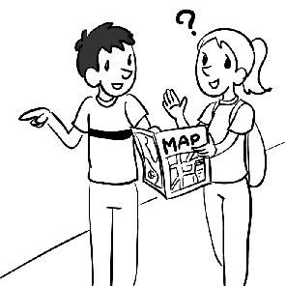 2. 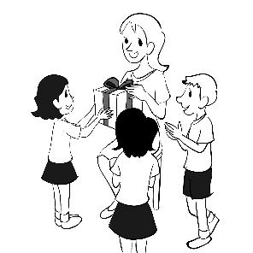3. 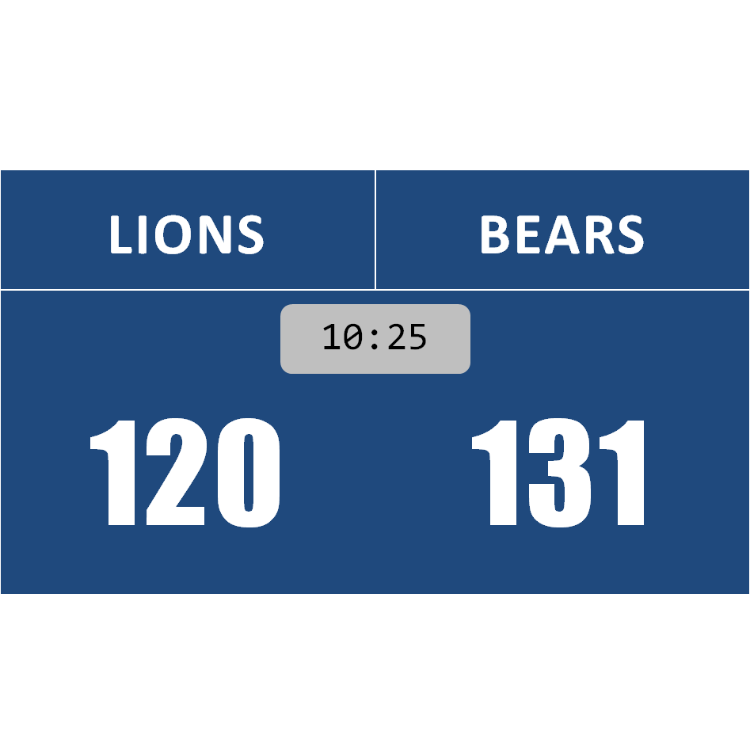  二、問答 說明：每題會播出一個問句或直述句，聽後請從A、B、C三個選項中，選出一個最適合的回答或回應。  4. ( ) (A) It sounds great. (B) I like singing, too. (C) She loves it.  5. ( ) (A) I don’t feel thirsty. (B) Without milk, please. (C) It tastes good, thanks.  6. ( ) (A) Yes, please. I’m really full now. (B) No, thanks. It will make me fat!  (C) It wasn’t made by me  7. ( ) (A) I just don’t feel sleepy. (B) I don’t want to have breakfast.  (C) You look tired today.  8. ( ) (A) Because it’s a worldwide tour. (B) That’s why it attracts so many tourists.  (C) Therefore, no one wants to visit there.  三、簡短對話 說明：每題會播出一段對話及一個相關的問題，聽後請從A、B、C三個選項中，選出一個最適合的回答。  9. ( ) (A) He ran into his house. (B) He was sleeping. (C) He was playing outside.  10. ( ) (A) She will consider taking this job. (B) She is likely to refuse the offer.  (C) She will accept the offer immediately.  II. 單片選擇20%  11. My laptop is running out of battery. I need to it now.  (A)beat (B)lose (C)donate (D)charge  12. The store is their products with low prices and free gifts.  (A)creating (B)attracting (C)promoting (D)celebrating  13. The comfortable ________ in the country are good for my grandfather’s health.  (A) convenience (B) surroundings (C) tourists (D) noise |  |  |  |  |  |  |  |  |  |  |  | 14. Mrs. Kennedy ________ one of her students to help check other students’ homework.  (A) picked out (B) picked up (C) turned out (D) turned into  15. I thought Mandy was at home, but it that she was out.  (A) picked out (B) picked up (C) turned out (D) turned into  16. When the old man fell down and hurt his knee, he was sent to the hospital ________.  (A) greedily (B) immediately (C) probably (D) lonely  17. Tom tells lies very often. Therefore, his friends refuse to believe him.  (A) Before (B) What’s more (C) Thus (D) Of course  18. To our surprise, the useful tool was created by a twelve-year-old child.  (A) picked (B) found (C) bought (D) made  19. Few people live in this region because of the cold weather.  (A) group (B) pond (C) circle (D) area  20. Nowadays, people have different thoughts about getting married.  (A) One day (B)Yesterday (C)Someday (D) Today  III. 對話10%  21. Mary: Wow, the dress is so beautiful. I can't say no to beautiful dresses.  Clerk: You're slim and tall. ________.  Mary: Great! I'll buy it.  (A) I have many sweaters. (B) You're too short for that.  (C) I don't like the red one. (D) It looks perfect on you.  22. A: Look! The mascot is doing silly things.  B: ________ It really makes me laugh.  A: Yeah. I want to take a picture with it.  (A)It’s so funny. (B)I have no idea. (C)I didn’t see anything. (D)I don’t think it’s serious.  23. A: I love mobile gaming. Action games are my favorite.  B: ________ I only play puzzle games.  (A) They are my favorite, too. (B) I prefer action games.  (C) I spend much time on action games. (D) That’s too much work for me.  24. A: My family went to KTV to celebrate my birthday yesterday.  B: Did you have a good time?  A: Well, actually, ________ because I’m not a good singer.  (A) KTV is a good place to kill time (B) I loving singing but I don’t have time  (C) I thought you like singing (D) I don’t like singing that much  (請翻面，背面尚有試題)
新北市立 新 北 高工 109 學年度 第一學期 第二次段考 |  |  |  |  |  |  |  |  |  |  |  |  | 班級 |  | 座號 |  | 成 | P.2
科目 | 英文 | 年級 | 一 | 科別 | 機鑄汽模圖電資訊 | 命題教師 | 陳玟如 |  | 審題教師 | 王懷嫺 |  |  | 姓名 |  |  |  | 績 | P.2
25. A: We have chicken and beef today. Both come with rice. ________  B: Beef, please.  (A)Do you like to eat rice? (B)What’s your favorite fruit?  (C)Which one do you prefer? (D)Do you prefer pork to chicken?  IV. 文法選擇16%  26. The death of the little girl made her family ________.  (A) sad (B) sadly (C) being sad (D) very sadly  27. ________ the cities in Taiwan, Hualian is my favorite place to visit.  (A) Over (B) Among (C) On (D) Along  28. you are taking a bus sitting on a toilet, smartphones are easy to take with you.  (A) If…rather than (B) Whether…or (C) Not only…but also (D) While…and  29. Miss Chen felt sad because her bird ________ by her cat.  (A) eat (B) eating (C) ate (D) was eaten  30. The doctor said that this medicine should ________ twice a day.  (A) is taken (B) be taken (C) took (D) take  31. Some hot games people big fans of mobile games.  (A) make (B) take (C) have (D) let  32. ________ the help of my best friend, I finally finished my report on time.  (A) Among (B) About (C) With (D) On  33. I bought the jeans on the internet in a store.  (A) not only (B) instead of (C) likely to (D) as well as |  |  |  |  |  |  |  |  |  |  |  | V.克漏字14%  (34-37) People of all ages love playing games. In the past, card games 34. to bring fun. Today, people have many other choices. One of them are mobile games. Why are they so popular? Their 35. may be the main reason. Mobile games are easy to get. Just touch on your smartphone, and the game can 36. . Then, you can play the game everywhere because it is always 37. to you on your smartphone.  34.( ) (A) to play (B) played (C) were played (D) were playing  35.( ) (A) experience (B) address (C) agreement (D) convenience  36.( ) (A) downloading (B) be downloaded (C) to download (D) being downloaded  37.( ) (A) hungry (B) likely (C) available (D) general  (38-40) Smartphones become great helpers in life. We use them 38. making calls, sending messages, taking photos, and playing mobile games. 39. , they are not perfect. Although many apps are free to get, we may spend much money on “IAP”(In-App Purchase應用程式內購買) unknowingly. 40. , we might hurt our eyes if we keep looking at the phone screens day and night. Therefore, we should be careful when we use smartphones.  38.( ) (A) by (B)for (C) to (D)with  39.( ) (A) In addition (B) At the end (C) However (D)Instead  40.( ) (A) In addition (B) At the end (C) However (D)Instead  選擇題 共40題 請仔細核對題號,並在答案卡劃上座號!! 未劃座號者酌扣五分  第二部分:非選擇題 請在P.3答案格中作答  I. 文意字彙18%  1. Products made in Taiwan grow famous w e, such as Giant bicycles and some electronic components.  2. Some tourists who got lost in the city asked the police officer for d ns.  3. Tony will hold an e t and invite bands to it.  4. The traffic a t caused the death of two drivers.  5. The g t failed to stop the prices of oil from going up.  6. You are putting yourself in d r by walking alone very late at night.  7. I was s ked when I saw a snake coming out of my desk.  8. The noise i ses when the garbage truck comes near the street.  9. Cythia s ed to swim to the shore before the shark killed her.  (試題尚未結束，請繼續下一頁)

新北市立 新 北 高工 109 學年度 第一學期 第二次段考 一年級 英文 (機鑄汽模圖電資訊) P.3

 | 班級 | 姓名 | 座號
I. 文意字彙18%(題目在P.2，請在P.3答案格作答)
II.引導式翻譯12%(請在P.3答案格作答)
(A)林先生對於做家務很在行。例如，他煮的菜餚好吃，也把家整理得很乾淨。
Mr. Lin is good at doing housework. 10. 11. , he cooks delicious dishes and makes the house very clean.
(B)搭公車到溪頭很容易，所以我的祖父母經常去那裡。
Xitou is easy to get to by bus, so my grandparents visit there 12. the (t) 13. .
(C)Ray正在嘗試分辨小鴨和小雞。
Ray is trying to 14. the little duck 15. the little chicken.
(D)故宮博物院裡有上千件藝術品，像是畫作、書法、珍貴的玉器等等。
There are thousands of works of art in the National Palace Museums, like paintings, calligraphy, precious jade sculptures, 16. 17. 18. .
(E)音樂錄影帶的功能是要宣傳歌曲。
The 19. of a music video is 20. 21. a song.
答案格
- 文意字彙18%
1. | 2. | 3.
4. | 5. | 6.
7. | 8. | 9.
- 引導式翻譯12%
10. | 11.
12. | 13.
14. | 15.
16. | 17. | 18.
19. | 20. | 21.

