一、看圖辨義 (2小題，每題1分，共2分)
試卷上該題有一張圖片，請聽一個和該題相關的問題，與(A)、(B)、(C)三個英語敘述後，選一個與所看到圖片最相符的答案。(只念1遍)
- 2.
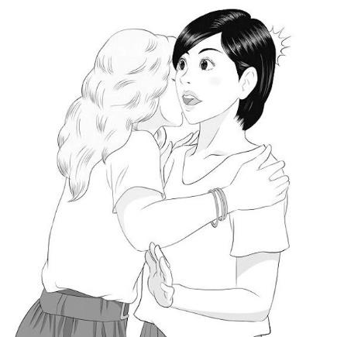 

二、問答 (3小題，每題1分，共3分)
每題會播出一個問句或直述句，聽後請由試卷上(A)、(B)、(C)三個選項中，選出一個最適合的回答或回應。（只念一遍）
- (A) Both of them are missing.
(B) You can find it online.
(C) Sure, I’ll tell them soon.

- (A) Probably in three days.
(B) I’m ging to have a celebration.
(C) Yes, Ive already finished it.

- (A) Yes, I’d love to play ball.
(B) Sure. Here you go!
(C) Yes, the ball game is over.

三、簡短對話 (3小題，每題1分，共3分)
每題會播出一段對話及一個相關的問題，聽後請由試卷上(A)、(B)、(C)三個選項中，選出一個最適合的回答。(念2遍)
- (A) The woman needs to work more carefully.
(B) The woman must try hard and believe in her own ability.
(C) The woman should ask someone for help.

- (A) The woman’s situation got worse.
(B) The woman’s situation improved.
(C) The woman experienced a funny situation.

- (A) The sign says not to do this.
(B) It’s not allowed in this place.
(C) The police told him not to.

四、短文聽解 (2小題，每題1分，共2分)
每題有三個圖片選項。請聽題目，並選出一個最適當的圖片。
- (A)  (B)  (C) 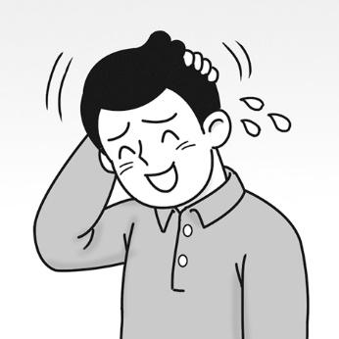

- (A) 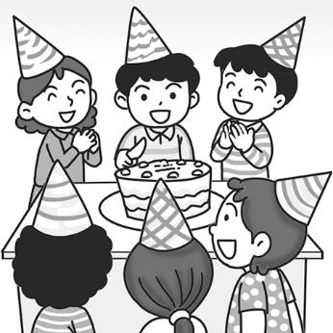 (B) 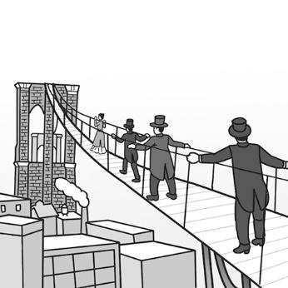 (C) 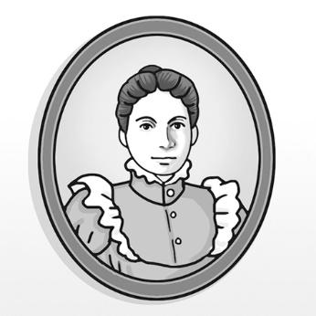
二. 綜合文法 (每題2.5分，共15分)
11. The boy ran away quickly, ____________ by a large dog.
(A) chased (B) chasing (C) chases (D) chase
12. Mike takes great pleasure in playing mobile games, ____________ all of his free time playing
them on his smartphone.
(A) spending (B) spends (C) spent (D) spend

13. It’s not difficult to pass the exam. All you need to do is ____________ the lessons regularly.
(A) reviewing (B) reviewed (C) being reviewing (D) review
14. English is an important language, ____________ in lots of countries around the world.
(A) speaks (B) speak (C) spoken (D) speaking
15. Making this cake is easy. All you have to do ___________ the steps in this book.
(A) is following (B) are follows (C) are following (D) is follow
16. Despite ____________ ill, Penny went to school this morning.
(A) was (B) be (C) being (D) been

三. 對話（每題2.5分，共15分）
17. Emily: Rita, thanks for inviting me over for dinner. I hope it wasn’t too much trouble.
Rita: ____________ I’m glad that you could come. Please have a seat and taste the fried rice I’ve
prepared for you.
Emily: It smells so wonderful. It’s making my mouth water!
Rita: Ok, let’s dig in!
(A) Not at all! (B) You’re right! (C) Make a wish! (D) It’s so easy!

18. Edward: Are there any places in Taiwan that you especially want to visit?
Hillary: Yes. I have heard that the night markets in Taiwan are quite famous. Can you take me to
one of them?
Edward: No problem! Raohe Night Market is not far from here. ____________
Hillary: That’s great! I do look forward to tasting the delicious food there!
(A) It’s located in the city center. (B) I have never been there!
(C) You’ll see it on your left. (D) Let’s go there tonight!

19. Naomi: Wow, look at all these people! It’s so crowded!
Warren: Yeah, after all, this is one of the most famous night markets in Taiwan!
Naomi: I am starving now. I want to eat some pig’s blood cake first. ____________
Warren: Well, I want to eat the fried chicken over there. It looks so delicious!
(A) Where are you? (B) How about you? (C) Are you OK? (D) What did you buy?

20. Winnie: I don’t know how to turn on the Bluetooth (藍芽) . ____________
Peter: Sure. It’s easy. Just press this button.
Winnie: I see. Thank you.
Peter: You’re welcome.
(A) Do you know where the button is? (B) Can you show me how to do it?
(C) That’s how I always do it. (D) How are you doing?

21. Carol: I really love this night market! The snacks here are so delicious.
Henry: I can’t agree more. I especially love the black pepper buns and oyster omelets（蚵仔煎）.
Carol: So do I. ____________
Henry: Yeah, I can still feel the taste in my mouth right now!
(A) Both are equally mouth-watering. (B) I can’t stand the smell and taste of them.
(C) I like neither of them, honestly. (D) One of them is the least popular among tourists.

22. Wei-ming: Is this your first time dining in a Chinese restaurant?
Sam: Yes, and actually I’ve never used chopsticks before.
Wei-ming: It’s easy. ____________
Sam: Ah, I see. I’ll try.
(A) Please give me a hand. (B) Just do it like this.
(C) I’m glad you like it. (D) You are a wonderful friend.

四. 克漏字 (每題2分，共20分)
People in Spain have a unique daily schedule. All I had to do during my trip was ______23______ some changes. First, their breakfast starts after 10 a.m. _____24_______, people sometimes don’t eat this morning meal at all. Meanwhile, lunch break seems ______25______ a long time. It ______26______ taking a nap till 4 p.m. Then the afternoon snack starts at 6 p.m. and dinner doesn’t happen till at least 9 p.m.!
Don’t panic if you ever experience cultural differences like this. It’s normal _____27______ a little culture shock when you travel. You have to be open to new experiences. They will teach you so much!
23. (A) making (B) made (C) make (D) makes
24. (A) For example (B) In fact (C) Therefore (D) However
25. (A) to last (B) lasting (C) lasted (D) last
26. (A) including (B) included (C) includes (D) include
27. (A) to experience (B) experiencing (C) experienced (D) be experienced

Do you like to travel? ______28______ can be a great way to grow. However, foreign customs are often so different ______29______ our own that it’s hard to get used to. Let’s find out how one traveler survived what is known ______30______ “culture shock.”
Meiling traveled to France, where they kiss to say hello. Once, she ____31_____ a cousin’s friend. The friend kissed Meiling on both cheeks. Meiling was so embarrassed that she just stood there. But she learned ______32______ she can get used to just about anything. So, the next time she goes to France, she’ll be ready.
28. (A) Travels (B) Traveled (C) Travel (D) Traveling
29. (A) such (B) so (C) very (D) too
30. (A) what (B) how (C) which (D) whom
31. (A) was introduced to (B) introducing with (C) was introduced with (D) introducing to
32. (A) whose (B) what (C) that (D) which

五.閱讀測驗（每題2分，共10分）
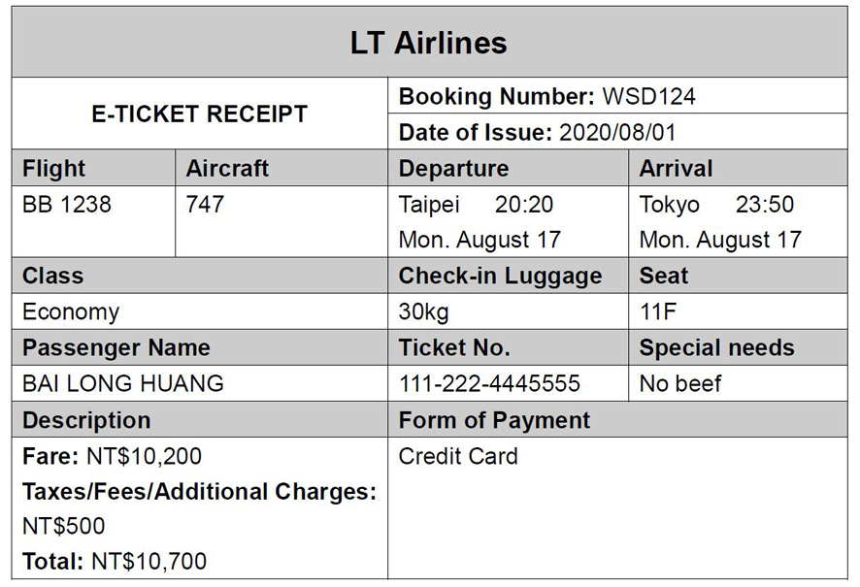
33. Which of the following is NOT true?
(A) The passenger is leaving for Tokyo. (B) The passenger paid with a credit card.
(C) The passenger paid a total of NT$10,200. (D) The passenger will fly economy class.
34. What does the word “Departure” mean on the receipt?
(A) An act of joining a group. (B) An act of leaving a place.
(C) An act of starting a trip. (D) An act of gaining something.

Dashrath Manjhi lived with his wife in a small Indian village where he worked as a laborer. In 1959, his wife died due to the lack of medical care. The nearest town with a doctor was 55 kilometers away, on the other side of a mountain. When Manjhi’s wife died, he was heartbroken. However, he was also determined to make sure no one else would suffer like she did.
Manjhi decided to make a path through the mountain so that people from his village could get to the nearest town faster. Every day, he used a hammer to chip* away at the mountain. Finally, twenty-two years later, he completed his path through the mountain. Thanks to this path, the distance to the nearest doctor was shortened from 55 kilometers to one kilometer. Manjhi became known as the Mountain Man and is still remembered for his amazing determination.
*chip (v) 鑿去
35. What’s the reading mainly about?
(A) When and why Manjhi’s wife and children passed away.
(B) Why and how Manjhi made a path through the mountain.
(C) Where Manjhi and his wife lived and how he made a living.
(D) People who helped Manjhi get over the loss of his wife.
36. How much time did it take Manjhi to complete the path through the mountain?
(A) 55 years. (B) 33 years. (C) 22 years. (D) 11 years.
37. Which of the following statements about Manjhi is NOT true?
(A) He lived in a small village in India and was a laborer.
(B) He felt extremely sad when his wife passed away.
(C) He is still remembered now for his great determination.
(D) His wife died because he had no money to pay the doctor.

六. 字彙選填（每題2分，共30分）
38. Unfortunately, no passengers s____________ed the air crash. That is, everyone died in the
accident.
39. The audience was shocked when the magician suddenly v____________hed in front of them.
40. It took over 22 years to c____________t the Taj Mahal (泰姬瑪哈陵), which is now one of the
most famous and popular tourist spots in India.
41. We have been taught to e____________e challenges in life, though it is sometimes not easy to do
so.
42. It’s reported that a new kind of virus (病毒) has i____________ted two-thirds of the people living
in this village.
43. You have to follow the doctor’s i____________ns if you want to get well soon.
44. Ted had a tight s____________e last week, so he didn’t have time to go to the movie with us.
45. If time p____________ts, we can spend an extra hour in the shopping mall.
46. Jerry is an e____________t on insects and he spends a lot of time studying them.

47. Jeremy is so f____________d of playing basketball that he can play it all day long without feeling
tired.
48. This old necklace may not be worth much money, but it is of great v____________e to Janet
because it was passed down to her from her grandmother.
49. The coach g____________ed to the player to throw the ball forward.
50. The old church that dates back to the 16th century is a famous l____________k in this town.
51. ___________ sandals ___________ shorts are suitable for a formal occasion.
（涼鞋和短褲都不適合於正式場合。）
52. The book is not dull at all; _________ the ____________, it’s very interesting.
（這本書一點都不無聊。相反地，它很有趣。）

38. | 39. | 40. | 41.
42. | 43. | 44. | 45.
46. | 47. | 48. | 49.
50. | 51. | 51. | 52.
52.

(字彙片語請作答於空格內，檢查字尾，本張試卷請寫上座號姓名繳回)

