第一部份: 聽力測驗 10%
一、看圖辨義
試卷上該題有一張圖片，請聽一個和該題相關的問題，與(A)、(B)、(C)三個英語敘述後，選一個與所看到圖片最相符的答案。
- _______
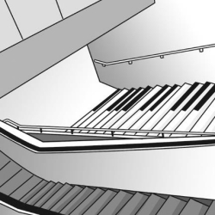
- _______
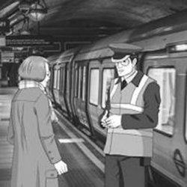
二、問答
每題會播出一個問句或直述句，聽後請由試卷上(A)、(B)、(C)三個選項中，選出一個最適合的回答或回應。
- (A) It should be coming soon.
(B) The red line to the north.
(C) Main Station.
- (A) Please stop. That’s dangerous.
(B) Because the colorful street is appealing.
(C) Here comes the bus.
- (A) I’m just feeling a little emotional.
(B) No, I’m not ready for it.
(C) As a matter of fact, I won.
三、簡短對話
每題會播出一段對話及一個相關的問題，聽後請由試卷上(A)、(B)、(C)三個選項中，選出一個最適合的回答。
- (A) Giving his grandmother a ride.
(B) Walking down the street with his grandmother.
(C) Boarding a train with his grandmother.
- (A) Dance like the red man.
(B) Wait for the cars to pass.
(C) Cross the street.
- (A) Look for some missing items.
(B) Buy some items in a shop.
(C) Find out who owns some items.
四、短文聽解
每題有三個圖片選項。請聽題目，並選出一個最適當的圖片。
- _____
(A) 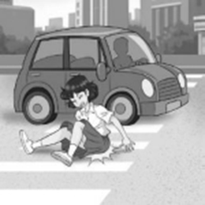 (B) 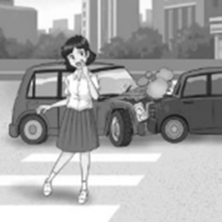 (C) 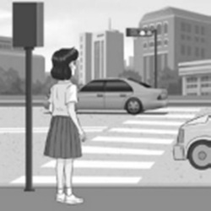
- _____
(A) 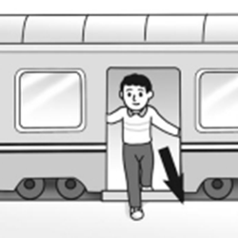 (B) 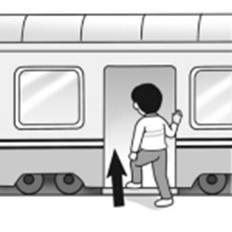 (C) 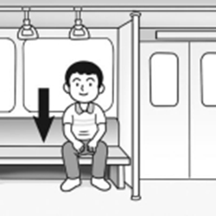
第二部份: 課本內容相關試題
一、字彙慣用語片語 34%
11. For your ______ , make sure you put on a helmet before riding a scooter. (A) goal (B) safety (C) system (D) experiment
12. Jane is ______ with the local area because she has lived here for twenty years. (A) previous (B) familiar (C) rushed (D) appealing
13. Mike expressed his ______ to me for helping him fix his bike. (A) gratitude (B) promotion (C) wrinkles (D) arrangement
14. All the ______ have to fasten their seat belts while the plane is taking off or landing. (A) announcement (B) behaviors (C) passengers (D) senses
15. As people age, they usually get ______ skin. (A) emotional (B) elegant (C) positive (D) wrinkled
16. It is convenient and saves me money to take the ______ around the city. (A) subway (B) signal (C) spark (D) platform
17. This building is so ______ that I got lost in it. (A) enormous (B) active (C) emotional (D) previous
18. Jack hurried to the hospital after he heard that his wife was going to give birth.
(A) rushed (B) posed (C) strolled (D) assisted
19. Sally was not satisfied with her former job, so she quit and is still looking for a new one.
(A) double (B) effective (C) previous (D) foolish
20. This small car was so attractive that Flora wanted to buy it on the spot.
(A) appealing (B) worthy (C) fierce (D) classic
21. In this amusing talk show, the audience always laughs out loud from beginning to end.
(A) dangerous (B) chemical (C) entertaining (D) digital
22. The speaker’s inspiring speech ______ me to keep going and never give up.
(A) entertained (B) warned (C) motivated (D) conducted
23. From the way Judy and Tom look at each other, I can tell there is a(n) ______ between them.
(A) goal (B) spark (C) escalator (D) behavior
24. “Please ______ the gap when you get off the bus,” said the bus driver.
(A) mind (B) improve (C) behave (D) conduct
25. It took the Wang family over ten years to ______ the trauma of the 921 earthquake.
(A) go up (B) get over (C) get off (D) go on
26. Nick Vujicic believes it is better to have a positive attitude toward life ______ giving up.
(A) lead to (B) rather than (C) but also (D) heading for
27.Global warming ______ rising sea levels.
(A) leads to (B) looks up (C) helps out (D) searches for
二、文法選擇: 20%
28. It was yesterday ______ Mom called me a “couch potato.”
(A) which (B) where (C) that (D) who
29. ______ a strange and loud sound this machine makes!
(A) What (B) How (C) Such (D) So
30. After ______ for only five minutes, I am already out of breath.
(A) ran (B) run (C) running (D) to run
31 “Welcome home,” said my father, ______ me a big hug.
(A) to give (B) gave (C) given (D) giving
32. _____ was George Washington that was the first president of the United States.
(A) What (B) This (C) That (D) It
33. ______ by her teacher for helping other students, Cindy felt very happy and confident.
(A) To praise (B) Praising (C) Praise (D) Praised
34. ______ a helmet, Eric suffered a serious brain injury in the accident.
(A) Didn’t wear (B) Not wearing (C) Because not wear (D) Not to wear
35. It seemed ______ the snake was full, because it didn’t attack the rat.
(A) be (B) as (C) being (D) like
36. ______ in poverty, Steve still refuses to give up his passion for painting.
(A) To live (B) Being lived (C) Living (D) Lived
37. There are many kinds of animals in the zoo. Some are birds. Others are elephants. ______ are pandas. (A) Still others (B) The others (C) Another (D) Others
三、綜合測驗20%
The woman sat quietly on a bench. I had already seen her twice. Trains came and went, ___(38)___ she didn’t get on any of them. It seemed (39) she was just listening to the voice that said, “Mind the gap.” She wasn’t causing any trouble. ___(40)__ the stationmaster, I decided to talk to her. I wanted to check (41) anything was wrong. But when I approached her, she spoke to me first. “The voice. It’s different. It’s not him,” she said. She became ___(42)___. She told me the _(43)_ recording had been of her late husband’s voice. (44) she missed him, she would come to the station. That way, she could hear him “ (45) .” But the subway system had ___(46)___ her husband’s voice with a new recording. Five days later, she came back. This time, she heard her husband’s voice once again. Her teary eyes shone _(47) happiness. Then she stepped on the train.
38. (A) or (B) because (C) but (D) however
39. (A) to (B) as (C) like that (D) like
40. (A) To (B) With (C) As (D) For
41. (A) that (B) if (C) when (D) what
42. (A) emotional (B) motivated (C) positive (D) elegant
43. (A) previous (B) fierce (C) temporary (D) slight
44. (A) Unless (B) Sometime (C) Ever since (D) Every time
45. (A) speak (B) spoke (C) spoken (D) to speak
46. (A) replaced (B) warned (C) wrinkled (D) promoted
47. (A) at (B) of (C) with (D) from
四、對話: 8%
48. Joe: Excuse me. I need a ticket to Taichung.
Rob: It will arrive at 9:30. That’s in less than 10 minutes.
Joe: OK. How much is the ticket?
Rob: It’s 500 dollars, sir.
(A) When is it scheduled to arrive? (B) How much do I have to pay?
(C) Where is Platform 2? (D) The train is too crowded.
49. Tourist: Hi, I need to go to Zhongli (中壢). _________________

Ticket Seller: The next train for Zhongli departs at 4:45 p.m.
Tourist: Great, please give me a one-way ticket for that train.
(A) Could you show me on the map? (B) How do I get to the platform?
(C) Could you tell me when the next train is? (D) How often does it stop here?
50. Charlotte: Excuse me. Is there a supermarket around here?
Passer-by: Yes. It’s just three blocks away.
Charlotte: _____________ ?
Passer-by: Sure. Let me see…. Right there, next to this parking lot.
(A) Should I take the next left?
(B) How do I get there?
(C) Could you show me on the map?
(D) How far is it?

51. Husband: Honey, __________ ? I want to sweep the garage floor.
Wife:It’s in the closet. You can also use the vacuum cleaner if you like.
(A) do you mean under the kitchen sink
(B) how am I going to do this
(C) are these household objects yours
(D) have you seen the broom
五、閱讀素養題:8%
Instructions
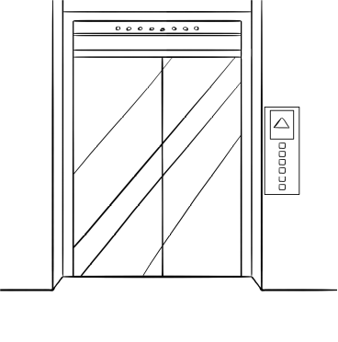
1. Stand clear of the doors.
2. Never try to stop a closing door; instead, wait for
the next elevator.
3. Hold children and pets firmly.
4. Don’t allow children to misuse the elevator.
5. Don’t overload* the elevator.
6. Don’t use the elevator during an earthquake.
7. In case of emergency:
● Use the ALARM button and telephone to call for assistance.
● Don’t panic. Stay calm and wait for help to arrive.
● Never climb out of the elevator.
＊overload vt. 超載
52. What does the word “assistance” mean, as used in the instructions?
(A) Wheel. (B) Symbol. (C) Help. (D) Value.
53. Where is this instruction mostly likely to be showing up?
(A) the classroom (B) the washroom (C) the department store (D) the hospital

All Bud wanted to do was talk to his wife Betty. They had been married for 56 years, until she passed away. As a way to remember her, Bud bought a park bench in her name.
Every day, Bud would visit the bench with some flowers and tell her about his day. But one winter, heavy snow covered the park. The snow was so thick that Bud could only drive close to the bench and talk to Betty from his car. However, two park workers, Jared and Kevin, noticed Bud. They had seen him many times before and were touched that he would still visit even when he couldn’t make it to the bench. So they decided to do something about it.
The next time Bud showed up, Jared and Kevin had cleared all the snow to Betty’s bench. They wanted to make sure Bud could still visit his wife every day. And they promised to keep the path clear for him all winter.
( ) 54. Who were Jared and Kevin?
(A) They sold park benches. (B) They were Betty’s coworkers.
(C) They took care of the park. (D) They were house cleaners.
( ) 55. Which of the following statement is true?
(A) Betty missed her husband very much.
(B) The park workers and Bud were family.
(C) Bud and Betty were a couple.
(D) Bud hired the park workers to keep the path clear.

- 試題結束，請再次檢查卡片資料及題號是否劃記正確，good luck!

