新北市立 新 北 高工 109 學年度 第一學期 期末考 |  |  |  |  |  |  | 班級姓名 |  | 座號 |  | 成
科目 | 英文閱讀 | 年級 | 二 | 科別 | 汽機鑄圖訊電資 |  | 出/審題 | 高麗雯 / 張哲瑋 |  |  | 績
一題五分，共一百分  - Since 1998, November 13th has been observed as World Kindness Day by many people  worldwide. The idea behind this day originally came from a group of nongovernmental organizations called the World Kindness Movement.  The purpose of World Kindness Day is to celebrate kind deeds and promote the positive feelings that such deeds can allow to grow among humans. The people who started the World Kindness Movement believed kindness to be something that exists in all humans and that can encourage people to ignore factors in society that tend to separate people, such as religion and race.  World Kindness Day is recognized in many countries, including Singapore, Italy, Canada, and Australia. Many people mark this day by performing small acts of kindness for others, whether they are loved ones or complete strangers.  （ ）1.What is the best title for this reading?  (A) The Date of World Kindness Day (B) The Purpose of World Kindness Day  (C) The People of World Kindness Day (D) The History of World Kindness Day  （ ）2. In which continent (洲) has World Kindness Day NOT been recognized?  (A) Asia. (B) Europe. (C) America. (D) Africa.  （ ）3. According to the passage, which of the following statements is NOT true?  (A) World Kindness Day has existed for more than twenty years.  (B) World Kindness Day originated from the World Kindness Movement.  (C) People can perform acts of kindness only for their loved ones on World Kindness Day. (D) World Kindness Movement is to promote kindness and ignore differences.  II. I was so excited when I got season tickets for my favorite baseball team, the Tokyo Giants. When I attended the first game on the opening day, an old man sat down beside me. The whole stadium was packed. There seemed to be few empty seats. But for the entire game, the seat next to the old man remained empty. I was too shy to ask him about it, and I didn’t think much about it, either. But the next game, that same seat was empty, and again the game after that. In fact, for the first month, whenever I came to the game, there was the old man, and beside him, there was the empty seat.  Finally, after a month of this, I decided to ask the old man about it. He looked at me and smiled. The seat, he said, used to be occupied by his son. Sadly, his son had died a year ago in a car accident. But when the man went to buy his new set of season tickets, he couldn’t bear to buy just one. He bought one for his son, too, even though he was already gone. Despite the empty seat, he said, he could feel his son was always with him in spirit.  （ ）4. Which is closest in meaning to the word “packed” in the first paragraph?  (A) Filled. (B) Boxed up. (C) Pressed. (D) Folded.  （ ）5.Which of the following emotions is NOT mentioned in the story?  (A) Sadness. (B) Shyness. (C) Pride. (D) Excitement.  （ ）6. What is the author trying to tell the readers?  (A) The old man missed his son very much. (B) It was not easy to get season tickets.  (C) The old man’s son lived in Tokyo. (D) Baseball is a very popular sport.  （ ）9. What is the main idea of the article?  (A) Ways to make the workplace better. (B) Steps for employees to do their work.  (C) Methods to help business earn large profits. (D) Things workers can offer a workplace.  （ ）10.What’s the purpose of a laughter room?  (A) To motivate employers to work effectively.(B) To offer employees a relaxing environment.  (C) To encourage workers to make more effort.(D) To offer customers a place to discuss business.  （ ）11.According to the article, how can you make your workplace more fun?  (A) Paint the rooms various colors and put up pictures.  (B) Play heavy metal music in the morning to help workers relax.  (C) Turn a spare room into a kitchen to offer food for employees.  (D) Decorate the rooms with humorous posters, photos, plants, and books.  V. The little girl sat on the bench. She stared into the distance while other kids ran happily on the playground with their parents. I went over to ask why she was alone. Emma, the little girl, said she lived near the park. “Daddy used to bring me here to play,” she paused. “But Mommy said he went to a faraway place.” I listened in silence, looking for words to comfort her. I happened to have drawing paper and crayons with me, so I asked her to draw anything she wanted.  Emma’s mother showed up ten minutes later. We exchanged greetings, and as Emma was deep into her drawing, her mother revealed that Emma’s dad had recently passed away. Suddenly Emma held her drawing up and shouted, “Mommy, look! It’s Daddy and us.” It was two tall stick figures and one short stick figure holding hands. Emma’s mom hugged her as she said, “I miss your daddy, too. Let’s talk more about him whenever we think about him.” They went home hand in hand, just like in the drawing.  （ ）12. What did Emma draw? (A) A hand holding another one. (B) Her father and mother. (C) Her family hand in hand. (D) Some sticks and numbers.  （ ）13.Which of the following is NOT true?  (A) The author gave drawing paper and crayons to Emma.  (B)Emma’s father worked in a distant place.  (C) Emma didn’t join other kids when they were playing.  (D) The author and Emma’s mother talked for a while.  （ ）14.Where is Emma’s father in the story?  (A) He’s traveling abroad. (B) He’s dead.  (C) He’s at the park with her. (D) He’s waiting at home.  VI. Jorge Munoz is a Colombian-American politician* known for his powerful back story. In  2004, Munoz was living in Queens, New York City. By day, he was a school bus driver. His  working day started around 5:15 a.m. and ended at 5 p.m. One day, while driving his bus, Munoz  noticed some people outside a food factory throwing away food. He asked them if he could return  daily to collect their unused food and give it to hungry people on the street. This gesture then grew  into a second job for him.  Munoz and members of his family started working hard in the late afternoons to  cook food for more than 100 people. Every day, when all the food had been prepared, Munoz  spent the rest of the evening near a subway station giving it away to people in need of a meal  Munoz funded this service himself, meaning that for several years, he spent  about half of his bus driver earnings* on food to feed others. He performed this good deed*  every single day simply because he believed it was a good thing to do. Truly, he is an example to  us all of the power of human kindness.  *politician n. [C] 政治人物 *earnings n. [pl.] 薪水；收入 *deed n. [C] 行為；功績  it has a blue light. (B) Because it has a cheap monitor. (C) Because it uses a Bluetooth device. (D) Because it uses a big capacity bottle.  22.（ ） Which of the following statements is true about Ecomo? (A) Its filter removes unwanted substances fast. (B) It can change any liquid into drinking water. (C) Its filter tells users to change the LED monitor. (D) It can be used to store water, juice, or coffee.  23.（ ）Which of the following inferences can be drawn from Ecomo? (A) Users can easily get the weather report through the bottle. (B) Users can use it to make an appointment with their doctor. (C) Users can use it to find various water drinking sites nearby. (D) Users can decide how much water they should drink daily.  VIII. Around 90 percent of all Americans use an electronic device* in the hour before they go to bed. If you do too, you might want to consider stopping. This bad habit is more harmful to your sleep than you might think.  Using your cell phone or another electronic device before you sleep can make it harder for you to fall asleep, and also can affect the quality of your sleep. There are two major reasons for this. The first is that by using these devices before you sleep, you cause your brain to become more active and your body to become less relaxed. The second reason is that the screens of electronic devices give off a blue light. Light makes you feel more awake and tricks your brain into thinking it’s daytime. Our bodies are especially sensitive to blue light because of its short wavelengths*. It’s been found to decrease* the body’s production of melatonin*, a chemical that makes us feel sleepy, more than any other type of light.  For a better night’s rest, you should begin to avoid all screens one hour before your bedtime. Rather than looking at your phone or watching TV before bed, you could try reading a book using lamplight*.  *device n. [C] 裝置 *wavelength n. [C] 波長 *decrease vt. 減少 *melatonin n. [U] 褪黑激素 *lamplight n. [U] 燈光  三、閱讀測驗題 (5小題 每小題2分 共10分)  At the 50th Golden Horse Film Festival, Beyond Beauty: Taiwan from Above  won the 2013 Best Documentary Award. Before directing the documentary, Chi Po-lin (齊柏林)  was a full-time photographer working for the Ministry of Transportation and Communications.  He had been taking pictures from an aircraft for twenty years.  In 2009, in a mission to record the damage caused by Typhoon Morakot, Chi found that the  landslides brought about by this typhoon buried several mountain villages, and many areas were  covered in flood waters. When Chi learned about the serious harm of land abuse, he decided to  quit his government job to make films.  During the filming of Beyond Beauty: Taiwan from Above, Chi had difficulties raising  funds. To meet the total costs of some NT$90 million, he used up all his savings and even asked  for a bank loan. After the successful release of the documentary in around thirty countries, Chi  planned to make a sequel. On June 10, 2017, unfortunately, when Chi was shooting the sequel,  his helicopter crashed in the mountains. Many were saddened by the news of his death, but Chi  will always be remembered for his contribution to promoting environmental awareness.  documentary: 紀錄片 |  |  |  |  |  | III.  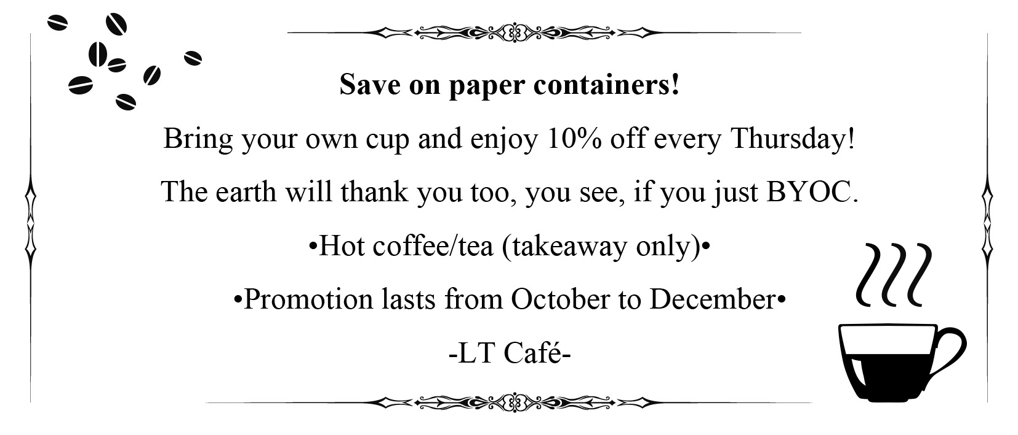  （ ）7. According to the poster, which of the following is a “container”? (A) 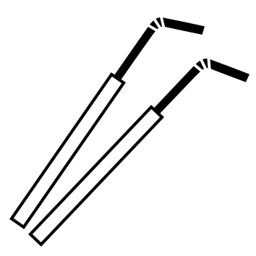 (B) 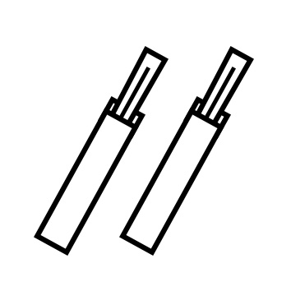 (C)  (D) 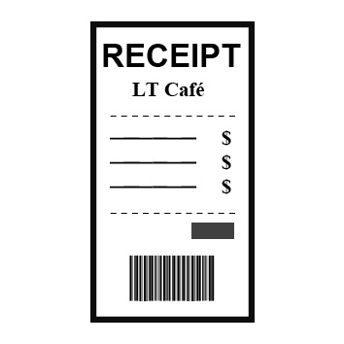  （ ）8. Which of the following slogans (口號) does NOT really apply to the message on the poster? (A) Let’s live a plastic-free life! (B) No more single-use cups!  (C) Save a tree with each cup of tea! (D) Reduce paper waste now!  IV. Many businesses around the world are attempting to bring more fun into their workplaces. Below are some ideas for how you can make your workplace more fun.  a. Decorate your workplace: Nobody likes to be surrounded by gray walls all day. You can brighten up your office by hanging posters on the walls, introducing plants, and displaying photos of your loved ones on your desk. You can also encourage your employees to follow these habits.  b. Create a “laughter room”: If your office has a spare room, consider turning this room into one where your employees can go to take a break and have a laugh. The laughter room could be filled with funny posters and books and perhaps a DVD player for viewing humorous movies and TV shows.  c. Play background music: Studies have shown that background music in an office can help workers focus on their tasks. Just make sure that the music you play is suitable for everyone (heavy metal may not be the best choice!).  Whatever your job, remember that a happy worker is a good worker. Try thinking about other ways you can introduce fun into your daily working life.  （ ）15.What is this passage mainly about?  (A) A food factory got rid of its unused food by selling it to local stores.  (B) A bus driver spent half of his earnings serving food to people in need.  (C) A politician hired a bus driver to deliver food to people on the street.  (D) A chef prepared more than 100 meals for the homeless.  （ ）16.According to this passage, what is true about Munoz?  (A) He was living in Columbia in 2004. (B) He worked in a food factory.  (C) He used to work about twelve hours a day. (D) He worked two jobs to make a living.  （ ）17.Which of the following is NOT true about Munoz’s good deed, as mentioned in this passage? (A) He collected unwanted food from a food factory.  (B) He gave out food every day to over 100 people on the street.  (C) His family joined him in the cooking of the food.  (D) He asked for more donations to fund his project.  VII. Habits are deeply rooted in our everyday routines. Thus, making changes can often be challenging. After some experiments, it was found that adding fun to an activity is a helpful ingredient. Let’s take a look at some examples.  There are those who enjoy grocery shopping, and there are those who just want to get things done quickly. To help the second group enjoy the activity more, a grocery shop in Germany attached* skateboards* to some of their shopping carts. Shoppers could use the skateboard to slide across different aisles* and even back to their cars after paying. Those who used regular carts were also smiling as they watched. In another example, a trashcan was built as if it were the “world’s deepest bin.” It made a long falling sound when items were thrown in, which encouraged people to throw waste into the bin rather than on the ground. The result? Trash put into the bin increased by 41%. It’s clear that fun can help people change for the better!  ＊attach vt. 裝上 ＊skateboard n. [C] 滑板 ＊aisle n. [C] 走道  （ ）18. What would be an appropriate title for the passage?  (A) Old Habits Die Hard (B) Reduce Garbage, Protect the Earth  (C) To Get More Discounts, Buy More (D) Fun in Change, Change for Fun  （ ）19. Why were people more willing to throw garbage into the special trashcan?  (A) It created an interesting sound when garbage was thrown into it.  (B) It gave people money when they threw garbage into it.  (C) It gave away free skateboards to people who threw garbage into it.  (D) It could squeeze garbage to make it much smaller.  （ ）20.What does the phrase “are... rooted in” mean, as used in the passage?  (A) To have been strongly affected by something.  (B) To have changed for the better.  (C) To have been grown and sold for money.  (D) To have done something and get a good result.  Only to obey nature in order to overcome nature.  - Darwin  3.
新北市立 新 北 高工 102 學年度 第二學期 期末考 |  |  |  |  |  |  | 班級 |  | 座號 |  | 成 | P.2
科目 | 英文 | 年級 | 一 | 科別 | 機鑄汽模圖電資 |  | 姓名 |  |  |  | 績 | P.2

新北市立 新 北 高工 102 學年度 第二學期 第二次 段考 一年級 英文 答案卷 P.3

班級 姓名 座號

得分 總分
VI. 文意字彙20%
1. | 2. | 3. | 4.
5. | 6. | 7. | 8.
9. | 10.

VII. 翻譯填空10%
11. | 12. | 13. | 14.
15. | 16. | 17. | 18.
19. | 20.

【請仔細核對題號 請在考卷及答案卷上都寫上姓名座號 答案卡請劃座號!!!!】

