一、請將下列各圖片的英文單字，填入空格中。 3%→42%
 | guava |  | watermelon | pear |  | strawberry |  | grape
 | orange |  | banana | star fruit |  | dragon fruit |  | bell fruit
 | pineapple |  | apple | mango |  | kiwi fruit
圖片 |  | 英文單字 |  |  | 圖片 |  | 英文單字
1. 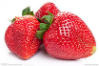 |  |  |  |  | 8. 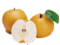
2. 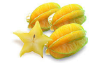 |  |  |  |  | 9. 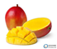
3. 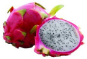 |  |  |  |  | 10. 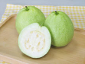
4. 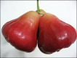 |  |  |  |  | 11. 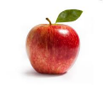
5. 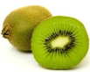 |  |  |  |  | 12. 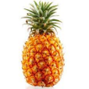
6. 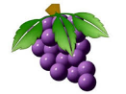 |  |  |  |  | 13. 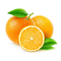
7. 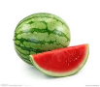 |  |  |  |  | 14. 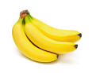
二、請將空格中填入適當的單字。 3%→18%
ice cream | wine | milk | juice | cake
pie | blue | bell | dragon boat | water

中文 | 英文 | 中文 | 英文
1. 香蕉牛奶 |  | 4. 芒果冰淇淋
2. 蘋果派 |  | 5. 鳳梨酥
3. 葡萄酒 |  | 6. 芭樂汁
四、請重新排列順序，組合成適當的句子。4%→12%
1. many do you have How fruit/fruits？

2. have four We lemon/lemons.

3. watermelon/ watermelons one have I.

五、請寫出下列各單字的阿拉伯數字。2%→16%
單字 | 阿拉伯數字 | 單字 | 阿拉伯數字
1. seven |  | 5. five
2. four |  | 6. one
3. three |  | 7. six
4. nine |  | 8. two

六、請將下列各句翻譯成中文句子。4%→12%
1. We have five pears.

2. You have four pineapples and one orange.

3. Jerry has two apples and seven guavas.

