Politeness seems to be disappearing from our world. In the past, people said “please” and “thank you” more often. Here's a story to make us think about kindness—Small acts of politeness can change people's lives.
Once upon a time, there was a poor couple. Although they did not have a lot of money, they were very kind. One day, a stranger came to town. He had lost his wallet and needed a place to stay. Everyone told the man to go away, except for the poor couple. They were polite and invited the stranger to stay with them for free. A few days later the stranger returned home, and then he went to the town to visit the couple again. He thanked them for being so kind and polite to a stranger. Before he left, the stranger dropped a bag of gold coins on their kitchen table. Inside was a note that read “Kindness always pays!”
coin 硬幣
( A ) 1. What is the main idea of the passage?
(A) Showing kindness to others changes people's own lives.
(B) Helping strangers is still common in today's world.
(C) Being polite will bring you a lot of money.
(D) Taking strangers home is a great idea.
( B ) 2. The word “disappearing” in the first paragraph means .
(A) Showing something in public.
(B) Becoming impossible to see.
(C) Getting together with each other.
(D) Being more than a certain number.
( B ) 3. According to the passage, which of the following is true?
(A) There is no politeness among people at all.
(B) Only the poor couple helped the stranger.
(C) The stranger never returned to thank the couple.
(D) The stranger forgot to take his gold coins with him.

根據以下內容，選出最適當的答案。

The Best Coffee Shops in People’s Minds
C=COFFEE BEAN & TEA LEAF
S=Starbucks
T=Tim Hortons
L=LOUISA COFFEE
So far, the best coffee shop voted by people online has more than 20,000 stores across the world. It sells millions of coffee cups in a day!

100%

Americans consume the most coffee in total amount, while Finland consumes the most coffee per person.
C S T L

Top 10 Coffee Consuming Nations
Rank | ﻿Country | Coffee Consumption  (Kg per Person Per Year) | Rank | Country | Coffee Consumption  (Kg per Person Per Year)
1 | Finland | 12.0 | 5 | Switzerland | 7.9
2 | Norway | 9.9 | 6 | Belgium | 6.8
3 | Denmark | 8.7 | 7 | Luxembourg | 6.5
4 | Netherlands | 8.4 | 8 | Canada | 6.5

vote 投票 consume 喝；吃 amount 數量 rank 級別 consumption 消費 per 每一

( D ) 4. According to the information above, which of the following is true?
(A) Americans consume the most coffee per person.
(B) People in Canada consume the least coffee in the world.
(C) Each person in Belgium consumes more coffee than in Denmark.
(D) Each person in Luxemburg and in Canada consumes the same amount of coffee.
( A ) 5. Which of the following is NOT mentioned in the passage?
(A) Coffee and tea are people's favorite drinks.
(B) Starbucks sells millions of cups of coffee each day.
(C) Starbucks has over 20,000 stores all over the world.
(D) The online voting tells us what the most popular coffee shop is.

Anila and Elton are together in a coffee shop for their first date. They are thinking about what they would like to taste.
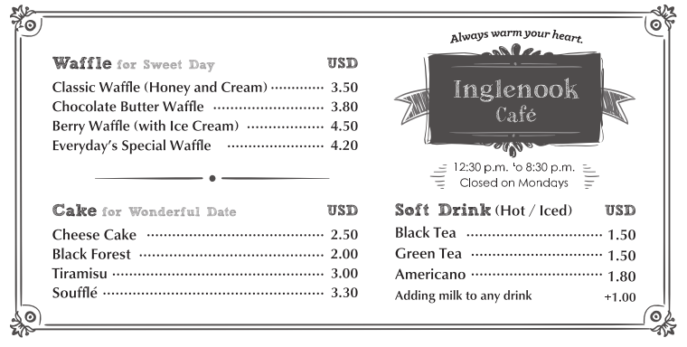
waffle 格子鬆餅 classic 經典的 berry 莓果
( ) 6. Both Anila and Elton like fruit. Which item might they choose?
(A) Cheese Cake. (B) Black Forest. (C) Classic Waffle. (D) Berry Waffle.
( ) 7. Elton wants to order iced black tea, and Anila wants to have hot Americano with milk. How much will they pay for the drinks?
(A) 3.3 USD. (B) 4.3 USD. (C) 4.4 USD. (D) 8.8 USD.

People today tend to be easy and free when they interact with each other. However, there are still some things that matter, and all children need to be taught how to behave when they are in public. Basic manners are very important for children, especially when they are with adults. If they are asking for something, they should always say “please,” and if they are given something, they should say “thank you.” When they want to use other persons’ possessions, they should first ask whether it is allowed. They must learn that doing all of these things shows respect to others. This is a part of life, and good manners allow people to show they are respectful and civilized.
interact 互動 manners 禮儀 especially 尤其是 possession 個人物品 respect 尊重
( ) 8. What is the best title for this passage?
(A) How to Show Respect (B) The Importance of Basic Manners
(C) How to Interact with People (D) The Advantages of Good Behavior

( ) 9. How can we express the word “civilized” in the last sentence of the passage?
(A) Being smart. (B) Living happily.
(C) Acting politely. (D) Becoming popular.
( ) 10. According to the passage, which of the following statements is NOT true?
(A) Children can do what they want when they are not in public.
(B) Showing respect to others can be also a part of people’s lives.
(C) Saying “please” and “thanks” is a way to show good manners.
(D) Children have to learn how to interact with others in a polite way.
(A) Freddie, David and Eric are in a restaurant for dinner. They are looking at the menu.
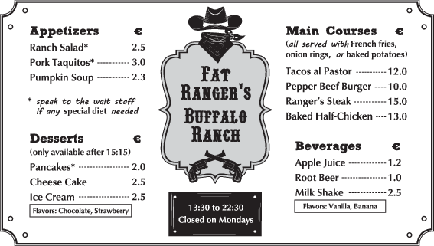
appetizer 前菜 main course 主菜 flavor 口味
( ) 11. Based on the menu, which of the following flavor of ice cream is available in the restaurant?
(A) Chocolate. (B) Banana. (C) Vanilla. (D) Apple.
( ) 12. According to the menu, which of the following is NOT true?
(A) If David is into beef, he can have at least two main courses to choose from.
(B) If Freddie doesn’t want any meat in Ranch Salad, he can try asking the waiter.
(C) It costs Eric more than 15 euros to order Ranger’s Steak and Pumpkin Soup.
(D) All the items on the menu are served between 13:30 to 22:30 in the restaurant.

Are you a kind person? If so, you may have good manners. These days, however, forgetting manners at times is common. Here are some tips on how to behave politely and kindly in public. First, put away your phone or headphones when you are talking with someone. Focusing on each other and making eye contact are important. People may think you don’t really care about them if you don’t pay full attention. Second, hold the door open for those who are behind you, or let others exit an elevator first before you step in. Third, if people drop things on the streets, you can help pick them up; others would consider you a warmhearted person. Simple acts like these will make communities and cities better places to live in.
headphones 耳機 eye contact 目光接觸 community 社區；群體
( ) 13. The passage is mainly about ________.
(A) how to behave politely in a society (B) what to do before you step in an elevator
(C) what to do when you listen to a speech (D) where to put your phone in a short talk
( ) 14. What does NOT the word “these” refer to?
(A) Holding the door open for the people who are behind you.
(B) Helping others pick up the things dropped on the streets.
(C) Making eye contact while you are talking with others.
(D) Turning cities into one community to live in.
( ) 15. According to the passage, if a guy keeps looking at his phone when talking with you, it may mean that ________.
(A) he really enjoys talking with you (B) he is expecting your reply
(C) he doesn’t really care about you (D) he tries focusing on your words

Credit Card Debt
Credit cards are a quick and easy way to pay for almost anything from a nice meal in a restaurant to a hotel room, Believe it or not, there are more active credit cards in Taiwan today than there are people. They have become so commonplace that many people could not imagine their life without one. This is especially true these days when so much shopping is done online. However, despite their convenience, there is a major pitfall that credit card users must be careful with.
Perhaps the greatest concern about credit card use is some people’s tendency to amass huge amounts of debt. Responsible consumers will use their credit card to buy things that they can afford, often because it is more convenient than paying with cash. At the end of the month, when the bill comes in the mail, these people will immediately pay it off completely. Others, however, use their cards to buy things that they cannot afford. By doing this, they are basically borrowing money from the bank. Unlike a normal bank loan, though, the interest rates on credit cards are extremely high. It is not uncommon for annual credit card rates to exceed 24%, many times the figure for a typical car loan or home loan. It can take some people years to pay off a large credit card bill because of these high interest rates.
Credit card debt was a major problem in Taiwan in the early 2000s when people owed a combined total of NT$70 billion. That figure is much lower today thanks to efforts to control people’s spending behavior. People must keep in mind that when they use a credit card, they are paying with the bank’s money, not their own.

commonplace常見的 pitfall陷阱 tendency傾向 amass聚集
loan貸款 interest rate利率 exceed 超過 figure數字 owe欠款

( ) 16. What is “one” in the first paragraph referring to?
(A) a meal
(B) money
(C) credit card
(D) online shopping

( ) 17 What is the meaning of “afford”
(A) to charge someone money
(B) to be able to pay
(C) to lose money
(D) to borrow money

( ) 18. What statement is NOT mentioned or suggested about credit cards?
(A) how many there are in Taiwan
(B) what people seldom use them for
(C) how high the interest rates can be
(D) what they are commonly used for
( ) 19. According to the passage, credit cards can be a major problem because _____.
(A) they are very convenient to use, especially for buy things online
(B) they prevent people from getting a normal car loan or home loan
(C) people may be charged for things that they never bought
(D) some people use them to buy things they do not have the money for

( ) 20. The passage asks readers to ______.
(A) remember whose money they are paying with when they use a credit card
(B) try to control their spending habits when they buy something not important
(C) avoid buying things that they cannot really afford to pay for
(D) totally pay off their credit card bill monthly to avoid paying interest

