新北市立 新 北 高工 109 學年度 第二學期 開學考 |  |  |  |  |  |  | 班級姓名 |  | 座號 |  | 成
科目 | 英文 | 年級 | 二 | 科別 | 訊機鑄汽圖電資 |  | 出/審題 | 高麗雯/楊韻薇 |  |  | 績
請在答案卡上劃卡作答 共 50 題, 每題兩分 請仔細核對題號!  一、字彙選擇  - （ ）Team ____________ is necessary for basketball players. They have to work with others to win the game. (A) survival (B) argument (C) engineering (D) spirit  - （ ）This new type of scooter ____________ less gas than the previous model. It’s eco-friendly (環保的). (A) consumes (B) damages (C) taps (D) gestures  - （ ）I switched my phone to silent mode (靜音模式) so as not to ____________ other readers in the library. (A) announce (B) arrive (C) bother (D) replace  - （ ）A wave of panic swept through the country after the ____________ of measures to try  to stop a pandemic (大流行病).  (A) gratitude (B) safety (C) familiarity (D) announcement  - （ ）The WHO (世界衛生組織) ____________ of the danger of hearing loss for people who are surrounded by loud noise for hours every day.  (A) permits (B) originates (C) skips (D) warns  - （ ）The secretary was asked to ____________ a meeting with the supplier (供應商) to discuss the new contract. (A) occupy (B) arrange (C) grab (D) embrace  - （ ）Remember to read the ____________ carefully before you turn on the machine.  (A) instructions (B) infections (C) celebrations (D) constructions  - （ ）The ____________ was hired to help the manager with the project.  (A) assistant (B) banquet (C) program (D) engineering  - （ ）If time ____________, we can spend an extra hour in the shopping mall.  (A) grabs (B) permits (C) gestures (D) panics  - （ ）For your own ____________, please remain seated until the vehicle has come to a complete stop. (A) motivation (B) safety (C) entertainment (D) promotion  - （ ）Some plants are ____________ to humans, so don’t eat or even touch wild plants.  (A) embarrassing (B) poisonous (C) doubtful (D) constructive  - （ ）The Moon Festival ____________ in China. It has been celebrated by Chinese people for a long time. (A) arranged (B) originated (C) swallowed (D) tossed  - （ ）Fresh meat is more ____________ and healthier than processed (加工的) meat such as sausage and bacon. (A) determined (B) faithful (C) immediate (D) nutritious  - （ ）To ____________ students’ learning environment, many schools have air conditioners in their classrooms. (A) improve (B) echo (C) bother (D) announce  - （ ）The science ____________ sounds great, but it is difficult to carry out.  (A) schedule (B) process (C) project (D) culture  三、對話  - （ ）Joe: Excuse me. I need a ticket to Taichung. ____________  Rob: It will arrive at 9:30. That’s in less than 10 minutes.  Joe: OK. How much is the ticket?  Rob: It’s 500 dollars, sir.  (A) When is it scheduled to arrive? (B) How much do I have to pay?  (C) Where is Platform 2? (D) The train is too crowded.  - （ ）Eva: Hey, Leo, are you planning to do anything this weekend?  Leo: Nothing in particular. Why are you asking?  Eva: I’m going to participate in a mountain cleanup and I’m wondering if you want to come.  Leo: Sure! ____________  Eva: It starts at 9 a.m. Glad you will join us!  (A) Why not stay home and rest? (B) I can pick you up at 10 a.m.  (C) How about taking a leave? (D) What time does it start?  - （ ）Customer: Excuse me, do you know where the toilet is?  Clerk: Just go straight, turn right at the elevator, and turn left at the statue.  Customer: I’m sorry. ____________  Clerk: I’ll just take you there. Please follow me.  Customer: OK, thanks!  (A) I can’t spell the word. (B) How many toilets are here?  (C) It’s really surprising to me. (D) Can you say that one more time?  - （ ）Charlotte: How was Hannah and Jay’s wedding reception?  Damien: It was just beautiful! ____________  Charlotte: I wish I could, but I had to take care of my dad in the hospital.  (A) The traffic was bad though. (B) I couldn’t receive it.  (C) Everyone was waiting for the newlyweds. (D) Too bad you couldn’t come.  - （ ）Mary: Do you want to go to the modern art exhibition in the museum?  Lily: Very much. But, it’s crowded on weekends.  Mary: Really?  Lily: Yes, I went there last Saturday; it was packed. I could hardly see my favorite paintings close up.  Mary: What a pity! ____________  Lily: Good idea. Which day would be the best?  (A) I prefer oil paintings to sculpture. (B) You are too busy to visit the museum.  (C) Let’s go there sometime during the week.(D) You shouldn’t have packed your paintings.  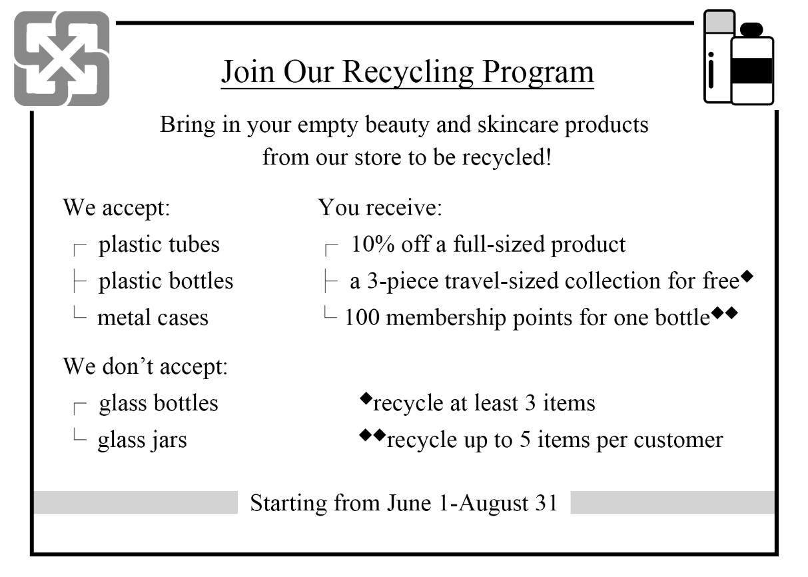  43.（ ）Who might run this program? (A) A coffee shop. (B) A sporting-goods store.  (C) A makeup store. (D) A science museum.  44.（ ）Sue returns two of the store’s plastic bottles and one of their glass jars. What will she get? (A) A 10% discount, a travel collection and 200 membership points. (B) A 10% discount, a travel collection and 300 membership points. (C) A 10% discount and 300 membership points. (D) A 10% discount and 200 membership points.  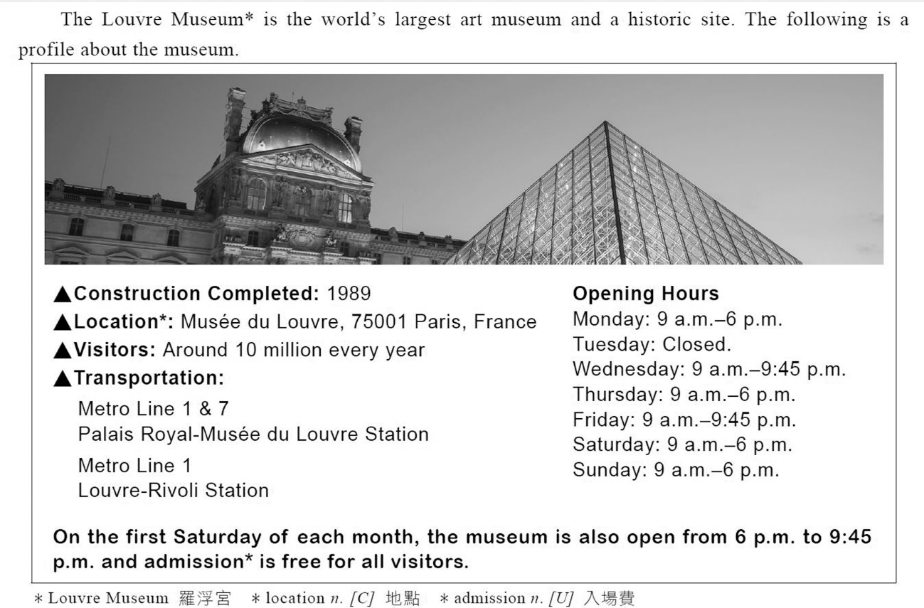 |  |  |  |  |  | - （ ）The company hired a group of experts to study the ____________ of consumers, and developed new products according to the findings.  (A) engineer (B) greeting (C) behavior (D) landmark  - （ ）Ms. Huang has a tight ____________. It seems that she doesn’t even have time for her children. (A) value (B) embrace (C) project (D) schedule  - （ ）Unfortunately, no passengers ____________ the air crash. That is, everyone died in the accident. (A) survived (B) damaged (C) infected (D) processed  - （ ）____________ are not allowed in this area. This is a walking district.  (A) Halls (B) Tents (C) Vehicles (D) Gatherings  - （ ）With a big supermarket in his ____________, it is very convenient for him to go grocery shopping. (A) exhibition (B) message (C) neighborhood (D) prayer  二、同義字選擇  - （ ）Everyone should instantly take action to help decrease global warming.  (A) carefully (B) immediately (C) fearfully (D) gently  - （ ）Chatting frequently with my American friend gives me a good chance to improve my English speaking ability. (A) opportunity (B) period (C) secret (D) surface  - （ ）Mr. Tsai hurried to the hospital after he heard that his wife was going to give birth.  (A) rushed (B) posed (C) strolled (D) assisted  - （ ）My teacher provided precious support for me when I was in trouble.  (A) dishonest (B) effective (C) extra (D) valuable  - （ ）I have confidence that Cliff will win the speech contest (比賽) because he has been practicing so hard. (A) princess (B) faith (C) postcard (D) reality  - （ ）During the Lunar New Year, the restaurant employed some part-time workers to help out. (A) tapped (B) bounced (C) hired (D) doubted  - （ ）Ella’s fear of letting her parents down drove her to work even harder.  (A) rushed (B) bothered (C) conducted (D) motivated  - （ ）People all over the world show their basic emotions with similar facial expressions. (A) feelings (B) positions (C) movements (D) abilities  - （ ）David’s mother asked Sally about her parents’ occupations. She wanted to know where they worked. (A) locations (B) goals (C) reactions (D) jobs  - （ ）Telling me that he had to take a train home in ten minutes, he vanished into the street. (A) disappeared (B) disappointed (C) deserved (D) ignored  P1  四、綜合測驗  Today, she was walking along the empty platform again. A train arrived, and I saw her stop __(36.)__ to the announcement. Wonder and joy filled her __(37.)__ face when she once more heard her lost love’s voice.  “Of course, we have a recording for you too,” I said, __(38.)__ her a digital copy. Her teary eyes shone __(39.)__ gratitude as she took the precious gift. Then she stepped onto the train. “Thank you. I can go on from here now,” she smiled __(40.)__ reply. “Carrying my memories with me, I no longer mind the gap.”  36.（ ）(A) listening (B) listen (C) to listen (D) listens  37.（ ）(A) previous (B) wrinkled (C) digital (D) fierce  38.（ ）(A) handing (B) handed (C) to hand (D) hand  39.（ ）(A) about (B) over (C) between (D) with  40.（ ）(A) in (B) at (C) on (D) with  五、素養題  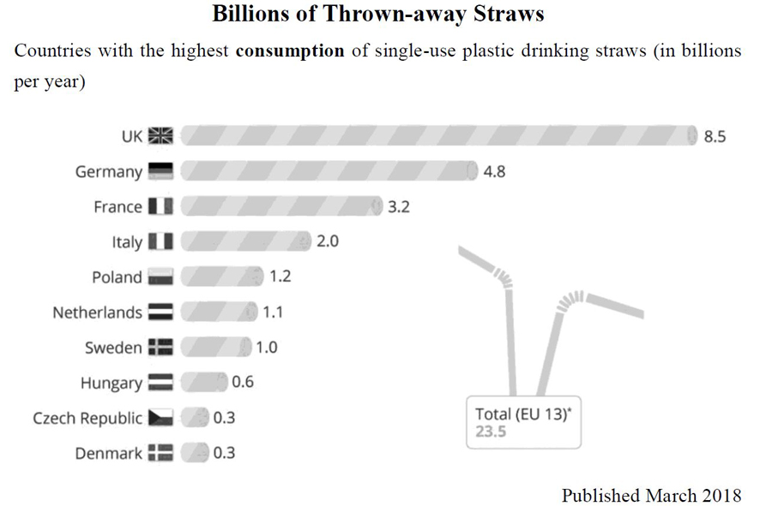  41.（ ）Which of the following is NOT true, according to the graphic?  (A) The UK used the most plastic straws.  (B) The Czech Republic used the same quantity of plastic straws as Denmark.  (C) France uses 3.2 billion plastic straws every year.  (D) Hungarians use fewer plastic straws than people in Denmark.  42.（ ）What does the word “consumption” mean, as used in the graphic?  (A) The amount of something that is offered.(B) The amount of something that is made.  (C) The amount of something that is used. (D) The amount of something that is shipped.  P2  45.（ ）Which of the following is NOT mentioned about the museum?  (A) Where the museum is. (B) How to get to the museum.  (C) The number of visitors per year. (D) When the museum’s construction started.  46.（ ） Which of the following is true about the museum on the first Saturday of each month? (A) It’s closed. (B) It closes later.  (C) It opens earlier. (D) It’s free omly for children.  六、閱讀測驗  In 2017, when she became a citizen, a robot named Sophia attracted worldwide attention to her human-like look and manners. Sophia is one model of a new invention known as social robots, a smart machine created to interact and work closely with people in different areas.  The service industry is among the first users of social robots. In 2020, friendly robots will assist human volunteers in hotels and at tourist attractions during the Tokyo Olympic Games. Social robots are also tested out in Japan to care for the elderly in nursing homes. There, gentle robot caregivers help to serve food and entertain lonely residents. Still another type of social robots does all the housework. As their prices fall, these hardworking housekeepers may become a common home appliance. Researchers even tried out robot teachers at elementary schools to engage students in learning, or to patiently help children with communication difficulties learn social skills.  However, not everyone welcomes social robots with open arms. Some people are afraid that human partners may be disappointed when robots do not behave exactly like humans. Others are not sure if children learning from robots will be able to handle surprises in real-world communication. These and many other questions are being asked, but researchers will not stop efforts to develop effective social robots.  47.（ ）What is the best title for this passage?  (A) Humans Learning from Robots (B) Giving Robots Rights of Citizens  (C) Making Robots at Low Costs (D) Living Side by Side with Robots  48.（ ）What does the phrase “with open arms” in paragraph 3 mean?  (A) showing pleasure (B) having doubts  (C) showing disagreement (D) having protection  49.（ ）According to the passage, which of the following is a problem with the use of robots?  (A) They do not punish students who are slow.  (B) They are not able to show every human ability.  (C) They do not give tourists the right information.  (D) They are not able to work when no one is home.  50.（ ）According to the passage, which of the following is true?  (A) Robot caregivers try to make the elderly happy.  (B) Children learning from robots do not make mistakes.  (C) Only robots will welcome tourists in the 2020 Olympics.  (D) The debate about robots prevents the development of robots.  P3  .  P3.
新北市立 新 北 高工 102 學年度 第二學期 期末考 |  |  |  |  |  |  | 班級 |  | 座號 |  | 成 | P.2
科目 | 英文 | 年級 | 一 | 科別 | 機鑄汽模圖電資 |  | 姓名 |  |  |  | 績 | P.2

新北市立 新 北 高工 102 學年度 第二學期 第二次 段考 一年級 英文 答案卷 P.3

班級 姓名 座號

得分 總分
VI. 文意字彙20%
1. | 2. | 3. | 4.
5. | 6. | 7. | 8.
9. | 10.

VII. 翻譯填空10%
11. | 12. | 13. | 14.
15. | 16. | 17. | 18.
19. | 20.

【請仔細核對題號 請在考卷及答案卷上都寫上姓名座號 答案卡請劃座號!!!!】

