- 聽力 10%
- 看圖辨義：試卷上該題有一張圖片，請聽一個和該題相關的問題，選一個與所看到圖片最相符的答案。
1. ( )   | 2. ( )  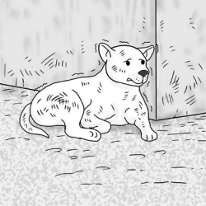

(二) 問答：每題會播出一個問句或直述句，聽後請由試卷上選出一個最適合的回答或回應。
3. ( )
(A) I need to see a doctor.
(B) I have to bathe him.
(C) I should put him into the shelter.
4. ( )
(A) I had support from my family.
(B) The homework is due on Monday.
(C) He is such a good student.
5. ( )
(A) I like eating fish.
(B) She made me a dog house.
(C) I like her very much.
6. ( )
(A) No, I didn’t really like it.
(B) I looked at it for a long time.
(C) It is filled with different faces.
(三) 簡短對話：每題會播出一段對話及一個相關的問題，聽後請由試卷上選出一個最適合的回
答。
7. ( )
(A) To figure out which kids damaged his car.
(B) To sell the car and get a new one.
(C) To ask the children to clean his car.
8. ( )
(A) She had a fight with her husband.
(B) Her son isn’t coming home for dinner.
(C) Her son isn’t paying attention at school.
(四) 短文聽解：每題有三個圖片選項。請聽題目，並選出一個最適當的圖片。
9. ( )

(A) 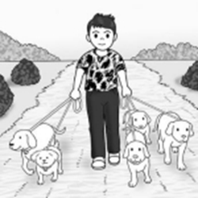 (B) 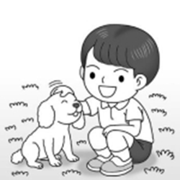 (C) 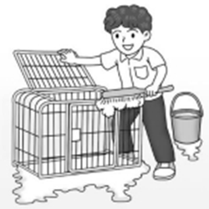

10. ( )
(A) 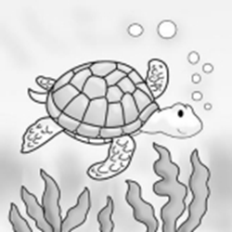 (B) 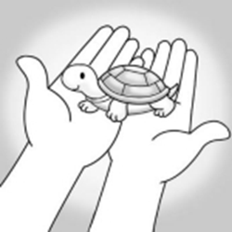 (C) 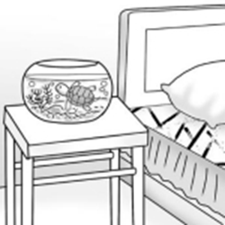

二、同義字 (選出與劃底線的字意思最相近的字) 8%
( ) 11. It is difficult for young kids to concentrate for so long.
(A) complain (B) determine (C) recognize (D) focus
( ) 12. Carl can learn languages more easily than other kids. He has a real gift for it.
(A) focus (B) talent (C) period (D) success
( ) 13. The sudden thunder frightened the little baby and caused him to cry loudly.
(A) terrified (B) exhausted (C) adopted (D) confirmed
( ) 14. Nancy felt very upset after seeing terrible pictures of the disaster on TV.
(A) focuses (B) periods (C) talents (D) images

三、文意字彙 36%
( ) 15. Brian didn’t recognize the man at first. It _______ that he was his classmate in college.
- turned out (B) nodded off (C) used to (D) gave up
( ) 16. Due to the pop music concert, the beach is now _______ with people.
- confident (B) eventual (C) crowded (D) forever
( ) 17. The girl was _______ when the large dog began to bark loudly at her.
(A) adopted (B) blessed (C) confirmed (D) scared
( ) 18. Put on your coat before you go out; _______, you might catch a cold.
(A) confidently (B) therefore (C) otherwise (D) forever
( ) 19. The man has been out of work for a(n) _______ of time. He feels upset and worried
about the future.
(A) talent (B) period (C) focus (D) image
( ) 20. A loud noise _______ Peter last night, so he didn’t get enough sleep.
(A) blessed (B) awoke (C) focused (D) confirmed
( ) 21. With the final exam _______, many students can’t help feeling nervous and start to
study very hard in order to pass it.
(A) awaking (B) oversleeping (C) approaching (D) chasing
( ) 22. Oliver drank too much and never cared about his health. He _______ got sick and spent a
week in a hospital.
- patiently (B) successfully (C) boredly (D) eventually
( ) 23. Daniel made a call to the hotel to _______ his reservation (預訂) for a single room.
(A) scare (B) confirm (C) exhaust (D) terrify
( ) 24. Kangaroos (袋鼠) are _______ to Australia; they have short front legs and long
powerful back legs.
(A) patient (B) determined (C) unique (D) confident
( ) 25. Cindy is very _______ with her children. She seldom gets angry when they are naughty.
(A) scary (B) patient (C) eventual (D) confident
( ) 26. The film about climate change _______ lots of people to care more about our planet.
- terrified (B) bored (C) inspired (D) determined
( ) 27. Ricky is good at public speaking. With his _______, I was able to prepare an excellent
speech.
- support (B) customer (C) difficulty (D) period
( ) 28. The long walk _______ the old lady. Therefore, she lay down and took a nap.
- awoke (B) confirmed (C) exhausted (D) approached
( ) 29. Shelly didn’t go to work yesterday; _______, she stayed home to clean her room.
(A) forever (B) otherwise (C) successfully (D) instead
( ) 30. Emma decided to get a pet from an animal _______ rather than get one from a pet store.
(A) blessing (B) talent (C) image (D) shelter
( ) 31. _______, their plan went well and they made a huge profit, but later something went
wrong, and they began to lose money.
(A) As for (B) At first (C) After all (D) At last
( ) 32. My friend told me not to _______ so easily and to give it another try.
(A) turn out (B) let out (C) give up (D) nod off

四、語法測驗 20 %
( ) 33. Jacob used to _______ off at school from time to time, but since he started going to sleep
earlier, he never fell asleep in class again.
- nodded (B) nod (C) nodding (D) has nodded
( ) 34. Not only my friends but also my elder brother _______ going to the party.
(A) am (B) are (C) is (D) be

( ) 35. Harvey doesn’t know _______ it’s already dark and that he should go home now.
(A) that (B) what (C) how (D) which
( ) 36. Phil loves sports _______ jogging, swimming, and surfing. He is good at them.
(A) such (B) for (C) on (D) like
( ) 37. To our surprise, using cola to clean a toilet _______ quite well.
(A) work (B) working (C) works (D) have worked
( ) 38. Due to his strong accent, the man has difficulty _______ himself understood in English.
(A) making (B) to make (C) make (D) made
( ) 39. Molly can speak not only Chinese but also _______ very well.
(A) speak English (B) English (C) can speak English (D) she can speak English
( ) 40. _______ out is a good way to help one lose weight.
(A) Work (B) Working (C) Worked (D) To working
( ) 41. Tim forgot his pen, so he had to _______ one.
(A) borrowing (B) be borrow (C) borrow (D) borrowed
( ) 42. Some students in Taiwan are not confident _______ asking questions in class.
(A) on (B) at (C) about (D) above

- 克漏字 20 %
When I was just a little puppy, a boy bought me at a pet store. Jimmy knew ___43___ about taking care of dogs. He wasn’t ___44___ that dogs must go outside to pee and poo. He also didn’t know I liked to chew on shoes. One day, Jimmy’s parents drove me out of town and took me for a walk. After they drove away, I realized that they would never come back. Later, I got caught and was ___45___ to a shelter. I hated it and felt ___46___. I thought I would never have fun again. Luckily, a little girl’s family ___47___ me. I love them and they love me, too!
( ) 43. (A) few (B) more (C) little (D) much
( ) 44. (A) aware (B) awake (C) awesome (D) awkward
( ) 45. (A) take (B) takes (C) taken (D) taking
( ) 46. (A) scares (B) scare (C) scaring (D) scared
( ) 47. (A) exhausted (B) adopted (C) terrified (D) confirmed

Are you thinking about getting a dog? There are some things you should know before you do that. ___48___ dogs are lots of fun, they are also lots of work. For example, you must take your dog for a walk ___49___ at least 30 minutes every day. Dogs also need to be fed and bathed. When you share your house with a dog, the house will ___50___ dog hair, so you need to clean it more often. Sometimes, dogs like chewing on things such as shoes and clothing. Finally, you need to train your dog to ___51___ it well-behaved. Being aware of these things ___52___ very important. If you can’t handle these tasks, you shouldn’t get a dog.
( ) 48. (A) Although (B) Because (C) Unless (D) After
( ) 49. (A) into (B) from (C) by (D) for
( ) 50. (A) turn out (B) take care of (C) be filled with (D) give up
( ) 51. (A) making (B) makes (C) made (D) make
( ) 52. (A) have (B) is (C) has (D) are

六ˋ對話 6%
( ) 53.Albert: Hi, Penny. I just came back from Japan yesterday and I brought back a box of
chocolates for you.
Penny: Thank you so much! Chocolates are my favorite!
Albert: ____________
(A) I really appreciate it. (B) I am glad you like them.
(C) I am worried about it. (D) I almost can’t wait!
( ) 54.Ted: Could you look after my dog, Cooper, when I am away?
Gary: No problem!
Ted: Thank you very much.
Gary: ____________ I love dogs.
(A) Great choice, Ted! (B) That’s so kind of you.
(C) Don’t mention it. (D) I’m sorry to hear that.
( ) 55.Carol: Max, can you do me a favor? This math problem is too difficult for me. Can you
explain it to me?
Max: No problem. I’ll be happy to teach you how to solve it.
Carol: ____________
Max: You’re welcome.
(A) I am proud of you. (B) It’s my mistake.
(C) It’s so kind of you. (D) I am just kidding.

