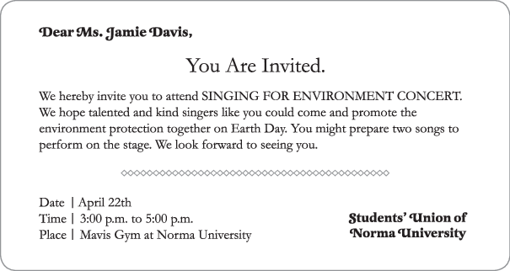
( )1.What does this piece of writing serve as?
(A) An invitation. (B) A thank­you note. (C) A love letter. (D) An E­mail.
( )2. What will Ms. Davis probably do at Mavis Gym of Norma University on April 22th?
(A) She will show her special talent.
(B) She will sing some songs to support environment protection.
(C) She will perform in a play about environment protection.
(D) She will prepare a speech on Earth Day.
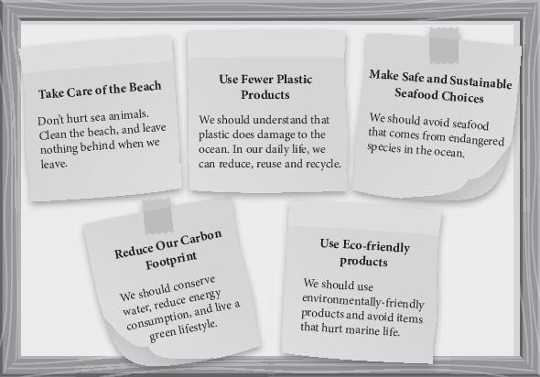
( )3.Which of the following is helpful in saving the ocean?
(A) Buying shampoo that contains plastic particles (塑膠微粒).
(B) Ordering shark's fin soup in a restaurant.
(C) Picking up trash when we leave the beach.
(D) Using plastic bags instead of paper bags.
( )4. To reduce our carbon footprint, we can ________.
(A) turn off the light when we don't need it
(B) drive cars to work every day
(C) take a bath instead of taking a shower
(D) turn on the air­conditioner all day long in summer

“Eco­friendly” means making choices that are better for the environment. Not sure where to start?
Begin by using less!
Cut back on the amount of energy and water you use by taking a shower instead of a bath, turning off the water when brushing your teeth or shaving, and only using the lights when you must. Using cold water also reduces energy used. To further cut back on elec-tricity, turn off and unplug everything that isn't being used. If you are not in hurry, please choose to walk or ride a bicycle instead of taking a car or taxi. You will not only make the Earth happy by reducing air pollution, but also make yourself healthier by exercising more often! The most important thing is to become conscious of what you use and use only what you need. When you really need something, make the choice that is best for our planet—and all of us!
( )5.What is the best title for this passage?
(A) Use Energy Whenever We Want (B) Say No to Riding a Bike
(C) Exercise More to Stay Healthy (D) Save Energy to Save the Earth
( )6. Which of the following actions is not eco­friendly?
(A) Using less water. (B) Cutting back on electricity.
(C) Spending less money. (D) Riding a bike instead of taking a taxi.

( )7.In this article, “to become conscious” means ________.
(A) to be aware of (B) to forget it
(C) to care nothing (D) to pretend that we don't know

On June 8th, people around the world may gather to celebrate. It is a time to come together to clean up and protect oceans, which is known as World Oceans Day.
The ocean covering 70% of the earth provides living things food, medicine, and most of the air for breathing. However, it is in deep trouble. Millions of tons of plastic now pollute the water and kill about 100,000 sea animals each year. World Oceans Day can draw attention to the importance of the ocean and the growing problems these days.
To celebrate World Oceans Day, people hold various events to promote why and how to protect oceans. Some clean up garbage on beaches and in waters. Others share photos that display the beauty and importance of the sea. These acts of service help to remember the relationship between humans and the nature of the Earth.
On World Oceans Day—and every day, let us appreciate and protect our blue planet together.
( )8.What is probably the main purpose of World Oceans Day?
(A) To stop people using plastic products.
(B) To stop people using plastic products.
(C) To promote the importance and protection of oceans.+
(D) To deliver the beauty and functions of oceans.
( )9.According to the passage, why does the ocean have trouble?
(A) Plastic things appear in the water. (B) Air pollution has influenced some oceans.
(C) Sea animals are killed without reasons. (D) It covers more ground than before.
( )10.Which of the following activities may NOT happen to celebrate World Oceans Day?
(A) Cleaning up beaches. (B) Showing pictures of oceans.
(C) Offering free water activities. (D) Speaking up for the importance of oceans.

In most societies, females and males are influenced by the power of gender* stereotypes*. Boys have traditionally been expected to be “manly” by appearing tough. For example, crying in public is a sign of weakness* that is not allowed to show on boys. Parents buy toy soldiers, and the media like to celebrate strong male heroes in action movies. On the other hand, girls tend to appear weak and quiet. Crying and talking about personal feelings is acceptable. Parents also give girls dolls, and girls’ magazines present images of gentle women. Nowadays, gender stereotypes have been changing, because men can show a softer side, while women may act with strength. Although gender stereotypes may help men and women form their identities*, they might also prevent individuals* from “being themselves.”
*gender stereotype n. 性別科版印象 *weakness n. 軟弱；identities n. 身分；individuals n. 個人
( )11.This passage is mainly about .
(A) the weakness of boys (B) the strength of girls
(C) the gender stereotypes (D) the influence of the media
( )12.What does “they” refer to in the last sentence of the passage?
(A) The men and women. (B) The gender stereotypes.
(C) The parents. (D) The societies.
( )13.According to the passage, what is NOT influenced by gender stereotypes?
(A) Females. (B) Males. (C) The media. (D) The nature.
( )14.According to the passage, what can gender stereotype help?
(A) It can help people be themselves.
(B) It can help parents buy the gifts.
(C) It can help people form their identities.
(D) It can help magazines sell well.
( )15.According to the passage, which of the following is NOT traditional gender stereotypes?
(A) Women can act with strength when they want.
(B) Parents buy toy soldiers for boys.
(C) Boys are asked to appear manly.
(D) Girl should act weak and quiet.

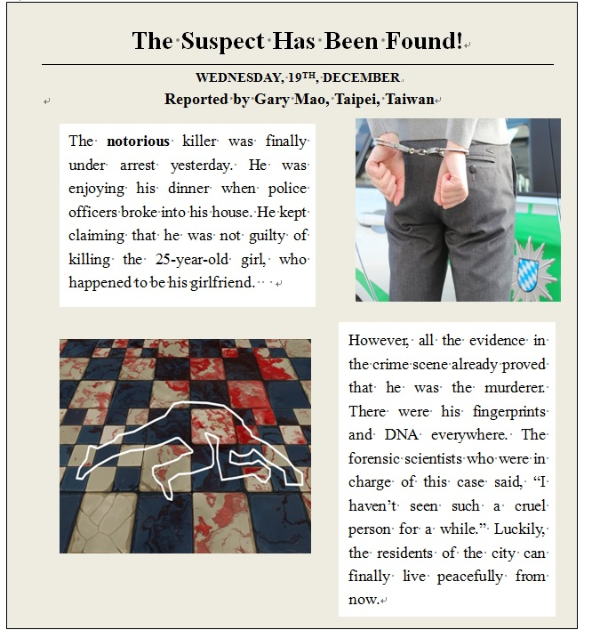
*arrest v. 逮捕；*cruel adj. 殘忍的：*claim v. 宣稱；*forensic scientists 鑑識科專員
( )16. What is the passage mainly about?
(A) A piece of news from the police.
(B) A letter from a cruel murderer.
(C) A guide to a secret crime scene.
(D) An invitation for the city festivals.

( )17.What does the word “notorious” in the first paragraph most likely mean?
(A) hot (B) sad (C) fat (D) bad
( )18. What was the suspect doing when he was caught?
(A) He was killing her girlfriend.
(B) He was having a meal at home.
(C) He was leaving some fingerprints.
(D) He was breaking into a house.
( )19. How did the police know that the man was the murderer?
(A) He had a date with his girlfriend before she was killed.
(B) Some of the city residents have seen the murderer’s face.
(C) They found his fingerprints and DNA at the crime scene.
(D) The 25-year-old girl called to report the case to the police.
( ) 20.Which of the following can be inferred from this passage?
(A) The murder is one of the cruelest cases recently.
(B) The city residents were not shocked by the murder.
(C) The suspect knew that he will be caught someday.
(D) The police work without any scientific measures.

