- 選擇題：請將答案畫記於答案卡。同時請於卡上畫記班級、座號。
- 聽力測驗 10%
（一）看圖辨義：試卷上該題有一張圖片，請聽一個和該題相關的問題，選一個與所看到圖片最相符的答案（每題播放1次）。
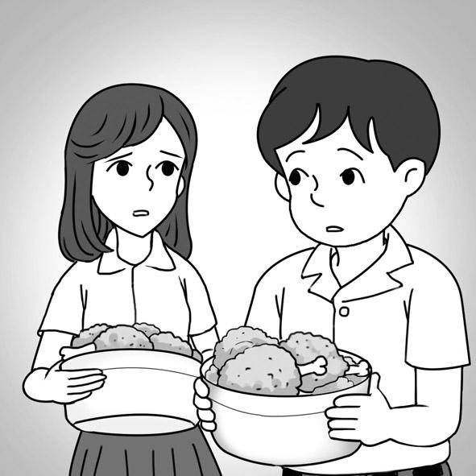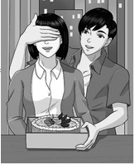
1. ______ 2. ______
（二）問答：每題會播出一個問句或直述句，聽後請由試卷上選出一個最適合的回答或回應（每題播放2次）。
- (A) Luckily, I wasn’t late. (B) Upset, of course. (C) Yes, it’s awesome.
- (A) No, thanks. I’m full. (B) I am thankful for your help.
(C) Please give each guest a piece of cake.
- (A) To be more carefree. (B) It was a long lesson. (C) We will start at 5 o’clock.
- (A) It’s quite interesting to me. (B) The movie begins with a song.
(C) It originally started in England.
（三）簡短會話：每題會播出一段對話及一個相關的問題，聽後請由試卷上選出一個最適合的回答（每題播放1次）。
- (A) The man. (B) The woman. (C) Marcus.
- (A) Curtis doesn’t know about it. (B) It will be over at 3. (C) Everybody will bring a dish.
（四）短文聽解：每題有三個圖片選項。請聽題目，並選出一個最適當的圖片（每題播放2次）。

(A) 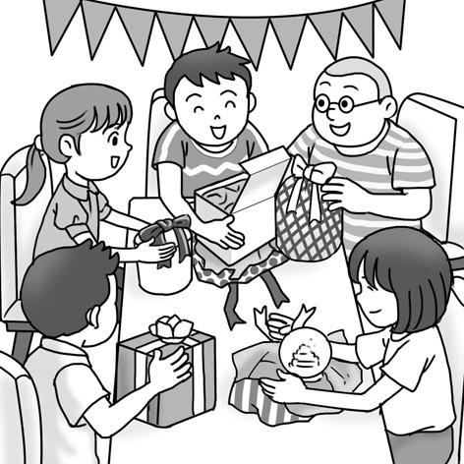 (B) 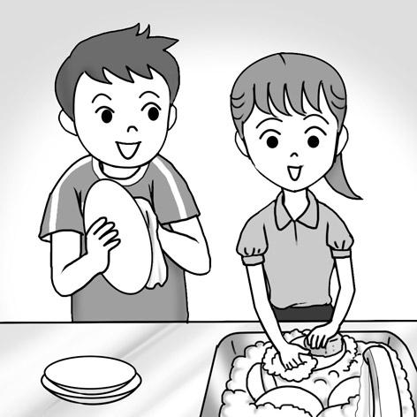 (C) 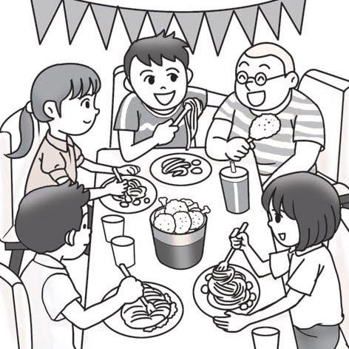

(A) 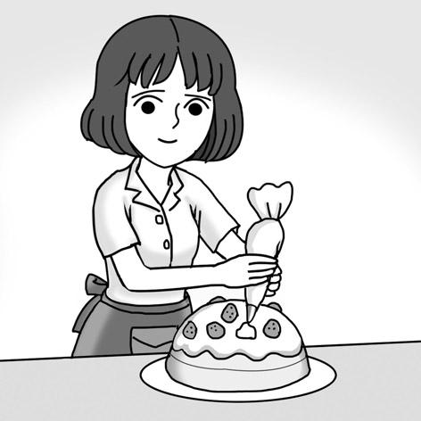 (B)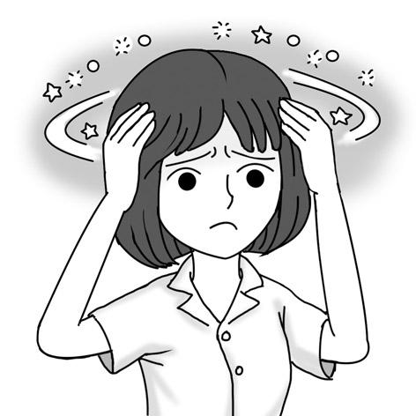 (C) 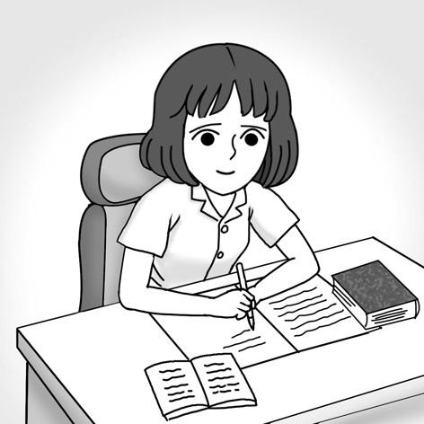
- 綜合選擇 26%
 | Miranda lives near an MRT station. She usually _____ the MRT to school.
 | (A) took | (B) takes | (C) take | (D) is going to take
 | After everything _____ ready for the party, Lucas went to bed.
 | (A) be | (B) is | (C) was | (D) will be
 | The movie star wants the public to know him _____ a professional actor rather than a handsome idol.
 | (A) as | (B) for | (C) to | (D) of
 | Marci enjoys outdoor activities. She _____ mountain climbing next Saturday.
 | (A) goes | (B) be going | (C) went | (D) will go
 | Cathy was very _____ when she knew that her favorite team had won the championship.
 | (A) excite | (B) exciting | (C) excited | (D) excitement
 | “I’d better leave soon,” Eric thought _____ himself after he took a look at the clock.
 | (A) at | (B) to | (C) in | (D) with
 | Tim is often mean _____ others at school; thus, he has few friends.
 | (A) in | (B) at | (C) with | (D) to
 | After I took the medicine, I felt _____ better.
 | (A) more | (B) very | (C) much | (D) most
 | After the car accident, Sarah would drive carefully for the rest _____ her life.
 | (A) of | (B) by | (C) at | (D) with
 | In Taiwan, Father’s Day _____ on August 8th.
 | (A) is falling | (B) fall | (C) will fall | (D) falls
 | We will miss the train if we _____ now.
 | (A) won’t leave | (B) didn’t leave | (C) don’t leave | (D) doesn’t leave
 | Benjamin was so busy that he didn’t have time _____ lunch.
 | (A) to eat | (B) ate | (C) for eat | (D) and eating
 | If you are hungry, you _____ the bread on the dining table.
 | (A) ate | (B) can eat | (C) are eaten | (D) are eating
- 克漏字 14%
I still remember my first day of high school. That morning, I _(24)_ early and felt happy. After I washed my face, I looked at myself _(25)_ the mirror to make sure that I looked perfect. _(26)_, I saw a huge red zit right on my nose. I thought it was the end of the world! I was _(27)_ that my classmates would laugh at me. _(28)_ my surprise, no one pointed at me or laughed at me that day. Still, I was worried that people would talk about it secretly.
A year later, I _(29)_ to my best friend about my zit. She told me that no one in my class had said anything about it. After I heard what she said, I found _(30)_ most people only focused on their own problems. Because of this event, I learned to be more carefree and confident.
 | (A) woke up | (B) went well | (C) referred to | (D) let out
 | (A) at | (B) of | (C) on | (D) in
 | (A) Because | (B) Otherwise | (C) Before | (D) However
 | (A) awesome | (B) certain | (C) mean | (D) pleasant
 | (A) From | (B) Of | (C) To | (D) As
 | (A) will talk | (B) talk | (C) and talked | (D) talked
 | (A) X | (B) it | (C) this | (D) what
- 對話 10%
- Jack: I am new here. I don’t know anyone and feel so lonely.
Teddy: ________ I don’t know anybody, either, because none of my friends are in the same class with me.
(A) Do you have any friends? | (B) Why are you so bored?
(C) I want to transfer to your school. | (D) I understand your feelings!
- Ben: My name is Ben. Nice to meet you.
Kate: ________ I’m Kate.
Ben: Are you here for Mr. Huang’s class?
Kate: Yes, that’s right.
(A) Nice to meet you, too. | (B) What do you do?
(C) What’s new? | (D) I quit.
- Cindy: My best friend isn’t in my class. I feel very sad.
Eric: ________ You can still go chat with her during each break, can’t you?
Cindy: Hmmm…You’re right! I feel better now.
(A) What a smart idea! | (B) It’s the end of the world.
(C) Everything will be OK. | (D) Everything goes well.
- Becky: I didn’t make any new friend today. No one talked to me.
Stanley: Don’t worry. ______ You’ll make new friends soon.
(A) You shouldn’t think about others’ problems. | (B) Just look on the bright side.
(C) People will talk about it behind your back. | (D) Most people are carefree.
- Jane: Thank you for stopping by. Can I get you anything?
Lisa: ________
Jane: Coming right up.
(A) You have nothing I want from you. | (B) A cup of coffee would be nice.
(C) I don’t know what I have in mind. | (D) No, I don’t drink in the daytime.
- 閱讀測驗 10%
I still remember my first summer camp. I was a freshman in high school then. The camp was a sports camp. About 50 other students and I traveled by bus to a lake a few hours from the city. It was beautiful there, and the camp had everything. There were basketball and tennis courts, a swimming pool, a soccer pitch, and a baseball field. The problem was that I didn’t know any of the other kids. They were all from other schools. But I quickly made friends with one of the other girls, and then another. Before I knew it, I had a whole new circle of friends. For two weeks, we played games together every day. At night, we gathered around a campfire to sing songs and tell ghost stories. I know I’ll remember that camp, and the people I met there, for as long as I live.
 | What is the best title of this story?
 | (A) How to Have Fun in Summer Camp |  | (B) Why I Want to Attend Summer Camp
 | (C) A Summer Camp That I’ll Never Forget |  | (D) A Boring Camp I Once Attended
 | How did the author and the other students go to the lake?
 | (A) By bus. | (B) By MRT. | (C) By train. | (D) On foot.
 | The summer camp lasted for _____.
 | (A) five days | (B) one week | (C) ten days | (D) two weeks
 | According to the reading, which of the following is NOT true?
 | - About fifty students attended the camp.
 | (B) There was a swimming pool at the camp.
 | (C) The author made many new friends at the camp.
 | (D) The author went to the camp with her classmates.
 | What does the underlined word “gather” mean?
 | (A) To be good at a sport. |  | (B) To come together in one place.
 | (C) To sing beautifully. |  | (D) To get something to eat.
- 非選擇題：題目印在另一張試卷上，請直接作答於該考卷。

