請在電腦答案卡上劃上座號，並劃卡作答,共 59 題，劃記不清者，扣總分5分!
- 單字(詞彙)測驗18% (1-10題: 看英選中；11-18題：看中選英 ) /@1
1. embarrassed (A) 有彈性的 (B) 尷尬的 (C) 各種的 (D) 有印象的
2. domestic (A) 迅速的 (B) 國內的 (C) 起初的 (D) 民主的
3. predict (A) 推廣 (B) 預防 (C) 預測 (D) 證明
4. tropical (A) 熱帶的 (B) 廣闊的 (C) 典型的 (D) 暫時的
5. private (A) 支薪的 (B) 珍貴的 (C) 受歡迎的 (D) 私人的
6. mature (A) 重要的 (B) 溶解的 (C) 成熟的 (D) 心理的
7. founder (A) 創辦人 (B) 發明者 (C) 開拓者 (D) 建築師
8. substance (A) 石油 (B) 物質 (C) 研究 (D) 系統
9. post (A) 提供 (B) 張貼 (C) 保護 (D) 預防
10. mental (A) 有意義的 (B) 主要的 (C) 心理的 (D) 金屬的
11. 脾氣 (A) temper (B) regard (C) charity (D) technique
12. 使惡化 (A) compose (B) affect (C) worsen (D) melt
13. 相對地 (A) regionally (B) relatively (C) reluctantly (D) rapidly
14. 精緻的 (A) delicate (B) original (C) various (D) impressive
15. 崛起的 (A) vacant (B) glorious (C) major (D) emerging
16. 心靈上地 (A) respectfully (B) spiritually (C) generally (D) physically
17. 選擇 (A) dorm (B) item (C) option (D) expense
18. 一模一樣的 (A) dual (B) annoyed (C) comfortable (D) identical
II. 文意字/詞彙 (19-33題) 30% /@2
19. The Alps are famous for _______ mountain views that change with every season.
(A) independent (B) intimate (C) magnificent (D) classical
20. Amber’s eyes hurt, so she downloaded an app to reduce ________ to the blue light from her cell phone.
(A) monument (B) exposure (C) glance (D) portion
21. A celebrity’s TED talk _______ David and inspired him to pursue happiness instead of wealth.
(A) immigrated (B) exposed (C) admired (D) enlightened
22. The _______ of minority races in the country is a serious problem.
(A) admiration (B) impression (C) oppression (D) sculptor
23. The train station is over there. You’d better slow down because we are __________.
(A) approaching (B) awaking (C) chasing (D) succeeding
24. The player _______to win the next game at any price.
(A) impressed (B) mastered (C) determined (D) described
25. A(n) ________face is essential to dramatic acting because it is good at showing all kinds of emotions.
(A) identical (B) expressive (C) protective (D) reasonable
26. I have to________ your idea of selling our products to Europe because shipping them out there is too expensive.
(A) shine (B) toast (C) reject (D) visit
27. Computer technology _______people to work at home effectively without having to go to the office.
(A) attacks (B) confuses (C) enables (D) reduces
28. A medical report indicates that there is an association between high levels of stress and skin problems.
(A) an obstacle (B) an exchange (C) a similarity (D) a relationship
29. The government declared that the new city hall would be open to the public this summer.
(A) imagined (B) discovered (C) announced (D) predicted
30. For the domestic pork industry, the government has made efforts to prevent the spread of African swine fever.
(A) risk (B) stop (C) cause (D) melt
31. Even though Nancy is busy at work, she still goes fishing from time to time on weekends.
(A) always (B) sometimes (C) generally (D) usually
32. Sam is not easy to get along with. I do not know how his friends can tolerate him without any complaints.
(A) put up with (B) break up with (C) catch up with (D) keep up with
33. The Taiwan Lantern Festival appealed to foreign tourists this year for its beautiful lantern shows. (A) advised (B) edited (C) attracted (D) envied
III. 對話 6% (34-36題) /@2
34. Kate: Hey Lindsey, Elizabeth and I are taking a trip to Italy. Do you want to join us?
Lindsey: Thanks for asking. You guys have a good time.
Kate: All right, we’ll bring you some souvenirs (紀念品)!
(A) But I don’t think I can afford that. (B) Is it within your budget?
(C) Let me check my schedule. (D) Is there anything cheaper?
35. Brian: Did you watch the World Cup final match last night?
Jordy: No, I couldn’t make it.
Brian: Too bad! ________
Jordy: What was the score at the end of the game?
(A) I don’t like to play soccer at all. (B) You shouldn’t have missed it.
(C) I’m not very good at sports. (D) You’ve got a point here.
36. Rose: Hey, let’s go to Mama’s Kitchen for some food.
Jane: Sounds great. ___________
Rose: No, it’s next to the bank.
Jane: Oh, it’s quite far from here. But never mind. Let’s go!
(A) Can you say it one more time? (B) Is the food there really good?
(C) Are you sure you want to go there? (D) Is it across from the Internet cafe?
IV. 文法選擇12% (37-42題)/@2
37. It was two in the morning the celebration was over.
(A) not until; while (B) not until; that (C) until; while (D) until; that
38. Excuse me, ma’am, could you tell me to the city hall?
(A) where far it is (B) where far is it (C) how far is it (D) how far it is
39. The sculptors _______ made this statue were inspired by Libertas, the Roman goddess of
freedom.
(A) whom (B) whose (C) who (D) they
40. I just said, Mr. Lewis is not as serious as he looks. In fact, he is pretty easy-going.
(A) Because (B) When (C) For (D) As
41. The laziest pig’s house was made straw, so the big wolf blew it down easily.
(A) at (B) in (C) of (D) on
42. The doctor recommends that Victoria regular exercise to stay fit.
(A) does (B) do (C) doing (D) done
V. 綜合測驗 20% (43-52題) /@2
(1) Welcome, everyone! On our ride to the Statue of Liberty, I’ll share some facts. 43
her tablet and her torch, her crown and chains also have special meanings. Her crown’s spikes represent the light of the sun, and the broken chains symbolize freedom. The builders who created her 44 by the Roman goddess of freedom. That is 45 she is wearing a Roman robe.
Okay, we 46 closer now! Besides 47 the outside, you can also go inside. I’d advise you to take the stairs up to the crown. When you reach it, you’ll see the view of Lower Manhattan! Enjoy your visit!
43. (A) Except (B) According to (C) Apart from (D) At least
44. (A) inspires (B) inspired (C) were inspired (D) were inspiring
45. (A) how (B) what (C) which (D) why
46. (A) are getting (B) got (C) were getting (D) had gotten
47. (A) view (B) viewing (C) to view (D) viewed
(2) Rainforests are the Earth’s oldest living ecosystems. They make up only a small part of the Earth’s surface, about six percent, but they are very important to us. For example, they provide us with 48 of the Earth’s oxygen and fresh water. A lot of medicines we use today to treat cancer or heart disease 49 the plants that grow only in rainforests. Many items we use in our own homes come from the rainforest 50 . Unfortunately, rainforests are disappearing at an alarmingly fast pace, largely due to human development over the past few centuries. Problems
51 the decrease of rainforests include more pollutions, less oxygen, and fewer species of animals. 52 rainforests from disappearing and save the Earth for our children, we must do something immediately.
48. (A) a few (B) several (C) many (D) much
49 (A) manufacture from (B) are manufactured from
(C) are manufacturing by (D) manufactured by
50. (A) as if (B) as though (C) as well (D) as usual
51. (A) result in (B) have resulted in (C) resulting from (D) that resulting from
52. (A) Keep (B) Keeping (C) To Keep (D) To be kept
六、閱讀測驗14% (53-59題) /@2

The Fastest Elevators in the World
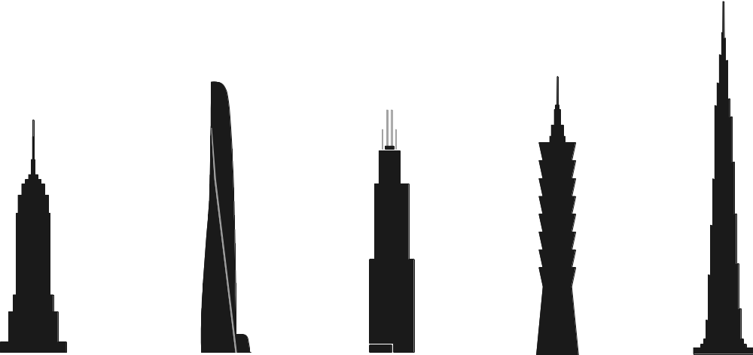
Empire State Building | Shanghai Tower | Willis Tower | Taipei 101 | Burj Khalifa
New York City | Shanghai | Chicago | Taipei | Dubai
7.1 m/s | 20.5 m/s | 8.1 m/s | 16.8 m/s | 10 m/s
53. Which of the following buildings is NOT located in Asia?
(A) The Empire State Building. (B) Taipei 101.
(C) The Shanghai Tower. (D) The Burj Khalifa.
54. Which of the following about the buildings’ elevators is true?
(A) The elevator of Taipei 101 is faster than that of Shanghai Tower.
(B) The elevator of Shanghai Tower is slower than that of the Burj Khalifa.
(C) The Shanghai Tower has the fastest elevator among the five buildings.
(D) The elevator of Taipei 101 is just as fast as that of the Empire State Building.

Last month, I took a trip to Matsu. It is a group of small islands named after Mazu, the goddess of the sea, that lies in the Taiwan Strait*. I started on my journey from Keelung harbor, where I caught the Taima ferry. A few hours later, I set foot on Dongyin, the most eastern of the Matsu islands. Rather than explore on foot, I decided to rent a scooter. This saved a lot of time and allowed me to take in* all the sights quickly. There were beautiful cliffs* and cool caves, as well as the island’s lighthouse.
The next morning, I was on the ferry again and heading for Nangan. Two hours later, I arrived there. Again, I rode a scooter around the island, stopping along the way to view Beihai Tunnel and the Iron Fort*. Then, on the northwest coast, I came upon* a giant statue of Mazu herself, standing over 25 meters high! In just three days, I was able to see the best Matsu had to offer. I definitely recommend coming here!
* the Taiwan Strait 臺灣海峽 * take in 看到 * cliff n. [C] 懸崖 * fort n. [C] 堡壘 * come upon 偶然發現
55. According to the passage, which of the following is NOT true?
(A) The author explored Matsu by ferry and scooter.
(B) Matsu is located in the Taiwan Strait.
(C) The author visited three of the Matsu islands.
(D) The Mazu statue in Nangan is over 25 meters high.
56. Where would the passage most likely be found?
(A) In a math textbook. (B) On a backpacker blog (部落格).
(C) In a food magazine. (D) In a transportation brochure (手冊).

Have you ever wondered who the first person was to propose the idea of handwashing to stop the spread of diseases? The answer is Ignaz Semmelweis, a Hungarian* doctor. When working at the Vienna General Hospital, Semmelweis noticed that compared with the women who were assisted by midwives* during childbirth, the women helped by doctors had a much higher chance to develop childbed fever* after giving birth. Therefore, Semmelweis decided to look into it.
Before long, Semmelweis found a big difference between midwives and doctors. In general, midwives only contacted pregnant women. On the contrary, doctors had to treat different patients and sometimes carried out autopsies*. Therefore, Semmelweis suspected that childbed fever was spread through doctors because they contacted a lot more people than midwives. Semmelweis then started to order the workers in the hospital to wash their hands frequently, especially after autopsies. The practice greatly reduced the rate of childbed fever in the hospital.
In 1861, Semmelweis published a medical book, Etiology, Concept and Prophylaxis of Childbed Fever, trying to tell the medical community about the importance of handwashing. However, many doctors rejected his idea because Semmelweis didn’t have any scientific evidence to explain his findings at a time when scientists had not discovered germs yet. Although Semmelweis continued to call upon people to stress the importance of handwashing, few people paid attention to him. Years later, Semmelweis finally gave up and ended up dying in a mental hospital in 1865.
*Hungarian adj. 匈牙利的 *midwife n. [C] 助產士 *childbed fever 產褥熱 *autopsy n. [C] 驗屍；屍體解剖
57. According to Semmelweis, why did women develop childbed fever after giving birth?
(A) The medical equipment was not sufficient (充足的).
(B) The doctors spread the disease to the women.
(C) Women were usually under a lot of pressure.
(D) The women’s health conditions were bad.
58. Why did many doctors disagree with Semmelweis’ idea of handwashing in the early 1800s?
(A) Many doctors got childbed fever and died.
(B) Many doctors thought Semmelweis was rude.
(C) Semmelweis couldn’t prove his finding in a scientific way.
(D) Semmelweis didn’t know how to debate with others.
59. According to the passage, which of the following statements is true?
(A) Only doctors could deliver babies in the early 1800s.
(B) Most doctors agreed with Semmelweis before he died.
(C) Midwives contacted more patients than doctors in hospitals.
(D) Semmelweis suspected that childbed fever might be spread through touch.

