- 選擇題：請將答案畫記於答案卡。 同時請於卡上畫記班級、座號。
第一部分：看圖辨義(3%) 1~10 每題1分(共10分)
試卷上該題有一張圖片，請聽一個和該題相關的問題，與(A)、(B)、(C)三個英語敘述後，選一個與所看到圖片最相符的答案。
  1. ______ | 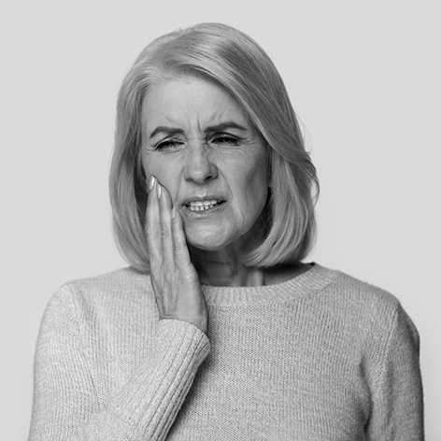  2. _____
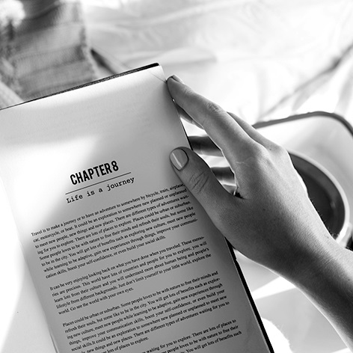
3. _____
第二部分：問答(5%)
每題會播出一個問句或直述句，聽後請由試卷上(A)、(B)、(C)三個選項中，選出一個最適合的回答或回應。
( )4. (A)I don’t believe what he says about it either.
(B)Sure. He knows nothing of significance.
(C)Apparently, he knows everything about it..
( )5. (A)Just leave it over there, please. (B)Don’t worry, we have plenty of time.
(C)Yes, we can stay as long as we want to.
( )6. (A)Yeah, I was really tired at the end. (B)Right. It was quite easy to run.
(C)Yes, because it wasn’t difficult.
( )7. (A)Yeah, the band was great. (B)No, it was a boring movie.
(C)It was delicious, thanks.
( )8. (A)Yeah, people always act peacefully then. (B)Well, I’m not a resident in the morning.
(C)Yes, it’s best to avoid it after it gets dark.

第三部分：簡短對話(2%)
每題會播出一段對話及一個相關的問題，聽後請由試卷上(A)、(B)、(C)三個選項中，選出一個最適合的回答。
( )9. (A)A cloud with a weird shape.
(B)The animals on the hill.
(C)A strange novel.
( )10. (A)Ways to distribute food to children in need.
(B)The solutions to children’s bad behavior at school.
(C)The need to educate children about the food they eat.
I. 單字選擇 10% (每題1分)
( )11 | I am a fan of Lamigo Baseball Team. I have watched its games for seven years and ________ it every time.
 | (A) supply | (B) advise
 | (C) support | (D) adjust
( )12 | The dentist advised the patient to quit drinking coffee and come back to have his teeth cleaned again in six months. (選同義詞)
 | (A) remained | (B) ignored
 | (C) suggested | (D) respected
( )13 | Alice had a weird dream about chasing after a rabbit. (選同義詞)
 | (A) wild | (B) wet
 | (C) straight | (D) strange
( )14 | After a twohour search, Sean eventually found his missing dog and cried with joy. (選同義詞)
 | (A) surprisingly | (B) friendly
 | (C) finally | (D) evenly
( )15 | Unlike me, my boyfriend spends his free time doing indoor ______, such as reading and playing the guitar.
 | (A) solution | (B) activities
 | (C) action | (D) celebrations
( )16 | The government needs to decide how to distribute limited resources (資源) to the  people. (選同義詞)
 | (A) give up (B) give out | (C) turn up (D) turn down
( )17 | Wearing a seat belt _____ the driver from harm in the traffic accident.  (A) provides (B) prevents (C) produces (D) advises
( )18 | Betty worked as a(n) ________ in Mr. Wilson’s office. She helped with the overseas business.
 | (A) alien (B) assistant | (C) accountant (D) apparent
( )19 | More and more people would buy online rather than go to supermarkets  in person.
 | (A) applied (B) apology | (C) apparent (D) groceries
( )20 | The engineer is working hard to find a ____ to the computer virus problem.
 | (A) solution (B) support | (C) sponsor (D) secretary
II克漏字選擇20%(每題2分)
For a better living environment, many famous people like Kevin Durant and Jamie Oliver have stood up to fight food waste. They try to 21 use of ugly food. For example, Kevin Durant, a basketball player, 22 food seriously and has invested money in a company that sells imperfect fruits and vegetables. Then, Jamie Oliver 23 is a wellknown chef, has promoted food saving. He encourages supermarkets 24 oddshaped vegetables and tells people about the value of food. In short, everyone should understand the importance of food even though it may look 25 .
( B ) 21. (A) put (B) make (C) get (D) take
( B ) 22. (A) take (B) takes (C) taking (D) to take
( C ) 23. (A) who (B) whom (C) , who (D) , whom
( D ) 24. (A) sell (B) sold (C) selling (D) to sell
( A ) 25. (A) strange (B) strangely (C) to be strange (D) strangeness
Have you heard of an old saying, “Don’t judge a book by its cover”? It means people can never know 26 a book is good or not simply by its outside. It is usually used when people express 27 someone should not judge others by their appearances. 28 , it is also true when it comes to food. Oddshaped vegetables and fruits are good for human bodies as common or beautiful ones. However, many studies point out that a lot of farm products are left and not sold 29 their imperfection. Humans should be encouraged 30 all the food in the world seriously and avoid wasting.
( A ) 26 (A) whether (B) which (C) why (D) how
( C ) 27. (A) whom (B) what (C) that (D) how
( C ) 28. (A) In total (B) After all (C) In fact (D) As for
( D ) 29. (A) when (B) instead of (C) since (D) because of
( D ) 30. (A) take (B) taken (C) taking (D) to take
III. 文法選擇 20% (每題2分)
( )31 | The 2020’s winner ________ ate 100 dumplings in 20 minutes, is Rebecca.
 | (A) which |  |  | (B) ,whom
 | (C) ,who |  |  | (D) that
( )32 | a fight, the two friends no longer talk to each other.
 | (A) Because |  | (B) Instead
 | (C) Because of |  | (D) Instead of
( )33 | Mark Zuckerberg created the social networking site Facebook, has been worldfamous since then.
 | (A) which | (B) ,which |  | (C) who | (D) , who
( )34 | I couldn't surf the Internet at that time there was no WiFi in that area.
 | (A) as a result | (B) as a result of |  | (C) because | (D) because of
( )35 | The professor(教授) took a deep breath before ________ his speech.
 | (A) started | (B) starting |  | (C) to start | (D) to starting
( )36 | Sophia took a day off she had a terrible stomachache.
 | (A) unless | (B) though |  | (C) if | (D) because
( )37 | The motorcycle seems out of control. I have to get it repaired.
 | (A) to be (B) that is |  |  | (C) being (D) is
( )38 | My high school teachers not only encouraged me to develop good habits but also ___ me about the value of life.
 | (A) education (B) educates |  |  | (C) educated (D) educating
( )39 | The café not only _____ tasty coffee but also provides a relaxing place.
 | (A) sold | (B) sell |  | (C) selling | (D) sells
( )40 | Because of _______, the school had to cancel the field trip(校外教學)
 | (A) the typhoon came  (C) it rained heavily |  |  | (B) the strong typhoon  (D) the earthquake occurred

IV. 對話選擇 10% (每題2分)
( )41. A: I have only one meal a day but haven’t lost a pound.
B: How come? What do you usually eat for the meal?
A: The Big Mac set from McDonald’s.
B: ________
(A) I’m also on a diet.
(B) That sounds amazing.
(C) I think changing diet habit is important for me.
(D) It might be better for you to order other things like salad.

( )42. A: There’s a big sale at the bakery, so I bought 3 birthday cakes home.
B: We cannot finish them in a week. ________
A: It would be a good idea to hold a party and invite our friends and neighbors.
(A) What’s wrong with us? (B) What should we do?
(C) Can you forgive me? (D) May I help you?

( )43. Fay: I’ll have an interview with Google next Monday. I’m so nervous. ________
Gloria: No worries. If I were you, I would do some studies on Google now.
(A) What’s wrong? (B) Can you forgive me?
(C) How does it work? (D) Do you have any advice for me?

( )44. Britney: I'm so worried about the coming test.
Maria: We will have a discussion this Saturday.
Britney: May I? That'll be wonderful!
Maria: You are very welcome.
(A) Why are you so negative about it?
(B) How about joining our study group?
(C) When did you prepare for the test?
(D) What do you think about the questions?
( )45. Bruce: I can’t eat anymore! Would you please help me with this?
Max: What? 20 donuts and a large cup of milk tea? ________
Bruce: Well, I just want to try every flavors.
(A) You shouldn’t have ordered so many. (B) Don’t let it get you down.
(C) I advise you to share them. (D) Everything will be fine.

- 非選擇題 (請作答於右邊空白答題欄)
A. 文義字彙 10% (請注意名詞複數變化；每題2分)
1. T h questions in the test made only 5% students in the class pass.

2. My company is planning to i t eight million dollars in building a shopping mall.

3. What we t re and value in life can influence our attitude and behavior.
4. People are often curious about personal lives of c ties.
5. Using smartphones too often has been an i ue under discussion.

B. 填空式翻譯16 % (請注意動詞變化；每格2分)
1. 搬去臺北前，Martin把舊傢俱送給需要的人。
Before moving to Taipei, Martin gave his old furniture to people i in n need .

2. 梅根決定丟掉她的舊沙發，買一張新的。
Megan decided to t______ her old sofa a______ and buy a new one.

3. 我決定不參加旅遊了。畢竟我已經去過那邊兩次了。
I decided not to join the trip. A After a all , I have been there twice.

4. 希望在新的一年我能更善用我的時間。
I hope I can m make better u use of my time in the new year.

請務必填寫考卷右上角的班級、姓名、座號，未寫扣5分。
A. 文義字彙 10% (請注意名詞複數變化；每題2分)
1 | __________________ | 2 | __________________
3 | __________________ | 4 | __________________
5 | __________________

B. 填空式翻譯 16% (請注意動詞變化與大小寫；每格2分；每格只填一個單字)
1
2
3
4

C. 單字片語選填(選出最符合句意的單字或片語，並填入代號) 每題1分，4%
(A) found out | (B) fight against
(C) deal with | (D) caught attention

( )1. The prices of some bags of fruit and vegetables ________my _____.
( )2. It was very difficult for Vincent to _____ these bad-looking food.
( )3. Getting vaccinated(注射疫苗) is going to help us ____ the Covid 19 virus.
( )4. During my search, I _____ that many students go to bed late.

