- Listening Comprehension 10%
一 請聽一個和該題相關的問題，選一個與所看到圖片最相符的答案。
1. 2.
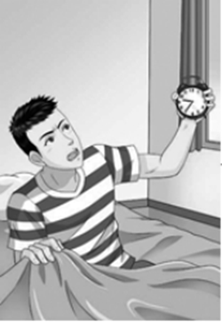 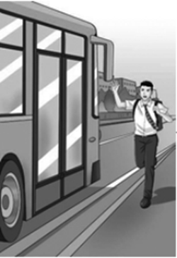
二 每題會播出一個問句或直述句，聽後請由試卷上選出一個最適合的回答或回應。
3. (A) She is recovering from surgery. (B) She’s having a great day. (C) She’ll be out soon.
4. (A) Yes, you can see it from the window. (B) You can reach the park in five minutes.
(C) Sorry about the problem with your room.
5. (A) I am going to go straight to sleep. (B) I should be home around 10 o’clock.
(C) I will wake up on time tomorrow.
6. (A) I think it was Sony. (B) Yes, it was my friend Nick. (C) I’m not sure why they created it.
三 每題會播出一段對話及一個相關的問題，聽後請由試卷上選出一個最適合的回答。
- (A) The man needs to exercise more. (B) The man needs to change his diet.
(C) The man doesn’t need to change anything.
- (A) She is sick. (B) Her room is too cold. (C) Her medicine isn’t strong enough.
四 每題有三個圖片選項。請聽題目，並選出一個最適當的圖片。
9.
(A) 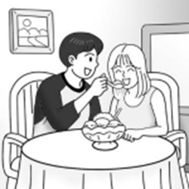 (B) 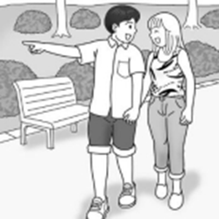 (C) 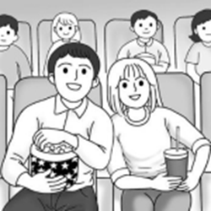
10.
(A) 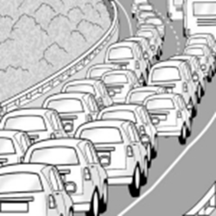 (B) 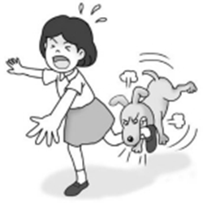 (C) 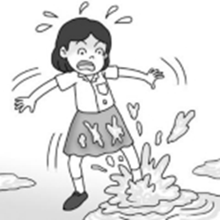
II. Grammar 30%
- You don’t need to listen to their suggestions _____ they didn’t pay attention to what you said.
(A) when (B) although (C) before (D) since
12. At seven o’clock tomorrow, we _____ football game on TV.
(A) are watching (B) will watching (C)were watching (D) will be watching
13. Selina can speak three languages. _____ is French, _____ is English, and _____ is German.
(A) One / the other / another (B) One / another / the other
(C) One / other / the other (D) One / one / the other
14. Chloe _____ with her friend on the phone when her mother called her.
(A) was chatting (B) chatted (C) is chatting (D) chats
15. Kelly cries day after day because her dog had an accident and _____ two months ago.
(A) passed away (B) turned down (C) turned around (D) passed by
16. In 20 minutes, the plane _____; we will see grandpa soon.
(A) was landing (B) will be landing (C) is landing (D) lands
17. My cellphone _____ by Rita’s father because he is a skillful engineer.
(A) fixed (B) was fixing (C) was fixed (D) is fixing
18. Albert communicates with others _____ a gentle way. He is really a nice man.
(A) with (B) for (C) on (D) in
19. Nelson _____ from a terrible accident and _____ from the injury 3 months later.
(A) returned / suffered (B) recovered / returned
(C) suffered / recovered (D) removed / recovered
20. Careful preparation _____ for the coming rainy season.
(A) should make (B) should be made (C) should be making (D) should made

21. Let’s go directly to Derrick’s birthday party. It is said that his party is awesome.
(A) straight / amazing (B) fast / shocked (C) quietly / colorful (D) fast / amazing
22. The report shows _____ teenagers spend more time _____ their cellphones.
(A) that / to use (B) that / using (C) this / to use (D) this / using
23. A hunter ______ Little Red Riding Hood from the wolf.
(A) will be saved (B) is saved (C) saved (D) was saved
24. Kenny ______ a giraffe on the cover of his biology book at ten this morning.
(A) draws (B) is drawing (C) was drawing (D) will be drawing
25. Listen! Somebody _____ in the restroom. Let’s see what happened.
(A) crying (B) was crying (C) is crying (D) cries
III. Cloze 14 %
Two amazing alarms, Tocky and Ramos, ___(26)___ for the heavy sleepers who often _(27)_ the snooze button to sleep more. Tocky is a ball-shaped alarm. It will jump off the table, run around everywhere and ___(28)___ lots of noise if you try to go back to sleep. However, Ramos works differently. When Ramos ___(29)___, you need to hold your smartphone near the Bluetooth beacon ___(30)___ the alarm far from your bed. Or you can _(31)_ a code and enter the number to stop the alarm. But if you have an ___(32)___ way to wake up on time, you can design your own alarm.

26. (A) was invented (B) invented (C) were inventing (D) were invented
27. (A) put (B) place (C) hit (D) chase
28. (A) make (B) do (C) makes (D) does
29. (A) gets on (B) goes off (C) gets out of (D) go on
30. (A) to stop (B) stopping (C) stopped (D) stop
31. (A) write (B) reply (C) set (D) assign
32. (A) even better (B) much good (C) even good (D) much well

IV. Dialogue 10%
33. Miss Chang: What’s that annoying noise?
Betty: Sorry, Miss Chang, it’s from my phone. ____________
Miss Chang: Please remember to put it on silent mode before our class starts.
Betty: I will. I’m sorry.
(A) You are welcome. (B) It’s not my fault.
(C) My bad. (D) I can’t believe my ears.
- Leslie: What took you so long? I’ve been waiting for 40 minutes! The movie is half over!
Will: ____________ My boss called me in to his office when I was about to leave.
Leslie: Well then, apology accepted. But you still have to make it up to me.
Will: Sure thing.
(A) I will make it happen. (B) I didn’t do it wrong.
(C) I owe you an apology. (D) I can’t wait to tell you about it.
- Will: Oh my, it’s raining now!
Kate: Did you bring an umbrella with you?
Will: No, I forgot. What can we do?
Kate: I don’t have one, either. ____________
Will: You are probably right. Let’s hope it will stop soon.
(A) We’d better stay here and wait. (B) Why don’t you just have some fun?
(C) I know the best umbrella-makers in the town. (D) Easy come, easy go.
- Miss Simpson: Have you had any question about lesson 4?
Students: __________.
Miss Simpson: Good and then we keep on next lesson.
- That’s all right (B) So far, so good (C) You can make it (D) Pig might fly
- Willy: I can’t sleep well. And this situation has kept several days.
Lucus: Why? Is it because of your new job?
Willy: I have no idea. And I eat a lot for breakfast but don’t feel hungry for the rest of the day.
Lucus: __________.
(A) You’d better keep it up (B) It seems that you need a check-up to find out
(C) Don’t be so childish (D) I suggest that you eat some late-night snacks.

V. Reading 6%
Can you delete yourself from the Internet? The short answer is: it depends, but probably not. Deleting your personal information from the Internet is not simple. According to cyber security experts, organizations like commercial businesses are tracking and collecting data about you - things like your credit history, shopping habits and your Internet browsing history.
Even the act of deleting a picture that you posted online is not simple. If you post a picture and then later decide to delete it, the odds are that that picture will have been downloaded and reposted somewhere else at the same time. You would then have to write a letter to different service providers to explain the situation in order to get it removed.
What do you do when you want to find out personal information about someone? You Google them. Google actually tells you what kind of personal information can be removed. Information like your social security number, bank account numbers and medical records can be deleted upon request. However, your date of birth, previous address and telephone numbers are among the things that Google will not agree to take down.
There is no centralized service that allows you to remove all of your information with a single request. Information is power, and some people are concerned that we are giving too much of our power away. A good way is not to put anything online if you don’t want them to be there forever.

- Which is the main idea of the passage?
- Erasing your personal data from the Internet can be difficult.
- Anything you post on the Internet can be deleted.
- We are giving up far too much personal information.
- Your data is tracked for advertising purposes.
- Why might it be difficult to totally delete a picture from the Internet?
- It may have been used on another website or platform.
- Most websites and social media platforms don’t allow you to delete pitcure.
- There is no such function on the net.
- We don’t know why.
- Which of the following is discussed in the passage?
(A) Commercial businesses track your location.
(B) Google allows you to delete certain information.
(C) Your personal information is sold to other companies.
(D) You can’t delete your any information on the Internet.

VI. Vocabulary 20%
- After everybody reads Derek’s poems, he is considered a child with i________n.
- Henry drew his dream car to his parents because he couldn’t find the words to d________e it.
- These friends kept their p________es to support each other for the rest of their lives
- The restaurant offers r________r size and extra-large size for guests to choose from.
- Some reports show, by playing with Lego bricks, children are able to become better at
c________e thinking.
- To solve the serious parking problems in Taipei, the local government has to think of a better
s________n.
- Our English teachers usually e_______e us to talk with foreigners to strengthen speaking skill.
- Leon has a rare brain d________e and now he is having a surgery in the hospital.
- When we e________r a difficult problem, we have to calm down first and search for a way to
deal with it.
- This famous fan is actually hard to use because of its poor d________n. I don’t why they
were sold out.

VII. Translation 10%
1. 假如計畫要住這個超夯的飯店, 你們最好四個禮拜前先預約好.
You’d better make a reservation four weeks __(1)__ __(2)__ if you plan to stay at this popular hotel.
2. 李老師詳盡地解釋這些物理題給那群困惑的學生聽
Ms.Li explained these physics questions __(3)__ __(4)__ to those confused students.
3. 如果你沒有採取一些行動在期限前交出作業, 老師會給你一些處罰
If you don’t __(5)__ some __(6)__ to hand in the assignment before deadline, the teacher
will give you some punishment.
4. Fiona根本不在乎那些人怎麼想; 所以,她撇過頭把門甩上
Fiona didn’t care what those people think at all; therefore, she __(7)__ __(8)__ and slammed the door.
5. 盡人事, 聽天命
Let God do the rest, and you __(9)__ your __(10)__.

