請將答案劃記在電腦答案卡上(否則不予計分), 共20題; 並劃上座號，劃記不清者或未畫座號者酌扣總分5分!
一、 素養題

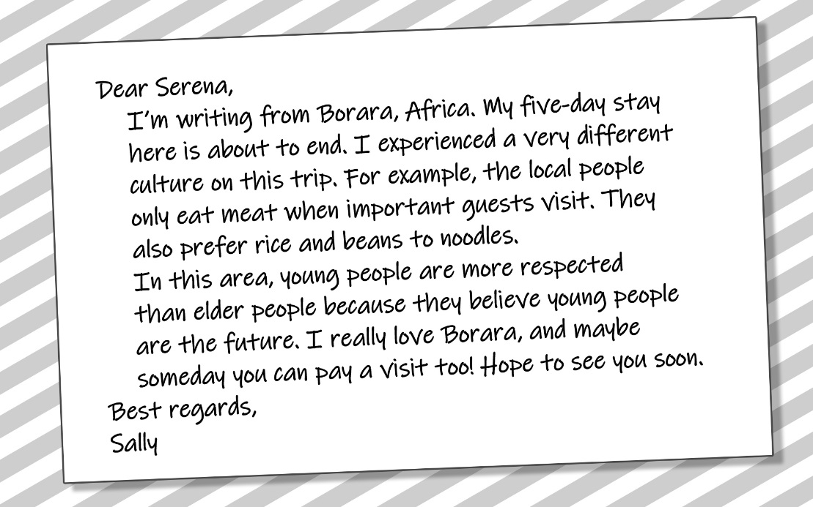

（ ）1. Where does this passage most likely appear? (A) In a diary.
(B) In a thank-you letter. (C) On a postcard. (D) In a travel book.
（ ）2. According to the passage, which of the following statements is true?
(A) People in Borara like noodles more than rice. (B) The locals in Borara respect old people more than young people. (C) Beans are difficult to find in Borara (D) Meat is usually served when important people visit.
（ ）3. Where is this sign most likely to be seen?
(A) At a park. (B) In a library. (C) At a theater. (D) In a restaurant.
（ ）4. What can we infer (推斷) from the sign?
(A) People in 1982 seldom talked face-to-face. (B) Everyone has to shut up and eat in Audrey & Will’s. (C) It would be terrible to live without Wi-fi. (D) Using cell phones all the time may upset someone.

（ ）5. What kind of event is the poster probably advertising (廣告)?
(A) A dance club party. (B) A store opening. (C) A book signing. (D) A pop-shop fair.
（ ）6. According to the poster, which of the following is true?
(A) There will be two speakers. (B) The event lasts for one hour.
(C) The event will be held in a gym. (D) The event is free.
二、閱讀測驗
- Hannah Montana is a movie about an ordinary teenager with a special secret, one that she is trying her best to hide from others. Apart from a few people, no one knows that the normal-looking Miley is actually the famous teen singer Hannah Montana. This double life can cause Miley to make mistakes; however, she is brave, smart, and also good-hearted.
Sometimes, Miley has to make courageous choices. For example, when she is late for her best friend’s birthday party and does not have time to change into an ordinary-looking teenager, she goes to the party as Hannah Montana. Unfortunately, the party turns into a big failure; everyone is more excited about seeing a great celebrity and forgets about making her friend happy. Nonetheless, we can still admire Miley for putting herself at risk for her friend.
Another reason for liking Miley is that she is smart. Her father takes her to live in her hometown of Crowley Corners, a very rural and simple town. One morning, Miley has to get some fresh eggs for breakfast, but she encounters a problem－the hens do not want to give her their eggs. Miley thinks up a clever idea. She sings and dances to distract the hens. It works, but in her excitement, she breaks almost all the eggs she has collected. Once again, she fails, but there is no doubt about how creative she is.
Perhaps the most important reason to like Miley is that she has a very good heart. She wants to help her friends and family, and in the process of doing this she would feel sorry when something goes wrong. Particularly, she does not want to lie to Travis, a boy who likes her very much. He does not know she is a great singer, so she feels upset in her heart about not letting him know.
There is a lot to see in Hannah Montana, but viewers will definitely enjoy the main
character in the movie. She is very humorous, courageous, and kind.
（ ）7. Who is Hannah Montana?
(A) A working mother. (B) A school teacher.
(C) A teen celebrity. (D) A movie director.
（ ）8. What happens at the friend’s birthday party?
(A) The birthday is canceled because of a sudden power failure.
(B) Everybody pays more attention to Miley than to her friend.
(C) Miley comes to the party as a normal-looking teenager.
(D) Her friend, the birthday girl, does not come to the party.
（ ）9. Based on the ideas of paragraph 3, where might Miley be?
(A) A singing contest. (B) A rural school.
(C) A city breakfast store. (D) A small farm.
（ ）10. Based on the passage, what kind of movie is Hannah Montana?
(A) Teen techno-thriller. (B) Teen sports-action.
(C) Teen comedy-drama. (D) Teen science-fiction.
（ ）11. Which of the following is NOT mentioned about Miley in the passage?
(A) She fails to collect all the eggs for breakfast.
(B) She is not as ordinary as many people think.
(C) She breaks up with Travis and has a broken heart.
(D) She cares much about her friends and family.

- Changdong is in the north of Seoul in South Korea. Only a few hundred thousand people live there, and it has few facilities. It is not as wealthy as many other places in Seoul, but after 2021, it will be one of the most exciting places to visit. The reason for this is Korean popular music, which everybody knows as K-pop－the South Korean government wants Changdong to become the K-pop capital of the world.
South Korea knows that K-pop is very important. In 2015, South Korea made $ 5 billion from selling K-pop music and related TV shows, films, games, and so on. Furthermore, because of K-pop, other Korean products like Samsung smartphones, Korean-made cars, and Korean-style clothes have become very popular.
K-pop is very global today. For a long time, it has been very popular in China, Japan,Taiwan, and Hong Kong. However, Billboard magazine found a different trend between 2013 and 2016. During this time, the United States was the third biggest buyer of K-pop music. Thus, it can be said that K-pop has a lot of fans in the West today.
To attract fans from around the world, there are big plans for Changdong. It will have concert halls, music schools, recording studios, art galleries, and a K-pop museum. The place that will be the most important venue, however, is the huge arena. About 20,000 fans will be able to enjoy K-pop events there. Since it is a very big and important project, the arena, which won’t be completed until 2021, is already being built. When everything is finished, Changdong will be a very exciting place to visit. For K-pop fans, it will be the coolest place on earth!
（ ）12. Where is Changdong?
(A) In the north of Seoul. (B) In the east of Seoul.
(C) In the south of Seoul. (D) In the west of Seoul.
（ ）13. What does the South Korean government want to do to Changdong?
(A) They want to reduce the number of visitors going there.
(B) They want to change it into the K-pop capital of the world.
(C) They want only a few hundred thousand people to live there.
(D) They want to protect its beautiful natural environment.

（ ）14. What can be inferred from the passage about other Korean products?
(A) People bought more of them. (B) They were seen less often on TV.
(C) They became cheaper and smaller. (D) People got disinterested in them.
（ ）15. What happened between 2013 and 2016?
(A) Billboard magazine was eventually founded in America by then.
(B) Asian people tended to buy less K-pop than American people.
(C) A lot of passionate fans traveled to America to spread K-pop.
(D) K-pop unexpectedly gained a larger customer base in America.
（ ）16. Which of the following is NOT mentioned in the passage about the facilities?
(A) 20,000 people will attend the opening of the arena.
(B) The facilities will include some venues for education.
(C) The main facility will take some time to build.
(D) Fans that visit Changdong will feel excited because of them.

(3) In 2017, when she became a citizen, a robot named Sophia attracted worldwide attention to her human-like look and manners. Sophia is one model of a new invention known as social robots, a smart machine created to interact and work closely with people in different areas.
The service industry is among the first users of social robots. In 2020, friendly robots will assist human volunteers in hotels and at tourist attractions during the Tokyo Olympic Games. Social robots are also tested out in Japan to care for the elderly in nursing homes. There, gentle robot caregivers help to serve food and entertain lonely residents. Still another type of social robots does all the housework. As their prices fall, these hardworking housekeepers may become a common home appliance. Researchers even tried out robot teachers at elementary schools to engage students in learning, or to patiently help children with communication difficulties learn social skills.
However, not everyone welcomes social robots with open arms. Some people are afraid that human partners may be disappointed when robots do not behave exactly
like humans. Others are not sure if children learning from robots will be able to handle surprises in real-world communication. These and many other questions are being asked, but researchers will not stop efforts to develop effective social robots.
（ ）17. What is the best title for this passage?
(A) Making Robots at Low Costs (B) Living Side by Side with Robots
(C) Humans Learning from Robots (D) Giving Robots Rights of Citizens
（ ）18. What does the phrase “with open arms” in paragraph 3 mean?
(A) showing disagreement (B) having protection
(C) showing pleasure (D) having doubts
（ ）19 According to the passage, which of the following is a problem with the use of robots?
(A) They are not able to show every human ability.
(B) They do not punish students who are slow.
(C) They are not able to work when no one is home.
(D) They do not give tourists the right information.
（ ）20. According to the passage, which of the following is true?
(A) The debate about robots prevents the development of robots.
(B) Only robots will welcome tourists in the 2020 Olympics.
(C) Children learning from robots do not make mistakes.
(D) Robot caregivers try to make the elderly happy.

Experience is the extract of suffering.
經驗是由痛苦中粹取出來的

