市立新北高工 110 學年度 第二學期 高二英文閱讀 |  |  |  |  |  |  |  |  |  |  |  |  | 班級 |  |  |  |  | 座號 |  |  | 成  績
科目 | 英文閱讀 |  | 審題教師 |  | 張哲瑋 |  | 2年級 |  | 出題老師 |  | 林筱雯 |  |  |  |  | 姓名 |  |  |  |  | 成  績
(1)  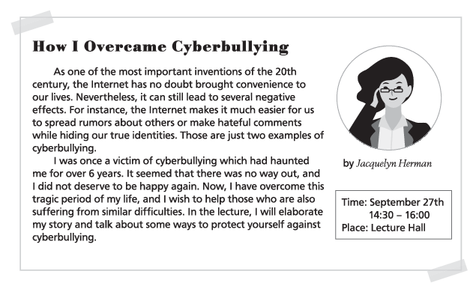  overcome 克服；戰勝 haunt 困擾；糾纏 lecture 演講 elaborate 詳盡闡述  ( ) 1. What kind of activity is the poster promoting?  (A) A concert. (B) A party. (C) A ball game. (D) A speech.  ( ) 2. Based on the poster, which of the following will be mentioned in the lecture?  (A) Rumors about Jacquelyn Herman and her true identity.  (B) Jacquelyn Herman's personal experiences.  (C) Famous inventions during the 20th century.  (D) Jacquelyn Herman's entire tragic life.  (2) Actress and singer Selena Gomez found fame at a very young age. So, she knows better than most what terrible effects bullying can have on one's selfesteem.  She is one of the mostfollowed people on Instagram, with nearly 100 million followers. Thus, she receives a lot of praise online, but she also experiences more than her fair share of negativity.  Responding to every mean comment is obviously impossible. In the interviews, she said she deleted her social media apps at least once a week in frustration. But rather than go to such |  |  |  |  |  |  |  |  |  |  |  |  | extremes, she encourages others to simply set limits on how much time they spend on social media. She herself takes regular social media breaks, which she announces ahead of time. “Limit your screen time,” she said, “and you take power away from the cyberbullies.” It is a simple solution, but one that really works. (self-esteem 自尊)  ( ) 3. What is this passage mostly about?  (A) Selena Gomez's dance battles. (B) Selena Gomez's road to success.  (C) Selena Gomez's fight against cyberbullies. (D) Selena Gomez as a bully.  ( ) 4. According to the passage, what is NOT true about Selena Gomez?  (A) She has a lot of followers on Instagram  (B) She knows terrible effects can be caused by bullying.  (C) She sometimes stays away from her social media apps.  (D) She did not become famous until she was 25 years old..  ( ) 5. According to the passage, what would Selena Gomez suggest to people?  (A) They should not spend too much time on social media.  (B) They should watch her interviews regularly.  (C) They should take both praise and criticism.  (D) They should remove their social media apps from their smartphones at least once a week.  . (3) I am so tired that I want to sleep for a week! Then I want to go back to Taitung. It would be worth the trip just for the bento at the Chishang Riceball Museum. It was so delicious! Our visit was during the hot air balloon festival, and it was amazing to see various balloons in the air. Thankfully, we could not go up in the balloons—I was a bit scared of heights. I especially loved the walkway at Seashore Park which was so shady and cool. My favorite part of the trip was having dinner in Sinasera 24 restaurant. The food was incredible, and we were very lucky to meet the chef, Nick Yang. Although being only thirty, he is so famous and talented. I hope I can visit Taitung again soon. (bento 便當 walkway 人行通道 shady 陰涼的；多陰的)  ( ) 6. What does this passage mainly talk about?  (A) Nick Yang, a famous chef in Taitung. (B) A trip to Taitung.  (C) Methods of beating the fear of heights. (D) Having bentos at a museum. 共3頁第1頁
市立新北高工 110學年度 第二學期 高二英文閱讀 |  |  |  |  |  |  |  |  |  |  |  |  | 班級 |  |  |  |  | 座號 |  |  | 成  績
科目 | 英文閱讀 |  | 審題教師 |  | 張哲瑋 |  | 2年級 |  | 出題老師 |  | 林筱雯 |  |  |  |  | 姓名 |  |  |  |  | 成  績
( ) 7. Why was the author glad that she could not go up in the balloons?  (A) The author could not wait to go to Sinasera 24 restaurant.  (B) The author was too tired to give it a try.  (C) The author was afraid of heights.  (D) The author wanted to visit the Chishang Riceball Museum.  ( ) 8. Which of the following places is NOT mentioned during the author's trip to Taitung?  (A) Seashore Park. (B) Taitung Forest Park.  (C) Sinasera 24 restaurant. (D) The Chishang Riceball Museum.  (4) Mr. Chen and his family plan to spend their summer abroad. They browse travel websites frequently and learn a lot about Michelin restaurants.  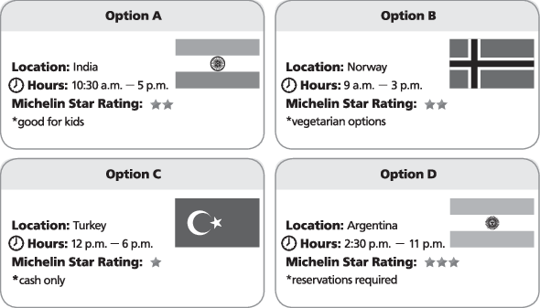  browse 瀏覽 vegetarian 素食的；素食者  ( ) 9. If Mr. Chen prefers to have dinner at 7:30 p.m., which restaurant would be his best choice? (A) Option A. (B) Option B. (C) Option C. (D) Option D.  ( ) 10. Which restaurant should they go to if they want to make sure that Mrs. Chen, who is a  vegetarian, can have vegetarian dishes? (A) Option A.(B) Option B.(C) Option C.(D) Option D. |  |  |  |  |  |  |  |  |  |  |  |  | (5) Unfortunately, many teenagers experience cyberbullying. For example, bullies try to amuse others with comments about someone's post or picture. However, these “jokes” are meant to hurt the person and make everyone laugh at him or her. To protect themselves, teenagers can do a number of things, including the following.  First, they can send bullies direct messages explaining why their comments are harming them. If bullies continue, they will be blocked. Also, most social networking sites allow users to choose a list of “close friends,” who can view their posts and make comments. In addition, if teenagers are upset, they can seek emotional support from someone they trust. Finally, bullies can be reported to the police who can take official action against them.  It is not easy to deal with cyberbullying, yet teenagers should realize that effective action is possible and that they can make a difference by being fearless.  ( )11. Which of the following is the best title for this passage?  (A) The Definition of Cyberbullying (B) Effective Ways of Cyberbullying  (C) Protection from Cyberbullying (D) A New Method of Cyberbullying  ( )12. What are bullies’ jokes meant to do?  (A) To protect victims. (B) To harm people.  (C) To make fun of bullies themselves. (D) To make friends with people.  ( )13. What does the word “fearless” mean in the last sentence?  (A) very frightened (B) extremely scary (C) not afraid (D) not brave  ( )14. Which of the following is NOT mentioned as a protection from cyberbullying?  (A) Blocking bullies.  (B) Sending bullies direct messages to tell them not to do it again.  (C) Asking bullies out and fighting back.  (D) Seeking emotional support from someone we trust  ( )15. Which of the following can be inferred from the passage?  (A) It's not easy to fight against cyberbullying, but we can still take action.  (B) We had better hide ourselves when being bullied.  (C) We had better quit every social networking site.  (D) There is nothing we can do with cyberbullying.  32. 文中提到可以搭渡輪，可見需經由水路到達。  共3頁第2頁
市立新北高工 110學年度 第二學期 高二英文閱讀 |  |  |  |  |  |  |  |  |  |  |  |  | 班級 |  |  |  |  | 座號 |  |  | 成  績
英文閱讀 |  | 審題教師 |  | 張哲瑋 |  | 2年級 |  | 出題老師 |  | 林筱雯 |  |  |  |  | 姓名 |  |  |  |  |  | 成  績
(6) When he was still a child, BoWei Yang became fascinated by cooking after seeing a Japanese cooking show on TV. From that moment on, he devoted himself to becoming an international chef. He studied cooking in high school and worked part time in hotels and restaurants to gain experience. After college, BoWei went to France, where he began his training at a restaurant. His talent and hard work brought him success as a chef and then as a manager at a top quality, Michelin 3star restaurant.  Having achieved his goal, BoWei decided to return to Taiwan. He wanted to create special cuisine with both his skills and Taiwanese ingredients. He became the chef of a hotel's French restaurant in Taitung, creating unique dishes by using local ingredients. Therefore, BoWei Yang lived his dream and brought it home. His story demonstrates that if people follow their passions with diligence, they can accomplish their goals eventually.  (*fascinated 著迷的Michelin 米其林cuisine 料理accomplish 完成  ( )16. What is the passage mainly about?  (A) The story of a cook working hard to pursue dreams.  (B) The importance of going to France for cooking skills.  (C) The right way to choose a useful cooking show.  (D) The recipe of adding Taiwanese ingredients to cooking.  ( )17. How did Yang get attracted to cooking in the first place?  (A) After working in hotels and restaurants. (B) After seeing Japanese cooking show on TV.  (C) After his training in France. (D) After his success as a chef  ( )18.Which of the following about Yang is NOT true according to the passage?  (A) He received his training at a restaurant in France. (B) He has never been to a cooking school.  (C) He is very diligent in pursing his dreams. (D) His skills help him in a Michelin 3star restaurant.  ( )19. What's the most special thing in Yang's cuisine?  (A) Full of amazing stories. (B) Using Taiwanese ingredients.  (C) Trying many cooking skills. (D) Applying Japanese cooking techniques.  ( )20. What does the word “demonstrate” mean in the last sentence?  (A) proves (B) challenges (C) doubts (D) denies |  |  |  |  |  |  |  |  |  |  |  |  | (7) In 1889, the Michelin brothers began their business making car tires in France. To promote the sales of their tires and cars, they came up with a brilliant idea, which is the “Michelin Guide.” This travel brochure was first printed in 1900 and was given free. The contents of the guide include maps, restaurants, car repair tips, gas stations, and rest places, which aim to help drivers find good places to go in France. It is not until 1920 that people need to pay for the Michelin Guide because it became so popular. Moreover, the star system of the guide first appeared in 1926, with secret reviewers scoring the restaurants while eating like a normal customer. From one star to three stars, more stars means the restaurant is more worthwhile for people to visit. Today, the Michelin Guide has become a world-famous index, covering cuisines from 34 countries around the world.  *brochure手冊worthwhile值得花時間的index指標  ( ) 21. What is the passage mainly about?  (A) Who began to publish the Michelin Guide.  (B) What Michelin brothers did to repair tires.  (C) Where Michelin restaurants are.  (D) How the Michelin Guide became famous.  ( ) 22. Why did they come up with the “Michelin Guide?”  (A) to promote the sales of their tires and cars (B) to promote good restaurants in France  (C) to allow secret reviewers to score the restaurants (D) to make money by printing the guide  ( ) 23. Which of the following is NOT included in the Michelin Guide?  (A) Maps. (B) Car prices. (C) Gas stations. (D) Rest places.  ( ) 24. According to the passage, which of the following statements is true?  (A) The first Michelin Guide is a brochure for car repairing.  (B) Michelin brothers began their business with a small café.  (C) The Michelin Guide is no longer free to get after 1920.  (D) The aim of the Michelin Guide is to help drivers to find good places to go in German.  ( ) 25. According to the star system, which of the restaurants is worth visiting the most?  (A) A restaurant with one star. (B) A restaurant with no star.  (C) A restaurant with two stars. (D) A restaurant with three stars.  共3頁第3頁

