- Listening Comprehension 10 %
- 看圖辨義 請聽一個和該題相關的問題，選一個與所看到圖片最相符的答案。
1. 2.
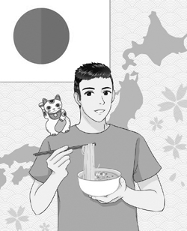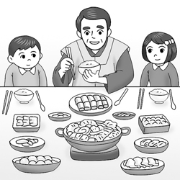

二、問答 每題播出一個問句或直述句，聽後請由試卷上選出一個最適合的回答。

3. (A) A popular new Thai restaurant. (B) Yes, this is a local restaurant.
(C) Because everyone loves this restaurant.
- (A) My parents bought all these things (B) We moved to a new house.
(C) Thanks to my brother’s help.
- (A) I’ll bring you one right away (B) I don’t know how to use chopsticks.
(C) That one is for eating dessert.
- (A) I would be honored. (B) I don’t have much of an appetite.
(C) It’s the custom in my country.

三、簡短對話 每題會播出一段對話及一個相關的問題，聽後請選出一個最適合回答。

- (A) Wash the dishes. (B) Wash his hands. (C) Eat the food.
- (A) It cracked the floor. (B) It burned the mother. (C) It fell onto Layla’s clothes.
四、短文聽解 每題有三個圖片選項。請聽題目，並選出一個最適當的圖片。
- (A) 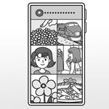 (B) 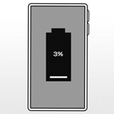 (C) 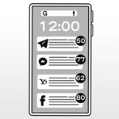.
- (A) 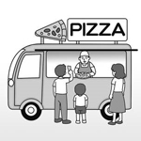 (B) 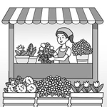 (C)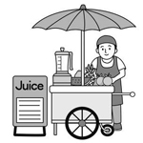
- Multiple Choice 30 %
- The policeman didn’t know __________ the child lived and __________ he got lost although
he tried to help him.
(A) which / when (B) where / which (C) how / what (D) where / how
12. I’ve found that you always look sleepy in class. I would like to know __________ at home.
(A) what do you use your time (B) how do you use your time
(C) how you use your time (D) what you use your time
13. The East Coast ＿＿＿＿ among the three places if Chloe’s family sets out from Yilan City.
(A) is nearer (B) is the nearest (C) are much nearest (D) are the nearest
14. London is a very busy city. It is ________ city in the UK, and it is sometimes ________ to
travel by the subway than by bus.
(A) the largest / faster (B) larger / faster
(C) the largest / the fastest (D) larger / the fastest
15. Ausome 3.0 has a storage capacity of 256GB, _______ IQ 200 has a storage capacity of 1 TB.
(A) so (B) which (C) what (D) while
16. I couldn’t call anyone in California for help because I have _________ friends in America.
(A) little (B) a little (C) few (D) a few
17. Sally is always excited to share how she practices her speaking ability when it comes to
________ Germany, and she is also ________ student in my class.
(A) learn / more popular (B) learning / the most popular
(C) learning / more popular (D) learn / the most popular
18. The firefighters were honored for saving the old woman from the burning house.
(A) accepted (B) controlled (C) doubted (D) respected
19. Because Bill is hard-working and also willing to help others, he is seen as the best student in
the classroom.
- puzzled (B) recorded (C) regarded (D) replied
20. Your dog ran to _______ a brush with blue paint _______ all over the floor.
(A) scatter / dripping (B) fetch / dripping (C) drip / fetching (D) fetch / scattering
21. I even don’t know __________.
(A) where the baseball field is (B) why are you so crazy about this sport
(C) What do I need to prepare (D) how can I get there
22. Put them in correct order.
(1) taste sweet (2) or juicy. (3) While these mangoes (4) they don’t (5) are cheaper,
(6) taste sweet. (7) are cheaper. (8) or juicy
(A) 31487 (B)35846 (C) 31542 (D) 35412
23. Put them in correct order.
(1) than (2) the old one. (3) much (4) Our new house (5) bigger (6) is
(7) is. (8) than.
(A) 453127 (B) 453612 (C) 463512 (D) 465328
24. Japanese enjoy their food _____ a quiet unique way and it is a way _____ honoring the chef.
(A) with / for (B) in / of (C) for / in (D) of / with
25. One of my goals for this year is to play ________ than before; for example, I want to climb
Mt. Jade because it’s _______ mountain in Taiwan.
(A) harder / the highest (B) harder / higher
(C) the harder / the highest (D) hardest / highest

- Cloze 14 %
There are different eating habits in different countries. Take Japanese for example first. They _(26)_ their noodles loudly in order to show they like the chef’s food. In Korea, older Koreans are honored __(27)__ and more experienced, so they take the first bite at mealtime. _(28)_ this isn’t a rule when they eat with friends, young people follow it at home. Indians are _(29)_ than most people in other countries about _(30)_. People there use fingertips of right hand to eat and they think it’s _(31)_ to use left hand to touch the food. Since you know these eating customs,
make sure you _(32)_ the local customs wherever you go.

26. (A) search (B) serve (C) seek (D) slurp
27. (A) for wiser (B) to be wise (C) for being wiser (D) to wise
28. (A) So (B) While (C) Because (D) If
29. (A) far more special (B) the most special (C) far most special (D) special
30. (A) how do they eat with hands (B) what will they eat in hands
(C) how they eat with hands (D) what they will eat in hands
31. (A) dripping (B) cracked (C) shameful (D) meaningless
32. (A) are on the other hand (B) keep an eye out for
(C) are likely to (D) take part in

- Dialogue 8 %
33. Allen: Thank you for inviting me to this restaurant. I heard it’s popular around here.
Richard: Yeah, and trust me, the food here won’t let you down.
Waiter: Here are your orders. __________
(A) It’s up to you. (B) Do me a favor. (C) Bottoms up! (D) Bon appétit!
34. Linda: Thank you for taking me to your Christmas party.
Cindy: __________. Is this your first Christmas in UK?
Linda: Yes, it is! I really enjoyed it.
(A) I’ll give it a shot (B) Bless you (C) My pleasure (D) Me too
35. Iris: Have you ever tried fried insect before? Larry: No, I haven’t, and __________.
Iris: Why not? Larry: They just look disgusting to me.
(A) let’s calm down (B) I’ll never give it a go (C) it must be tasty (D) dig in
36. Brown: It’s not okay to leave the chopsticks upright in a bowl of rice.
Rabbit: Really? Why not? Brown: __________.
(A) It’s our eating habit (B) It’s a shameful way
(C) It’s a taboo in the local custom (D) It’s about a ghost story
- Vocabulary 24 %
- The rude teenager did not a__________y to Mary for stepping on her toes.
- We have made a dinner r__________n for two people at 7 p.m. tonight in the new Japanese restaurant.
- Kelly lost her a__________e after she saw a cockroach on the floor in the restaurant.
- The teacher asked the students to line up p__________y and not to crowd around the door.
- Most people usually pray five times a day in Muslim s__________ies.
- When Diana turned down Danny’s invitation, he was in an awkward s__________n.
- The water pipe under your sink needs to be fixed because it is l__________g.
- People in this village are still open to modern ideas although they keep their t__________l beliefs.
- Hiding your true feelings will not help so it’s good to talk about your e__________ns with others.
- One of Mark’s f__________ws is that he is always late for meetings and work.
- Diana was p__________ed for saving an injured dog. She is really kind-hearted.
- Calvin is very p__________r about food. It’s not always easy to find a restaurant that he would go to again.

- Guided Translation 14 %
1. _____(1)_____ _____ (2)_____ our effort and practice, we were able to beat the other team.
幸虧有我們的努力和練習，我們才能夠擊敗另外一個隊伍.
2. The students were studying _____(3)_____ _____(4)_____ even though the teacher
was not in the classroom.
那些學生們一如往常在唸書，即使老師不在教室裡.
3. It is okay to have special treats ____(5)____ ____(6)____ ____(7)____ _____(8)____
though healthy eating is important,
雖然健康的飲食很重要，但是偶爾吃些特別的零嘴還是可以的。
4. You should put it into practice _____(9)_____ _____(10)_____you have come up with a
solution,
既然你已經思考出解決方法, 你應該付諸實現.
5. _____(11)_____ _____(12)_____ action figures, I’ve collected quite a few; _____(13)_____
i_____(14)_____e, Iron Man and Spider Man.
說到公仔, 我蒐集很多, 例如: 鋼鐵人和蜘蛛人

選擇 ___________ 手寫___________ 總分 _____________________

非選答題區 (作答請用黑色或藍色原子筆)

- Vocabulary 24 %
1 | 2 | 3 | 4
5 | 6 | 7 | 8
9 | 10 | 11 | 12

- Guided Translation 14 %
1 | 2 | 3 | 4
5 | 6 | 7 | 8
9 | 10 | 11 | 12
13 | 14

