新北市立 新 北 高工 110 學年度 第二學期 期末考 |  |  |  |  |  |  | 班級姓名 |  | 座號 |  | 成
科目 | 英文 | 年級 | 三 | 科別 | 訊機鑄模汽圖電資 |  | 出/審題 | 高麗雯/陳旻旻 |  |  | 績
請在答案卡上劃卡作答 共 50 題, 每題兩分 請仔細核對題號!  一、歷屆單字選擇  （ ）1. consciously (A) 有意識地 (B) 遺憾地 (C) 變化地 (D) 互動地  （ ）2. provide (A) 通信 (B) 提供 (C) 互動 (D) 掩埋  （ ）3. occupation (A) 帳戶 (B) 支持 (C) 職業 (D) 雇用  （ ）4. establish (A) 建立 (B) 劃分 (C) 隨意 (D) 鬆弛  （ ）5. cautious (A) 寶貴的 (B) 節約的 (C) 小心的 (D) 互動的  （ ）6. purchase (A) 不幸 (B) 購買 (C) 間接(D) 雇用  （ ）7. expression (A) 不幸 (B) 印象(C) 間接 (D) 表達  （ ）8. claim (A) 克服 (B) 宣稱 (C) 拒絕 (D) 鼓勵  （ ）9. .inspire (A) 表達 (B) 冒風險 (C) 損傷 (D) 激勵  （ ）10. put off (A) 溝通 (B) 拒絕 (C) 鼓勵 (D) 延期  （ ）11. contribute to (A) 損傷 (B) 貢獻 (C) 冒風險 (D) 乾杯  （ ）12. interfere with (A) 鼓勵 (B) 干擾 (C) 指導 (D) 運輸  （ ）13. 舉行 (A) get along (B) put up (C) take place (D) set up  （ ）14. 獎賞 (A) apply (B) reward (C) entertain (D) interact  （ ）15. 消費者 (A) editor (B) provider (C) creator (D) consumer  （ ）16. 忌妒的 (A) envious (B) patient (C) creative (D) encouraging  （ ）17. 財務的 (A) financial (B) necessary (C) patient (D) domestic  （ ）18. 有壓力的 (A) producer (B) vacant (C) adventurous (D) stressful  （ ）19. 行為 (A) tourism (B) behavior (C) condition (D) immigration  （ ）20. 薪水 (A) salary (B) trick (C) risk (D) imagination  （ ）21. 偏見 (A) goal (B) prejudice (C) influence (D) industry  （ ）22. 包含 (A) lift (B) collect (C) tolerate with (D) consist of  （ ）23. 有效的 (A) environmental (B) intense (C) effective (D) amazing  （ ）24. 成癮 (A) communication (B) function (C) effort (D) addiction  （ ）25. 貧窮 (A) amazement (B) landslide (C) poverty (D) development  - 對話選擇  （ ）36.Gina: Do you have a math tutor or do you go to a cram school?  Jack: My parents hired a tutor for me.  Gina: Why is that?  Jack: First of all, it takes me too much time to go to a cram school downtown. ____________ Last, I don’t like to go out at night.  (A) Next, my parents are happy about my math grades.  (B) Second, I am bad at English and I am very worried.  (C) To say is one thing, and to do is another  (D) Second, the tutor is one of my father’s friends.  （ ）37.Mr. Liu: OK. That’s it for today’s online lesson. Before it ends, do you have any questions?  Duncan: Is there any homework for this week, Mr. Liu?  Mr. Liu: Thank you for reminding me. Please finish the exercises on page 13. OK. ____________  Duncan: Goodbye.  (A) See you on Monday evening. (B) Let’s talk about the exercise.  (C) It’s time to start today’s conversation. (D) Are you reading anything about history.  （ ）38. Jack: What made you sign up for the online lessons?  James: ____________  Jack: It does save you some time!  (A) The main reason is that I don’t want to leave home.(B) Second, I think it is very convenient. (C) I can’t believe I did it again. (D) You should try the lessons too.  （ ）39. Ted: How long have you been talking to this guy on the Internet?  Sarah: About a month.  Ted: ____________  Sarah: Actually, we are seeing each other this Saturday.  (A) What do you think of him? (B) Why don’t you meet in person?  (C) How long have you known each other? (D)How did you meet each other?  五、素養題  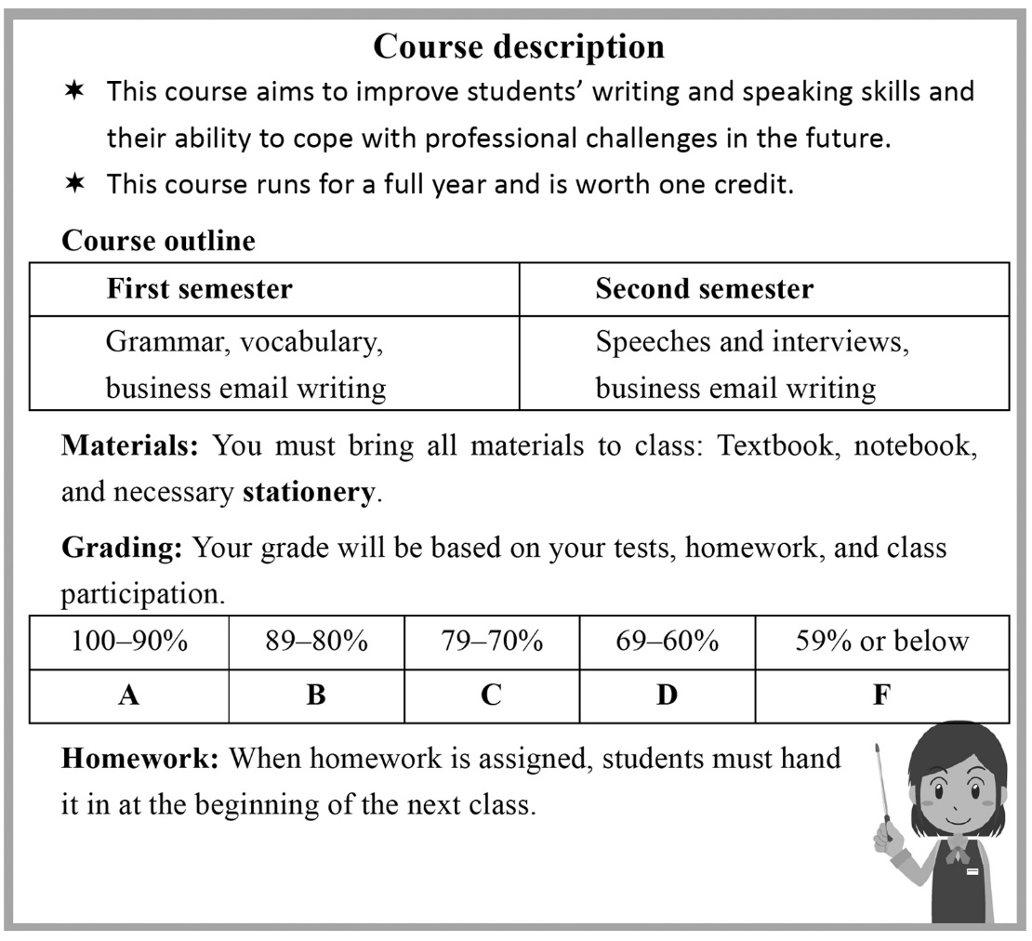  （ ）47 Which of the following is true?  (A)Students getting a passing grade in this course can get two credits.  (B) Students can improve their reading skills in this course.  (C) Students can learn business email writing only in the second semester.  (D) There are five grading scales based on tests, homework, and class participation.  （ ）48. What does the word “stationery” mean?  (A) A paper that can show people’s identity.  (B) Materials that people use for writing.  (C) Grades that are given at the end of a semester.  (D) A form that lists all the courses students take. |  |  |  |  |  | - 文法字彙綜合選擇  （ ） 26. The road are blocked because a shooting happened here last night.  - policy (B) mode (C) incident (D) slogan  （ ） 27. The restaurant is closing due to poor and lack of workers.  (A) risk (B) concept (C) hardship (D) management  （ ） 28. Telling a joke is not on a serious occasions such as a funeral.  (A) benefited (B) appropriate (C) conductive (D) motivated  （ ）29. Elsa has a(n)____________ for singing, so she is encouraged to sign up for the  singing competition. (A) talent (B) threat (C) outbreak (D) demand  （ ）30. Everyone in the company is wondering how to get through this period of financial  difficulty. (A) attitude (B) hardship (C) baggage (D) cricket  （ ）31. Because of a serious back injury, he can barely walk and even feels pain when  lying down. (A) scary (B) severe (C) complex (D) diligent  （ ）32.The hotel provided guests with a choice of two swimming pools, one outdoor and  one indoor. (A) crawled (B) challenged (C) attempted (D) offered （ ）  （ ）33.With the world population ____________ at a rapid rate, food distribution and  shortages are becoming bigger problems.  (A) to grow (B) growing (C) grows (D) grew  （ ）34.Iceland, ____________ visitors can see the Northern Lights, is a popular tourist  destination. (A) which (B) that (C) where (D) when  （ ）35.It is considered impolite to talk ____________ your mouth full of food.  (A) by (B) when (C) as (D) with  .  P1  （ ）40.Greg: Why are you home? I thought you were out with your friends.  Jenny: ____________ I can barely stand on it now.  Greg: Oh, I’m sorry about that.  Jenny: No worries.  (A) Yes, I would like to go out with you. (B) I kept it a secret.  (C) I am not a fan of hiking. (D) That’s because I hurt my ankle.  （ ）41.Albert: It was great meeting you today.  Nathan: You as well! We should meet more often.  Albert: Let’s keep in touch.  Nathan: Sure. ____________  (A) I’ll take it. (B) Catch you later!  (C) It’s a pity. (D) How dare you!  四、綜合測驗  Bangladesh experiences flooding every year due to heavy rain. Because of this, thousands of schools close. This can happen _____42._______ months! Luckily, a solution was proposed by an architect _____43._______ Mohammed Rezwan: boat schools.  Boat schools are equipped just like regular schools, with tables, chairs, and a blackboard. ______44.______, they can hold 30 students. They come six days a week to pick the students up at docks for lessons, and then drop them back off after class. Then they continue to their next stop, ______45.______ another 30 students are waiting. ______46.______ these unique classrooms available, more students can receive lessons anytime, anywhere. Thousands of youths in Bangladesh have benefited from them.  （ ）42. (A) at (B) in (C) for (D) with  （ ）43. (A) named (B) names (C) to name (D) naming  （ ）44. (A) In addition to (B) In addition (C) Additional (D)Addition  （ ）45. (A) who (B) which (C) when (D) where  （ ）46. (A) Of (B) When (C) For (D) With  P2.  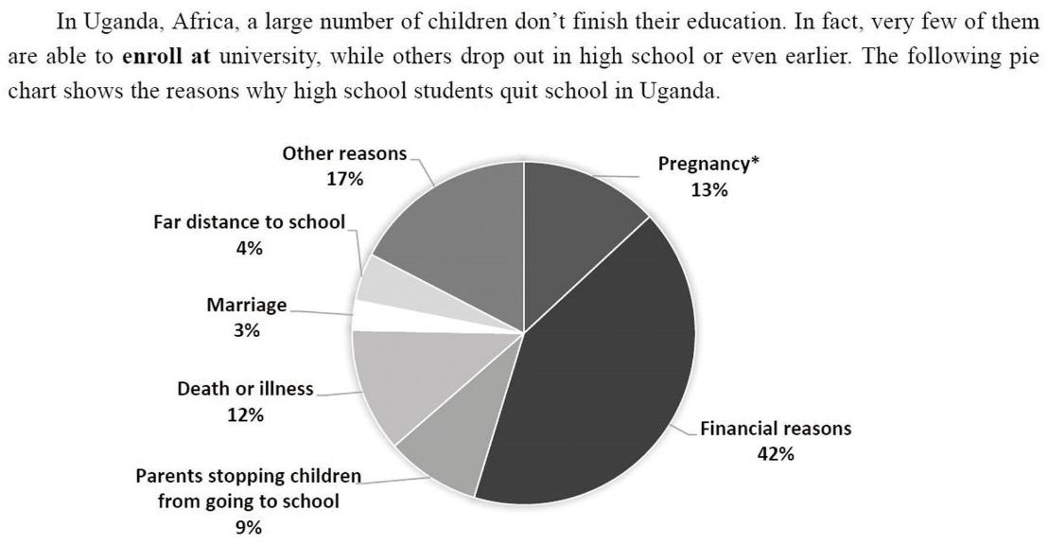  * pregnancy n. [U] 懷孕  （ ）49. What does “enroll at” most likely mean?  (A) Build. (B) Quit. (C) Attend. (D) Find.  （ ）50. What is the most common reason why high school students quit school in Uganda?  (A) They live too far from their schools.  (B) They have problems with money.  (C) They suffer from serious diseases.  (D) They have family issues.  People may say I can’t sing  but no one can ever say I didn’t sing.  人們可以說我不會唱歌，但沒有人能說我沒唱過。  -電影【走音天后】  P3
新北市立 新 北 高工 102 學年度 第二學期 期末考 |  |  |  |  |  |  | 班級 |  | 座號 |  | 成 | P.2
科目 | 英文 | 年級 | 一 | 科別 | 機鑄汽模圖電資 |  | 姓名 |  |  |  | 績 | P.2

新北市立 新 北 高工 102 學年度 第二學期 第二次 段考 一年級 英文 答案卷 P.3

班級 姓名 座號

得分 總分
VI. 文意字彙20%
1. | 2. | 3. | 4.
5. | 6. | 7. | 8.
9. | 10.

VII. 翻譯填空10%
11. | 12. | 13. | 14.
15. | 16. | 17. | 18.
19. | 20.

【請仔細核對題號 請在考卷及答案卷上都寫上姓名座號 答案卡請劃座號!!!!】

