<注意> ①1-4題為是非題；5 ~ 22題為選擇題 ②配分: 1~5題: 3% ; 6~22題皆為5%

SEA CITY MUSEUM
Tickets and Opening Time
Starting in September, we will be open from 10 a.m. to 4 p.m., Monday to Sunday.
You must book a ticket online in advance before your visit – Book here.
You can book tickets on Tuesday for the following week.

Ticket Prices (All Exhibitions)
Children 12 and under: $ 4.00
Teenagers: $ 6.00
Adults: $ 8.50
Seniors 65 and above: $6.00
Family Discount (2 adults and 3 children): $25.00
Caretaker can enter the museum for free with a fully-paid disabled.

※ Q1~Q4 are true / false questions. If the statement about Sea City Museum is correct, mark A;
if not, mark B. (以下1~4題,答案為A或B。如為正確敘述,答案請畫A；錯誤敘述則畫B)
- There is a booking link provided on this website.
- Physically disabled visitors can enter for free.
- The museum is open for six hours a day.
- Visitors must pre-book a ticket online before going to the museum.
- The Lin family is going to visit the museum. There are two parents, a son aged 12, a pair of 7-year-old twins, and a grandpa aged 68. How much in total do they need to pay for the tickets?
(A) $ 29 (B) $ 31 (C) $ 36 (D) $ 42

(ii)
Course description
- This course aims to improve students’ writing and speaking skills and their ability to cope with professional challenges in the future.
- This course runs for a full year and is worth one credit.
Course outline
First semester | Second semester
Grammar, vocabulary,  business email writing | Speeches and interviews,  business email writing
Materials: You must bring all materials to class: Textbook, notebook, and necessary
stationery.
Grading: Your grade will be based on your tests, homework, and class
participation.
100–90% | 89–80% | 79–70% | 69–60% | 59% or below
A | B | C | D | F
Homework: When homework is assigned, students must hand it in at the beginning of
the next class.

- Which of the following is true?
(A) Students can improve their reading skills in this course.
(B) Students can learn business email writing only in the second semester.
(C) There are five grading scales based on tests, homework, and class
participation.
- What does the word “stationery” mean?
(A) Grades that are given at the end of a semester.
(B) A paper that can show people’s identity.
(C) Materials that people use for writing.

A
(ii)
(iii)
In Uganda, Africa, a large number of children don’t finish their education. In fact, very few of them are able to enroll at university, while others drop out in high school or even earlier. The following pie chart shows the reasons why high school students quit school in Uganda.
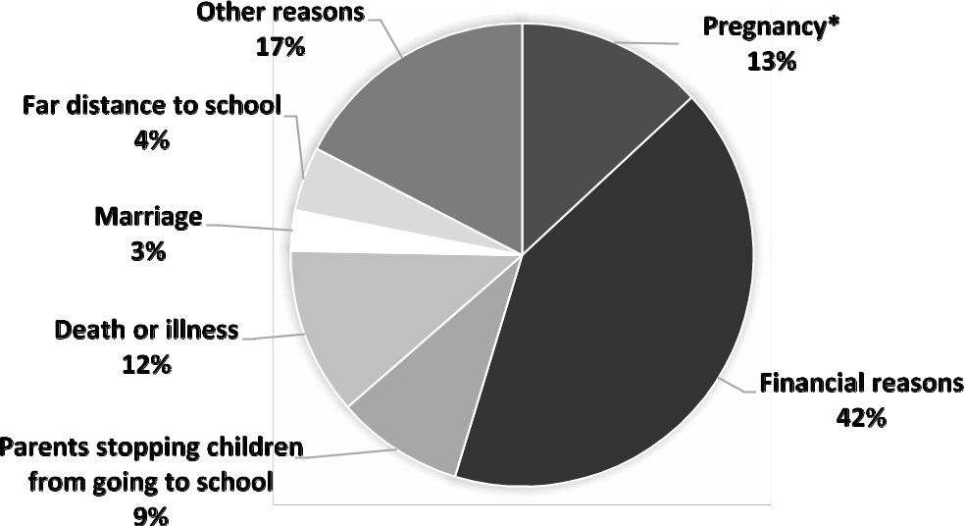
* pregnancy n. [U] 懷孕
- What does “enroll at” most likely mean?
(A) Quit.
(B) Attend.
(C) Build.
- What is the most common reason why high school students quit school in Uganda?
(A) They have problems with money.
(B) They live too far from their schools.
(C) They suffer from serious diseases.

(iv)
Pool Rules
Swimming Pool Hours
7:00 a.m. ~ 9:00 p.m.
Hotel guests only.
Swimmers must wear swimsuits.
Please shower before entering pool.
No food or drinks allowed.
No pets allowed.
Fruit aid kit available at front desk.
Do not use pool if you are ill.
No person under 12 is allowed
Without an adult present.
NO DIVING
Note: Last entry into the pool is 50 minutes before choosing.

- According to the passage, who can enter the pool alone?
(A) A 7-year-old child.
(B) A high school student.
(C) The fastest swimmer in the class.
(D) A businessman staying at this hotel.
- At what time can’t a person enter the pool?
(A) 8:00 a.m.
(B) 11:30 a.m.
(C) 4:30 p.m.
(D) 8:30 p.m.

(v)
Education is one of the things that every person should have the right to. Unfortunately, not every kid is able to stay in school. Students might, for example, live in very poor or very remote areas where resources are limited. In some cases, natural disasters* such as flooding and earthquakes might also prevent them from attending class. Finally, serious pandemics* such as COVID-19 can interfere* with children’s education as well, and even make going to school dangerous.
For most of these situations, there is only one practical solution that stands out: online learning. In China alone, for example, around 250 million students attended daily e-learning sessions in 2020. These virtual* classrooms made sure that learners, despite not being able to go to school, didn’t stop their studies. Research has even suggested that online students are more productive*. They keep information better, and e-learning has been shown to take less time than regular schooling. All in all, online learning can be a lifeline for students everywhere.
* disaster n. [C] 災難 * pandemic n. [C] 大流行疾病 * interfere vi. 干擾 * virtual adj. 虛擬的
* productive adj. 富有成效的
- What is the main idea of this passage?
(A) COVID-19 has posed a great threat to students’ education.
(B) Online learning is a solution for students who have difficulty going to school.
(C) Every person should have the right to education and stay in school.
(D) Online learning enabled Chinese students to keep learning during a pandemic.
- Which of the following is NOT mentioned as a reason why students can’t stay in school?
(A) Natural disasters. (B) Pandemics. (C) Location. (D) Low intelligence.
- According to this passage, which of the following is one of the advantages of online learning?
(A) It can make students more focused on learning.
(B) It can help students remember information longer.
(C) It can reduce the gap between the rich and the poor.
(D) It can save students school tuition fees.

(vi)
India is a very poor Asian country and has nearly 1.4 billion people. Every day, many Indians use trains to get to work or school. Unfortunately, many poor families also live near the country’s huge network of train tracks. The parents of these families cannot afford to send their children to school, so the children go to nearby train stations to beg for money on the platforms instead.
A teacher named Inderjit Khurana saw this problem when riding the train every day to work. She knew the children couldn’t leave the platform, so she decided to create a “train platform” school. On the platform, she would hold lessons in reading, math, health, music, and dancing. In the beginning, only 20 children came, but soon the news spread. Eventually, more than 100 children joined her classes. She wanted to help more children, so she created more schools and hired other teachers. Today, there are more than 70 schools, all located on different train platforms. With these schools, the children can earn money while also having hope for a brighter future.
- What is the best title for the passage?
(A) A Train Station Transports Rich and Poor People
(B) A Teacher Helps Create a Friendly Train Station
(C) A Unique School Brings Hope to Poor Children
(D) A Gap between the Rich and the Poor Exists in India
- Why do poor children hang around train platforms?
(A) They call for equal education.
(B) They actually live in the train station.
(C) They want to make friends with rich children.
(D) They ask people for money.
- What does the word “all” refer to?
(A) Poor children who need education.
(B) “Train platform” schools.
(C) Train stations in India.

(vii)
Have you ever skipped sleeping over a video game? Computer game designers often create interesting video games to tempt players to keep playing. These days, many employees are found to play video games at work even though their employers have set rules to stop them from doing so. In fact, video game addiction is regarded as harmful, just like addiction to drugs, alcohol, or gambling, and should be treated with care. In the workplace, addicted players are often seen as lazy, not sick; their bosses are not sympathetic to their addiction. If they have been caught several times playing video games at work, their salary may be cut, and even worse, they may lose their jobs. In some companies, the addicted players are allowed to play video games only on stressful days, but their bosses will check their computers from time to time to make sure that they are doing their work. However, while some companies continue to find some methods of preventing workday playing, addicted players still have their own ways to enjoy playing video games during working hours.
- What is the passage mainly about?
(A) Video game jobs.
(B) Computer game designers.
(C) Computer game companies.
(D) Video game addicts.

- According to the passage, why do some companies allow their workers to play video games?
(A) Because they can improve computer skills.
(B) Because they can design more interesting games.
(C) Because they can learn important gaming skills.
(D) Because they can feel relaxed when stressed out.

- According to the passage, which of the following is similar to video game addiction?
(A) Addiction to work.
(B) Addiction to sports.
(C) Addiction to sleep.
(D) Addiction to drugs.

- According to the passage, what may some companies do to their workers addicted to video games?
(A) To cut their pay.
(B) To send them to the doctor.
(C) To give them a computer that cannot play video games.
(D) To help them find ways of playing video games.

- According to the passage, which of the following is NOT true?
(A) Companies may check workers’ computers to see if they play video games during work.
(B) Video game addicts are rewarded with higher pay for playing at work.
(C) Companies keep finding ways to stop workers from playing video games while working.
(D) Video game addiction is a behavior which has to be treated like alcoholism.

