市立新北高工 111 學年度 第一學期 高三英文閱讀 |  |  |  |  |  |  |  |  |  | 班級 |  |  | 座號 |  | 成  績
科目 | 英 閱 | 命題教師 | 林筱雯 | 審題教師 | 張哲瑋 | 年級 | 3 | 科別 | 全 | 使用電腦卡 |  | 姓名 |  |  | 成  績
(1)  Patrick is preparing for a speech. The topic of his speech is about countries with the largest indigenous populations in the Americas. The following is a chart he found on www.statista.com. He has made some changes to the chart and removed some data in order to interact with his audience during his speech.  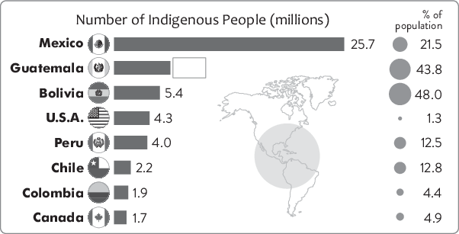  1. According to the information, which of the following is true?  (A) The chart that Patrick found online is not useful for his speech.  (B) About 13% of the population of Peru are indigenous.  (C) All the countries will see an increase in indigenous population.  (D) The indigenous population of the U.S.A. is the smallest.  2. Guatemala, a developing country in Central America, has a population of around 18 million.  According to the information, which of the following is the possible indigenous population of  Guatemala?  (A) 7,884,000. (B) 9,600,000. (C) 13,540,000. (D) 19,980,000.  3. Which of the following statements about Bolivia can be inferred from the chart?  (A) It has the largest indigenous population on the American continent.  (B) The indigenous population of Bolivia is more than 15 million.  (C) The total population of Bolivia is around 5 million.  (D) Nearly half of its population is of indigenous origin. |  |  |  |  |  |  |  |  |  | (2) Everyone knows human rights are important. In spite of this, human rights abuses are still going on in many parts of the world. We cannot create a world free of human rights abuses unless we know more about them. Yet, many of us are still unaware of terrible things that are happening now.  In North Korea, for instance, human rights nearly do not exist. There, there is no such thing as “innocent until proven guilty,” which is the key to a fair and equal justice system. Prisoners who haven't been given a proper trial are treated worse than animals. Similarly, in Venezuela, its government has been found to ignore the laws by holding people in prison, torturing, and killing them without a proper trial.  More attention must be given to human rights abuses around the world. If governments are not being called to take responsibility for their actions, they will continue doing whatever their power permits them to.  4. What is the best title for this passage?  (A) Safety as a Basic Human Right  (B) The Victims of Human Rights Abuses  (C) Preventing Human Rights Abuses in Taiwan  (D) The Human Rights Abuses Happening Right Now  5. According to the passage, if Shane is involved in stealing cars in Venezuela, what is LEAST  likely to happen to him?  (A) He may receive unfair treatment.  (B) He may be held without a proper trial.  (C) He may be wellprotected by laws.  (D) He may be beaten and killed in prison.  6. According to the passage, which of the following statements is NOT true?  (A) In Venezuela, the government ignores its laws and abuses its power.  (B) In North Korea, people are often treated as innocent until proven guilty.  (C) If we want to stop human rights abuses, we must know about them first.  (D) People must pay more attention to human rights abuses around the world. 共3頁第1頁
  abuse 濫用 innocent until proven guilty 無罪推定原則
  Venezuela 委內瑞拉 torture 折磨
市立新北高工 111 學年度 第一學期 高三英文閱讀 |  |  |  |  |  |  |  |  |  | 班級 |  |  | 座號 |  | 成  績
科目 | 英 閱 | 命題教師 | 林筱雯 | 審題教師 | 張哲瑋 | 年級 | 3 | 科別 | 全 | 使用電腦卡 |  | 姓名 |  |  | 成  績
(3) In Taiwan, there are about 560,000 indigenous people. Although they make up only 2.7% of the population, they are considered an important part of the country's identity. Unfortunately, their traditions are dying fast, and Taiwan is now racing against time to preserve them.  Taiwan has 16 nationally recognized indigenous tribes, out of a total of 29 tribes. Since the 17th century, as Taiwan became a colony of the Netherlands and Japan, the indigenous people had no choice but to forget their languages and cultures. Even today, most of them are below the poverty line, face racism, and lack access to high-quality education. Hoping to get away from their difficult situations, they leave their hometowns and head for the cities. As a result, it may become harder for their future generations to reclaim their traditions.  Now, the Taiwanese government, along with several institutions and foundations, is aiming to preserve the indigenous people's cultures by providing them with resources. The good news is that based on research, the living condition of the indigenous people is indeed improving, and their cultures seem to be more capable of surviving.  Netherlands 荷蘭 racism 種族歧視 access 機會，權利 reclaim 取回，恢復  7. What is this passage mainly about?  (A) Ways to reclaim the Chinese language and culture.  (B) Solving racism with the help of indigenous people.  (C) Japan's influence on Taiwanese indigenous people.  (D) Preserving Taiwanese indigenous people's cultures.  8. How does the Taiwanese government help the indigenous people preserve their cultures?  (A) Do a research on the number of tribes. (B) Encourage them to leave their hometowns.  (C) Give them the resources they need. (D) Turn to the Netherlands for assistance.  9.What is the author's attitude toward preserving the indigenous people's cultures?  (A) The author thinks their situation will change for the better.  (B) The author is certain that their cultures will eventually die out.  (C) The author is convinced that it is meaningless to preserve their cultures.  (D) The author believes their future generations will all go back to their tribes. |  |  |  |  |  |  |  |  |  | 10. Which of following is true about indigenous people in Taiwan?  (A) They used to colonize Japan and Netherlands.  (B) They are above the poverty line.  (C) Most of them are highly educated.  (D) Their tradition is dying quickly.  (4) 12. What might be the best title for this article?  11. Which of the following meaning of the word is closest to preserve?  (A) protest (B) save (C) change (D) oppose  (4) 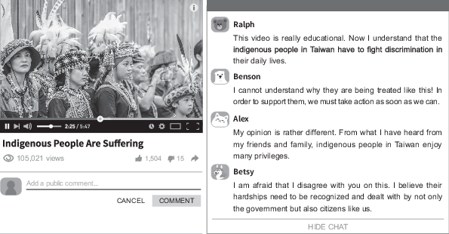  * discrimination 歧視 ; privileges 特殊待遇  12. After watching the video, who held a different view from the other three students?  (A) Ralph. (B) Benson. (C)Betsy. (D) Alex.  13. According to the students' responses to the video, which of the following is NOT true?  (A) Betsy believed only the government could help out.  (B) Benson wanted to do something to make a change.  (C) Alex doubted the truth of the video.  (D) Ralph learned something new from the video.  14. Which of the following meaning of the word is closing to “deal with”?  (A) handle (B) trade (C) protect (D) broaden  共3頁第2頁
市立新北高工 111 學年度 第一學期 高三英文閱讀 |  |  |  |  |  |  |  |  |  | 班級 |  |  | 座號 |  | 成  績
科目 | 英 閱 | 命題教師 | 林筱雯 | 審題教師 | 張哲瑋 | 年級 | 3 | 科別 | 全 | 使用電腦卡 |  | 姓名 |  |  | 成  績
15. According to the article, which of the following is true?  (A) People leave their comment after they read the travel magazine.  (B) All of the viewers share the same view.  (C) The video is made by the government to protect indigenous people.  (D) The video raise people’s awareness toward the pains of indigenous people.  (5) Human Rights Day takes place annually on December 10th. Settled by the United Nations, this day is an important milestone and proof in the aspect of rights for human beings. Rather than being a celebration, the day is a reminder that all people are born free and equal. This means everyone deserves to be treated with dignity regardless of sex, skin color, age, nationality, or religion. Despite this basic truth, millions of people around the world have their rights and freedom denied every day. In reality, people with more resources are usually in a position to control and bully the weak. Unfair as it is, not everyone has the same access to resources like money and power, and some people have more opportunities that are not available to others. Even so, Human Rights Day reminds us that we are all brothers and sisters. Everyone deserves to be safe and respected as we pursue health, education, happiness, and fulfillment in our daily lives.  16. What is the purpose of this passage?  (A) To explain how Human Rights Day was settled in the past.  (B) To make everyone keep in mind that all men are born equal and free.  (C) To give amazing ideas for celebrating Human Rights Day.  (D) To offer tips for pursuing higher positions and getting respected.  17. What does the word “milestone” in line 2 refer to?  (A) A group that has formed for a particular purpose.  (B) A significant event in the development of something.  (C) A piece of rock from space that has landed on Earth.  (D) A beautiful stone that has been cut into a special shape. |  |  |  |  |  |  |  |  |  | 18. According to the passage, which of the following statements is true?  (A) It is a fact that some people can't have as many resources as others.  (B) Human Rights Day, settled by the UN, is held every two years.  (C) It is more important to celebrate the day than to remember its meaning.  (D) Thanks to Human Rights Day, all humans have had dignity and freedom.  19. Which of the following statements is true about Human Rights Day?  (A) It takes place once every four years.  (B) It is settled by the United States.  (C) The day is more of a celebration than a reminder.  (D) People deserve to be treated equally with respect regardless of their origins.  20. Why is Human Rights Day important?  (A) People with more resources have the rights to control and bully the weak.  (B) Everyone has the same access and opportunities to money and power.  (C) It reminds us that people on earth are all brothers and sisters.  (D) Millions of people enjoy equal rights and freedom around the world every day.  共3頁3頁

