請在電腦答案卡上劃上座號，並將選擇題答案劃卡作答,共60題，劃記不清者，扣總分5分。

第一部分: 聽力測驗 (共10題，每題1分)
a、看圖辨義 (2小題，每題1分，共2分)
試卷上該題有一張圖片，請聽一個和該題相關的問題，選一個與所看到圖片最相符的答案。
- 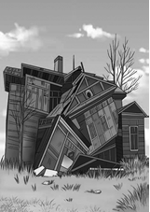
- 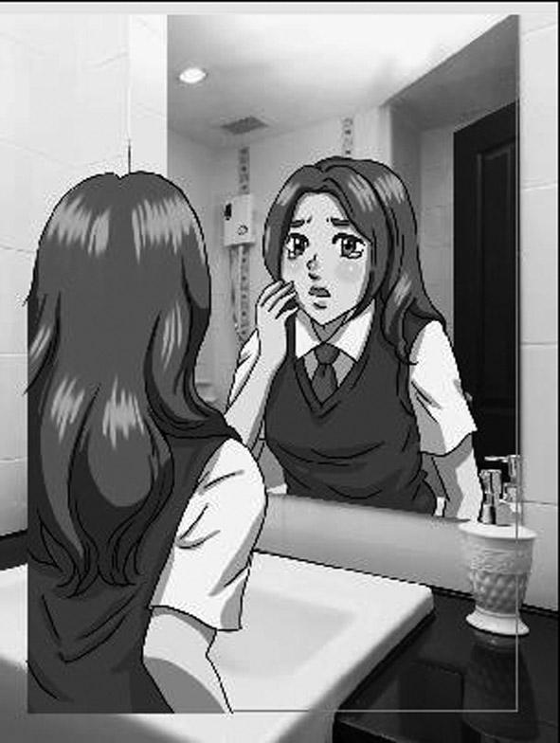
b、問答 (4小題，每題1分，共4分)
每題會播出一個問句或直述句，聽後請由試卷上選出一個最適合的回答或回應。
- (A) Delicious.
(B) Bitter.
(C) Salty.
(D) Strange.

- (A) It was a long lesson.
(B) To be more carefree.
(C) We will start at 5 o’clock.

- (A) Excited.
(B) Pleased.
(C) Awkward.
(D) Smart.

- (A) It was perfect.
(B) I just came home.
(C) I’m in grade six.

c、簡短對話 (2小題，每題1分，共2分)
每題會播出一段對話及一個相關的問題，聽後請由試卷上選出一個最適合的回答。
- (A) It will be over at 3.
(B) Curtis doesn’t know about it.
(C) Everybody will bring a dish.

- (A) The man.
(B) The woman.
(C) Marcus.

d、短文聽解 (2小題，每題1分，共2分)
每題有三個圖片選項。請聽題目，並選出一個最適當的圖片。
- (A) 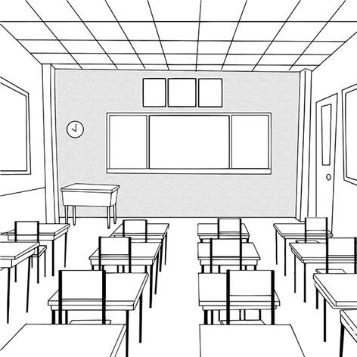 (B) 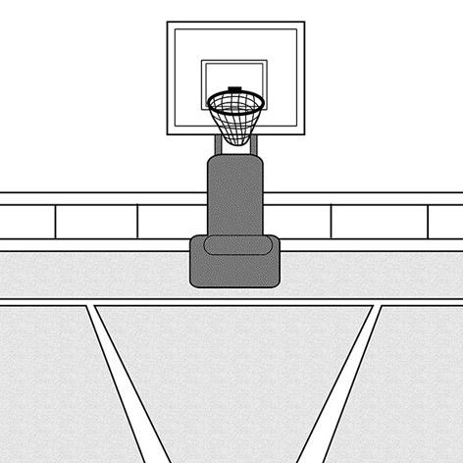 (C) 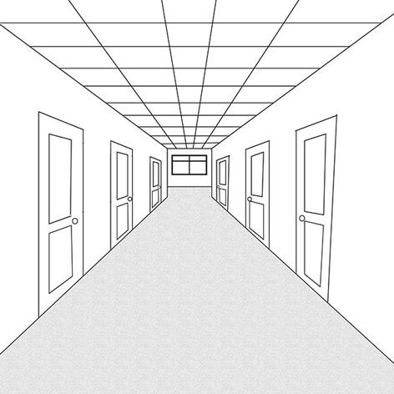

- (A) 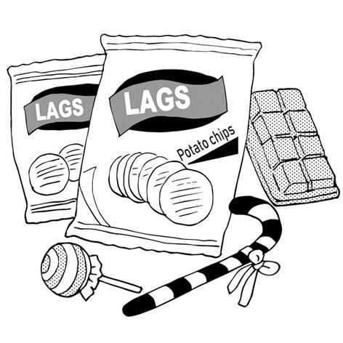 (B) 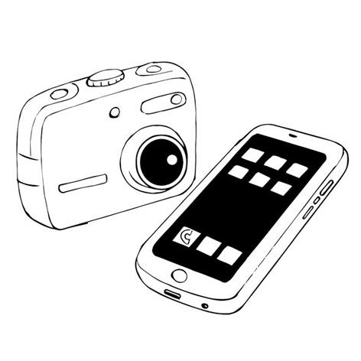 (C) 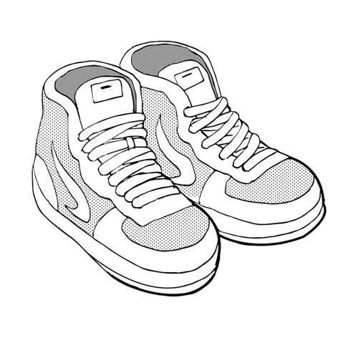

第二部分: 綜合測驗 (共15題，每題2分)
- （ ）Stop being so cruel to me. Aren’t you my friend?
(A) mean (B) correct (C) careful (D) deep
- （ ）Amber missed her bus. Luckily, another bus came a few minutes later.
- Really (B) Together (C) Fortunately (D) Quietly

- （ ）The show was great, and everyone enjoyed it a lot.
(A) mean (B) certain (C) fresh (D) awesome

- （ ）All my children were surprised by their aunt’s surprising visit last week.
(A) unexpected (B) awesome (C) certain (D) perfect

- （ ）Tommy is good at painting; thus, he dreams of becoming an artist.
(A) fortunately (B) certainly (C) therefore (D) calmly

- （ ）The Brown family had a pleasant weekend; they saw many cute animals at the zoo. (A) basic (B) enjoyable (C) funny (D) delicious

- （ ）If it ____________ sunny this weekend, I will go camping with my classmates.
(A) was (B) will be (C) is (D) were

- （ ）I know you miss your parents. Why not ____________ a video call to them?
(A) making (B) makes (C) made (D) make

- （ ）You can’t move those boxes ____________ yourself. You need some help.
(A) as (B) on (C) of (D) by

- （ ）For many people, stinky tofu smells really ____________.
(A) badness (B) badly (C) bad (D) worst

- （ ）Kevin is nothing ____________ a liar. He hardly tells the truth.
(A) but (B) and (C) for (D) or
22.（ ）If the old man ____________ up in the middle of the night, he can’t fall asleep again. (A) wake (B) wakes (C) woke (D) waken

- （ ）Jim: We’re going to Amy’s potluck party this weekend.
Linda: What can we bring?
Jim: How about some seafood salads?
Linda: ____________
(A) Keep in touch! (B) Don’t let me down.
(C) I’ll be right there! (D) That sounds great!

- （ ）Ryan: Hi, Sophie. I plan to have a birthday party for my son. Would you like to bring your daughters over?
Sophie: ____________ I believe they’ll have a great time.
(A)Why? I am busy. (B) Sure. I’d be happy to.
(C) I am not sure. (D) No wonder.
- （ ）Vivian: Hey, Carl. Should I bring anything to your party?
Carl: ____________ Sharon will make some sushi, and David will buy some drinks. I think that’s enough.
Vivian: Well, in that case, I’ll just bring flowers.
(A) No, thanks. (B) OK. I see. (C) Sure. Go ahead. (D) Yes, please.
第三部分: 克漏字測驗 (共10題，每題2分)
- At a potluck party, each guest brings something for other people to try, and this makes everything easy for the host. Some people cook their own dishes, and __26.__ buy food at a store. This __27.__ that there will be a large variety of unique dishes! Sometimes, 28.__, this is not a good thing. __29.__ two people bring the same dish, it might be a problem. So, the host needs to do some planning before the event. _30.__, he or she can suggest particular dishes to some of the guests. That way, nobody will feel awkward.
（ ）26. (A) others (B) other (C) the other (D) another
（ ）27. (A) talks (B) refers (C) turns (D) means
（ ）28. (A) however (B) because (C) in addition to (D) therefore
（ ）29. (A) So (B) If (C) However (D) Because of
（ ）30. (A) For example (B) Such as (C) Including (D) Like

- A “potluck” did not originally refer to a party. The word __31.__ to 1592. At that time, people usually did not throw out leftovers. They kept them in a pot for __32.__ guests. __33.__, when guests suddenly showed up at someone’s house, they tried the “luck of the pot” and ate anything in it.
These days, a potluck party _34._ a small food fair. Guests spend a lot of time __35.__ their own dishes. People may use Grandma’s secret recipe for their dish or buy something at a top-rated restaurant. It is thus a truly enjoyable eating experience.
（ ）31. (A) comes back (B) dates back (C) turns back (D) gives back
（ ）32. (A) unexpectedly (B) expecting (C) unexpected (D) expected
（ ）33. (A) However (B) Therefore (C) Hardly (D) Wherever
（ ）34. (A) is like (B) looks as (C) is almost (D) feels similar
（ ）35. (A) prepares (B) prepare (C) prepared (D) preparing

第四部分: 素養題測驗 (共5題，每題2分)
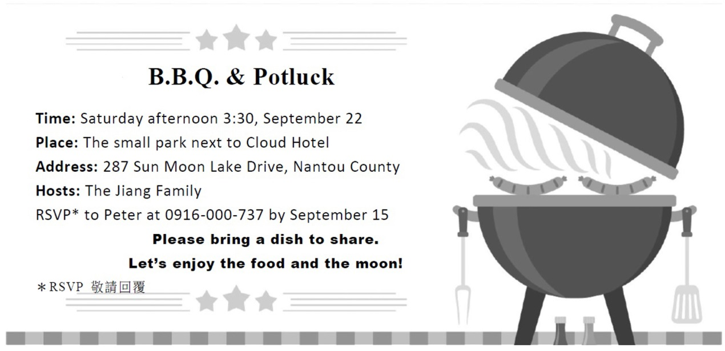
（ ）36. What holiday is the party probably held for?
(A) Christmas. (B) Dragon Boat Festival. (C) Mid-Autumn Festival. (D) New Year’s Eve.
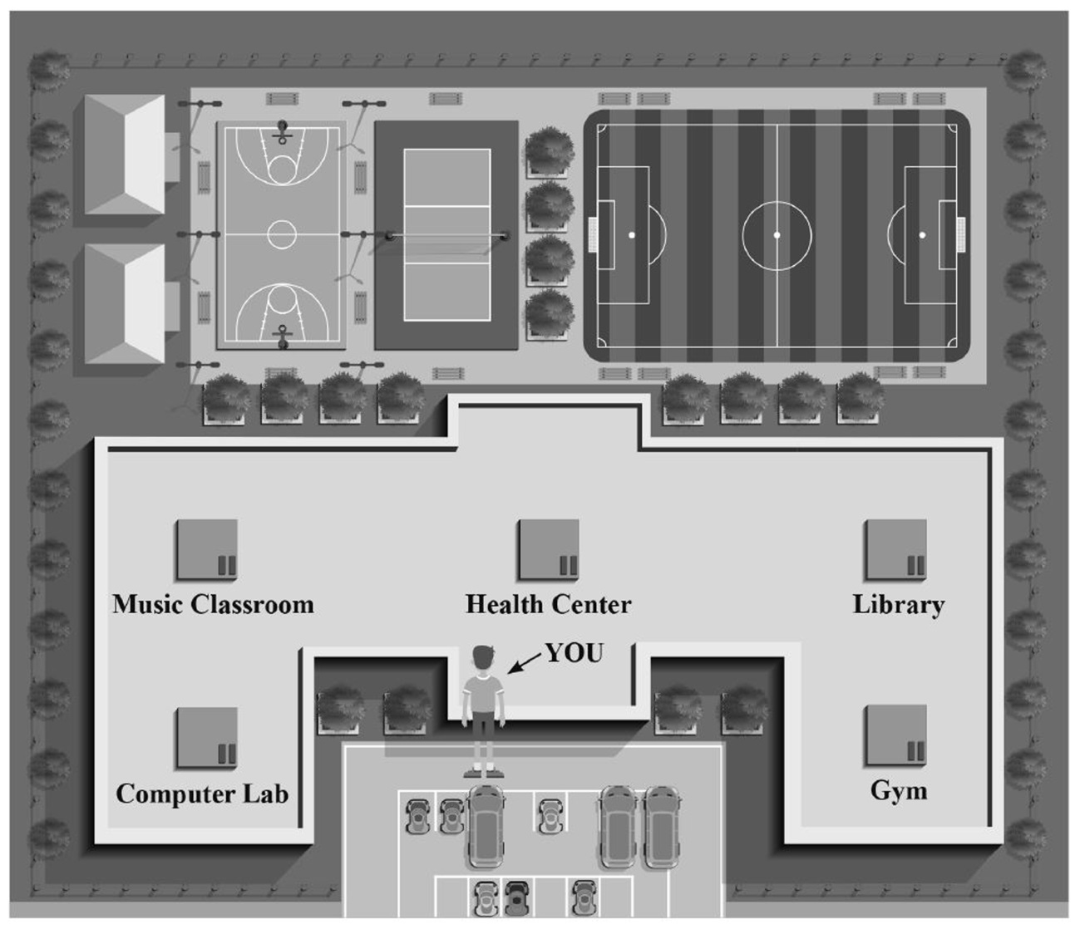
（ ）37. Which building is in the center of the school map?
(A) The Health Center. (B) The Computer Lab.
(C) The Library. (D) The Gym.
（ ）38. If you go straight and turn left when you run across a building, what can you see?
(A) The Library. (B) The Computer Lab.
(C) The Music Classroom. (D) The Gym.

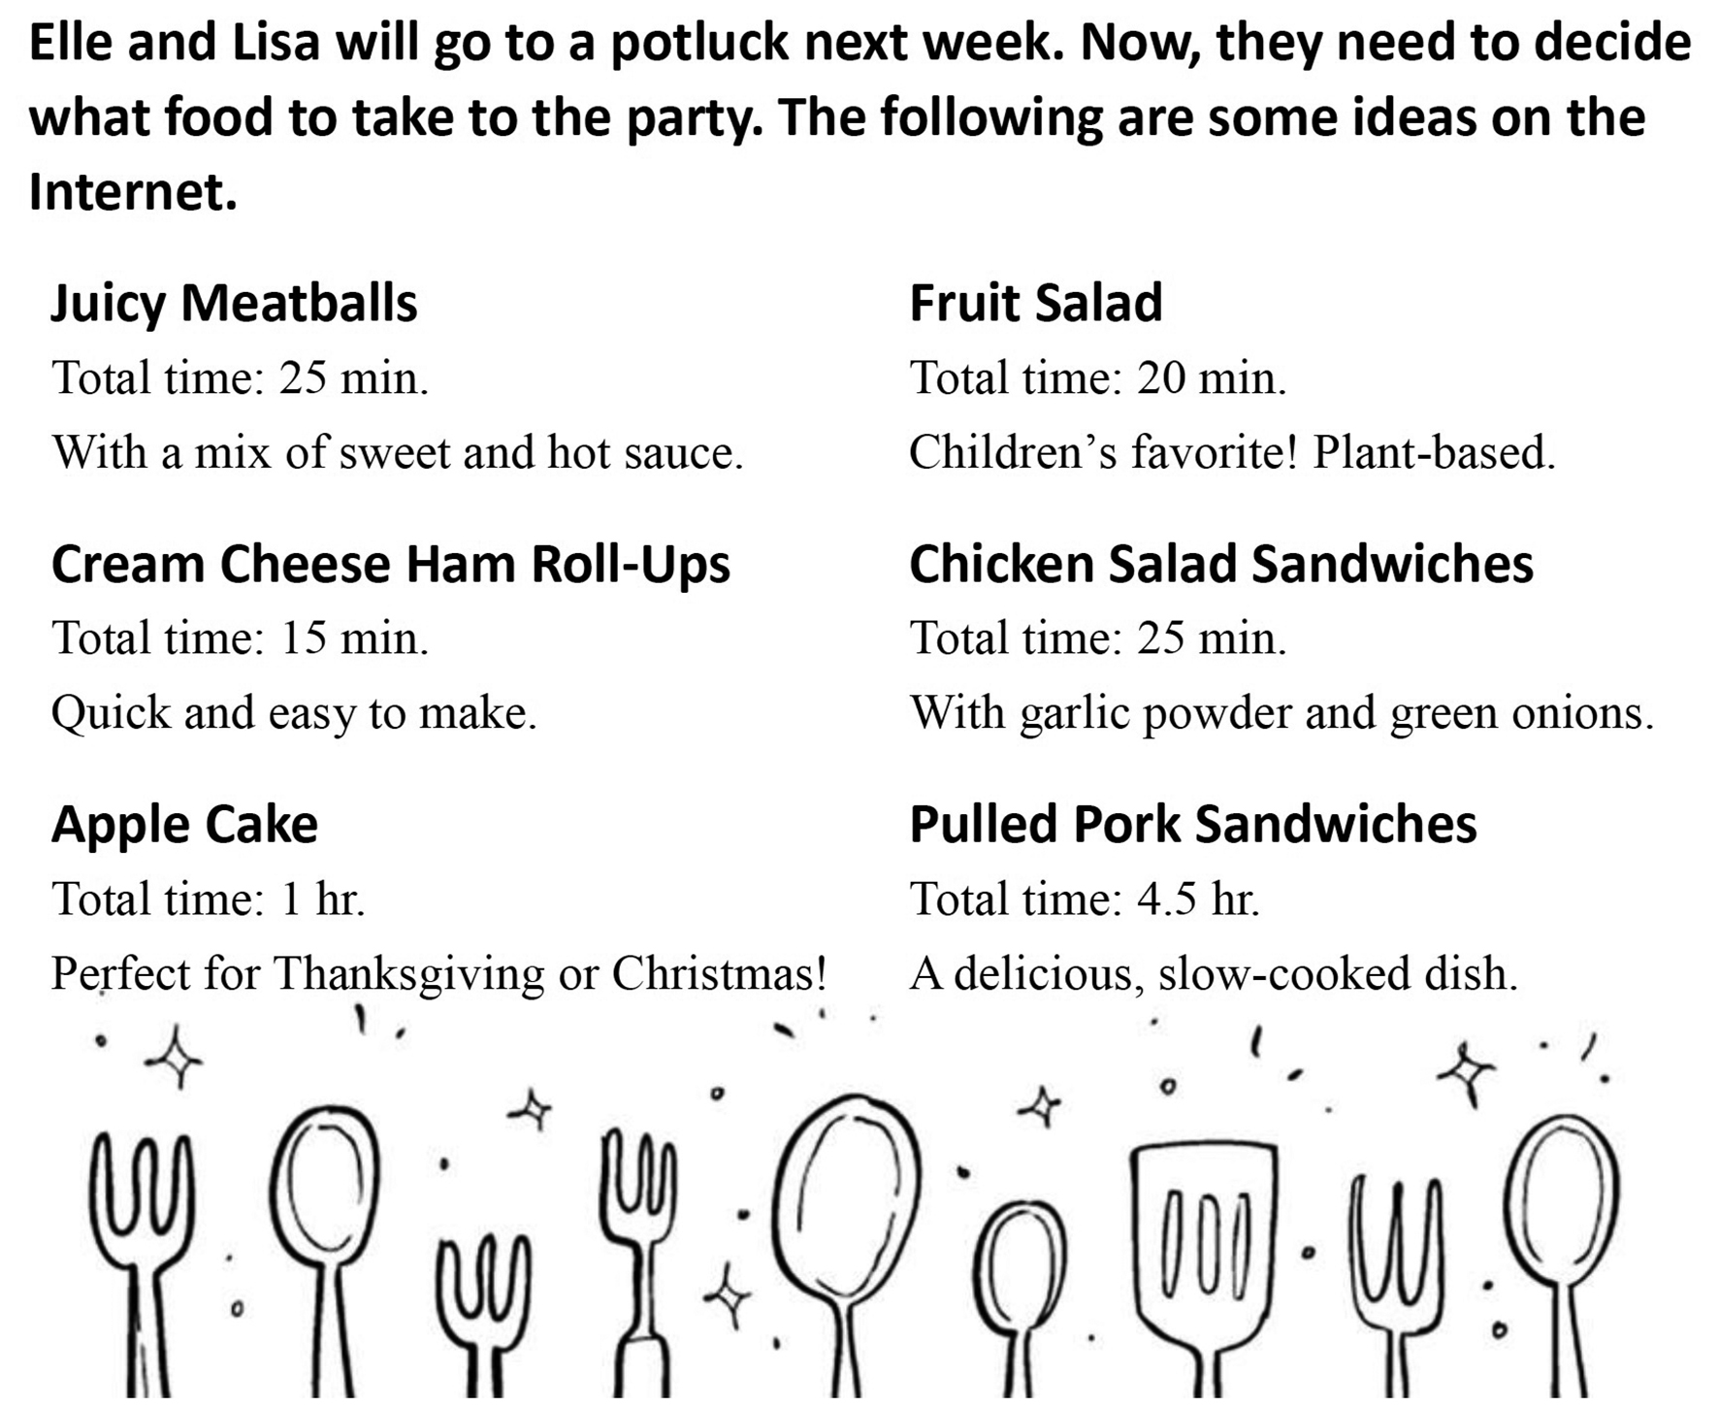
（ ）39. If Elle wants to save the most time on preparing a dish, which recipe should she choose?
(A) Chicken salad sandwiches. (B) Juicy meatballs.
(C) Cream cheese ham roll-ups. (D) Apple cake.
（ ）40. Some guests at the party don’t eat meat. Which of the following would be an excellent choice if Lisa wants everyone to enjoy her food?
(A) Chicken salad sandwiches. (B) Fruit salad.
(C) Juicy meatballs. (D)Pulled pork sandwiches.

這張考卷請和題目卷分開交，請記得寫上班級座號姓名

第五部分: 字彙填空 (共10題，每題2分)
- ____________________ In most countries, shaking your head up and down m____________ns “yes.”

- ____________________ Please r____________y as soon as you get my email.
- ____________________ Every time I look at these pictures, sweet m____________ries of my family members come to my mind.
- ____________________ On the first day of school, the teacher a____________ned us to clean the classroom.
- ____________________ After a long period of c____________n, Barbara finally decided to paint her bedroom walls yellow.
- ___________________ David is very close to his father. There are no s____________ts between them.
- ____________________ Taiwan’s handling of COVID-19 (新冠肺炎) i____________sed everyone around the world.
- ____________________ Phil o____________y didn’t want to get a cat, but now he loves it.
- ____________________ Molly was very u____________t because her best friend wouldn’t talk to her.

- ____________________ The typhoon r____________ned the roads and bridges in this town.
第六部分: 翻譯填空 (共10格，每題1分)
大部分的螞蟻只不過是小昆蟲罷了。牠們不會傷害你。
Most ants are _____51______ ______52______ small insects. They won’t hurt you.

Johnson想出了一個好方法來感謝他的老婆。
Johnson (c)______53______ ______54.______ ______55.______ a good way to thank his wife.
當人們說到「沙漠之舟」時，它一般是指駱駝。
When people use the phrase “the ship of the desert,” it generally _____56._______ ______57.______ a camel.

令人驚訝地，這習俗可以追溯到1700年代。
Surprisingly, this custom may (d)_____58._______ (b)______59.______ ______60.______ the 1700s.
第五部分: 字彙填空 (共10題，每題2分)

41. | 42. | 43. | 44. | 45.
46. | 47. | 48. | 49. | 50.
第六部分: 翻譯填空 (共10格，每題1分)

51. | 52. | 53. | 54. | 55.
56. | 57. | 58. | 59. | 60.

