- Listening Comprehension 10 %
- 看圖辨義 請聽一個和該題相關的問題，選一個與所看到圖片最相符的答案。
1. 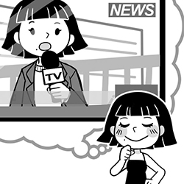 2. 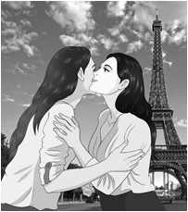
- 問答 每題播出一個問句或直述句，聽後請由試卷上選出一個最適合的回答。

3. (A) It’s my passion. (B) I received your request.
(C) I scored another goal. (D) Because of its appearance.
4. (A) I’m very sorry to hear that. (B) Sounds like he rescued his career.
(C) That’s too bad. How did he lose it? (D) I’m afraid I can’t really help.
5. (A) We’ll spend three days there in total. (B) I loved the parade that we saw there.
(C) We’re going to Disneyland in Tokyo. (D) The trip only took about five hours.
6. (A) Yes, it was the hardest one. (B) He had a good attitude.
(C) I failed the mid-term. (D) I work hard for it.
三. 簡短對話 每題會播出一段對話及一個相關的問題，聽後請選出一個最適合回答。

7. (A) She will return to her country soon. (B) She always forgets her schedule.
(C) She can’t get used to waking up early.
8. (A) The sign says not to do this. (B) It’s not allowed in this place.
(C) The police told him not to.
四. 短文聽解 每題有三個圖片選項。請聽題目，並選出一個最適當的圖片。
9. (A) 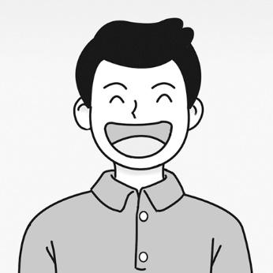 (B) 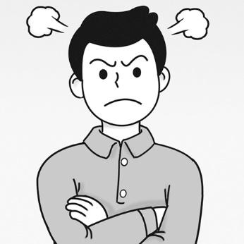 (C) 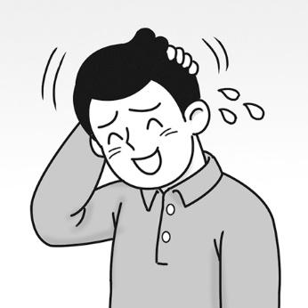
- 10. (A) 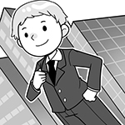 (B) 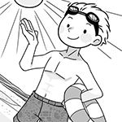 (C) 
- Multiple Choice 32%
11. The host amused the audience with some magic and funny jokes.
(A) proved (B) conveyed (C) overcame (D) entertained
12. My teacher always provided precious support for me when I was in trouble.
(A) hopeless (B) effective (C) valuable (D) extra
13. Each individual should take action ________ to reduce the use of plastic products.
(A) extremely (B) immediately (C) accidentally (D) apparently
14. We respect your right to express yourself ________ disagreeing with your argument.
(A) although (B) in spite of (C) however (D) in order to
15. I saw the Spanish daily ________, ________ by their time arrangement.
(A) gesture / shocked (B) passion / shocking (C) schedule / shocked (D) failure / shocking
16. Rosie dropped the baton, _______ to 3rd place; she was still ________ by her fans.
(A) fell / cheered (B) fell /cheering (C) falling / cheering (D) falling / cheered
17. All we can do is ________ money to help those earthquake victims.
(A) donating (B) donate (C) to donating (D) be donate
18. ________ I travelled to Norway and experienced the beauty of this country. You can make a
journey ________ you are interested in the natural scenery.
(A) Once / if (B) When / if (C) Once / while (D) When / while
19. All of Eason hard work ________ when he got accepted into his dream university.
(A) paid back (B) paid off (C) put into (D) looked around
20. Sandra is also fond of detective and horror movies ________ action movies.
(A) in addition to (B) in turn (C) put into (D) put away
21. The night market is always busy, ________ with tourists from all over the world.
(A) crowded (B) crowding (C) and crowding (D) be crowded

22. (1) and work hard (2) Since the exams are (3) only two weeks away (4) is
(5) try to focus in class (6) all I can do (重組)
(A) 236451 (B) 264513 (C) 254361 (D) 235461
23. 選出劃線部分正確動詞形式
(A) Ms.Lin is talking to Peter, trying to know why he skiped the class again.
(B) He saw the puppy and pated on its head and back happily.
(C) A kid in the park grabed little Jimmy’s toy car and ran away.
(D) The news proved he was guilty.
24. 選出劃線部分錯誤的用字
(A) Fingerprints and DNA test helped the police to determine the identity of the killer.
(B) J.K. Rowing established many difficulties when she writing her first novel.
(C) When a rocket carried the rich man to the moon, his dream was finally fulfilled.
(D) Chatting with some famous painters gave me inspiration of what to draw.
25. 選出劃線部分文法正確的句子
(A) We can see a group of third-year girls running past us, dashed to the finish line.
(B) This movie seemed last for a long time, so we decided not to see.
(C) All you have to do is to try our homemade recipe.
(D) Monks in Thailand allow to touch the heads of the children.

- Cloze 14 %
Culture shock means foreign customs are __(26)__ different from our own __(26)__ our travelling experience often surprises us. For instance, most Taiwanese feel __(27)__ when French people greet them __(28)__ a kiss on the cheeks. But it’s a common way for them to say hello to each other. Besides, we can’t __(29)__ people __(29)__ their heads in Thailand. Only the king, monks and parents can do that because people’s heads are holy. In Spain, their lunch break sometimes lasts until 4p.m.; 6 p.m. is the time for afternoon snack and 9 p.m. is for dinner. We have to __(30)__ their strange timetable if we travel there. __(31)__ the travel to the full, all we have to do is __(32)__ to the new things and hug the feeling of culture shock.

26. (A) such…that (B) such…which (C) so … which (D) so…that
27. (A) inspirational (B) fond (C) awkward (D) valuable
28. (A) for (B) with (C) by (D) at
29. (A) touch…with (B) pat…on (C) touch … for (D) pat…with
30. (A) get used to (B) be used with (C) be used for (D) get used for
31. (A) For enjoying (B) With enjoying (C) Enjoying (D) To enjoy
32. (A) open (B) to open (C) be open (D) be opening

IV. Dialogue 8%
33. Mandy: Don’t you eat fried rice with chopsticks or a spoon?
Zoe: Here we often use a fork, but I can get you a spoon if you need it.
Mandy: No, a fork is fine. Thanks!
(A) What do you think about it? (B) How do you do?
(C) I can do it by myself. (D) That’s how I always do it.
34. Zach: I’ve made some beef noodles for dinner.
Kyle: They smell so good! I can’t wait to taste them.
Zach: ________. I hope you’ll like them.
(A) It must be difficult to make them (B) Just go ahead
(C) You can do much better than this (D) I need to go to the convenience store
35. Zoe: Mom, could you teach me how to cook your yummy seafood fried noodles?
Mom: Of course! But why?
Zoe: My friends are throwing a potluck party this weekend.
And I just want to bring something delicious to impress them.
Mom: I see. Come on. ________
(A) Today is really not my day. (B) I’ll help you with your math homework.
(C) You’re not helping here. (D) Let me show you how to do it.
36. Lily: How do I look in this dress?
Brian: White really suits you.
Lily: Thanks, I think I’ll wear it to Jane’s wedding.
(A) You look gorgeous. (B) I agree with you.
(C) It is nice of you. (D) I love the way you work.

V. Reading 8 %
A man just moved into an apartment and walked to the receptionist to get his keys. The receptionist gave him the key with a smile but warns him not to disturb the door with no number on his floor. He wondered why but he had no time to ask, he was too busy with his new apartment to care. After he finished unpacking he began to get curious. He questioned why the receptionist would warn him of such things, and so he walked out of his apartment to check the door with no number.
He tried the door knob first but it was locked, so he got onto his knees and peeked through the keyhole. The apartment he was looking into was empty. His eyes scanned the whole place before stopping at a woman, standing face against a wall, in the corner. He noticed her pale skin and long black hair; suddenly, he felt he invaded someone else’s privacy. He stood up right away and left. He thought she was someone that did not want to be disturbed.
The next day he got more curious about the woman and eventually went back, straight away getting onto his knees. He peeked through the keyhole and saw all red. Red. He thought that the pale woman must have caught him peeking the last time and covered the hole with something red.
He left the door alone and went down to the receptionist to ask her questions. The receptionist sighed and asked, “you looked through the keyhole, didn’t you?”
He admitted to it and so she decided to tell him the story. She told him that a couple used to live in that apartment a long time ago, but the husband went crazy and killed his wife. However, this couple wasn’t normal.
They had pale skin, black hair and red eyes.

warn (v) 警告 disturb (v)打擾 door knob (n)門把 peek (v)偷看
scan (v) 掃描 bother (v) 打擾 invade (v) 侵犯 privacy (n) 隱私

- The man felt curious because _______.
- the receptionist gave him a key with a smile
- he wandered why he was so busy
- he was warned not to disturb the door with no number
- the door with no number was locked
- What may receptionist NOT do in daily life?
- welcome or help the visitors (B) answer the phone
- sort (分類) mail (D) walk dog
- The man thought the woman ________.
- tried to peek at him (B) was scanning him
(C) didn’t want to be bothered (D) invaded his privacy
- The man went back to the door without number again and ________.
- broke his knees
- saw the woman’s eye
- covered the keyhole with something red
(D) the receptionist caught him peeking

VI. Vocabulary 20 %
- Steve Jobs faced many c________es after he set up Apple Inc. but he never gave up.
在建立蘋果公司後, Steve Job 面對許多挑戰, 但他從來沒有放棄
- Peggie is praised for her good a________e toward work; she always handed in reports
on time.
大家都稱讚Peggie工作上的良好態度, 她總是準時交報告
- Batman and Robin aren’t the only c________rs in the movie; there are some bad guys.
蝙蝠俠跟羅賓不是電影唯一角色, 裡面還有一些反派
- The country a________ed its goal of lowering air pollution by 50% by switching to
cleaner energy sources.
藉由轉換到更潔淨的能源來源，該國達成了將空氣汙染降低百分之五十的目標。
- Thanks to the e________ts of the health care workers, the patients usually recover
very quickly.
由於醫療員工的努力, 病人們康復得非常快
- Katie is an open-minded and outgoing person. She e________es every opportunity
to learn something new.
Katie 是個心胸開闊且外向的人. 她欣然接受每個機會學習新事物
- The first step to know a country is to learn its c________e and the custom.
認識一個國家的第一步就是學習他們的文化與習俗
- It was a miracle that the airplane landed on the ocean safely and all of the passengers
luckily s________ed
飛機安全迫降在海面上, 全部乘客倖存下來真是個奇蹟
- Kelvin had an e________g situation at school today because he spilled juice on
his own face carelessly in class.
Kelvin今天在學校有個尷尬的情況, 因為他不小心把果汁潑到自己的臉上
- When you go to the beach, try not to e________e your skin to the sun for too long.
當你去海邊的時候, 不要讓皮膚在陽光下曝曬太久.

VII. Guided Translation 10 %
- 除了父親, 我們因為看到這小丑的把戲而笑開懷.
___(1)___ ___(2)___ Father, we laughed out loud when watching the clown’s tricks.
- 這中藥一點都不苦；相反地，嚐起來還有點甜。
This Chinese medicine is not bitter at all; ___(3)___ the ___(4)___, it tastes a little bit sweet.
- 向這位歌手提問之後，記者把麥克風交給她。
The reporter___(5)___ the microphone ___(6)___ to the singer after he asked her a question.
- Maggie 擅長唱歌; 換句話說, 她是歌唱領域的專家
Maggie is good at singing; in ___(7)___ ___(8)___, she is an expert in the singing field.
- 我外婆通常來接我放學，因為我母親那個時候正忙著工作。
My grandmother usually ___(9)___ me ___(10)___ after school because my mother is
busy working at that time.

非選答題區 (作答請用黑色或藍色原子筆)

選擇 ___________ 手寫___________ 總分 _______________________

- Vocabulary 20 %
1 | 2 | 3 | 4
5 | 6 | 7 | 8
9 | 10

- Guided Translation 10 %
1 | 2 | 3 | 4
5 | 6 | 7 | 8
9 | 10

