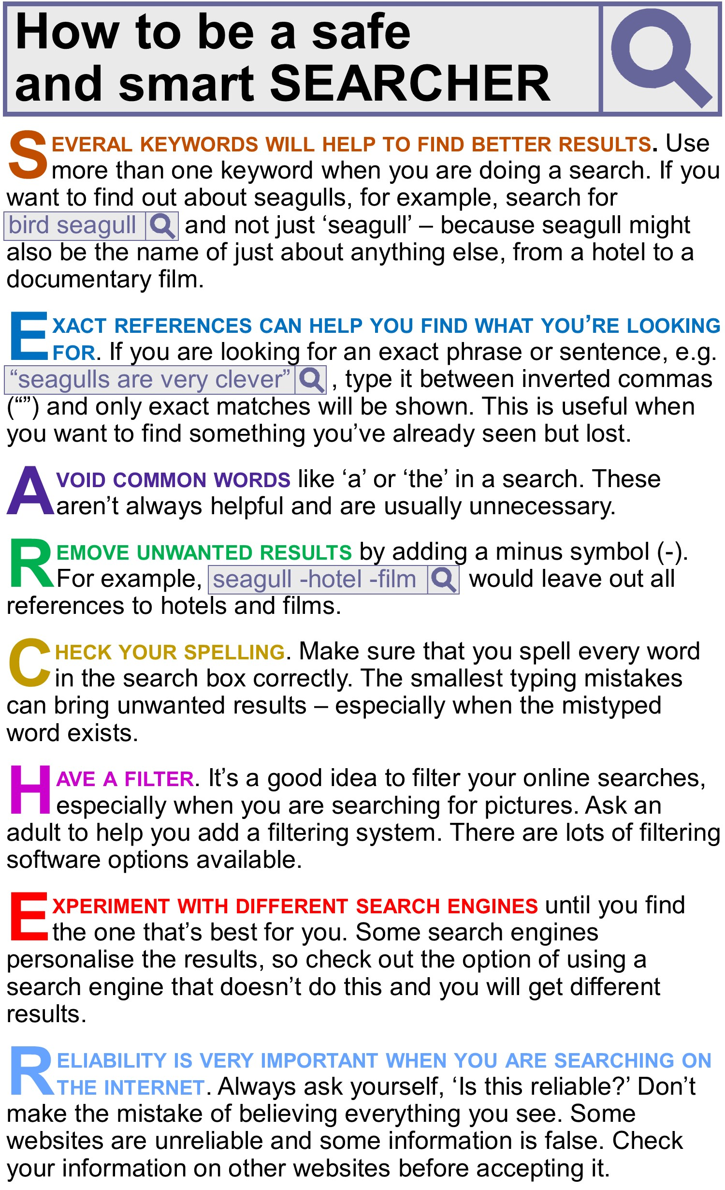

personalise (v) 個性化 reliability (n) 可信度
If the sentence is right, choose T; if it is wrong, choose F
1. You should only use one keyword in a single search. (A) T (B) F

- Inverted commas are useful to find something you’ve already seen. (A) T (B) F

- Words like ‘a’ are unhelpful in a search. (A) T (B) F

- If your keyword could refer to a lot of different things, you can't avoid getting a long list of results. (A) T (B) F

5. Small spelling mistakes aren’t important. (A) T (B) F

- Filter software is especially important for image searches. (A) T (B) F

7. Some search engines give different results to different people. (A) T (B) F

- Some websites contain false information. (A) T (B) F

A man just moved into an apartment and heads to the receptionist to get his keys. The receptionist gave him the key with a smile but warns him not to disturb the door with no number on his floor. He wondered why but didn’t bother to ask. He was too busy with his new apartment to care. After he finished unpacking he began to get curious. He questioned why the receptionist would warn him of such things, and so he stepped out of his apartment to check the door with no number.
He tried the door knob first but it was locked, so instead he got onto his knees and peeked through the keyhole. The apartment he was looking into was empty. His eyes scanned the whole place before stopping at a woman, standing facing against a wall, in the corner. He noticed her pale skin and long black hair before stepping back. He suddenly felt he invaded someone else’s privacy. He left at once, assuming she was someone that did not want to be disturbed.
The next day he got more curious about the woman and eventually went back, straight away getting onto his knees. He peeked through the keyhole and saw all red. Red. He assumed that the pale woman must have caught him peeking the last time and covered the hole with something red.
He left the door alone and instead went down to the receptionist to ask her questions. The receptionist sighed and asked, “you looked through the keyhole, didn’t you?”
He admitted to it and so she felt obliged to tell him the story. She told him that a couple used to live in that apartment a long time ago, but the husband went crazy and killed his wife. However, this couple wasn’t normal.
They had pale skin, black hair and red eyes.

- The man felt curious because _______.
- the receptionist gave him a key with a smile
- he wondered why he was so busy
- he was warned not to disturb the door with no number
- the door with no number was locked
- What may receptionist NOT do in daily life?
- welcome or help the visitors (B) answer the phone
- sort mail (D) walk dog
- The man thought the woman ________.
- tried to peek at him (B) was scanning him
(C) didn’t want to be bothered (D) invaded his privacy
- The man went back to the door without number again and ________.
- broke his knees
- saw the woman’s eye
- covered the keyhole with something red
- the receptionist caught him peeking

Travel is a good way to learn about the cultures of other countries. Sometimes, however, foreign customs can be so different that one can be quite surprised by them. This kind of experience is known as culture shock.
My recent trip to Singapore was a perfect example of this. I landed there after a four-hour flight and headed downtown to meet up with a local friend. As we chatted with him, I took out a piece of gum to chew, so I could feel more awake.
My friend whispered to me, “Don’t you know that gum has been banned* here since 1992?” Feeling a bit shocked, I nervously asked, “Am I going to be arrested?” He laughed and explained that although selling gum is not allowed in Singapore, it can still be bought from a drugstore with permission from a doctor. While chewing gum is thus legal in some cases, it isn’t welcomed.
This is because people used to do improper things with their chewed gum such as spitting it out on trains and causing the doors to stick. Moreover, the rule has helped a lot to keep the country clean in other ways. After hearing this, I wrapped my gum up in some paper and immediately threw it in a nearby trash can. Now I know not to take along any gum next time I go to Singapore. My memory of this slightly shocking experience is surely going to “stick” with me for a while!

- What is the passage mainly about?
(A) A doctor’s advice about chewing gum.
(B) The laws in Singapore about gum.
(C) One person’s culture shock experience.
(D) A very boring trip to Singapore
- According to the passage, which of the following is true?
(A) The author was arrested for chewing gum.
(B) Anyone can freely buy gum at a drugstore in Singapore.
(C) Gum was not banned in Singapore until 1992.
(D) The author didn’t care about the gum rules in Singapore.
15. According to the passage, why was chewing gum banned in Singapore?
(A) It was leading to trains getting stuck.
(B) Locals were chewing a shocking amount of it.
(C) It was causing a lot of cleanliness issues.
(D) Visitors were carrying too much of it.

Hand signs usually have different meanings and can be used for different reasons. The following are three common or interesting signs and their meanings.
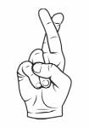 | Crossed fingers are used when someone is wishing for good luck.  The sign is also used when people are lying but don’t really want to hurt people. It is commonly used in the US.
? | The shaka sign is made by pointing the little finger and the thumb.  The other fingers are put on the palm. It means everything from hello to goodbye, thank you, no need to rush, and everything is all right. The shaka sign is said to come from Hawaii.
The Vulcan salute looks like the V-sign. It is a way for fans of the Star Trek series*
to say hello. Some people who like sci-fi* will also use this sign.

16. Which of the following is NOT mentioned in the chart?
(A) The shaka sign is said to have developed in Hawaii.
(B) The Vulcan salute is a common sign in the US.
31. 本文僅指出交叉手指的手勢在美國很常見。

(C) People in the US cross their fingers when they are hoping for good luck.
(D) The shaka sign can mean hello or goodbye.

17. Which of the following is the shaka sign?
(A) 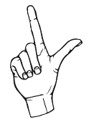 (B) 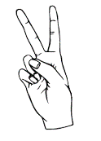 (C) 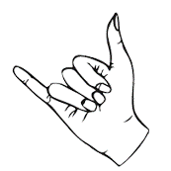 (D) 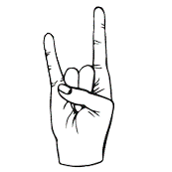

When people arrive in a new country or environment, they may experience culture shock. But what is culture shock?
Culture shock is not caused by a specific event. Instead, it comes from experiencing things that are strange to us. This includes getting to know a new environment, meeting new people, and learning the customs of a different country. Culture shock can affect anyone. It is usually strongest in the beginning. After the excitement of being in a new culture is gone, people begin to miss what is familiar to them, especially their homes.
The signs of culture shock include headaches or stomachaches, difficulty focusing, and crying more than usual. Culture shock can be painful, but it does get better over time. As a person becomes more familiar with a place, the language, people, and how to get around, they become more comfortable.
It is important to remember that culture shock is totally normal. In fact, the experience can be a great learning experience. It can help you develop precious skills and build your self-confidence.

18. What is the purpose of the second paragraph?
(A) To show the good aspects of culture shock.
(B) To discuss the problem of culture shock.
(C) To introduce some ways to reduce culture shock.
(D) To explain what culture shock is about.
19. Which of the following is NOT mentioned as a sign of culture shock?
(A) Loss of friends
(B) Inability to pay attention.
(C) Headaches
(D) Tearfulness.
20. Which of the following statements about culture shock is true?
(A) Only a few people experience culture shock.
(B) Culture shock usually affects people the most in the beginning.
(C) It is better to avoid culture shock because it makes people sad.
(D) Culture shock is caused by a particular event.

