請在電腦答案卡上劃上座號，並將選擇題答案劃卡作答,共40題，劃記不清者，扣總分
5分! 祝同學能有好成績，加油!!
一 、Listening Comprehension Test聽力測驗 10% (共10題) /@1
- 看圖辨義 (2小題)
試卷上該題有一張圖片，請聽一個和該題相關的問題，選一個與所看到圖片最相符的答案。
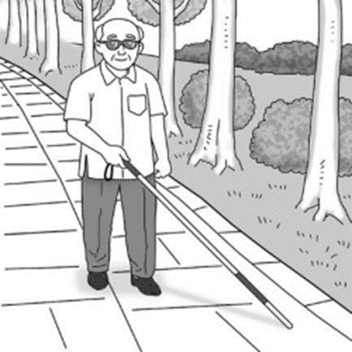
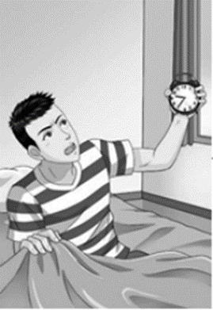
- _____ 2. _____

- 問答 (4小題)
每題會播出一個問句或直述句，聽後請由試卷上選出一個最適合的回答或回應。
  - _____ (A) She is recovering from surgery.
(B) She’s having a great day.
(C) She’ll be out soon.
  - _____ (A) Yes, you can see it from the window.
(B) You can reach the park in five minutes.
(C) Sorry about the problem with your room.
  - _____ (A) I think it was Sony.
(B) Yes, it was my friend Nick.
(C) I’m not sure why they created it.
  - _____ (A) That’s really the best way.
(B) I promise I will give it back.
(C) You must go to bed earlier.
- 簡短對話 (2小題)
每題會播出一段對話及一個相關的問題，聽後請由試卷上選出一個最適合的回答。
- _____ (A) Her hand hurts.
(B) She feels a pain in her head.
(C) Her legs are sore.
(D) She is feeling good.
- _____ (A) The man needs to exercise more.
(B) The man needs to change his diet.
(C) The man doesn’t need to change anything.
- 短文聽解 (2小題)
每題有三個圖片選項。請聽題目，並選出一個最適當的圖片。
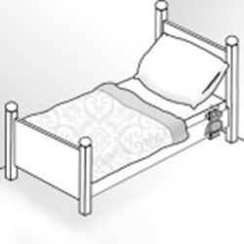
- _____
(A) 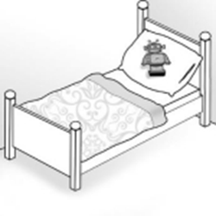 (B) 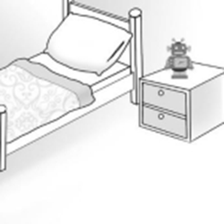 (C)
- _____
(A) 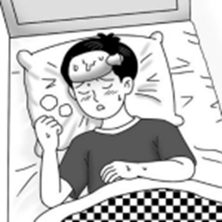 (B) 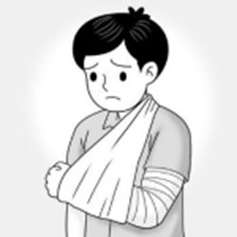 (C) 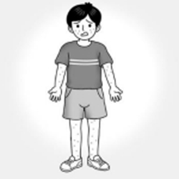
二、文意字彙選擇 20% (11-20題)/@ 2
11. Do you know the between a moth (蛾) and a butterfly?
(A) color (B) difference (C) creation (D) solution
12. Karl Benz was the of the world’s first modern car.
(A) driver (B) image (C) view (D) inventor
13. Our local government must come up with a/an to the serious parking problem. (A) view (B) design (C) solution (D) image
14. Jenny’s brother laughed out loud when she a joke into his ear
(A) whispered (B) woke (C) shook (D) solved
15. Leo’s poem shows that he is a kid with a great .
(A) impression (B) imagination (C) invention (D) solution
16. My grandfather usually takes a in the afternoon.
(A) couple (B) description (C) view (D) nap
17. When we encounter a problem, we should calm down and try to solve it.
(A) impress (B) recover (C) create (D) experience
18. Harold can’t sing at all, but his guitar skills are awesome.
(A) creative (B) different (C) amazing (D) terrible
19. Vincent knew that his uncle was a famous chef after he read the newspaper.
(A) viewed (B) impressed (C) realized (D) prepared
20. Mr. Huang booked a hotel room with a sight of the sea.
(A) view (B) picture (C) secret (D) fair
三、會話10% (21-25題) /@2
21. Mr. Grant: Zoe, why are you late for work?
Zoe: , Mr. Grant. My daughter was sick this morning, and I had to take her to
the doctor.
Mr. Grant: Well then, next time remember to give me a call first.
Zoe: Yes, Sir.
(A) Thank you (B) Apology accepted (C) I apologize (D) It’s your fault
22. Mr. Lin: Eric, would you turn off your cellphone? We’re in class right now.
Eric: I’m turning it off right now. It won’t happen again.
Mr. Lin: Thank you.
(A) My bad. (B) I’m twenty minutes late.
(C) You are wrong. (D) Go back to your seat.
23. Jessica: Sorry, Ms. Simpson. I forgot to bring my English textbook.
Ms. Simpson: Move your desk next to one of your classmates.
Jessica: Thank you, Ms. Simpson.
Ms. Simpson: But you still have to pay attention and take notes!
(A) So far, so good. (B) That’s all right.
(C) Pigs might fly. (D) You can make it.
24. Allen: I can’t sleep well recently. And I always eat a lot for breakfast but don’t feel hungry for the rest of the day.
Bob: Why? Is it because of your new job?
Allen: I have no idea.
Bob:
(A) Don’t be so childish.
(B) Everything seems fine. Don’t worry.
(C) You shouldn’t worry too much about me..
(D) It seems like you need a check-up to find out
25. Phoebe: Chad, I noticed you often eat fried chicken at night.
Chad: Yes, it’s my favorite!
Phoebe: It will only make you fat and unhealthy.
Chad: OK. I’ll try to eat some healthier snacks instead.
(A) You’d better keep it up.
(B) It won’t if you buy me some fried chicken too.
(C) Of course, but I don’t think so.
(D) I suggest that you stop eating that as your late-night snack.

四、文法選擇 10% (26-30題) /@2
26. Rita’s new cellphone while she was shopping in a department store.
(A) stole (B) has stolen (C) was stolen (D) was to steal
27. The twin sisters are my classmates. One is Rita. is Rebecca.
(A) another (B) next (C) other (D) the other
28. Mary has three dresses. One is pink, is blue, and the other is purple.
(A) another (B) next (C) other (D) the other
29. You have to up, or you will be late for school again.
(A) hurries (B) hurry (C) hurrying (D) hurried
30. David asked the salesperson a polite way to stop giving him the hard sell.
(A) by (B) with (C) for (D) in
五、綜合測驗 20% (31-40題) /@2
(1)
Do you always wake up late in the morning? Do you set the alarm at night, then 31 the snooze button the next morning and go directly back to sleep? A study shows 32 40% of all people do this and then oversleep! 33 you are one of them, don’t worry—two amazing new alarm clocks were invented to solve the problem.
The designers of both Tocky and Ramos said that they created their clocks 34 they always overslept. If you have the same problem, maybe you can come up with an even 35 way to wake up without oversleeping. Someday, others may use your idea to wake up, too.
31. (A) take (B) pick (C) put (D) hit
32. (A) this (B) that (C) what (D) which
33. (A) If (B) Because (C) As soon as (D) Since
34. (A) before (B) yet (C) while (D) since
35. (A) good (B) well (C) best (D) better

(2)
When your cellphone rings, do you press the off button and go back to sleep? If yes, two new clocks can help. The first is Tocky, and it 36 like a ball. Tocky rolls around on the floor while ringing. It really 37 a lot of noise! 38 is
Ramos, and it is a different design. To turn it off, you have to place your cellphone near a beacon or enter a code somewhere 39 your bed. 40 , you’ll be up! Which way do you think would work better for you?
36. (A) shapes (B) is shaped (C) is shaping (D) shaped
37. (A) does (B) keeps (C) makes (D) takes
38. (A) other (B) the other (C) another (D) others
39. (A) above (B) close to (C) far from (D) next to
40. (A) Either way (B) One way (C) In addition (D) However

六、字彙及翻譯填充 (手寫題) 30% (共30格: 1-10格, 每格2分/11-20每格1分）
1. The police finally caught the drunk driver after a high-speed c e.
在一陣高速追逐後，警方終於逮到了那名酒駕者
2. You’ll need to do some serious r h before you start writing your report.
在你開始寫你的報告之前，你將需要做些認真的研究。
3. Arvin kept his p e to his wife and did not drink and drive again.
Arvin對妻子遵守承諾，不再酒駕了。
4. A group of birds is flying in a s t line across the sky.
一群鳥兒正成一條直線飛過天空。
5. The boy couldn’t find the words to d e his dream car, so he drew a picture of it.
男孩找不到文字來描述他夢想中的汽車，所以他把它畫出來。

6. Mike’s parents always e e him to work hard and follow his dreams.
Mike的父母一直鼓勵他努力工作，追求夢想。
7. Do you know any good ways to r e the price sticker from this box?
你知道有什麼好方法可以移除這個盒子上的價格標籤嗎？
8. Flora was sh d and upset when she heard the bad news.
當Flora聽到那個壞消息時，她既沮喪又震驚。
9. Ray s red from back pain before, but the pain went away after he started doing gentle
exercise.
Ray以前受背痛所苦，但是在他開始做些和緩的運動後，背痛就消失了。
10.If you want to stay at this popular hotel, you’d better make a reservation three months in
a e.
如果你想要入住這間受歡迎的飯店，最好在三個月前事先預訂。
11-12.學校裡的火災警鈴響起時，所有的學生與老師們都到戶外去。
All the students and teachers went outside when the fire alarm in the school
13-14.下星期我家人將要離開城去度假。
My family is going to g of town for a vacation next week.
15-16.老師向學生詳細解釋這道數學題。
The teacher explained the math problem to the students d l.
17-18. 那位知名男演員於睡夢中安詳辭世。
The famous actor peacefully in his sleep.
19-20. Gary轉身數到10，同時他所有的朋友都去找地方躲起來。
Gary and counted to 10 while all his friends found places to hide.
請分開收卷，以利批閱。同學務必寫上班級／座號／姓名
(注意：非選擇題答案請寫在此答案卷上，任何試題卷上作答均不予計分)
手寫答案卷

六、30% (共20格: 1-10格, 每格2分 / 11-20每格1分）

1. | 2. | 3. | 4. | 5.
6. | 7. | 8. | 9. | 10.
11. | 12. | 13. | 14. | 15.
16. | 17. | 18. | 19. | 20.

