(1)
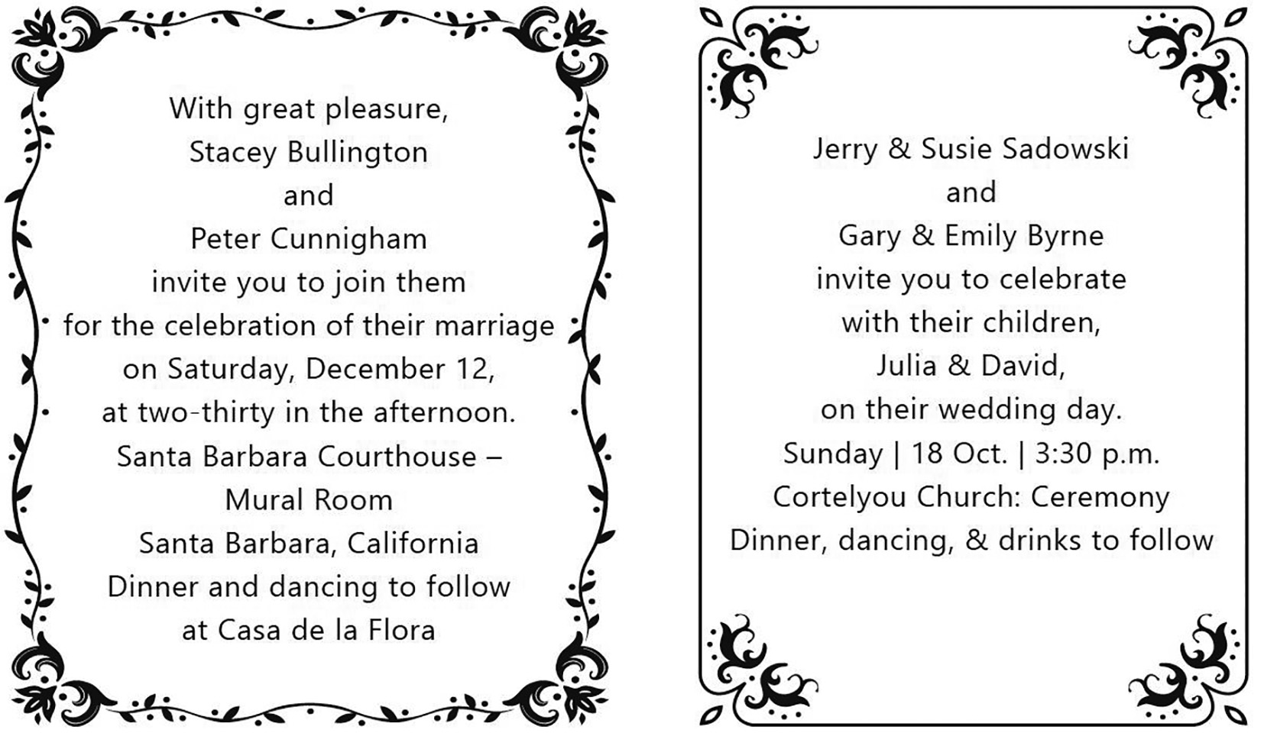
( )1. Which of the following two couples are getting married?
(a) Stacey and Peter; (b) Jerry and Susie; (c) Gary and Emily; (d) Julia and David
(A) (a)(b) (B) (a)(d) (C) (b)(c) (D) (a)(c)
( )2. Which of the following statements about the weddings is NOT true?
(A) Both weddings begin in the afternoon. (B) Both weddings are followed by dinner.
(C) Both weddings are on weekends. (D) Both weddings will be held in restaurants.
(2)
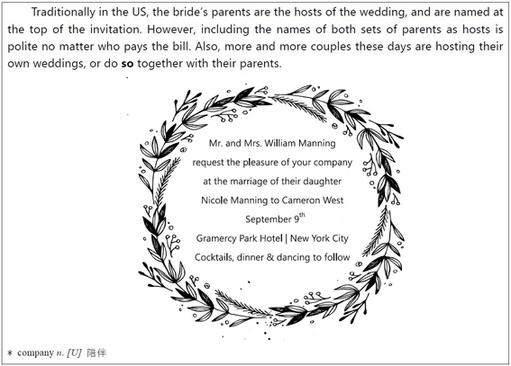
* bride n. 新娘

( )3. What does “so” mean in the first paragraph?
(A) Inviting friends. (B) Getting married.
(C) Holding a wedding. (D)Sending invitations.
( )4. Which of the following is missing in the invitation?
(A) The name of the bride’s father. (B) The location of the wedding.
(C) Who is getting married. (D) What time the wedding will begin.
(3)
My best friend’s Indian wedding last year reminded me of the interesting cultural differences that exist in this world. Unlike the usual one-day weddings in the States, Indian weddings usually last at least three days. It was a large event with over 300 people, as Indians tend to invite all of their friends and family members.
The main wedding activity took place in a large, grand room. Buffet stations were set up outside and servers stood behind each station. I got so hungry as I eyed the huge selection of food, which included oven-baked bread, various types of curry, spiced chicken, and vegetables. I also couldn’t ignore the selection of desserts that included Indian ice cream and sweets made from nuts. Another Indian friend explained that these types of food were mostly from North India. If it had been a South Indian wedding, the food would have been mainly vegetarian and included many different rice dishes. They would have been served on banana leaves with no utensils provided. Who knew there could be such cultural differences in food alone?
( )5. What would be the best title for the passage?
(A) How to Serve Food on Banana Leaves
(B) My Terrible Experience at a South Indian Wedding
(C) A Cultural Difference that Embarrassed and Shocked Me
(D) Cultural Differences: My Experience at an Indian Wedding
( )6. According to the passage, which of the following is true?
(A) Traditional Indian weddings usually only last for a day.
(B) At South Indian weddings, rice dishes are not common.
(C) South Indian wedding dishes usually don’t include meat.
(D) Indian weddings always take place in the open air.
( )7. What can we learn from the very last sentence of the passage?
(A) The writer now knows cultural differences only apply to food.
(B) The writer did not expect Indian weddings to be so different.
(C) The writer doubts whether food is an important part of culture.
(D) The writer is known for having very different opinions on food.
(4)
Corn has been consumed by Americans and people all over the world for centuries. Cornbread is made from corn and holds an important place in American cuisine.
When European settlers first moved to America, they discovered that the soil was not rich, so in many places, corn was the only thing that would grow. They used corn for everything from food to soap. However, eating “corn on the cob” like we do today was not common. Most corn was ground into powder and used to make cornbread.
Soon cornbread became the common table bread. Each family had their own recipe that they would pass down to their children. Cornbread was especially popular because it was so easy to make and required few ingredients. The most basic cornbread can be made with just ground corn, water, oil, and salt.
As time went on and people became richer, they started adding other ingredients such as eggs, milk, and sugar. These additional ingredients changed the heavy cornbread into the lighter and sweeter cornbread we know today.
( )8. What is the main idea of this passage?
(A) Cornbread has become popular because it is easy to make and corn is common.
(B) Cornbread is consumed by Americans and people around the world.
(C) There are many ways to make cornbread, so cornbread has become popular.
(D) Corn can be used to make not only food but also soap.
( )9. Which of the following statements is true?
(A) Corn on the cob was popular among European settlers.
(B) Many cornbread recipes have been lost.
(C) Oil and salt are the basic ingredients to make cornbread.
(D) The cornbread today is heavier and sweeter.
( )10. Why is corn a common plant across the US?
(A) European settlers brought corn to America. (B) European settlers loved corn.
(C) Corn can grow on poor soil. (D) Cornbread is badly needed.
(5)
Before the computer was invented, doctors wrote down their prescriptions* on the paper. Some doctors wrote neatly and clearly, but most did not. They wrote quickly and untidily*. Druggists had a lot of practice in reading doctors’ notes, but sometimes doctors wrote so badly that even the druggist couldn’t read them.
One day a lady wrote a letter to a doctor inviting him to have dinner at her house. The doctor wrote a reply, but he wrote so carelessly that the lady could not read it.
“What shall I do?” she said to her husband anxiously. “I don’t know if he is going to come or not. And I don’t want to phone him and say that I can’t read his writing.”
Her husband frowned thoughtfully. Then he had an idea.
“Take it to the druggist,” he said. “He will be able to read it easily.”
“Thank you,” said his wife gratefully. “That’s a very good idea.”
She went to the drugstore and gave the doctor’s note to the druggist. The druggist looked at it very carefully. Then he got his glasses and looked at the note more closely.
“Could you wait a moment, Madam?” he said politely. He went to the back of his store. After a few minutes, he returned, smiling cheerfully and carrying a large bottle. He gave the bottle to the lady,
“Take one spoonful before every meal, ” he said!
*prescription (n.) 處方籤 *untidily (adv.) 潦草地
( )11. Most of the notes written by doctors are _____________.
(A) neat (B) clear (C) easy to read (D) untidy
( )12. What does “it” in the second paragraph refer to?
(A) the weather (B) the dinner (C) the doctor’s reply (D) the lady’s house
( )13. The doctor in the story wrote a note to the lady to _____________.
(A) answer her letter (B) turn down her invitation
(C) accept her invitation (D) have dinner at her house
( )14. The lady took the note to the druggist because _____________.
(A) she was sick
(B) she could not read it
(C) her husband needed some medicine
(D) her husband had a friend who was a druggist
( )15. Who suggested that the lady take the note to the druggist?
(A) The doctor. (B) The druggist’s friend. (C) The lady’s husband. (D) The lady’s son.
(6)
Cancer is one of the most frightening disease that we may face. But scientists believe that most kinds of cancer are related to your personal life style. This means that you can reduce your risk of getting cancer by making some simple changes in the way you live. The most important thing to do is stop smoking. If you don’t smoke, don’t start. Smoking is the number one cause of cancer.
Secondly, modify* your diet by reducing the amount of fat you eat and by increasing the amount of vegetables and high fiber* food in your diet. In addition, it is important that you do not drink too much alcohol and you try to keep your weight down.
Finally, avoid too much sun. Do not stay outside during the middle of the day if you can help it. Remember, adopting a few healthy habits now can help you to enjoy a long and happy life.
*modify (v.) 改變 *fiber (n.) 纖維
( )16. What is the main idea of this article?
(A) Cancer is a terrible and frightening disease. (B) It is important to eat healthy food.
(C) A few healthy habits can help you avoid cancer. (D) Cancer is usually caused by smoking.
( )17. Which of the following is NOT suggested in this article?
(A) To eat more vegetables. (B) Not to smoke.
(C) To eat more fat. (D) Not to stay under the sun at noon.
( )18. What habit is most likely to cause cancer?
(A) Smoking. (B) Drinking alcohol. (C) Eating meat. (D) Staying outside all day.
( )19. Which statement can be inferred from this article?
(A) Fiber food is fattening
(B) Fat people are more likely to get cancer.
(C) Sun is always good for our health.
(D) Changing your lifestyle can completely (完全地) avoid the danger of cancer.
( )20. This article is most likely to be found in _____________.
(A) a sports magazine (B) a health magazine
(C) a fashion magazine (D) a magazine about economics

