新北市立新北高工111學年度第1學期 開學考 試題 |  |  |  |  |  |  |  |  |  | 班別 | 甲 乙 | 座號 |  | 電腦卡作答
科 目 | 英文 | 命題  教師 | 施懿珊 | 審題教師 | 林信宏 | 年級 | 一 | 科別 | 應英 | 姓名 |  |  |  | 是

第一部份：單題 62.5%（共25題，每題2.5分）

- （ ）Look at the picture. What is the boy in the bed doing?
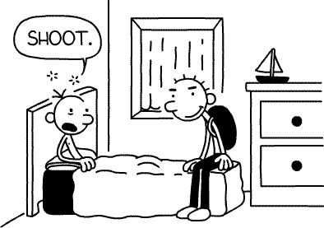
(A) He is speaking. (B) He is swearing.
(C) He is talking to himself. (D) He is smiling.
- （ ）A: May I speak to Tom?
B: _____. What’s the matter?
- This is Tom speaking.
- Hold on, please.
- Wait a moment.
- Would you like to take a message?
- （ ） Tom drank _____ bottles of wine yesterday. There are just a few bottles left for us to drink tonight.
(A) some (B) few (C) many (D) much
- （ ）Joan loves reading but she does not have much money to buy books. She is happy that there is a public right next to her house.
(A) garden (B) library (C) playground (D) restroom
- （ ）Ms. Smith is at telling stories, so all of her students enjoy story time in her class very much.
(A) convenient (B) excellent
(C) lucky (D) ready
- （ ）Waiter：Are you ready to take an order?
Mr. Ya：____.
- Yes, I am very hungry.
- I would like some hamburgers.
- Yes, I would like to.
- Can you pass the salt to me?
- （ ）Everyone mistakes in his or her life. The important thing is not to repeat them.
(A) does (B) forgets (C) makes (D) takes
- （ ）The driving test is not very difficult, and most people are to pass it.
(A) able (B) afraid (C) correct (D) serious
- （ ）I was not home when the brought the package, so I’ll have to get it myself at the post office.
(A) bus driver (B) mail carrier (C) police officer (D) shopkeeper
- （ ）We don’t have enough toys for each child, so they will have to them with each other.
(A) follow (B) prepare
(C) repeat (D) share
- （ ）Derek：Oh, I missed the ball game on TV.
Frank：You can watch it on the .
Derek：But I don’t have a computer.
(A) blackboard (B) Internet (C) playground (D) tape
- ( ) Most of Jeff’s best books when he was sick and poor.
(A) have written (B) were written
(C) would write (D) wrote
- （ ）Before Dad came to my bedroom, I _____ my homework.
(A) was finishing (B) finished (C) had finished (D) will finish
- （ ）Grace: How many people in the office when the fire happened?
Harry: Five. Luckily, nobody got hurt.
(A) did they (B) had they (C) were there (D) would there be
- （ ）Gary：I can’t find my pen.
Nina：Is the one on Jack’s desk ?
Gary：Yes, thank you.
(A) mine (B) ours (C) theirs (D) yours
- （ ）Jason felt bored staying at the hotel, so he asked me to take him for a ____.
(A) bath (B) rest (C) vacation (D) ride
- （ ）Lisa is new here, so she doesn’t know the restaurant is.
(A) that (B) where (C) whether (D) which
- （ ）Ken’s brothers like to watch tennis, but Ken . He is crazy about baseball.
(A) is (B) isn’t (C) does (D) doesn’t
- （ ）The little boy jumped up and down happily when he saw a bee into the house.
(A) flown (B) to fly (C) flying (D) has flown
- （ ）A: I heard your mom ____ on the street? B: Really? Oh, that’s terrible.
(A) danced (B) to dance (C) dancing (D) are dancing
- （ ）Mr. Yang has worked in this factory 1968.
(A) before (B) for (C) in (D) since
- （ ）_____ you come or not is not important, we have already had our own dancing partner.
(A) When (B) If (C) Whether (D) No matter when
- （ ）For the last two month, Rick _____ five pounds.
(A) gains (B) gained (C) have gained (D) has gained
- （ ）On the way to work, Natasha was surprised to find she was wearing a white earring on one ear and a gray earring on .
(A) another (B) the next (C) the other (D) the second
- （ ）Learning foreign languages me to know more about other countries.
(A) helps (B) helping
(C) help (D) to help

第二部份：題組 37.5%（共15題，每題2.5分）

Last night I had a bad dream. In my dream, I 26. to a room by three strange-looking people. They talked to each other in a language I didn’t understand. I didn’t know what they 27. to me. Would they do anything bad? I was so afraid that I started to cry. Suddenly, one of them came up to me and tried to hurt me with a knife. I cried out loudly and then I 28. up. Luckily, there were no people around-I was in my own bed!
 strange-looking 長相奇怪的 suddenly 突然得
26. ( ) (A) am takenˉ(B) was taken
(C) have been taken ˉ(D) would be taken
27. ( ) (A) are doingˉ(B) didˉ
(C) have doneˉ(D) would do
28. ( ) (A) wakeˉ(B) wokeˉ
(C) was wakingˉ(D) was going to wake
Dear Mark,
How is everyone? I’m now in Cork for 29. . Life is very busy here.
I have 30. hours of English class a week. From Monday to Friday, there are four classes every morning for listening, speaking, reading, and writing, one hour for each. In the afternoon, I have PE classes for different sports, and I really enjoy my time 31. , running and laughing with my new friends. I’m flying back in August. I’ll tell you more about my life here. See you then.
Best wishes
Howard
29. ( ) (A) a summer school (B) a special art show
(C) doing some business
(D) visiting a friend of mine
30. ( ) (A) four (B) five (C) twelve (D) twenty
31. ( ) (A) after breakfast
(B) on the Internet
(C) for popular music
(D) outside the classroom

Moonspeak is a kind of language used on the Internet. People who talk in moonspeak use numbers, simple words, and even symbols to replace (取代) the difficult ones. For example, they would use LOL for laugh out loud. They would also use “ u r l8” instead of saying, “You are late.” For Chinese, they would use 881 for bye-bye because the sounds are alike. They would also use some symbols to express (表達) their meaning. “:p” is a good example of this, which means you are sticking out your tongue. “XD” means that you are laughing happily. However, while most people think that moonspeak is not a formal language, some moonspeak seems to appear on students’ homework. That is terrible for their teachers.
32. ( ). What is so special about moonspeak.
(A) It uses symbols.
(B) It uses numbers.
(C) It uses simple words.
(D) All the above.
33. ( ) Why do Chinese people use 881 for bye-bye?
(A) Because they are moonspeak.
(B) Because they are not formal.
(C) Because they are languages.
(D) Because they sound alike.
34. ( ) If you friend showed “XD” to you, why he did it?
(A) Because you had a bad day.
(B) Because you love him,
(C) Because you told a bad joke.
(D) Because you just told him a great joke.

What comes to your mind when you hear the word “twins”? Born on the same day? Looking almost the same? Or having same hobbies? Well, I have a twin brother who was born on a different day from me. We do not look very much alike and we are always interested in different things.
Twelve years ago, my brother, Wayne, was born at eleven fifty-eight on the night of May 28. Five minutes later, I was born – on May 29. Since the time we were born, I have always been heavier and stronger than Wayne, so people usually think I am the older brother.
But Wayne is always smarter than I. He loves reading and learns many things quickly. He knows a lot about animals, although he does not spend much time with our dogs and birds. He knows a lot about bicycles, but never likes to ride bikes as much as I do.
Though we are very different, I love my brother very much. I hope both of us can have a happy life in the future.
35. ( ) Which is most likely the picture of the twins in the
reading? most likely 最有可能
(A) 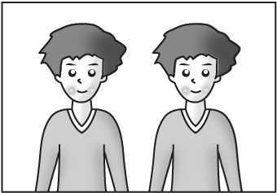 (B) 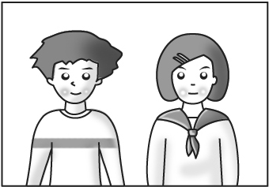
(C) 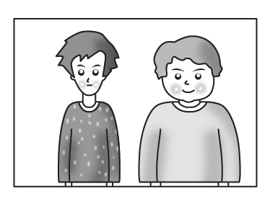 (D) 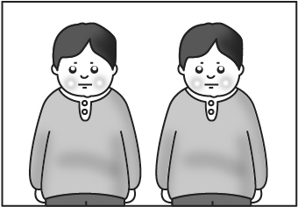
36. ( ) What do we know about the twins?
(A) They are twelve years old.
(B) They have the same interests.
(C) They were born on the same day.
(D) They both want to be teachers in the future.
37. ( ) Which is true about the writer?
(A) He has several pets.
(B) He is the older one of the twins.
(C) He does not enjoy reading a bicycle.
(D) He does not like to stay with his brother.

Read the diary and answer the following questions.

Tuesday, December 14th
Today Mr. Underwood, the Phys Ed teacher, made an announcement (公告). He said the girls and the boys will be doing separate (分開的) units for the rest of the month. The girls will be doing gymnastics (體操), and the boys will be doing wrestling (摔角).

Now, if there is one thing the boys in my school are into, it’s professional (職業的) wrestling, so everyone was wired after the announcement. Lunch comes right after gym, so the cafeteria (學生餐廳) was a total madhouse (瘋人院).
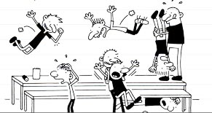

38. ( ) What does Mr. Underwood teach?
- He teaches people how to do exercise.
- He teaches people how to play games.
- He teaches people how to dance.
- We don’t know.
39. ( ) What does wired mean?
(A) interested (B) satisfied
(C) bored (D) excited
40. ( ) How do the boys feel about wrestling?
- They like it. (B) They hate it.
- They are not familiar with it.
- They are professionals.

一、1-10 BACBBBCABD 11-20 BBCCDDBDCC
21-25 DCDCA
二、26-30 BBBAD 31-35 DDDDC 36-50 AAADA

