市立新北高工111學年度第1學期 開學考 試題
科 目 | 英文 | 命題  教師 | 陳玟如 | 審題教師 | 劉欣潔 | 年級 | 二 | 科別 | 機鑄汽模圖電資訊
一、單片與同義字選擇
- （ ）Simon’s parents are quite ____________ about his poor grades in school and have asked him to study harder.
(A) difficult (B) disappointed (C) bored (D) romantic
- （ ）David sent a(n) ____________ to his wife to tell her that he would get back home at around 10 p.m.
(A) relationship (B) introduction (C) connection (D) message
- （ ）Peter ____________ his new girlfriend to everyone at the party.
(A) introduced (B) enabled (C) cheered (D) communicated
- （ ）Many people trust Jessica because she is a(n) ____________ girl.
(A) delicious (B) cracked (C) honest (D) actual
- （ ）Richard is very ____________ with his students. They all love him.
(A) popular (B) meaningful (C) traditional (D) shameful
- （ ）Students are always told to ____________ their elders.
(A) avoid (B) reserve (C) regard (D) respect
- （ ）There is a(n) ____________ smell in this room, and it is making me sick.
(A) meaningful (B) traditional (C) ashamed (D) awful
- （ ）Tracy ____________ the printer to her computer, and then printed out some family photos. (A) connected (B) confirmed (C) considered (D) complained
- （ ）Jason decided to read lots of books in order to gain more ____________ on the subject. (A) knowledge (B) response (C) attention (D) introduction
- （ ）My pain ____________ after I took some medicine and had a good sleep.
(A) disappeared (B) disappointed (C) connected (D) communicated
- （ ）The teenager ____________ his parents’ warning and went swimming in the dangerous lake; as a result, he almost drowned.
(A) connected (B) agreed (C) ignored (D) aimed
- （ ）Mark ____________ his living room with a painting by a famous modern artist. (A) scattered (B) reserved (C) praised (D) decorated
- （ ）In modern ____________, smartphones are a must for people to communicate efficiently. (A) society (B) emotion (C) crack (D) flaw
14.（ ）Lawrence ____________ dogs to cats. You can say that he is a dog person.
(A) prefers (B) maintains (C) respects (D) lacks
班別 |  | 座號 |  | 電腦卡作答
姓名 |  |  |  | 是
15.（ ）Fruit is good for you because it ____________ lots of vitamin C.
(A) donates (B) prefers (C) rescues (D) contains
16. ( ）To many teenagers, the mobile phone is not only a way of ____________ but also a very important part of their daily lives.
(A) introduction (B) communication (C) relationship (D) attention
17. ( ）I don’t think I have the ____________ to go any further. Let’s take a break.
(A) strength (B) lack (C) emotion (D) weight
18.（ ）Are you entirely sure about the café’s closing time?
(A) hardly (B) simply (C) carefully (D) completely
19.（ ）Brendon is a very clever boy who learns very quickly.
(A) intelligent (B) normal (C) romantic (D) cheerful
20.（ ）I like to eat the dishes my mom makes because all of them are tasty.
(A) traditional (B) awful (C) local (D) delicious
21.（ ）We all thought that you agreed with our work arrangements because you didn’t
reply soon. (A) respond (B) bother (C) arrest (D) charge
22.（ ）It took five people and two dogs to save the climber who had been trapped in the valley for three days. (A) imagine (B) cause (C) rescue (D) offer
23. （ ）Scott seldom ____________ his teacher for help because he is very shy.
(A) hangs out (B) takes personally (C) turns to (D) goes through
24. （ ）Alex ____________ the race and won first place.
(A) set up (B) took part in (C) was born with (D) was known as
25. （ ）Tina ____________ math, and she often gets a perfect score on her math tests. (A) gives up (B) turns to (C) is good at (D) takes part in
二、對話
26.（ ）Kevin: I forgot to bring my wallet. Can you lend me some money?
Harry: Sure. Here you are.
Kevin: Thanks a million! I’ll return it to you as soon as possible.
Harry: ____________
(A) It’s my money. (B) I like cold drinks. (C) You’re welcome. (D) That’s my fault.
27.（ ）Clark: May I dig in now? Mom: ____________
Clark: It’s really delicious! Mom: I am glad you like it!
(A) No. I can’t stay here much longer. (B) No. I think I have to go.
(C) Sure. It is sunny today. (D) Sure. Bon appétit!
(請翻頁繼續作答)
28.（ ）Adrianne: George just broke up with me.
Naomi: ________________________ Is there anything I can do for you?
(A) I’m sorry to hear that. (B) Why don’t you leave him?
(C) You broke my heart. (D) I feel bored when he’s not around.
29.（ ）Donald: ( It’s raining heavily.) I have an extra umbrella I can lend to you.
Kelly: Really? Thanks so much! I’ll return it to you tomorrow.
Donald: ____________
(A) Count me in. (B) It’s no big deal. (C) Way to go. (D) Give me a break.
30.（ ）Susan: Thanks for inviting me to the party. I really enjoyed it.
Johnson: ________________________ You are very welcome to join us again.
(A) My pleasure. (B) What a pity! (C) I can’t believe it. (D) Be cool.
31.（ ）Alison: Would you like to join the charity marathon this weekend?
Peter: I don’t really like running. ____________
(A) Let me join you. (B) I go jogging daily.
(C) Let me think about it. (D) I like long-distance races.
- 文法選擇(課本句型)
32.（ ）It is boring to ____________ the same thing every day.
(A) doing (B) did (C) done (D) do
33.（ ）Jason’s rude words made Helen ____________.
(A) cry (B) cried (C) cries (D) crying
34.（ ）I ____________ Zack since he moved to Taipei last year.
(A) didn’t see (B) haven’t seen (C) don’t see (D) hadn’t seen
35.（ ）I’m wondering ____________ Nick is angry at me.
(A) what (B) when (C) why (D) where
36.（ ）This is the new song ____________ was released online yesterday. Isn’t it cool? (A) which (B) × (C) what (D) who
37.（ ）The little child ____________ Zoe is playing with is my nephew.
(A) when (B) which (C) who (D) what
38.（ ）Lily is ____________ than her brothers and sisters. She paints and sings very well. (A) most talented (B) the most talented (C) more talented (D) the more talented
39.（ ）Lisa told us ____________ sad story that we were all moved to tears.
(A) so a (B) a so (C) such a (D) a such
40.（ ）Joana can speak English as ____________ as an American.
(A) well (B) good (C) better (D) best
41.（ ）The college ____________ Wendy goes to is a world-famous one.
(A) what (B) who (C) whom (D) that
42.（ ）There are plenty of museums in New York. One of ____________ is the Metropolitan Museum of Art. (A) the good (B) the best (C) better (D) more better
四、綜合測驗
This is a heartwarming* story of a man and his son. The man, (43)____________ Dick Hoyt, had a boy, Rick. Rick was born with a rare disease. The disease meant there was little hope that Rick would live a normal life. However, Dick and his wife kept (44)____________ their son. One day, when he was 15, Rick told his father (45)____________ he wanted to participate in a running race with him. Rick couldn’t walk, so Dick had him (46)____________ in his wheelchair and pushed him. They finished second (47)____________ last. However, they realized that they loved running together. They would go on to race together all over the US as Team Hoyt.
*heartwarming adj. 感人的
（ ）(43) (A) that (B) was (C) is (D) ×
（ ）(44) (A) teaching (B) taught (C) to teach (D) teaches
（ ）(45) (A) which (B) what (C) that (D) whom
（ ）(46) (A) sitting (B) sit (C) sits (D) sat
（ ）(47) (A) of (B) in (C) to (D) for
五、素養題
- 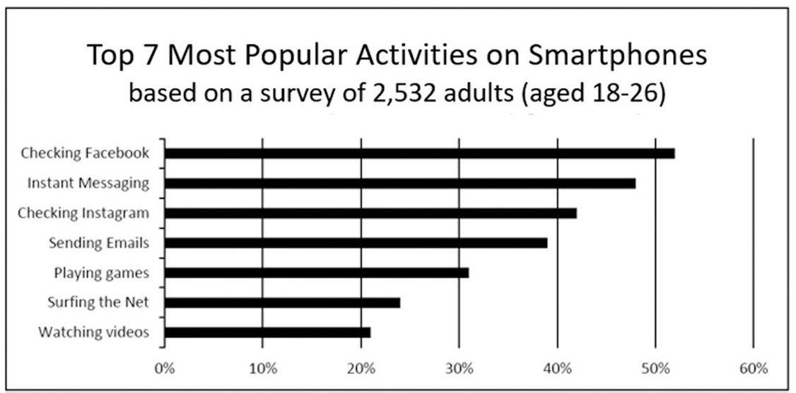
（ ）(48) According to the data above, what activity does the average young adult spend the most time on?
(A) Checking Facebook. (B) Checking Instagram.
(C) Playing games. (D) Watching videos.
（ ）(49) Who of the following was most likely to have been surveyed for this data? (A) A junior high school student. (B) A college student.
(C) Frank’s grandfather. (D) A newborn baby.
( ) (50) According to the data, about 40 % of people spend the most time on _______.
(A) Checking Facebook. (B)Sending E-mails.
(C) Playing games. (D) Watching videos.

#共50題，請在答案卡上作答。請確實劃好座號，座號未劃記正確者酌扣十分!

