- 請將答案畫記在電腦答案卡上，同時畫記班級和座號，未畫者，酌扣總分5分!

I素養題

＊solar adj. 太陽的 ＊diameter n. [C] 直徑 ＊billion n. [C] 十億
（ ）1. Which of the following is NOT true?
(A) There are eight planets in our solar system.
(B) Only Mercury and Venus don’t have moons.
(C) Saturn is the farthest planet from the Sun.
(D) Jupiter is the biggest planet in the solar system.
（ ）2. Which of the planets is closest to the Sun?
(A) Venus. (B) Mercury. (C) Saturn. (D) Mars.

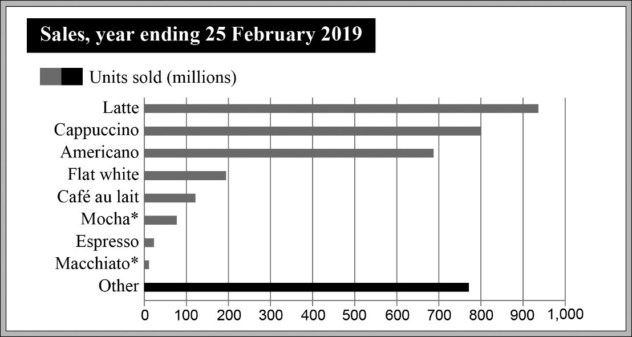
＊Mocha n. 摩卡 ＊Macchiato n. 瑪奇朵
（ ）3. What’s the best title for this chart?
(A) Japan’s Best Coffee Brand. (B) Taiwan’s Coffee Chain Stores.
(C) The UK’s Favorite Coffee Drinks. (D) America’s Coffee History.
（ ）4. Which of the following is NOT true?
(A) Flat white had almost 200 million units sold.
(B) Latte had the most units sold.
(C) Mocha had more units sold than Macchiato.
(D) Americano had more than 700 million units sold.

*lifespan n.[U] 壽命 *bush n.[C] 樹叢 *stem n.[C] 莖 *sugar cane 甘蔗

（ ）5. What is the purpose of this table?
(A) To say what will happen. (B) To make some comparison.
(C) To make people laugh. (D) To teach people a skill.
（ ）6. According to the table, which of the following is NOT suggested?
(A) We can tell the difference by looking at their ears.
(B) Both kinds of elephant get their food only in the wild.
(C) African elephants live longer than Asian elephants.
(D) Asian elephants seem less likely to survive.

（ ）7. What is the purpose of the above text?
(A) To honor nature. (B) To educate people.
(C) To indicate danger. (D) To sell something.
（ ）8. According to the description, which of the following is true?
(A) The fruit came from foreign countries.
(B) There are three different flavors.
(C) The dessert is juicy, like fresh fruit.
(D) You need to eat the dessert within 30 days.

.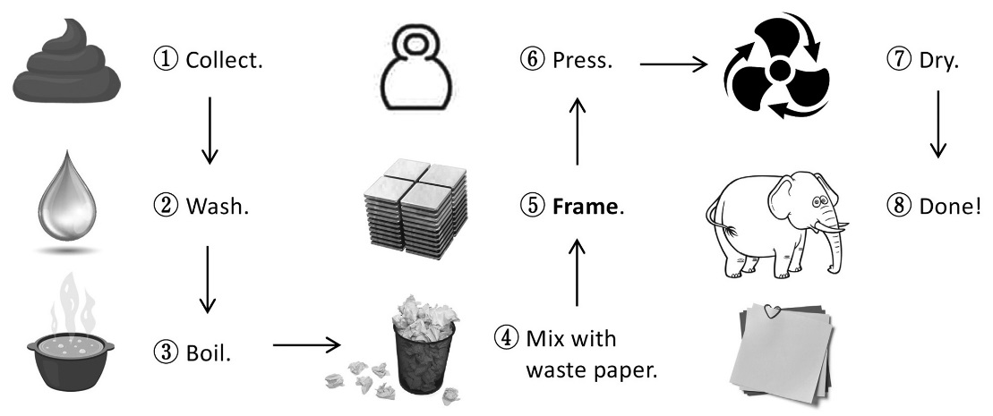
（ ）9. What is the purpose of this chart?
(A) To show how to make something.
(B) To show when to do something.
(C) To show which group something belongs to.
(D) To show who is responsible for something.
（ ）10. What does the word “frame” mean in this chart?
(A) To discuss a plan. (B) To say something carefully.
(C) To draw something. (D) To give something a shape.
II閱讀測驗
- When we think of bugs and insects, we usually think of them as being “dirty.” But a recent report by the United Nations says that we should all eat insects. Experts believe that eating bugs could be the solution to the world’s hunger problem. This is because bugs are high in vitamins* and easier to produce compared to beef or pork.
Although dining on insects might sound gross, these bugs have been eaten for thousands of years. In fact, two billion* people around the world eat insects regularly, and there are about 2,000 types to choose from. The most commonly eaten insects are beetles, bees, and ants. They can be eaten sweet, salty, or in sandwiches. But don’t worry, eating bugs will not make you sick. These tasty creatures are washed and cleaned before they are cooked.
Even so, it’s hard to imagine a day when we will be buying barbequed spiders as a snack. What do you think about eating insects? Would you be brave enough to try a baked cockroach or honey-flavored ants?
＊vitamin n. [C] 維他命 ＊billion n. [C] 十億

（ ）11. What’s the best title for this passage?
(A) Dining on Bugs—A Solution to World Hunger and a New Food Choice
(B) Eating Bugs—A Way to Protect the Environment and Humans
(C) Catching Bugs—A Way to Help Farmers and Plants
(D) Buying Cooked Bugs—Another Choice for Vitamin Pills
（ ）12. Which of the following is true?
(A) People have eaten insects for a few hundred years.
(B) Butterflies are one of the most-eaten insects.
(C) A report by the United States suggested everyone eat bugs.
(D) People can safely eat bugs after they are cleaned and cooked.
（ ）13. What does the word “gross” possibly mean in this passage?
- Not salty. (B) Not fresh. (C) Not sweet. (D) Not pleasant.

2. Visiting an elephant camp is a very popular activity in Thailand. Visitors can ride elephants through the jungle*, help them take a bath, or feed them. At some elephant camps, the elephants have even been trained to do tricks or draw pictures.
Unfortunately, there is a dark side to elephant tourism*. To teach the elephants to do tricks, the trainers often hurt them. For example, they use sharp hooks* to hurt their ears. What’s more, carrying people all day can hurt an elephant’s back, and the chair that is placed on their back can break their skin.
However, not all elephant camps are bad. The Elephant Nature Park in Chiang Mai, Northern Thailand is one example. This park rescues elephants from all over Thailand and tries to make their lives better. Many of them have been hurt badly by their former trainers. Some are even blind because their trainers hurt their eyes. Visitors can stay there and help take care of them. If you decide to visit an elephant camp, make sure it is a good one like this.
* jungle n.[C] 叢林 * tourism n.[U] 觀光業 * hook n.[C] 鈎

（ ）14. What does the author suggest in this passage?
(A) Elephant trainers must be punished.
(B) Elephant camps are fun for everyone.
(C) Visitors should choose an elephant-friendly camp.
(D) Elephants should be trained to serve humans.
（ ）15. In this passage, which of the following is NOT one of the things that elephants are taught?
(A) Doing tricks. (B) Drawing. (C) Rescuing people. (D) Carrying people.
（ ）16. According to the passage, which of the following is NOT true?
(A) Elephants are important for the tourism industry in Thailand.
(B) Visitors can help elephants take a bath in elephant camps.
(C) The main focus of the Elephant Nature Park is caring for elephants.
(D) Elephant trainers are the only ones that hurt elephants in Thailand.
（ ）17. The dark side to elephant tourism may hurt elephants; which of the
following may not be the body part that humans inflicted(傷害) on elephants?
(A)Their backs. (B)Their skins. (C)Their mouth. (D) Their ears.

3. In Indonesia*, there is one very special way to make coffee. People feed coffee beans to the civet*, a cute, furry animal. Then, they collect the beans from the animal’s dung and use them to make coffee. Drinkers say this coffee is really delicious and smooth. It can be sold for up to US$100 per cup, and this makes it one of the most expensive coffees in the world. Many coffee shops in other countries even buy civet coffee from Indonesia.
However, there are some problems with the civet coffee industry. Civets are often kept in very small cages. They are forced to eat large amounts of coffee beans to make more civet coffee. They are also kept awake all day, even though they should sleep during the daytime. One animal protection organization found that these animals were not healthy at all. If you see civet coffee on a café menu, it is best not to order it.
* Indonesia n. 印尼 * civet n.[C] 麝香貓

（ ）18. What is this passage mainly about?
(A) A country. (B) An organization. (C) A cup. (D) A drink.
（ ）19. How does the author feel about civet coffee?
(A) Positive. (B) Excited. (C) Negative. (D) Not interested.
（ ）20. Which of the following about civet coffee is NOT true?
(A) It is sold to shops around the world.
(B) It is an animal-friendly product.
(C) It comes from animal waste.
(D) It costs a lot of money.

Winners do what losers don't want to do.
勝利者做失敗者不願意做的事！

