一 、Listening Comprehension Test聽力測驗 10% (共10題) /@1
- 看圖辨義
試卷上該題有一張圖片，請聽一個和該題相關的問題，選一個與所看到圖片最相符的答案。
- _____ 2.______
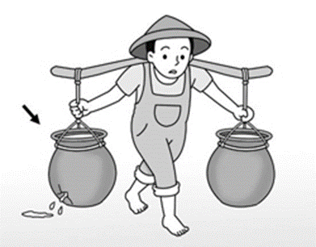
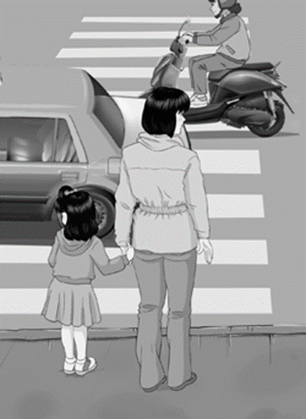
right

- 問答 (4小題)
每題會播出一個問句或直述句，聽後請由試卷上選出一個最適合的回答或回應。
  - (A)My parents bought all these things.
(B) We moved to a new house.
(C) Thanks to my brother’s help.
  - (A) I’ll bring you one right away.
(B) I don’t know how to use chopsticks.
(C) That one is for eating dessert.
  - (A) Don’t be ashamed. It happens.
(B) I’m glad to hear you passed.
(C) What a great idea!
  - (A) A popular new Thai restaurant.
(B) Yes, this is a local restaurant.
(C) Because everyone loves this restaurant.
- 簡短對話 (2小題)
每題會播出一段對話及一個相關的問題，聽後請由試卷上選出一個最適合的回答。
- (A) Because Kevin helped her.
(B) Because she prepared a lot.
(C) Because she had good luck.
- (A) He is telling the truth.
(B) He has some other ideas.
(C) He also wants to give a speech.
(D) He actually didn’t like the speech.
- 短文聽解 (2小題)
每題有三個圖片選項。請聽題目，並選出一個最適當的圖片。
9.
(A)  (B)  (C) 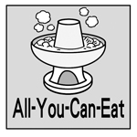

10.
(A) 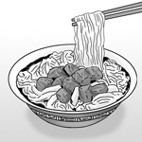 (B) 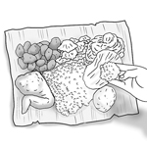 (C) 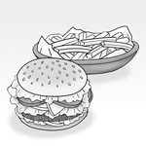
二、文意字彙選擇 20% (11-20題)/@ 2
11. It is that some people smoke next to where the children play in the park.
(A) wonderful (B) honest (C) popular (D) shameful
12. Danny was in an awkward when Diana turned down his invitation.
(A) situation (B) tradition (C) society (D) respect
13. You need to save some money before you go to study . Living in another country can
be expensive.
(A) daily (B) indeed (C) properly (D) abroad
14. Billy threw the ball across the field, and his dog ran to it.
(A) regard (B) fetch (C) decorate (D) apologize
15. This online game is now very with teenagers. Almost everyone at school knows
about it.
(A) popular (B) traditional (C) social (D) local
16. To cut your steak, you need to use appropriate steak knife, not a butter knife.
(A) awful (B) actual (C) delicious (D) proper
17. One of Anne’s shortcomings is that she is always late for school.
(A) flaws (B) cracks (C) apologies (D) emotions
18. My truthful opinion is that this novel is very well written.
(A) shameful (B) honest (C) awesome (D) damaged
19. Though healthy eating is important, it is okay to have special treats occasionally.
(A) as usual (B) for example (C) in fact (D) from time to time
20. Ian is watching out for any taxi which may be passing by right now.
(A) good at (B) taking action
(C) paying off (D) keeping an eye out for
三、會話10% (21-25題) /@2
21. Ben: Hey, Gina. Do you have a minute? I just wanted to say thanks.
Gina: Oh, sure. But what for?
Ben: Well, the other day you pointed out a weak point of mine. At the time I was angry, but actually it helped me a lot.
Gina: After all, what are friends for?
(A) So far, so good. (B) Just between you and me.
(C) Don’t mention it. (D) That’s a good point.
22. Gloria: Shall we get this book for your baby brother?
Brian: Let me see. Oh, is this the story about the old jar that doesn’t know how useful it is?
Gloria: Yes, it is. It’s a great story, isn’t it? Kyle will love it.
Brian: Uh, , I’m not sure what kind of books he likes to read these days.
(A) on the other hand (B) to be honest
(C) don’t mention it (D) just to make sure
23. Lee: Thanks for inviting me to your place for Christmas!
David: Is this your first Christmas in the UK?
Lee: Yes, it is! I’m so excited.
(A) Bless you. (B) My pleasure.
(C) I’m fine, thank you. (D) I’m ready to give it a shot
24. Iris: Have you tried fried insects before?
Jacob: No, I haven’t, and .
Iris: Why not?
Jacob: They just look disgusting to me.
(A) I will never give them a try (B) I don’t think so
(C) they must be delicious (D) please excuse me
25. Lisa: In Taiwan, it is not okay to leave your chopsticks upright in a bowl of rice.
Zoe: Really? Why not?
Lisa:
(A) You can use a fork. (B) It is polite to do so.
(C) That’s interesting. (D) It is a taboo in the local culture.

四、文法選擇 10% (26-30題) /@2
26. Tokyo is ________ city in Japan.
(A) much busy (B) the very busy (C) the busiest (D) more busy
27. When it comes to _______, Michael Phelps is a very excellent swimmer in the world.
(A) swim (B) swims (C) swimming (D) swum
28. Eve and I haven’t met for years. Now she is _______ and _______ than before.
(A) slim; beautiful (B) very slim; much beautiful
(C) more slim; more beautiful (D) slimmer; more beautiful
29. To earn more money, one of my goals for this year is to work than before.
(A) even harder (B) very harder (C) little harder (D) less hard
30. To save power, please remember ___________ the light when you leave the classroom.
(A) turn off (B) to turn off (C) turning off (D) turned off
五、綜合測驗 20% (31-40題) /@2
(1)
Different countries have different eating habits. 31 , in Japan, eating loudly means you think the food is very tasty. Koreans, on the other hand, are 32 at meal times. In Taiwan, most people eat with chopsticks, 33 people in Europe mainly use a knife and fork. In India, the custom is to use the right hand to eat. This is because the left hand is 34 going to the bathroom and considered “dirty.” So be sure to check local customs.
These are just 35 of the different eating habits found around the world. Have you seen any other interesting customs when you traveled?
31. (A) However (B) Thus (C) For example (D) Such as
32. (A) quietly (B) more quietly (C) quieter (D) quietest
33. (A) while (B) if (C) before (D) so
34. (A) used as (B) used for (C) regarded as (D) known for
35. (A) little (B) a little (C) few (D) a few
(2)
There are different eating customs in different parts of the world. 36 Japan, people enjoy slurping ramen loudly. It shows that they can’t wait 37 the tasty food in their mouths and to honor the chef. In Korea, those at the table wait patiently for their elders to start eating first. It is a way 38 their respect. Moreover, in India, people eat food 39 the fingertips of right hand. The locals believe that this is 40 satisfying way to enjoy a meal. Since you’ve learned about some different eating customs, you should be ready to travel around Asia. And don’t be afraid to try these unique ways of eating!
36. (A) Speaking of (B) To speak (C) Speak with (D) Speak to
37. (A) getting (B) to get (C) gets (D) gotten
38 (A) to showing (B) of show (C) to show (D) shown
39. (A) by (B) with (C) on (D) in
40. (A) much good (B) many more (C) the very (D) the most

六、字彙及片語填充 (手寫題) 30% (共20: 1-10格, 每格2分/11-20每格1分）
1. Audrey說幫助醫院裡的病人使她的生活更有意義。
Audrey said that helping the sick in the hospital has made her life more m l.
2. 為了減重爸爸一直避免吃宵夜。
Dad has been trying to a d eating midnight snacks to lose some weight.
3. 這些餅乾是保留給明天的茶會用的，所以我們現在不能吃。
These cookies are r ved for our tea party tomorrow, so we can’t eat them now.
4. 印度人對於如何將食物送入口中，比其他大部分的人更為講究得多。
Indians are far more p r than most people about how they put the food into their mouths.
5. 孩子們在遊樂場玩了一上午後整個胃口大開。
After the kids played on the playground all morning, they had a huge a e.

6. 我家附近的人行道都有裂縫，因為它們是好多年前建造的。
The sidewalks in my neighborhood are all c d because they were built many years ago.
7. 農夫在他的菜園周遭撒了植物的種子。
The farmer s red the plant seeds around his vegetable garden.
8. 消防員們因為在地震後從倒塌的建築物中救出一個嬰兒而受到大家的致敬。
The firefighters were h red for saving a baby from the collapsed buildings after the earthquake.
- 這台車的老引擎正在漏油到路上。
The car’s old motor is l king oil onto the road.
10. 如果你看到水龍頭在滴水，請關上它。
Please turn off the faucet if you see that it is d ping.
11-12. 既然你已經思考出解決方法，你應該付諸實現。
(N) 11 12 you have come up with a solution, you should put it into practice
13-14. 下個月我們可能會去臺東拜訪一些朋友。
We are (l) 13 14 visit some friends in Taitung next month.
15-16. 從前從前，有三隻小豬住在森林裡。
(O) 15 16 a time, there were three little pigs that lived in a forest.
17-18. Mandy非常喜歡球類運動，例如，籃球是她最喜歡的。
Mandy likes ball games very much. 17 (i) 18 , basketball is her favorite
sport.
19-20. 這個兒子看似嚴肅，但是他的母親一直都知道他只是在開玩笑。
The son looked serious, but his mother knew (a) 19 20 that he was only
kidding.

請同學務必在此答案卷上寫班級／座號／姓名
(注意：六、1-20答案請寫在答案欄內，任何試題卷上作答均不予計分)
手寫答案卷

六、30% (共20格: 1-10格, 每格2分 / 11-20每格1分）

1. | 2. | 3. | 4. | 5.
6. | 7. | 8. | 9. | 10.
11. | 12. | 13. | 14. | 15.
16. | 17. | 18. | 19. | 20.

