- 請將答案畫記在電腦答案卡上，同時畫記班級和座號，未畫者，酌扣總分5分!

I素養題
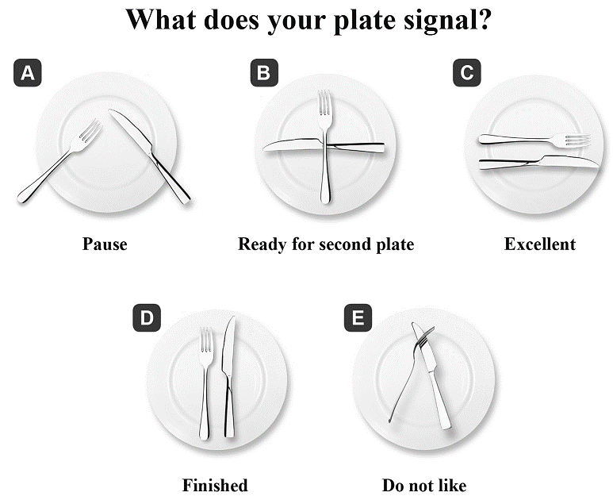
(1)

1. Where are people most likely to see this graph?
(A) On a website that teaches basic cooking skills.
(B) In a book about following a healthy diet.
(C) On a website that teaches formal table manners.
(D) In a book about traditional Chinese food.
2. If you would like to praise the food, which “plate” can do this for you?
(A) A (B) B (C) C (D) E
3. If you have a huge desire for food, which “plate” can do this for you?
(A) A (B) B (C) C (D) D
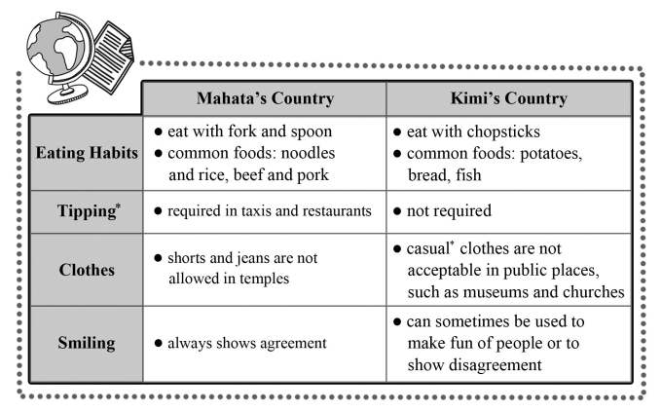
(2) Mahata and Kimi are pen pals, while they have very different cultures. These are some
differences they have learned about each other’s countries in their letters.

4. According to the passage, which of the following customs is similar in Mahata’s and Kimi’s
countries?
(A) Clothes. (B) Tipping. (C) Eating habits. (D) Smiling.
5. What is the purpose of this information?
(A) To explain the eating habits of two countries. (B) To sell a tour package.
(C) To introduce two languages. (D) To show cultural differences.
6. If you have a chance to take a trip to Kimi’s country, what may be impolite in the society?
(A) Wearing formal clothes to visit an art gallery.
(B) Eating seafood with forks and hands.
(C) Giving a smile to reject an idea.
(D) Only paying what you have ordered at a restaurant without tips.
II閱讀測驗
- How did you celebrate your last birthday? Perhaps you gathered with some family and
friends. They sang “Happy Birthday” and brought out a cake with burning candles for you. You made a wish, blew out the candles, and then opened gifts. If this sounds familiar, it’s because these birthday traditions are shared by people around the world. However, did you know that birthday parties go back thousands of years?
We can thank the ancient Greeks for many of today’s birthday party traditions. The ancient Greeks honored the moon goddess* Artemis by baking round cakes to represent the full moon and putting candles on these cakes to make them glow*. Smoke from the candles was believed to carry prayers to the gods up in the sky. This is where the modern custom of making a wish before blowing out the candles comes from.
At first, the ancient Greeks only celebrated the “births” of gods and goddesses. Later, they also celebrated the birthdays of kings and queens. Then, in ancient Rome, men started to celebrate their 50th birthday with a special cake. Unfortunately, however, women’s birthdays weren’t celebrated until over 1,000 years later.
*glow 發光
7. What’s the best title for this passage?
(A) Kings’ and Queens’ Birthdays.
(B) A Modern Tradition with Ancient Origins.
(C) The Invention of Birthday Candles.
(D) The Origins of the “Happy Birthday” Song.
8. According to the passage, why were birthday candles blown out in ancient times?
(A) To send people’s prayers up to the gods.
(B) To drive evil ghosts away.
(C) To celebrate the birthdays of gods.
(D) To let people know the date of a birthday.
9. Whose birthdays started being celebrated the most recently?
(A) Goddesses. (B) Fifty-year-old men.
(C) Queens. (D) Regular women.
10. What does the word “represent” in the second paragraph mean?
(A) To show a symbol of a particular thing. (B) To give an agreement on something.
(C) To give worship to gods. (D) To watch beautiful scenery.
11. According to the passage, what is NOT mentioned as a way to celebrate birthdays?
(A) Unwrapping the presents people may receive.
(B) Inviting some friends to gather together.
(C) Making moon cakes to honor the guests at a party.
(D) Lighting the candles on a cake to make a wish.
(2) India is one of the world’s largest countries. People in different parts of India eat different kinds of food. But there’s one custom they all share: eating with their hands.
In the south of India, rice is the most important dish. One common way to serve food is to
put it on a large banana leaf instead of a plate. A pile of rice and several side dishes are placed
on each person’s leaf. Diners then mix the side dishes with the rice and scoop up* bites with the
fingers of their right hand. Because southern India is near the sea, fish is also commonly eaten.
In the north of India, bread is more common. Each person is served a large, round piece of bread, and the dishes come in metal bowls and are shared. Diners rip off* pieces of their bread and use them to scoop up bites of the dishes.
If you travel to India, eating might just be the best part of your trip. Don’t be afraid to take food with your hands; it is part of the experience!
* scoop up 舀出、挖出 * rip off 撕掉
12.What is this passage mainly about?
(A) The importance of rice and bread in India.
(B) The weather in northern and southern India.
(C) The eating customs in different parts of India.
(D) The history of Indian foods.
13. Which of the following statements is true about the south of India?
(A) People there eat with chopsticks. (B) Side dishes are mixed with rice.
(C) Bread is more common than rice. (D) It is far from the sea.
14. According to the passage, what do people use to pick up food in the north of India?
(A) Bowls. (B) Spoons. (C) Bread. (D) Banana leaves.
15. Which of the following statements is NOT true about the north of India?
(A) The dishes are served in wooden bowels.
(B) Each diner has a big, round piece of bread at mealtime.
(C) Bead has to be ripped off pieces before start eating.
(D) People eat food with hands as the locals in the south of India do.
(3) Knowing a culture is not just to learn the vocabulary, phrases, or grammar rules. In order to communicate successfully in a foreign country, you have to gain knowledge of cultural etiquette. If you don’t your behavior may shock your foreign friends.
In the United States, for example, the thumbs-up sign is used as a way to say “Good job!” However, in other places such as Iran and Spain, it can be very offensive. If you go to an Arab country, you should be careful to keep your feet on the floor. It is extremely rude to the Arabs to show the bottoms of one’s feet to people. In Indonesia, you should never use your left hand to give things to someone because the left hand is considered unclean. In some western societies, people greet children with a pat on the head, while in other Asian counties, that may be considered rude. In Chinese society, it is not a good idea to give clocks, umbrellas, or shoes as gifts because they all have bad signs: “to attend a funeral ritual”, “to separate” and “evil” meanings. Besides, when a Chinese accepts a gift, he or she won’t open it in front of the giver.
On the contrary, it is polite to open a gift right away and thank the giver for the gift in European cultures.
Just as the old saying goes, “When in Rome, do as the Romans do.” If you know some of the special customs or taboos in the places you are visiting, you will have a good time traveling there and avoid embarrassing yourself.
16. The word “etiquette” in the first paragraph means “ . “
(A) pros and cons of a culture
(B) a set of rules for polite behavior
(C) the official language of a country
(D) ways to shock one’s foreign friends
17. According to the passage, a person had better not ________ in an Arab country.
(A) raise his or her thumb up and show it to others
(B) open a present right away in front of the giver
(C) give other people things with his or her right hand
(D) show other people the bottoms of his or her feet
18. Why do Indonesians prefer the right hand to the left hand when they give things to others?
(A) Because they are used to using the right hand.
(B) Because they are not left-handed people.
(C) Because they think the right hand is related to God
(D) Because they think the left hand is dirty.
19. According to the passage, which of the following is Not true?
(A) A pat on a kid head is considered to be offensive in the United States.
(B) Europeans are very happy and willing to open the gifts in front the givers.
(C) Don’t show your thumbs up in Iran because the locals will feel insulted.
(D) Giving shoes as gifts to friends will bring bad luck to them in Chinese society.
20. According to the passage, the author ____________.
(A) focuses on the grammar rules of every country
(B) always has fun whenever traveling in a foreign country
(C) suggests that travelers learn the local culture before traveling
(D) usually shocks his or her friends with awkward behavior

