The Night Parade
一、單字選擇題，每格3分，共63分
1. ( ) v.關上 |  | (A)shut (B)chase (C)noise
2. ( ) v.數數 |  | (A)noise (B)shadow (C)count
3. ( ) n.綿羊 |  | (A)tired (B)sheep (C)count
4. ( ) v.照耀 | 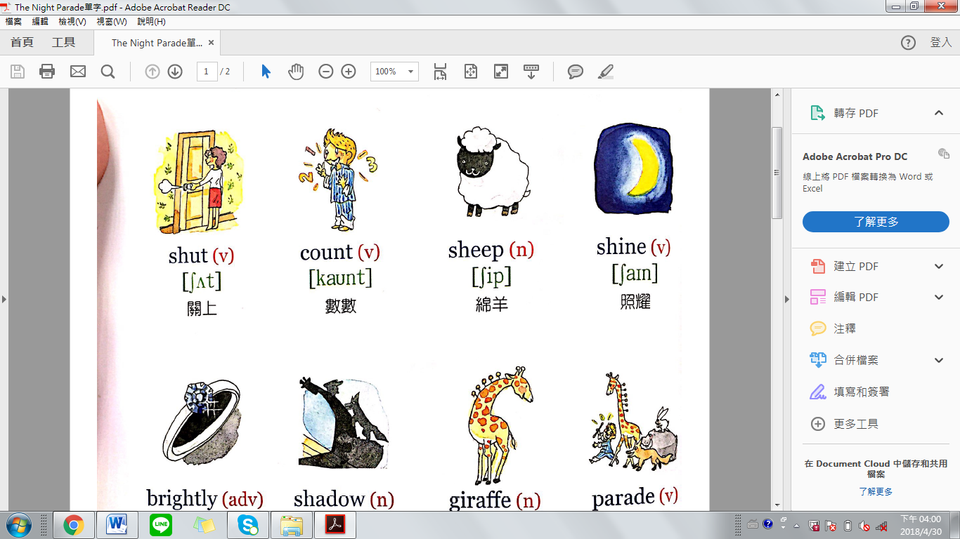 | (A)find (B)sheep (C)shine
5. ( ) adv.明亮地 |  | (A)parade (B)outside (C) brightly
6. ( ) n.影子 |  | (A)shadow (B)sheep (C)shine
7. ( ) n.長頸鹿 |  | (A)next (B)asleep (C)giraffe
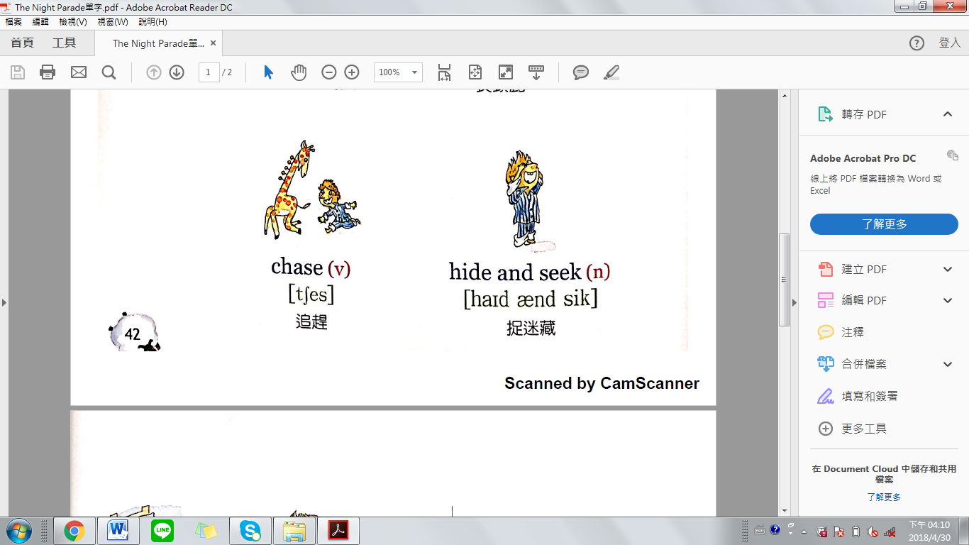  8. ( ) v.遊行 |  | (A)parade (B)sheep (C)asleep
9. ( ) v.追趕 |  | (A)behind (B)chase (C)round
10.( ) n.捉迷藏 |  | (A)next (B)tomorrow (C)hide and seek
11.( ) v.找 | 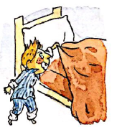 | (A)remember (B)find (C)round
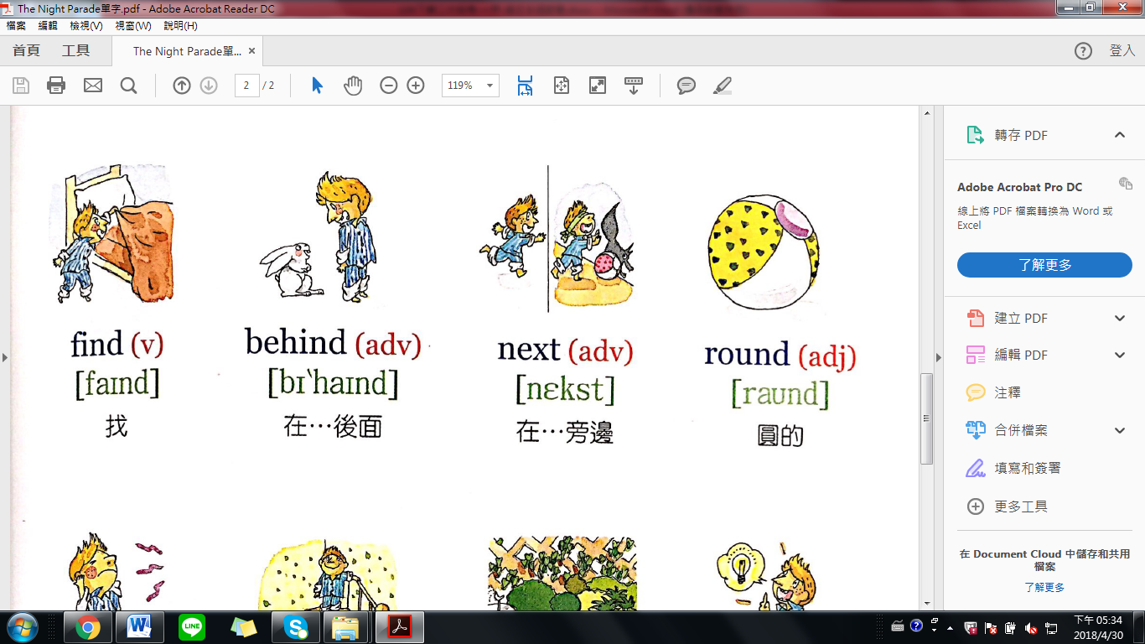  12.( ) adv.  在…後面 |  | (A)round (B)next (C)behind

13.( ) adv.  在…旁邊 |  | (A)round (B)next (C)behind
14.( ) adj.圓的 |  | (A)round (B)next (C)behind
15.( ) n.噪音 |  | (A)round (B)noise (C)behind
16.( ) n.樓上 |  | (A)upstairs (B)noise (C)sheep
17.( ) adv.在外面 |  | (A)tired (B)find (C)outside
18.( ) v.記得 |  | (A)round (B)remember (C)tomorrow
19.( ) n.明天 |  | (A)round (B)remember (C)tomorrow
20.( ) adj.很累的 |  | (A)tired (B)find (C)outside
21.( ) adj.睡著的 |  | (A)round (B)remember (C)asleep

二、選擇題，每題3分，共30分
1.( ) This is just like a ______. (這就像遊行一樣)
(A)asleep (B)parade (C)giraffe (D)bed
2.( ) Next, they play ___________. (接下來，他們玩捉迷藏)
(A)hide and seek (B)round (C)outside (D)remember
3.( ) This time, Thomas finds ______ first . (這一次，Thomas先找到長頸鹿)
(A)hippo (B)rabbit (C) giraffe (D)fox
4.( ) Next he sees Mr. ______. (接下來，他看到河馬先生)
(A)hippo (B)rabbit (C) giraffe (D)fox
5.( ) But where is Mr. ______. (但兔子先生在哪裡呢？)
(A)hippo (B)rabbit (C) giraffe (D)fox
6. ( ) It’s ______ now. (現在很黑)
(A)dark (B)round (C)sheep (D)parade
7. ( ) “Night, night, don’t let the bed _______ bite!”(晚安，不要被床蟲咬了!)
(A)noise (B)bugs (C)shadow (D)giraffe
8. ( ) He sees a _______! (他看到一隻狐狸!)
(A)hippo (B)fox (C)rabbit (D)giraffe
9. ( ) Thomas stares in _______. (Thomas驚訝地盯著.)
(A)surprise (B)sad (C)happy
10. ( )請問“Wait a minute! ”的意思是?
(A)一分鐘 (B)等一下 (C)不用等了

三、配合題，請將正確的選項填入空格中，共7分
Mr. Mrs. Miss.

1.( )請問稱呼別人「先生」要用？(3分)
2.( )請問稱呼別人「小姐」要用？(2分)
3.( )請問稱呼別人「太太」要用？(2分)

