一.聽力測驗 (10%)
第一部分：看圖辨義(2%) (念兩遍)
試卷上該題有一張圖片，請聽一個和該題相關的問題，與(A)、(B)、(C)三個英語敘述後，選一個與所看到圖片最相符的答案。
 | 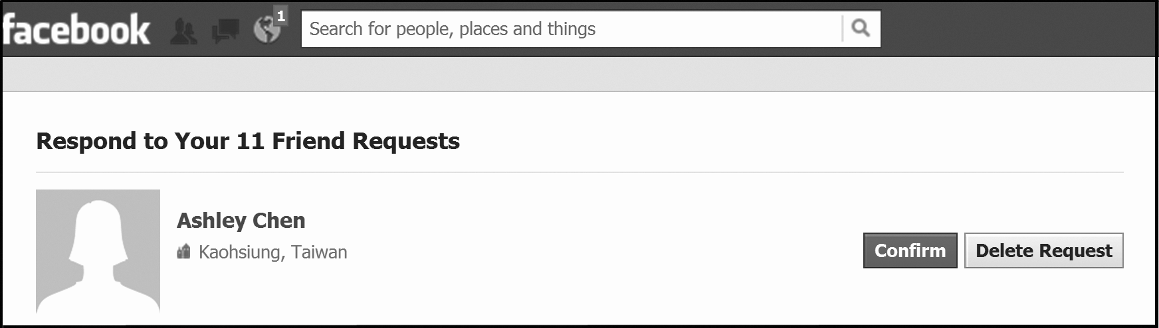
1. ______ | 2. ______
第二部分：問答(3%) (念兩遍)
每題會播出一個問句或直述句，聽後請由試卷上(A)、(B)、(C)三個選項中，選出一個最適合的回答或回應。
_______ 3.(A) Well, it starts at 4:30.
(B) More than twelve people are coming!
(C) Because he’s not on Facebook.
_______ 4.(A) I sent it one minute ago. Just wait.
(B) I always reply to your messages.
(C) I used my computer to reply.
_______ 5.(A) You can win NT$10,000.
(B) It’s a fun competition.
(C) When I was 30 years old.

第三部分：簡短對話(3%) (念一遍)
每題會播出一段對話及一個相關的問題，聽後請由試卷上(A)、(B)、(C)三個選項中，選出一個最適合的回答。
_______ 6.(A) Every class.
(B) Every student.
(C) Only the students who want to.
_______ 7.(A) Yes, he will.
(B) He’s not sure yet.
(C) No, because they had a tie.
_______ 8.(A) They didn’t see the post online.
(B) They all forgot to come.
(C) They don’t like the man.
第四部分：短文聽解(2%) (念一遍)
每題有三個圖片選項。請聽題目，並選出一個最適當的圖片。
9. _______
(A) (B) (C)
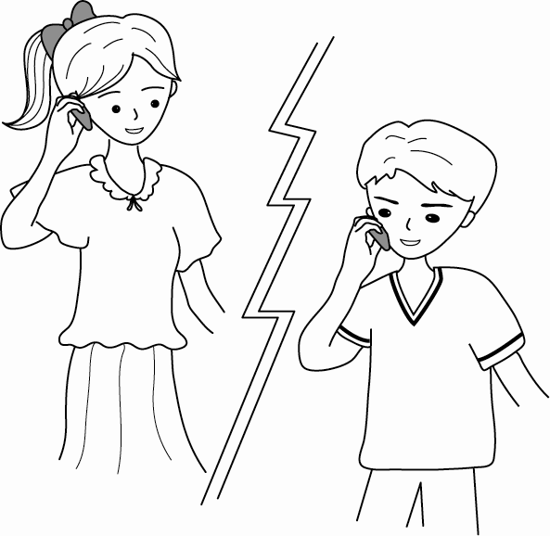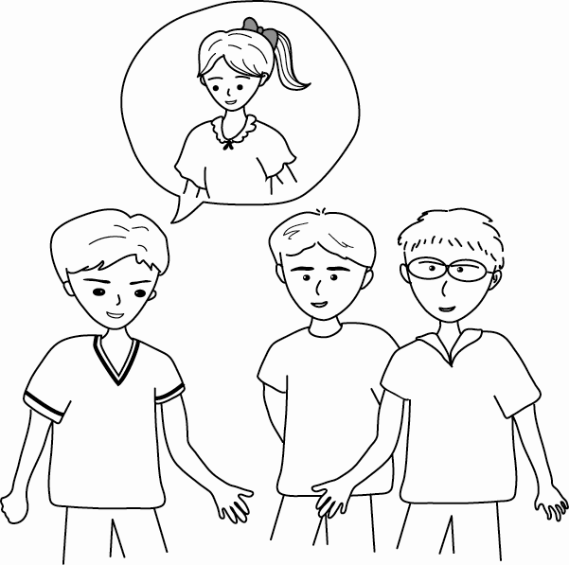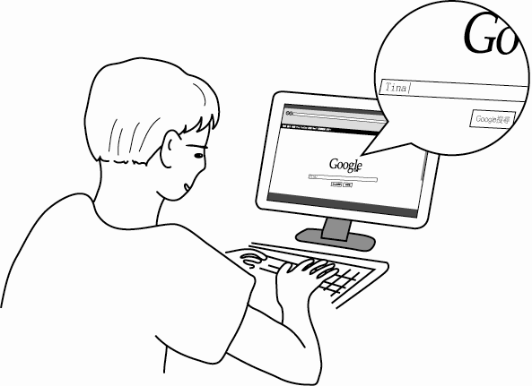

10. _______
(A) (B) (C)
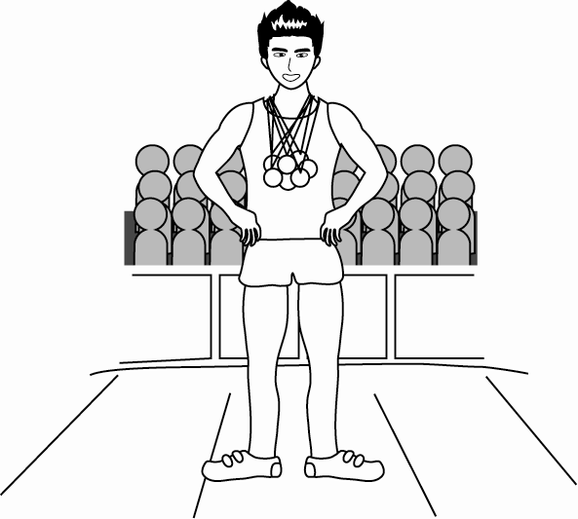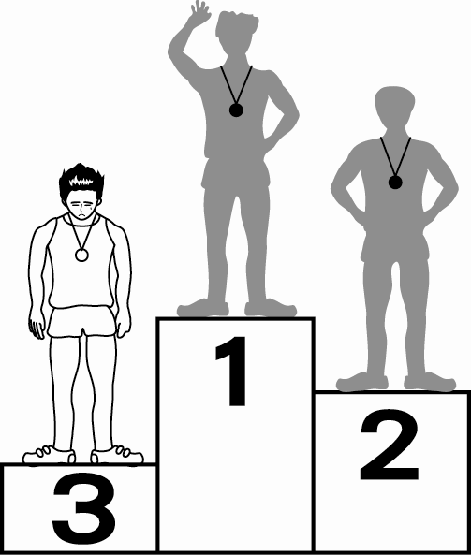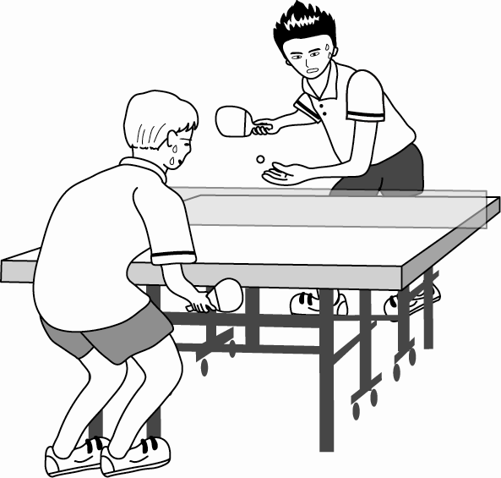

二、慣用語選擇題：(5小題，每題2分，共10分)
11. （ ）I have several close friends, _____ Mike and Peter.
(A) as for (B) such like (C) such as (D) as
12. （ ）_____ singing, people always remember the late singer Fong Fei-fei (鳳飛飛).
(A) Think of (B) When it comes to (C) Take part in (D) A number of
13. （ ）This website is supposed to be fun; let’s _____.
(A) watch out for it (B) look out for it (C) check it in (D) check it out
14. （ ）When someone _____ the idea of an “i-cloud” several years ago, few people thought it would ever become popular.
(A) came up with (B) made use of (C) taken place (D) laughed at
15. （ ）Shopping centers _____ Costco and IKEA are always crowded with customers on weekends.
(A) after all (B) in fact (C) all of a sudden (D) such
三、綜合測驗題：(5小題，每題2分，共10分)
More and more people are using social networking websites like Facebook, Google+, Twitter, and Plurk. Users _____(16)_____ their personal information and share pictures and videos on these websites. This is a great way to stay in touch with their friends. _____(17)_____, there are some things that you have to watch out for. For one thing, while you are using these websites, ____(18)_____ give your personal information to others. _____(19)_____, do not post anything that you might be sorry about later. Visiting social networking websites can also be a(n) _____(20)_____. So, remember to live in the real world.
16.（ ） (A)put out (B) communicate (C) post (D) search
17.（ ） (A) Besides (B) However (C) When (D) Though
18.（ ） (A) do (B) never (C) always (D) sometimes
19.（ ） (A) For another (B) For others (C) To another (D) To others
20.（ ） (A) old-fashioned tool (B) co-ed school (C) long-lost friend (D) waste of time
四、文法選擇題：(10小題，每題2分，共20分)
21. （ ）Facebook helps people _____ long-lost friends.
(A) finding (B) to finding (C) find (D) found
22. （ ）These are the novels _____ she wrote when she was young.
(A) who (B) whom (C) what (D) which
23. （ ）The girl _____ you saw at the restaurant yesterday is my sister.
(A) where (B) which (C) when (D) whom
24. （ ）Do you know the woman _____ across the street?
(A) who living (B) lives (C) who lives (D) lived
25. （ ）While I was taking a shower, I _____ the phone ring.
(A) hear (B) heard (C) have heard (D) had heard
26. （ ）I am glad _____ you have passed the exam.
(A) of that (B) of what (C) that (D) what
27. （ ）Don’t waste too much time on the Net; remember _____ in the real world.
(A) to live (B) living (C) to living (D) live
28. （ ）If it _____ tomorrow, we will cancel the trip.
(A) rains (B) will rain (C) rained (D) had rained
29. （ ）The powerful engine makes the car _____ very fast.
(A) running (B) to run (C) runs (D) run
30. （ ）_____ is not safe for people to post too much personal information online.
(A) This (B) That (C) There (D) It
五、單選對話題：(5小題，每題2分，共10分)
31. ( ) (on the phone)
Eric: May I speak to Vicky Lin?
Ann: She is not in. _____
Eric: Don’t bother. I’ll call her later.
(A) May I take a message?
(B) Who’s calling?
(C) You have the wrong number.
(D) Hang on, please.
32. （ ）Sandy: I’m new to Facebook. Are you on there?
Jenny: _____, and you will be able to see my latest news.
Sandy: Great, thanks!
(A) I’m about to call you
(B) Yeah, let me add you as a friend
(C) You are welcome
(D) It’s not bad to meet new people
33. （ ）Peter: Allow me to introduce myself. I’m Peter Lin.
George: _____ I’m George Wilson.
(A) How have you been?
(B) How are you doing?
(C) How’s everything?
(D) How do you do?
34. （ ）Adam: Do you mind if I use your laptop computer? I have an important e-mail to send.
Jack: _____, but you have to wait a moment until I finish uploading my photos.
Adam: OK. Thanks for your help.
(A) It’s up to you
(B) I think I do
(C) I appreciate it
(D) Not at all
35. （ ）Helen: Are you leaving already? Something wrong with the party?
Grace: _____ I have to go home now; my husband is waiting for me.
Helen: Well then, see you soon.
(A) Sorry I stood you up.
(B) It’s nothing personal.
(C) Sorry for being late.
(D) Don’t take it so hard.
六、閱讀測驗題：(每題2分，共10分)
These days, single men and women may not have a chance to find dates in the traditional ways. As a result, some are now searching for romance* on the Internet. This practice is called cyberdating.
One form of cyberdating is talking in Internet chat rooms. If two people like to chat with each other, they may “instant message*” each other for a private* talk. Another form of cyberdating involves using certain websites on which singles looking for dates can post their profiles with information and pictures. Then they can browse* through the profiles of other single people, and contact those whom they are interested in by e-mail.
However, the Internet is full of cheats who trick others into giving them money. Those who want to cyberdate must take some steps to protect themselves from being deceived*. First, they should avoid answering questions that seem too personal. Second, they should watch out for those who ask them for money. Most importantly, if they decide to meet their dates face to face, they should choose a public place.
If people are aware of the dangers of cyberdating and take steps to avoid them, this activity can be safe and effective.
*romance n. [C] 戀愛 *instant message 即時通聯 *private adj. 私人的 *browse vi. 瀏覽 *deceive vi. 欺騙
36.（ ）What is the main idea of this passage?
(A) Surfing the Internet can be dangerous, as there are many con artists online.
(B) Online romance sites are always safe and effective.
(C) Do not trust anyone on the Internet.
(D) Cyberdating is a new way to find romance, but its potential dangers cannot be ignored.
37.（ ）When the person you are cyberdating asks you questions, you should _____.
(A) be honest and tell him or her everything about yourself
(B) overstate how good you are
(C) try not to reveal personal things
(D) pretend you know nothing
38.（ ） Which of the following is mentioned as a tip for safe cyberdating?
(A) Meet your date in a public place.
(B) Give your date all the help he or she asks for.
(C) Take a friend with you when meeting your date.
(D) Do not hide anything about yourself.
39.（ ）The word “profile” in the second paragraph probably means _____.
(A) a side view of a person’s face
(B) a short description of a person
(C) a person’s height
(D) a person’s marital status
40.（ ）What’s the author’s attitude toward cyberdating?
(A) Indifferent.
(B) Totally approving.
(C) Hostile.
(D) Cautious.

七字彙填空題：(15小題，每題2分，共30分)
41. Over one hundred people entered the speech c_____t. It won’t be easy to win.
42. The Internet is necessary for people in modern s_____y.
43. We are not in direct c_____n with the boss. We need to talk to her secretary first.
44. The swimming c_____p will be held next Monday.
45. Lisa finally a_____ed her goal of becoming a singer.
46. The police are s_____hing this area for the missing child.
47. Necessity is the mother of i_____n.
48. The careless man fell off the p_____m in a train station and got seriously hurt.
49. With his great h_____r, Peter often makes people around him laugh.
50. Dogs can help people find things because they have a strong s_____e of smell.
51. Johnny skipped town without telling any of his friends or r_____ves. He just vanished into thin air.
52. Do not p_____t rude comments on Facebook because it may get you in trouble.
53. After graduating from c_____e, Edward wanted to go for advanced study abroad.
54. Due to e_____e weather conditions, Beijing suffered its heaviest rainfall in 60 years.
55. The report that New York was largely destroyed by the terrible hurricane named Sandy has a_____ted international attention.

41. | 42. | 43.
44. | 45. | 46.
47. | 48. | 49.
50. | 51. | 52.
53. | 54. | 55.

