新北高工 一七0學年度第 一學期 段考 |  |  |  |  |  |  | 班級 |  | 座號 |  | 成
科目 | English | 年級 | 二 | 科別 | 模 |  | 姓名 |  |  |  | 績
聽力選擇10% (請選出最適合的答案)  本測驗分三部分，全為三選一之選擇題，每題播出一遍。  1. 看圖辨義：  每題請聽錄音內容所播出的題目和A、B、C三個選項後，選出與所看到的圖畫最相符的答案。  2. 問答：  每題請聽錄音內容所播出的英語句子，再從試題上A、B、C三個選項中，選出一個最適合的回答或回應。  3. 簡短對話：  每題請聽錄音內容所播出的一段對話和相關問題，再從試題上A、B、C三個選項中，選出一個最適合的答案。  Hindus. The way to present a gift is also important. To show respect, gifts should be given to a Japanese person ___26____ both hands. ___27____, in Asian countries, it is not suggested to open the gift in front of the givers. On the other hand, people in Western countries prefer ___28____ their gifts right away. Always ___29____ the cultural differences in mind. Not only can you make a good impression on your friends, ___30____ the friendships may also become closer and last longer.  21. (A) to give (B) gave (C) giving (D) given  22. (A) take (B) cost (C) pay (D) spend  23. (A) whom (B) who (C) whose (D) that  24. (A) as (B) in (C) for (D) at  25. (A) since (B) though (C) until (D) so  26. (A) of (B) to (C) for (D) with  27. (A) Therefore (B) In addition (C) Thus (D) For example  28. (A) open (B) opened (C) to opening (D) to open  29. (A) stay (B) get (C) keep (D) have  30. (A) and (B ) but (C) or (D) when  Reading Comprehension 20% (請選出最適合的答案)  The Japanese are said to have many rules and customs of giving gifts. There are a lot of important rules both gift receivers and givers must be careful about. If the rules are not followed, the good intention of giving gifts might turn out to be offense.  For instance, on lots of important occasions, a person must never attract attention when he or she gives a gift. Also, the gift is usually carefully covered in plain wrapping paper without ribbons so that it cannot be easily determined to be a gift. Moreover, the gift is best given near the end of a meeting when the giver is alone with the receiver.  What’s more, it is better to say the gift is nothing important. The act shows the very careful practice of giving a gift is more important than the gift itself. Besides, it is rude to open a gift right away in front of the giver. Sometimes it is more polite to refuse the gift a few times before the receiver accepts it.  It is very important to understand the local customs to prevent offense and embarrassment. When you pay a visit to Japan, make sure you know how to present gifts to your Japanese customers or friends.  31. What is the main idea of the passage?  (A) Japanese arts industry. (B) Japanese medical care.  (C) Japanese eating habits. (D) Japanese gift-giving customs  32. According to the passage, when presenting a gift to a Japanese person, the giver should ______.  (A) cover the present in colorful paper (B) ask the receiver to open the gift right away  (C) let everyone know what the gift is (D) tell the receiver the gift is not important  (A) It is easy to cause offense if you do not understand the gift-giving customs in other cultures.  (B) People from Latin America do not like leather products because they consider cows sacred.  (C) People should receive a gift with the left hand and give a gift with the right hand in the Middle East.  (D) A Muslim will be offended if he or she receives a compass as a gift.  文意字彙30%  1. To h_______r the great woman, the building was named after her.  2. My sister is c_______t she will win the race because she is the fastest runner in the school.  3. Sean did not understand the m_______g of the sentence, so he asked me to explain it to him.  4. My good friend u_______ed me to join the school club with her so that we could spend more time together.  5. The movie is very exciting because it contains a lot of fight s_______es.  6. Mia is an old friend of mine. We have known each other for two d_______es.  7. The construction of the new shopping mall took six years to c_______e.  8. The house was sold for two million dollars, i_______g tax.  9. _______ _______ _______ the fact that Mr. Collins is busy with his work, he never forgets to call his parents on weekends. (despite)  10. Gary got lost. _______ _______ _______, his car ran out of gas. |  |  |  |  |  | 綜合選擇20%(請選出最適合的答案)  11. It was very thoughtful _______ Ethan to help his father do the dishes.  (A ) to (B) in (C) that (D) of  12. It was at a welcome party _______ Cynthia first met her cousin.  (A) that (B) which (C) what (D) who  13. _______ his son won the race, Mr. Chen was very happy.  (A) Know (B) Knew (C) Knowing (D) To know  14. It was sweet of Nina _______ a bottle of wine to the potluck party.  (A) bring (B) to bring (C) bringing (D) brought  15. He did not seem to be satisfied with the gift because I saw him turn _______ when he opened the gift.  (A) international (B) pale (C) normal (D) pleased  16. Mary asked George _______.  (A) wrong was what (B) what wrong was (C) was what wrong (D) what was wrong  17. This gift is considered _______ in Chinese culture.  (A) unlucky (B) be unluckily (C) be unlucky (D) unluckily  18. Lilian is fond _______ antiques and cooking.  (A) for (B) from (C) of (D) about  19. He decided _______ out more about gift-giving customs around the world.  (A) finding (B) to find (C) to finding (D) find  20. _______ this way, they can show respect for the people who have given them these gifts.  (A) At (B) Upon (C) In (D) Onto  Cloze 20 % (請選出最適合的答案)  Gift-giving customs are different around the world. To avoid ___21____ the wrong gifts, people should ___22____ some time studying the gift-giving customs. For instance, it is rude to give a clock to Chinese people, ___23____ believe giving a clock sounds like attending a funeral. In France, chrysanthemums are regarded ___24____ a symbol of death and should only be used for funerals. Also, in India, gifts of leather should be avoided ___25____ cows are sacred animals to  33. According to the passage, before a gift is received, the receiver may _______.  (A) refuse it several times (B) open it right away (C) throw it away (D) cover it in plain paper  34. According to the passage, which of the following is true in Japan?  (A) The giver should give the present to the receiver in private.  (B) The price of the gift should be the higher the better.  (C) The gift should be given with ribbons to show more respect.  (D) The gift should be given at the beginning of the meeting.  35. We may read the passage in a book about _______.  (A) culture (B) science (C) sports (D) economy  There is always a birthday, holiday, or other special occasions to give someone a gift. As the world  becomes more and more diverse, however, finding the perfect gift has become more complicated. The chance  of unintentionally offending someone is high, so it is important to understand other cultures before you give  someone a gift.  Countries in the Middle East have their own gift-giving practices, which are closely related to the  religious beliefs there. In Islam, the left hand is considered dirty, so it is important to give and receive gifts  with only the right hand. Also, avoid giving pictures of dogs because dogs are believed to be unclean. A  suitable gift for a Muslim would be a compass since it can direct them to Mecca-the Islamic holy land.  People from Latin America like to receive things they cannot easily get. For instance, Argentina is a  major cattle and leather producer, so receiving leather products would not excite Argentinians. iPods or other  electronics, on the other hand, are very expensive in Argentina, and a lot of people cannot afford them. Thus,  they would make a nice gift.  When it comes to gifts, it is supposed to be the thought that counts. In order for this to be true, however, one must give some thought to the gift before giving it to someone. So, next time you give a gift, think twice to make sure your gift sends the right message.  36. The gift-giving practices in the Middle East are closely related to _______.  (A) social classes (B) religious beliefs (C) occasions (D) time differences  37. According to the passage, Muslims give and receive gifts with _______.  (A) the left hand (B) both hands (C) either hand. (D) the right hand  38. According to the passage, which of the following is considered a nice gift for people in Argentina?  (A) A compass. (B) A picture of dogs. (C) A leather purse. (D) An iPod.  39. According to the passage, which of the following is true?  (A) Argentinians would be excited about receiving leather products. (B) In Latin America, pictures of dogs are believed to be unclean. (C) Electronics may make nice gifts in the Middle East because lots of people cannot afford it. (D) It is a good idea to give a compass as a gift to a Muslim friend.  40. What can we inferred from the passage?
  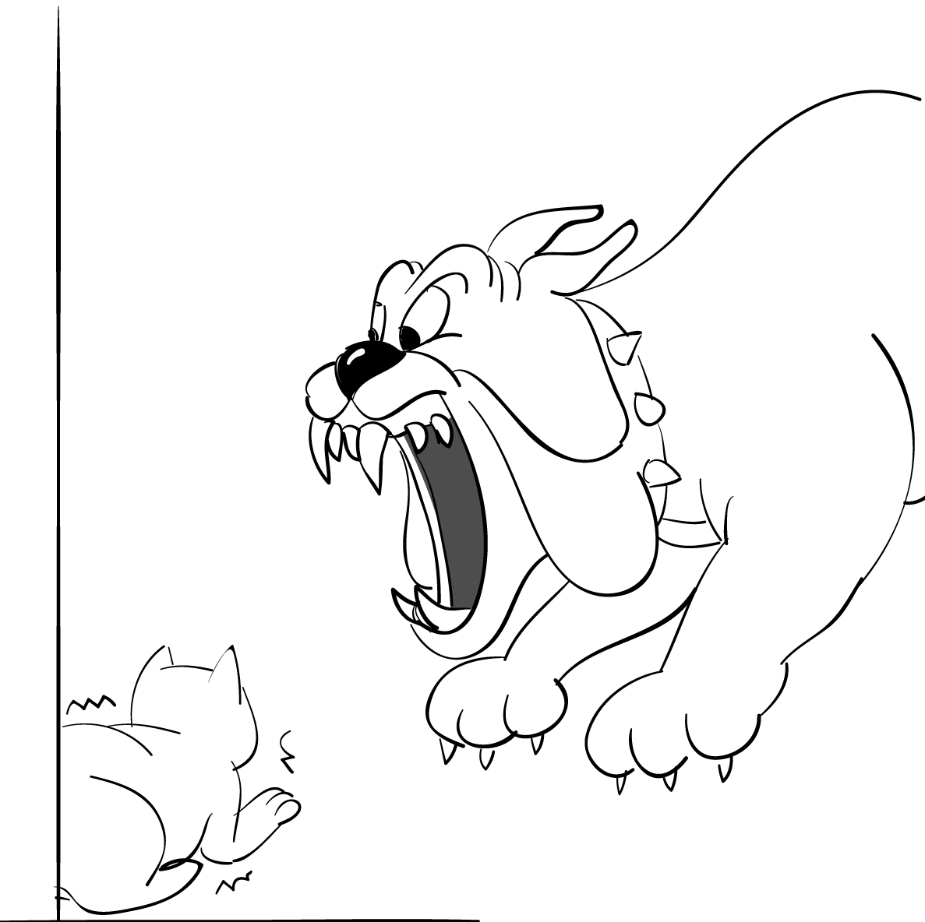 |  | 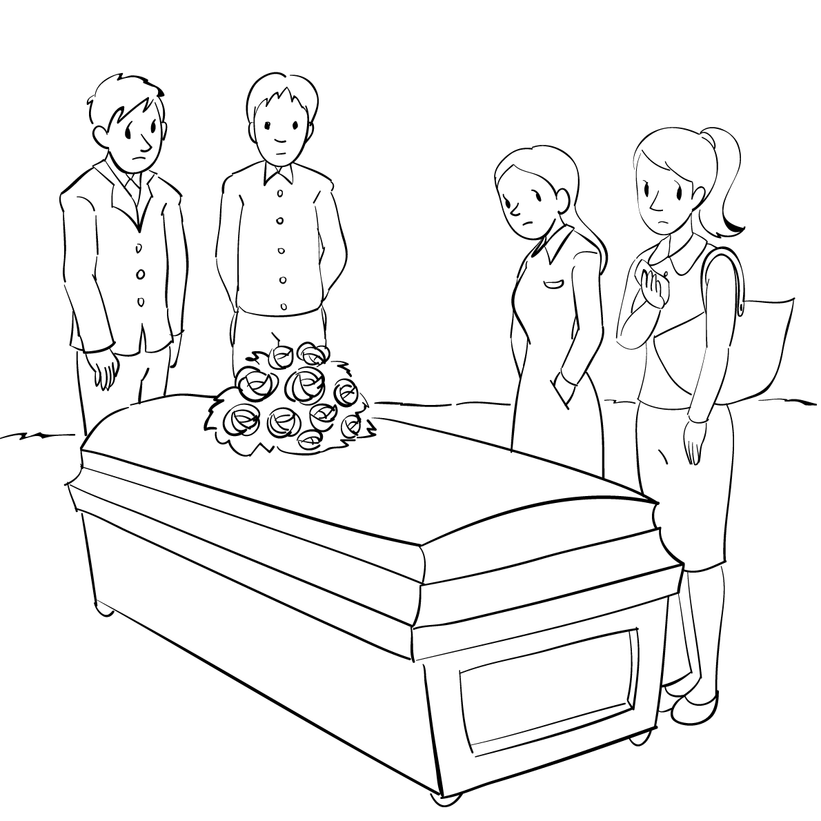
  1. ______ |  | 2. ______
   | ( ) 3. |  | (A) So sorry about that.  (B) I’m glad to know that.  (C) Don’t worry. It doesn’t matter.
   | ( ) 4. |  | (A) Right, he is very like his brother Paul.  (B) Maybe he’s sick or something.  (C) His face is red because he has finished a marathon.
   | ( ) 5. |  | (A) Well, it’s no wonder he passed the exams.  (B) That’s why I’m surprised he failed the exams.  (C) I can’t believe he passed the exams.
  ( ) 6. |  | (A) Right, it was great.  (B) Yeah, it was a waste of money.  (C) I thought that was terrible, too.
  ( ) 7. |  | (A) Thanks. I’ll keep that in mind.  (B) OK, then I’ll take the train leaving at 10 p.m.  (C) No problem. I’ll get to the airport on time.
  ( ) 8. | (A) He felt pleased.  (B) He felt satisfied.  (C) He felt disappointed.
  ( ) 9. | (A) It was the woman who had no money with her.  (B) It was the man who forgot his wallet.  (C) It was kind of the man to pay for the meal.
  ( ) 10. | (A) Asking about the man’s family background.  (B) Questioning the man about his work experience.  (C) Urging the man to work harder in his job.

新北高工 一0五 學年度第 一 學期 段 考 |  |  |  |  |  |  |  | 班級 |  | 座號 |  | 成
科目 | English | 年級 | 二 | 科別 | 機鑄汽模圖資電訊 |  |  | 姓名 |  |  |  | 績
國立海山高工 九十六 學年度第 一 學期 段 考 |  |  |  |  |  |  |  | 班級 |  | 座號 |  | 成
科目 | English | 年級 | 二 | 科別 | 機鑄汽模圖電資 |  |  | 姓名 |  |  |  | 績
國立海山高工 九十一 學年度第 一 學期 複 習 考 |  |  |  |  |  |  |  | 班級 |  | 座號 |  | 成
科目 | English | 年級 | 三 | 科別 | 機鑄汽模圖電資 |  |  | 姓名 |  |  |  | 績

