一、 聽力測驗 (10%)
第一部分：看圖辨義(2%)
試卷上該題有一張圖片，請聽一個和該題相關的問題，與(A)、(B)、(C)三個英語敘述後，選一個與所看到圖片最相符的答案。
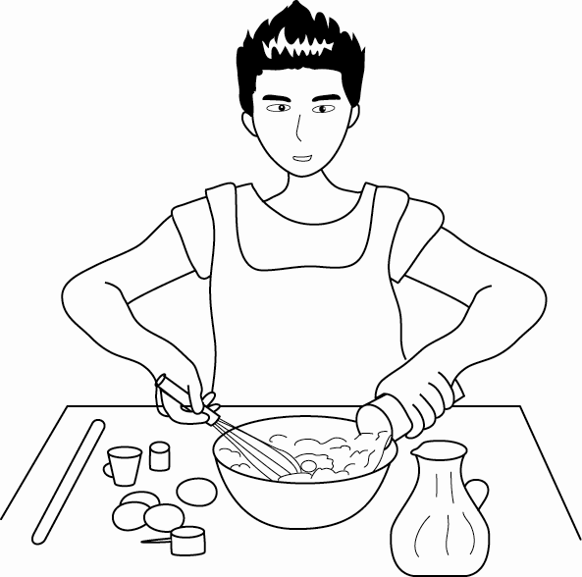 | 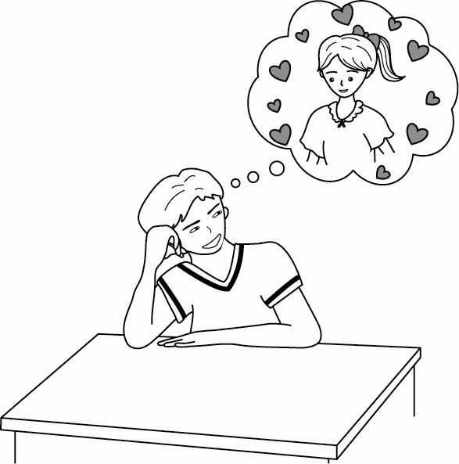
1. ______ | 2. ______
第二部分：問答(3%)
每題會播出一個問句或直述句，聽後請由試卷上(A)、(B)、(C)三個選項中，選出一個最適合的回答或回應。
_______ 3. (A) It has seafood in it.
(B) It’s the best spaghetti in town.
(C) It’s NT$120.
_______ 4.(A) He always tells me what to do!
(B) He’s always driving me crazy!
(C) He always uses old expressions!
_______ 5.(A) They were both born in Japan.
(B) My father is a baker and my mother works in a restaurant.
(C) My father was born in 1959 and my mother in 1962.
第三部分：簡短對話(3%)
每題會播出一段對話及一個相關的問題，聽後請由試卷上(A)、(B)、(C)三個選項中，選出一個最適合的回答。
_______ 6.(A) No, she will stop soon.
(B) Yes, she likes it.
(C) She thinks it’s boring but she will continue.
_______ 7.(A) He is biting his tongue.
(B) He is annoyed.
(C) He thinks the girl is a native English speaker.
_______ 8.(A) Use an idiom that the girl doesn’t understand.
(B) Use an expression that is not very funny.
(C) Use some slang to encourage the girl.
第四部分：短文聽解(2%)
每題有三個圖片選項。請聽題目，並選出一個最適當的圖片。
9. _______
(A) (B) (C)
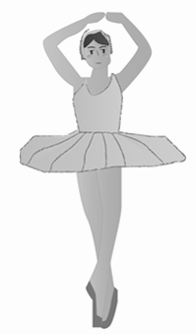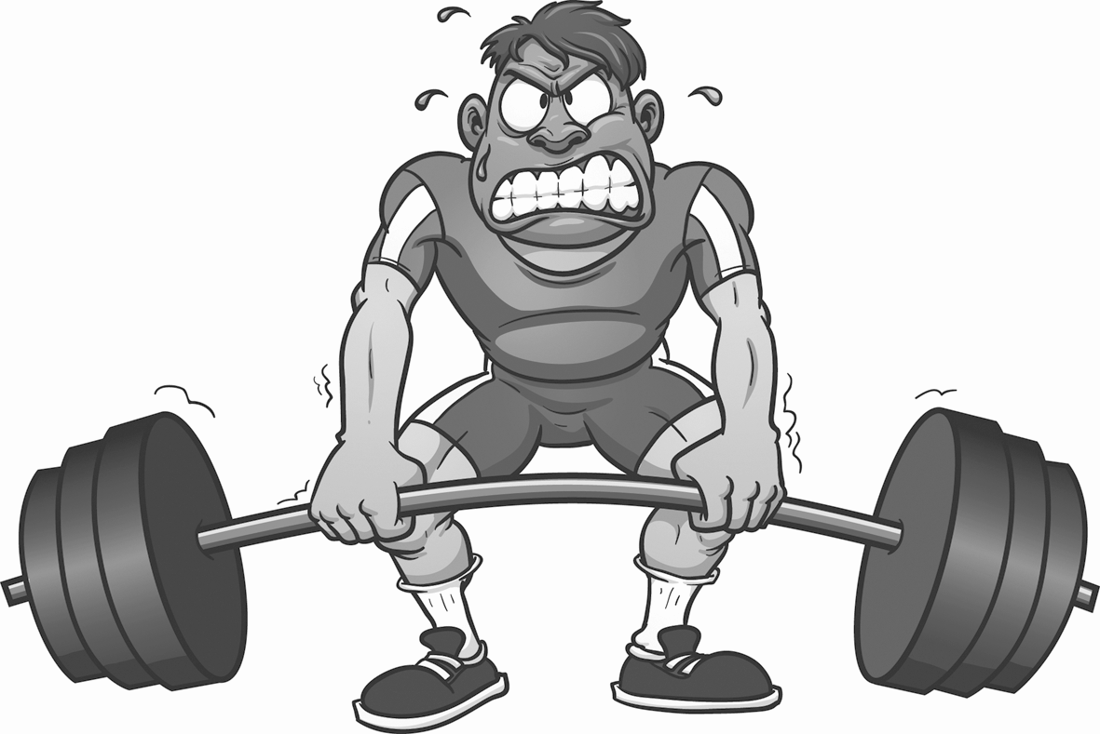

10. _______
(A) (B) (C)
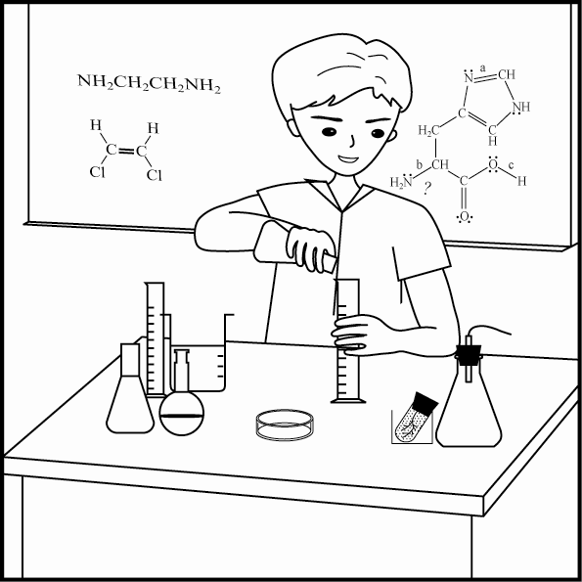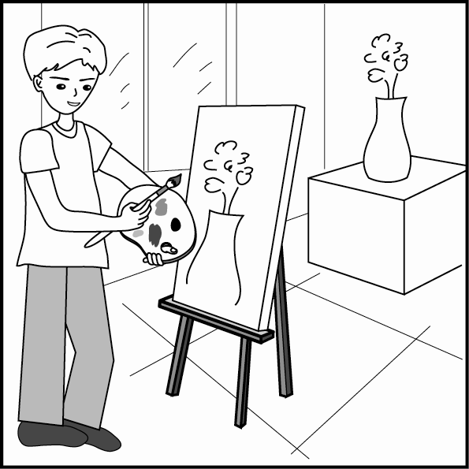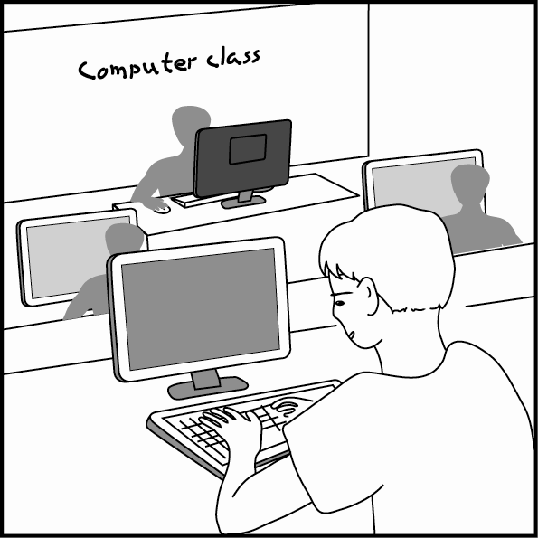

二、文意字彙 (36%)
11.（ ）The new _____ sells a variety of (各種的) cookies that are hard to resist.
(A) bathroom (B) bathing (C) bakery (D) baking
12.（ ）Family _____ has a great influence on a child’s growth.
(A) path (B) ingredient (C) education (D) county
13.（ ）The noise from next door really _____ me last night. That was why I didn’t sleep well.
(A) expressed (B) annoyed (C) fixed (D) rocked
14.（ ）My _____ language is Chinese, while English is my second language.
(A) native (B) awesome (C) daily (D) particular
15. （ ）Teachers should pay _____ attention to the students with learning difficulties.
(A) educational (B) original (C) particular (D) powerful
16. （ ）To _____ my gratitude (感激), please let me treat you to dinner.
(A) describe (B) encourage (C) continue (D) express
- （ ）You had better change your eating habits; _____, it will be hard for you to lose weight.
(A) nowadays (B) instead (C) otherwise (D) anyway
- （ ）Apple Inc. is a company with a good name for the high _____ of its products.
(A) conversation (B) fashion (C) attitude (D) quality
- （ ）Everyone should have a positive _____ toward his or her life.
(A) education (B) legend (C) attitude (D) stage
- （ ）Fans often show their support for their favorite singers by saying, “You _____!”
(A) rock (B) risk (C) fix (D) include
- （ ）The restaurant gives its regular _____ a discount (折扣) on special holidays.
(A) customers (B) masters (C) legends (D) qualities
- （ ）My whole family will watch the famous actor _____ in the play tonight.
(A) relax (B) perform (C) bake (D) educate
- （ ）Black and white will never go out of _____ because they are the most fundamental colors.
(A) education (B) fashion (C) information (D) communication
- （ ）You cannot bargain (殺價) in this shop because the prices are all _____.
(A) fixed (B) awesome (C) joyful (D) incredible
- （ ）My brother will _____ the most beautiful girl in his class tonight. He has prepared a gift and
flowers for her. (A) dance (B) date (C) dawn (D) deal
26. （ ）Vincent van Gogh, who was a(n) expert of painting, had a great influence on 20th-century art.
(A) educator (B) monster (C) baker (D) master
27.（ ）What Ben wears and the way he talks are both old-fashioned. In my opinion, he is not cool at all.
(A) familiar (B) fashionable (C) outdated (D) charming
28.（ ）The concert was wonderful! It’s too bad that you missed it.
(A) annoying (B) outdated (C) awful (D) awesome

三、語法與慣用語 (24%)
29. （ ）_____ the student was not familiar with his new school, but he gradually (逐漸地) got used to it and
finally made some friends. (A) At first (B) At last (C) At least (D) After all
30.（ ）Kim signed up for a job internship (實習) _____ more practical experience before graduating from
college. (A) gain (B) gained (C) gaining (D) to gain
31.（ ）The teacher makes Stacy practice the piano for at least three hours a day, so she is getting better at
_____ it now. (A) played (B) playing (C) plays (D) play
32.（ ）There are many different kinds of Taiwanese snacks in the night markets, _____ the oyster omelet
(蚵仔煎) and stinky tofu (臭豆腐). (A) so as to (B) so that (C) such as (D) such that
33.（ ）Mark Zuckerberg, the founder (創辦人) of Facebook, is not only famous but also _____.
(A) succeed (B) successful (C) success (D) successfully
- （ ）Although Pao-chun Wu was a slow learner in the bakery, _____ he kept working harder than all
the others. (A) × (B) but (C) and (D) or
- （ ）Not only his parents but also his brother _____ proud of his success.
(A) be (B) am (C) is (D) are
- （ ）The smell of garbage made me _____ sick.
(A) feel (B) feeling (C) to feel (D) felt
- （ ）Going hiking with friends _____ a lot of fun.
- be (B) is (C) are (D) have
38. （ ）Sophie sent postcards _____ her friends from all over the world. (A) for (B) of (C) at (D) to
- （ ）It _____ that the survivors of a plane crash would never want to take a plane again.
(A) bites its tongue (B) wins its case (C) has a sense of humor (D) makes sense
- （ ）The taxi driver couldn’t stand the _____ telling him how to drive.
(A) couch potato (B) back seat driver (C) sweet talker (D) penny pincher

四、綜合選擇 (10%)
Pao-chun Wu didn’t achieve success all of a sudden. After practicing for years, he finally became a baker. In the beginning he did a great job, but his achievement did not last 41 long. There was a growing demand for higher-quality bread on the part of customers. Luckily, Wu met a true master, Fu-guang Chen,
42 made him change his attitude toward baking. Therefore, he started 43 special ingredients, such as red wine, roses, and lychees. He even went to Japan to learn more for the purpose of improving his baking skills. As time went by, his hard work 44 . In the end, he became a world-famous baking master. Master Wu’s early life was not smooth. 45 he started out on a bumpy road, he still managed to find the path to success. He is not only the pride of Taiwan but also a living legend.
（ ）41. (A) for (B) with (C) at (D) of
（ ）42. (A) which (B) what (C) who (D) ×
（ ）43. (A) to be used (B) using (C) used (D) to using
（ ）44. (A) took off (B) got off (C) paid off (D) saw off
（ ）45. (A) Although (B) Whenever (C) Because (D) Unless

五、對話(10%)
46.（ ）Waiter: Are you ready to order?
Andy: Not yet.
Waiter: Oh, take your time, sir. _____
(A) That’s not what you ordered. (B) Coming right up.
(C) I’ll be right back. (D) I forgot to bring the check.
47.（ ）Harper: I think everyone should share the responsibility (責任) for protecting our Mother Earth.
Kate: _____ After all, we have only one earth!
(A) It’s none of my business. (B) Why do you care so much?
(C) You can say that again. (D) It really depends.
48.（ ）Customer: I’d like to order a cappuccino.
Waiter: Would you like your cream on the top?
Customer: Yes, please.
Waiter: _____
Customer: Here.
(A) Here you are. (B) For here or to go? (C) Is that all? (D) What will it be?
49.（ ）Waiter: What would you like for your main course ?
Edward: I’d like a steak. Medium (五分熟), please.
Waiter: _____ We have the best tiramisu in town.
Edward: Sounds great. I’ll have one.
(A) How would you like it? (B) Would you like tea or coffee?
(C) What did you do next? (D) Would you like something for dessert?
50.（ ）Daughter: Dad, do you love Mom?
Dad: _____ I have loved her for my whole life.
(A) Not at all. (B) I have no idea. (C) Absolutely! (D) Don’t mention it.

六、閱讀測驗 (10%)
There are many expressions which involve the word “cold.” Take the word “cold-blooded” for example. Cold-blooded is used to describe those who show no human feelings or emotions, and do cruel and terrible things to others. For instance, you might read in the newspaper that a cold-blooded killer murdered* a victim*, showing no mercy*.
What about other parts of our body? If you get/have cold feet, you might not have enough courage to do something you are supposed to* do. For example, you take part in a singing contest but when you get up on the stage, you suddenly have cold feet and become speechless*. Due to your poor performance, the merciless judges might give you the cold shoulder and ask you to step down. When someone gives you the cold shoulder, he or she might refuse to speak to you and act in a “cold” way toward you. Try to imagine someone who doesn’t want to talk to you face-to-face, but rather suddenly turns his or her back to you*.
Above all*, remember not to be a cold fish. Be warm and friendly to others from the bottom of your heart, and you will find our world much more enjoyable!
*murder vt. 謀殺 *victim n. [C] 受害者 *mercy n. [U] 仁慈 *be supposed to 應該
*speechless adj. 說不出話的 *turn one’s back to sb. 不理會某人 *above all 最重要的是
（ ）51. What is the best title for this passage?
(A) Cold-blooded Animals (B) Ways to Keep Warm in the Cold Weather
(C) Expressions about the “Cold” (D) How to Cure a Cold
（ ）52. In the second and third paragraphs, the word “merciless” means _____.
(A) cruel (B) fixed (C) native (D) casual
（ ）53. Which do you think has the closest meaning to the word “cold-blooded”?
(A) Heart-broken. (B) Warm-hearted. (C) Kind-hearted. (D) Cold-hearted.
（ ）54. According to the passage, which of the following statements makes sense?
(A) A cold-blooded man shows his pity to the injured and takes good care of them.
(B) Frank is willing to help others and acts like a cold fish.
(C) Our host family welcomed us wholeheartedly, and gave us the cold shoulder.
(D) Lacking of confidence, Lena got cold feet while speaking in front of her classmates.
（ ）55. In the last paragraph, a “cold fish” might refer to _____.
(A) fish living in cold waters (B) a cold and unfriendly person
(C) any kind of cold-blooded animal (D) a humorous and popular person

