- 請將答案畫記於答案卡。同時請於卡上畫記班級、座號。
- 聽力測驗 10%
- 看圖辨義：每題請聽錄音機所播出的題目和選項後，選出與所看到的圖畫最相符的答案(本大題播出1次)。
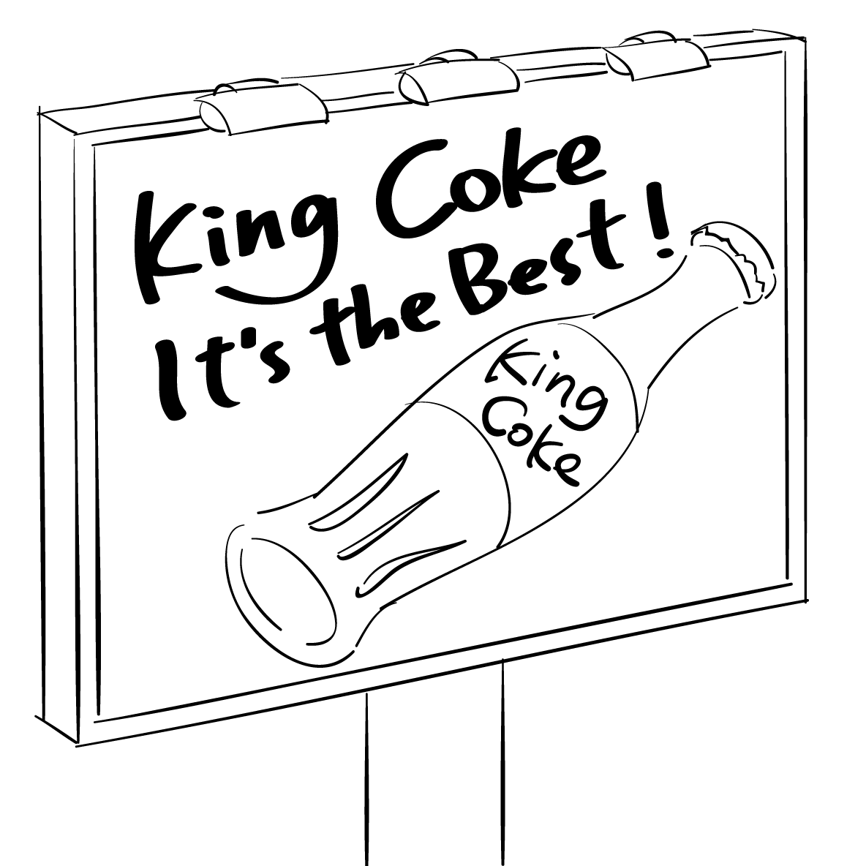 | 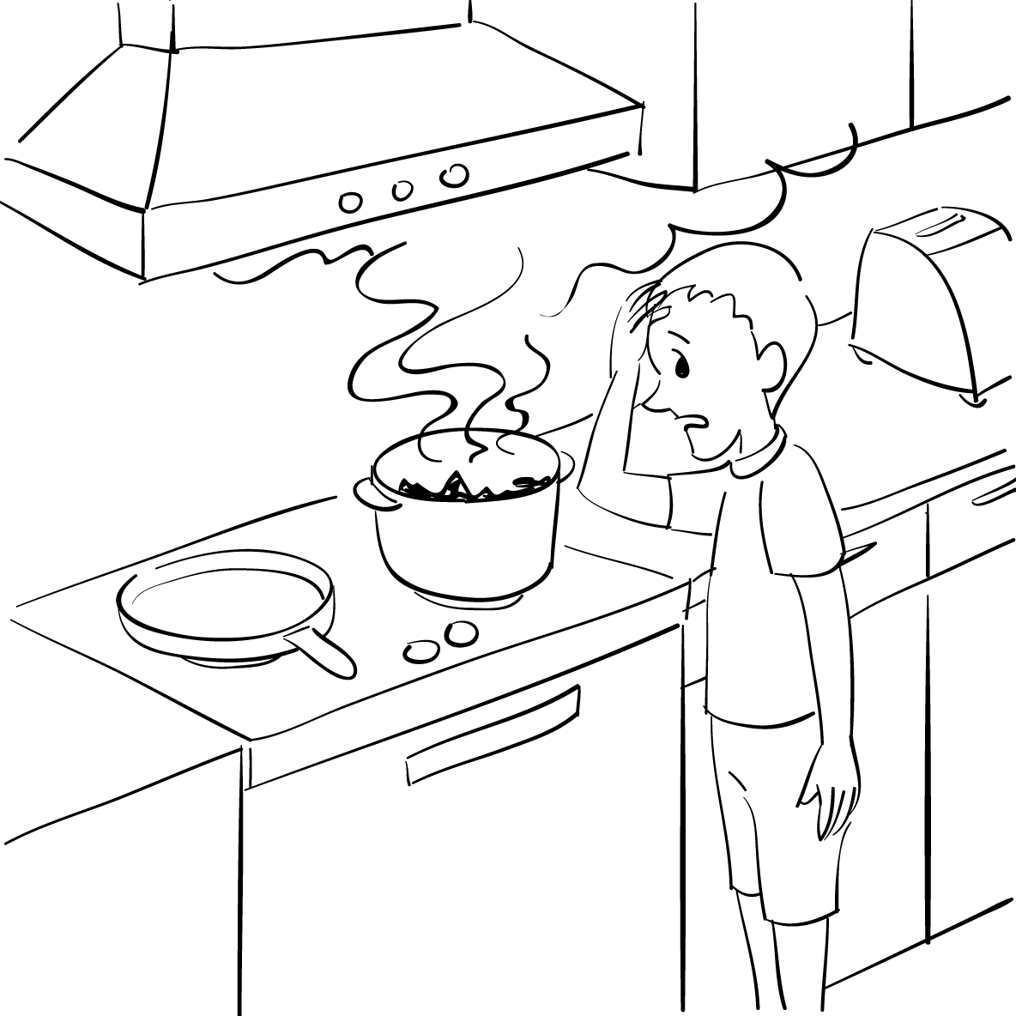
1. ______ | 2. ______
- 問答：每題請聽錄音機所播出的英語句子，再從試題上各選項中，選出一個最適合的回答或回應 (本大題播放2次) 。
- (A) You should make it stand the test of time.
(B) These are happy memories of my years in high school.
(C) How about writing it down when you try to remember it?
- (A) It’s nice of you to help me. (B) That’s all right. (C) I promise it won’t happen again.
- (A) Then we’d better hurry. (B) The excuse is not good enough.
(C) I usually go to work by train.
- (A) I don’t think it’s a good idea to invite him. (B) I’d like to, but I’m simply too busy.
(C) Thanks, I really had a great time.
- (A) Yeah, we have the same employer. (B) Yes, he works for a competitor.
(C) Yes, we’re employed by different companies.
- 簡短對話：每題請聽錄音機所播出的一段對話和相關問題，再從試題上各選項中，選出一個最適合的答案(本大題播出1次)。
- (A) Offering the teacher some food. (B) Making a promise to the teacher.
(C) Complaining to the teacher.
- (A) Teachers should only focus on students’ grades.
(B) Sports and exercise are not really important.
(C) Physical education is as important as other subjects.
- (A) The man turned down the woman’s invitation.
(B) The man decided to see a movie with the woman.
(C) The woman successfully persuaded the man to see a movie.
- 文義字彙 30%
 | Being careful can _____ the chances of making mistakes.
 | (A) concern | (B) decrease | (C) educate | (D) embrace
 | Many athletes took part in the game to _____ for the gold medal.
 | (A) compete | (B) heal | (C) promise | (D) memorize
 | Kevin had a bad headache; _____ he still kept on working.
 | (A) including | (B) therefore | (C) otherwise | (D) nevertheless
 | That man saved a child from a burning house. I _____ him for his courage.
 | (A) manage | (B) admire | (C) rush | (D) persuade
 | Our _____ problem is lack of money. Without enough money, it’s hard to complete the work.
 | (A) talented | (B) persuasive | (C) inspiring | (D) major
 | This highly _____ book has made a lot of people change their lifestyles.
 | (A) frustrated | (B) physical | (C) influential | (D) sticky
 | You shouldn’t have been so rude to Maggie. I think you should _____ to her.
 | (A) advertise | (B) apologize | (C) employ | (D) admire
 | Anna has an amazing _____ for music. She has a good voice and plays the piano well.
 | (A) talent | (B) frustration | (C) apology | (D) feature
 | Dr. Williams was honored for his great scientific _____.
 | (A) wound | (B) admiration | (C) achievements | (D) agents
 | Mandy’s smile _____ that she was pleased with what you said.
 | (A) implied | (B) inspired | (C) achieved | (D) promised
 | That man _____ silent when the police officer asked him questions.
 | (A) wounded | (B) related | (C) praised | (D) remained
 | The trip to Spain was a(n) _____ experience for Hailey. She learned a lot of things there.
 | (A) valuable | (B) active | (C) chemical | (D) local
 | This product has been selling well _____ it came on the market.
 | (A) no wonder | (B) even though | (C) in order to | (D) ever since
 | This accident _____ our trip _____ a disaster.
 | (A) washed, away | (B) turned, into | (C) kept, in mind | (D) persuaded, into
 | I am sorry for being late. Let me buy you a drink to _____ you.
 | (A) play with | (B) relate to | (C) make it up to | (D) look forward to
- 綜合選擇 30%
 | Viola is good at singing. She sings as _____ as a professional singer.
 | (A) beautifully | (B) beautiful | (C) more beautifully | (D) more beautiful
 | It was a new bicycle _____ Billy’s father sent him on his birthday.
 | (A) what | (B) which | (C) who | (D) that
 | Cedrick came in first in the race. His family and classmates are very proud _____ him.
 | (A) of | (B) in | (C) on | (D) at
 | This box is too heavy. No matter _____ hard I try, I can’t move it.
 | (A) what | (B) how | (C) when | (D) which
 | After the party, Lucy stayed to help _____ the room.
 | (A) to cleaning | (B) cleaning | (C) cleaned | (D) clean
 | No matter _____ you leave the house, remember to turn off the lights.
 | (A) what | (B) which | (C) when | (D) who
 | The man said that he would not make the same mistake again _____ the rest of his life.
 | (A) from | (B) for | (C) at | (D) with
 | My heart felt as _____ as the sun when I saw the baby’s smile.
 | (A) warmly | (B) warmer | (C) more warmly | (D) warm
 | _____ we grow older, we get more life experience.
 | (A) As | (B) At | (C) With | (D) In
 | _____ about his father’s health, Eric moved back to his parents’ house.
 | (A) Concern | (B) Concerns | (C) Being concerned | (D) Be concerned
 | Don’t give up! As long as you keep working, things will get better _____ time.
 | (A) over | (B) as | (C) from | (D) at
 | After you make a decision, please give me a reply as soon as _____.
 | (A) possibly | (B) it possibly | (C) possible | (D) is possible
 | There are various products in this store. Some products are clothes. Other products are toys. _____ products are picture books.
 | (A) Another | (B) Still other | (C) The others | (D) Still others
 | My computer doesn’t work. I’ll send it to the factory to have it _____.
 | (A) fix | (B) fixes | (C) fixed | (D) to fix
 | The music was so loud that I had to shout to make myself _____.
 | (A) hear | (B) to hear | (C) hearing | (D) heard
- 克漏字 20%
Jason was handsome and smart, but he had some problems with self-control. He often _(41)_ his temper and got mad easily. When he became angry, he would say hurtful things to other people; therefore, he had _(42)_ friends at school. This situation made his father very worried. Thus, his father _(43)_ an idea to teach him how to control his anger. His father suggested that he _(44)_ a nail into the fence in their backyard whenever he felt angry. On the first day, Jason pounded 37 nails into the fence. Since the fence was very tough, Jason found that it was easier _(45)_ his anger than to hammer nails into the fence. _(46)_, he started to learn to control himself. After several months, he _(47)_ needed to pound nails into the fence. Then, Jason’s father told him to pull a nail out of the fence each day if he successfully controlled his temper. In the end, Jason pulled all the nails out of the fence. _(48)_ at the fence scarred by the holes, Jason realized one thing: Angry words _(49)_ the nails and they can hurt people and leave scars _(50)_ will never disappear. Since then, Jason never said hurtful words to others again.
 | (A) kept | (B) made | (C) missed | (D) lost
 | (A) little | (B) a little | (C) few | (D) a few
 | (A) resulted in | (B) thought of | (C) turned off | (D) passed away
 | (A) pounding | (B) pounds | (C) pound | (D) to pound
 | (A) to control | (B) to controlling | (C) controlled | (D) for controlling
 | (A) At the end of | (B) As a result | (C) For instance | (D) What is worse
 | (A) no longer | (B) as long as | (C) no sooner | (D) as soon as
 | (A) Look | (B) Looked | (C) To look | (D) Looking
 | (A) as | (B) like | (C) as are | (D) are like
 | (A) what | (B) X | (C) that | (D) it
- 對話 10%
- Naomi: You are one hour late, Howard.
Howard: I’m so sorry. I got caught in traffic.
Naomi: ______ I’m not sure if I can accept your apology.
(A) No problem. (B) This isn’t the first time.
(C) Good for you. (D) You can say that again.
- Ginny: I’m so sorry for forgetting your birthday.
Kurt: ______ We are still good friends.
(A) That’s wonderful. (B) Quite the contrary. (C) Don’t talk to me. (D) Never mind.
- Michelle: Have you ever thought of taking a bus to work?
Kent: ________ Why do I need to do that?
Michelle: Well, then you can save some money on gas.
(A) I got it. (B) Of course. (C) Not really. (D) That’s true.
- Kate: May I borrow your bike?
Linda: ______ I need it myself.
Kate: Okay, I will ask someone else for help.
(A) I am afraid not. (B) You’ll love it. (C) Go ahead. (D) It’s not a problem at all.
- Jeremy: Did you watch the NBA games last night?
Sophie: No, I am not a basketball fan.
Jeremy: Then, ______
Sophie: I am a fan of the baseball games.
(A) who is your favorite player? (B) what sports do you like best?
(C) what fans do you prefer? (D) are you good at basketball?

