一.聽力測驗 (10%)
第一部分：看圖辨義(2%) (念兩遍)
試卷上該題有一張圖片，請聽一個和該題相關的問題，與(A)、(B)、(C)三個英語敘述後，選一個與所看到圖片最相符的答案。

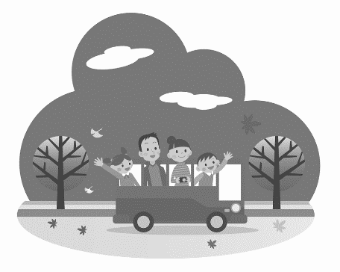

1. _________



2. _________

第二部分：問答(3%) (念兩遍)
每題會播出一個問句或直述句，聽後請由試卷上(A)、(B)、(C)三個選項中，選出一個最適合的回答或回應。
_______ 3.(A) 10% is enough.
(B) On the table is fine.
(C) After you eat, of course.
_______ 4.(A) I want to broaden my horizons.
(B) I will leave next week.
(C) I am going with my best friend, Danny.
_______ 5.(A) We will stay in a village.
(B) A lot of fruit farms.
(C) Tokyo and Mount Fuji.
第三部分：簡短對話(3%) (念一遍)
每題會播出一段對話及一個相關的問題，聽後請由試卷上(A)、(B)、(C)三個選項中，選出一個最適合的回答。
_______ 6.(A) She totally forgot.
(B) She didn’t really like the food.
(C) She thought it was already on the bill.
_______ 7.(A) She went sightseeing.
(B) She was a volunteer.
(C) She learned English.
_______ 8.(A) It’s more meaningful to her.
(B) She thinks it will be fun.
(C) She is not willing to be a nurse
.第四部分：短文聽解(2%) (念一遍)
每題有三個圖片選項。請聽題目，並選出一個最適當的圖片。
9. _______
(A) (B) (C)
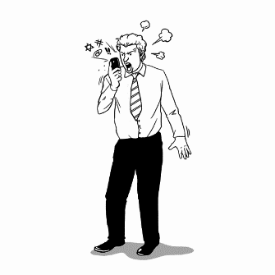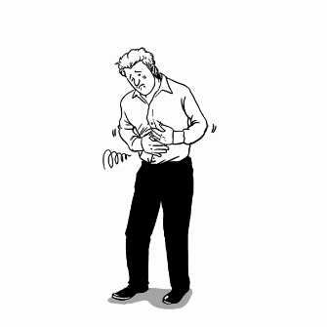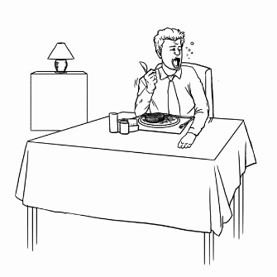
10. _______
(A) (B) (C)
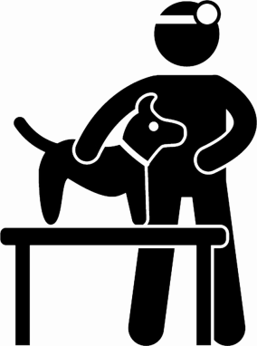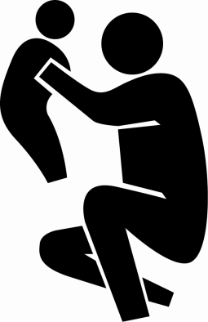
二、文法選擇題：(10小題，每題2分，共20分)
11. （ ）_____ is impossible for you to finish the race within five minutes.
(A) That (B) It (C) This (D) What
12. （ ）The couple is having dinner in a restaurant and eating their steaks _____ knives and forks.
(A) at (B) by (C) with (D) for
13. （ ）Study hard, _____ you will fail the monthly exam.
(A) do (B) and (C) are (D) or
14. （ ）It is important for students _____ attention in class.
(A) to pay (B) pay (C) paying (D) paid
15. （ ）_____, and you will find the best way to solve the problem.
(A) Staying calm (B) To stay calm (C) Stay calm (D) Stayed calm
16. （ ）It is impossible for a two-month-old baby _____ on its own.
(A) walking (B) to walk (C) walked (D) walks
17. （ ）Tina is 160 cm tall. Her sister, Joyce, is 160 cm tall, too. Joyce is _____ Tina.
(A) less tall than (B) as tall as (C) taller than (D) the tallest of
18. （ ）Mark drives as _____ as his father.
(A) fast (B) careful (C) hardly (D) friendly
19. （ ）Some people like to go to a movie theater. _____ prefer to watch a DVD at home. Still others
like to watch movies on their smartphones.
(A) Other (B) Others (C) Another (D) The other
20. （ ）John is patient and friendly. He always speaks _____ a polite way.
(A) in (B) with (C) at (D) for
三、綜合測驗題：(10小題，每題2分，共20分)
People in different cultures around the world have very different ways of enjoying their meals. _____(21)_____, Arabs eat with their fingers. In India, people use their right hands to touch their food as the left hand is_____ (22)_____ as the dirty hand. In Japan, it is a way of _____ (23)_____ the chef to slurp loudly. And in Korea, letting the elderly at the table take the first bite _____ (24)_____ a way to show respect. Next time you visit other countries, keep an eye out for the local eating _____ (25)_____.
（ ）21.(A) In fact (B) For instance (C) Such as (D) At least
（ ）22. (A) praised (B) practiced (C) regarded (D) reserved
（ ）23. (A) praising (B) reserving (C) dining (D) wiping
（ ）24. (A) was (B) is (C) being (D) be
（ ）25. (A) accidents (B) hobbies (C) customs (D) embarrassments
Noodle dishes, _____ (26)_____ ramen, are popular in Japan. If you walk into a _____ (27)_____ restaurant in Tokyo, you may hear a very special noise. The Japanese like to slurp their noodles ___ (28)__ when they eat. _____(29)_____ noodles is a way of praising the chef. It means _____ (30)_____ you like your food very much and can’t wait to get it in your mouth!
（ ）26.(A) for instance (B) such as (C) as well (D) because of
（ ）27.(A) deep (B) extra (C) local (D) social
（ ）28.(A) loudly (B) aloud (C) louder (D) loudness
（ ）29.(A) Slurped (B) Have slurped (C) Slurp (D) Slurping
（ ）30. (A) which (B) when (C) that (D) where

四、單選對話題：(5小題，每題2分，共10分)
31. （ ）Henry: How much is the tip?
Olivia: _____
Henry: So, is it OK to pay 15% for the tip?
Olivia: Fair enough!
(A) That’s really kind of you.
(B) It depends on the quality of service.
(C) Thank you for the tip.
\(D) Let me pay it for you.
32. （ ）Tina: This is the worst meal I’ve ever had.
Ben: Yeah. The food is cold and the service is bad.
Tina: I’ll never come back here.
Ben: _____
(A) You are wrong!
(B) We need to call the police.
(C) You can say that again!
(D) Thank you very much.
33. （ ）Maria: I wonder why that noodle store is always crowded with people.
Gary: When Ang Lee comes back to Tainan, he often eats there. He says he misses the flavor.
Maria: _____
(A) I’m on a diet.
(B) It’s a long story.
(C) So far, so good.
(D) Oh, no wonder.
34. （ ）Darren: Hi, Kate. How’s your summer vacation?
Kate: _____ I had a great time in Singapore.
(A) Awful!
(B) Terrible!
(C) Awesome!
(D) Surprise!
35. （ ）Tom: Hello, Huck. How was your vacation to Korea?
Huck: Good. And how was your summer camp?
Tom: _____
Huck: Perfect! We both had a wonderful summer.
(A) It was awesome!
(B) I hope so.
(C) The summer camp was terrible.
(D) Sounds terrific.

五、閱讀測驗題：(5小題，每題2分，共10分)
As the saying goes, “Do in Rome as the Romans do.” If you love traveling, you had better know about some special dining habits around the world. In China, when you are invited to have dinner at your friends’ house, you should not finish all the food on your plate because it means that the host didn’t prepare enough for you.
In Greece, people always start their dinner around 9 p.m. That’s because they take a rest at home first after work, and then go out to eat. Therefore, restaurants are empty during the normal “rush hour.” In Mexico, if people make a phone call or use the bathroom right after they finish a meal, it’s considered rude. In Sweden, to go Dutch* is quite common, even for a couple. People tend to pay for their own meals.
＊to go Dutch 各付各的
（ ）36.What’s the main idea of the passage?
(A) Rome is a place that you can’t miss.
(B) To know about the special dining habits around the world is necessary.
(C) When we eat with our friends, we had better pay the bill.
(D) Choosing what kind of food to eat is important for a traveler.
（ ）37.According to the passage, what should people be aware of when they have dinner at someone’s house in China?
(A) They should leave some food on their plate.
(B) They should be late for a dinner date.
(C) They can’t make a phone call during a meal.
(D) They can’t use the restroom after a meal.
（ ）38.What is the reason that people in Greece eat dinner late?
(A) They work late and can’t have their dinner any earlier.
(B) The traffic after work is always heavy.
(C) They need to dress up before having dinner.
(D) They love to go home and rest first after work.
（ ）39.When you are in Sweden, what should you do when you eat out?
(A) You should order a drink for your friend.
(B) You should order some food for your friends.
(C) You should pay for your own meal.
(D) You should not eat very much.
（ ）40.Which of the following words is closest in meaning to “rude”?
(A) Friendly.
(B) Fashionable.
(C) Impolite.
(D) Convenient.

六.字彙填空題：(15小題，每格2分，共30分)
41. In Japan, it is a c_____m to take off your shoes before you enter someone’s house.
42. The coach p_____ed his players for their great performance in the competition.
43. In Chinese society, we are taught to respect our e_____rs and take care of the young.
44. That c_____f has a lot of talent. You will enjoy everything he cooks.
45. What a s_____e! You missed a wonderful show.
46. I just took a b_____e of the apple and it’s really fresh and juicy.
47. My mother asked me to w_____e the table clean after dinner.
48. Tanya wants to be a v_____r in the church and help other people.
49. What color of shoes do you want? We have many c_____es here.
50. Trisha just returned from her three-month j_____y across Europe.
51. It is everybody’s duty to protect our natural e_____t.
52. Joe was born in a v_____e, but later his family moved to the city.
53. The trip to Japan b__________d Tom’s horizons. He now knows more about Japan.
54. The meal is ready! Let’s d________g in.
55. I am w_________g to be a volunteer in the hospital because I love to help others.

41. | 42. | 43.
44. | 45. | 46.
47. | 48. | 49.
50. | 51. | 52.
53. | 54. | 55.

