- 選擇題：請將答案畫記於答案卡。 同時請於卡上畫記班級、座號。
- 聽力測驗 10%(每題1分)
（一）看圖辨義：說明：每題請聽錄音機所播出的題目和選項後，選出與所看到的圖畫最相符的答案。
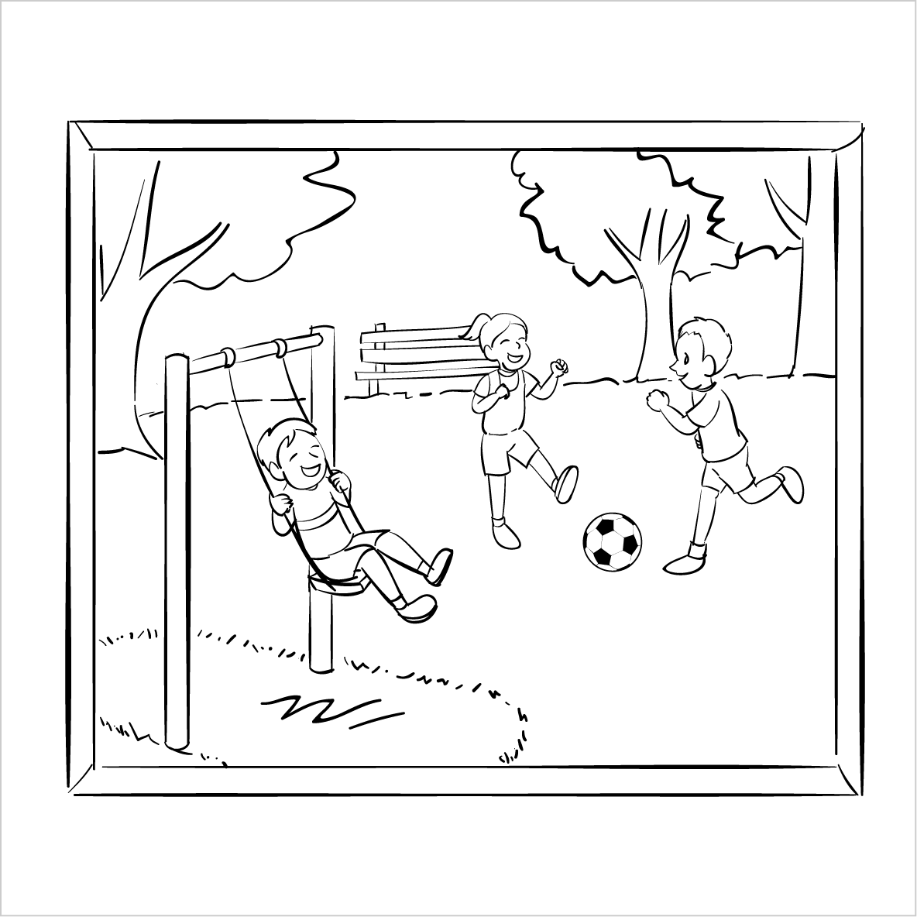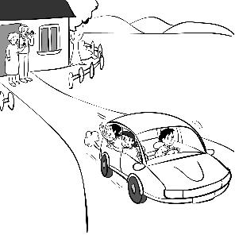
1. ______ 2_______

（二）問答：說明：每題請聽錄音機所播出的英語句子，再從試題上各選項中，選出一個最適合的回答或回應。
3. ( ) (A)I wasn’t too surprised to hear it, either.
(B)It met everyone’s expectation.
(C)Wow, the news came out of the blue.
(D)Well, that was what you expected.
4. ( ) (A)No, I don’t have a present.
(B)Yes, they are very nice.
(C)Thanks. It’s a lovely gift.
(D)Jack doesn’t seem to be here.
5. ( ) (A)Yes, I’ve always been interested in it.
(B)Yeah, I usually have bread for breakfast.
(C)No, I can’t find that baking book.
(D)No, baking is my favorite.
6. ( ) (A)I agree. It’s not very effective.
(B)It doesn’t appeal to me, either.
(C)Yeah, it’s a pleasant picture.
(D)In fact, I’m not fond of big cities.

7. ( ) (A)Right, and we’d better shake a leg.
(B)I’m always glad to help.
(C)Maybe you should catch some Z’s.
(D)Please wake me up in an hour.

(三) 簡短對話：
說明：每題請聽錄音機所播出的一段對話和相關問題，再從試題上各選項中，選出一個最適合的答案。
8. ( ) (A)Exchanging their phone numbers.
(B)Combining their cell phones.
(C)Checking each other’s presence.
(D)Talking on their cell phones.
9. ( ) (A)The English spoken in the United States.
(B)An American movie they saw.
(C)A confusing English test.
(D)The different languages in the United States.
10. ( ) (A)They will have a picnic despite the bad weather.
(B)They will have a picnic even though the girl is sick.
(C)They won’t have a picnic because the girl is sick.
(D)They won’t have a picnic due to the heavy rain.

- 克漏字選擇10%(每題1分)
You may feel annoyed when you are phubbed. Phubbing, 11 means “to keep using smartphones in others’ company,” is considered rude. When people are busy 12 with their electronic devices, they don’t pay attention to others who are actually 13 them. More and more smartphone users ignore people 14 using their smartphones all the time. It seems that people like to be 15 with the virtual world more than the real world. 16 , phubbing sometimes can even cause serious accidents. 17 , there are more traffic accidents because the road users are using smartphones instead of paying attention.
Smartphones encourage people 18 photos on social networking websites. Nevertheless, since it feels bad to be phubbed, using smartphones too much 19 not a good idea. If you are a phubber, maybe it’s time 20 your smartphone down and go back to the real world.
( B ) 11. (A) who (B) which (C) whose (D) that
( C ) 12. (A) to interact (B) interact (C) interacting (D) interacted
( A ) 13. (A) next to (B) next (C) to (D) besides
( D ) 14. (A) with (B) for (C) on (D) by
( D ) 15. (A) present (B) instant (C) attractive (D) connected
( A ) 16 (A) In addition (B) For instance (C) However (D) For example
( B ) 17. (A) Finally (B) That is (C) Therefore (D) As a result
( B ) 18. (A) share (B) to share (C) sharing (D) shared
( C ) 19. (A) been (B) are (C) is (D) to be
( C ) 20. (A) putting (B) put (C) to put (D) being put

III. 單字選擇 5% (每題1分)
( )21 | The teacher wanted us to discuss the issue(議題) about road safty. (選同義詞)
 | (A) connected | (B) plenty
 | (C) regarding | (D) strict
( )22 | Annie looked completely surprised when she heard that her pet cat was missing.  (選同義詞)
 | (A) eager | (B) stunned
 | (C) pleasant | (D) confused
( )23 | There is a ______ trend toward online shopping because it is more convenient for some people, especially younger generation(世代).
 | (A) grows | (B) growing
 | (C) grew | (D) grow
( )24 | The idea of traveling around the world is so _____ to Vincent. He is saving money for it.
 | (A) confusing | (B) connected
 | (C) unpleasant | (D) appealing
( )25 | The mistake in the sentence was so _____ that I found it right away.
 | (A) odd | (B) flexible
 | (C) obvious | (D) informal

- 文法選擇 30% (每題2分)
( )26 | Nicky’s father rarely smokes, and ________.
 | (A) my father does, too |  |  | (B) my father doesn’t, either
 | (C) neither will my father |  |  | (D) so does my father
( )27 | Sam is humorous, and ________. No wonder they are popular in school.
 | (A) neither is Ben |  | (B) Ben does, too
 | (C) Ben doesn’t, either |  | (D) so is Ben
( )28 | Alex found a wallet ________ on the table with five hundred dollars in it.
 | (A) which is leaving | (B) that left |  | (C) leaving | (D) left
( )29 | The English teacher had no choice but ____ his students since  they didn’t submit(繳交) the report.
 | (A) to failing | (B) to fail |  | (C) failed | (D) fail
( )30 | The boy _____ by a car was taken to the hospital right away.
 | (A) hit | (B) was hit |  | (C) hitting | (D) who hit
( )31 | Some students are busy _____ on their cellphone in class. They just need to stop doing so.
 | (A) play | (B) to play |  | (C) played | (D) playing
( )32 | The castle ________ in 1914 attracts many visitors around the world.
 | (A) that built |  |  | (B) built
 | (C) was built |  |  | (D) building
( )33 | All the characters _________ in the book do not exist (存在) in real life.
 | (A) that mentioned | (B) mentioned |  | (C) were mentioned | (D) mention
( )34 | Sandy decided to have salad for dinner, and ___________.
 | (A) so did Lucy | (B) neither did Lucy |  | (C) so was Lucy | (D) Lucy does, too
( )35 | Ben spent a lot of time reading the book ________ by that famous writer.
 | (A) wrote | (B) write |  | (C) written | (D) writing
( )36 | Students should never cheat on their exams, _______?
 | (A) aren’t they | (B) should they |  | (C) are they | (D) shouldn’t they
( )37 | The interview went really well, _________?
 | (A) didn’t it | (B) wasn’t it |  | (C) did it | (D) was it
( )38 | Oliver has to get up at six every morning, ________?
 | (A) hasn’t he | (B) has he |  | (C) doesn’t he | (D) does he
( )39 | Gary has never been to China before, ________?
 | (A) doesn’t he |  |  | (B) does he
 | (C) has he |  |  | (D) hasn’t he
( )40 | John and Eddie won’t go to the party tonight, ________?
 | (A) will they |  |  | (B) would they
 | (C) will he |  |  | (D) did they
- 對話選擇 10% (每題2分)
( )41. A: I feel I’m phubbed because you keep on using your smartphone.
B: Sorry. I just want to share my photos with my friends.
A: Don’t you think I am the one you should share with right now?
B: You are right.
(A) I’m putting my smartphone down now.
(B) I think using smartphones is no big deal.
(C) I don’t know why you are so angry.
(D) Let’s take a selfie together.
( )42. Lynn: How’s your first date with Jeff?
Rachel: It was awful. ________
Lynn: That’s too bad! It was really rude of him to do so.
(A) He enjoyed the party. (B) He was very humorous.
(C) He was fond of country music. (D) He kept on using his smartphone.
( ) 43. A: Are you OK? You look pale.
B: No. I didn’t sleep well last night. ________
A: Maybe you should go ask him to stop making noise like that.
(A) My friend and I went to a KTV and had a good time.
(B) I drank too much coffee before I went to bed.
(C) My neighbor played the guitar all night.
(D) I stayed up late to finish my homework.
( )44. A: Owen, could you stop using your iPad?
B: ________ Let me check my Facebook page first.
A: You’d better start your meal. Your soup is getting cold.
(A) Just a second. (B) Just kidding. (C) Help yourself. (D) Not really.
( )45. A: You shouldn’t drink so much cola. It’s not good for you.
B: That’s true, but . I will drink less next time.
(A) I will drink as much as I like (B) I just can’t help it
(C) I can’t afford to buy cola (D) I had better start drinking it now
閱讀測驗 10% (每題2分)
“OK” is one of the most common and useful words in English. But do you know where it came from?
If not, that’s OK. Even though it is a common word, people had a hard time discovering where OK came from. Some thought it came from a Native American language or from Aafrican slaves. However, in the 1960s, a man named Walker Allen Read showed that it came from the US. People began saying itin Boston, Massachusetts, in the late 1830s. At that time, it was fashionable to spell words wrong and use new acronyms. For instance, some people wrote “OW” “for oll wright”, meaning “all right”.
That didn’t stick, but OK, for “orl korrekt,” did. However, it only became really popular in the 1840 US presidential election. One candidate, Martin Van Buren, was from a town called Kinderhook. His supporters called him “Old Kinderhook,” or “OK”. They encouraged people to “Vote for OK!” Suddenly, people all across the US began saying it. Today, people all around the world think saying OK is….OK!
Vocabulary:
Native American 美國原住民 slave 奴隸 Boston波士頓
Massachusetts 麻塞諸塞洲 acronym首字母縮寫語
presidential election總統選舉 candidate候選人
( ) 46. The reading is mainly about ________.
(A) How people started to say “all right”
(B) Native American language
(C) How the word “OK” became popular
(D) The story of African slaves
( ) 47. According to the reading, the word stick has the closest meaning with ____.
(A) make sense (B) confuse
(C) remain (D) exchange
( ) 48. When people encourage you to do something, it means _____.
(A) They want you to ignore something.
(B) They want to persuade you to do something.
(C) They want you to stop doing something.
(D) They allow you to do something.
( ) 49. Based on the reading, which statement is Not True?
(A) Martin Van Buren’s supporters invented the word, “OK”.
(B) “Oll Wright” means “all right.
(C) “OK” is a common word used by many people in English.
(D) People had different ideas about the origin of “OK”.
( ) 50. About Martin Van Buren, we would Not know from the reading that____.
(A) He was a presidential candidate. (B) He won the election.
(C) He was from kinderhook. (D) People called him “Old Kinderhoook”.
請務必填寫考卷右上角的班級、姓名、座號，未寫扣5分。
- 非選擇題 (請作答於右半頁作答區)
A. 文義字彙 10% (請注意動詞變化；每題2分)
1. Since a lot of people do not understand what I’m talking about, I will c_____y my idea in
another way.
2. If you cannot meet the s____d, you will not pass the English course.
3. Body language can be an e_____e form of communication.
4. Doris has e______ed in many political(政治的) campaigns since she was young
5. David seldom looks on the bright side. He has a very n____e attitude toward life.

B. 填空式翻譯 10% (請注意動詞變化；每題1分)
1. Hank 總是在他的朋友面前表現得體。
Hank is always well-behaved _____ his friends’ ____________.

2. 身為一個業務員，Paul 經常喜歡面對面與顧客談話。
As a salesperson, Paul always like to talk to his customers _______ _____ _______.

3. 為了看起來更迷人並且吸引注意力，Vicky決定選擇紅色的洋裝。
To look more attractive and get the attention, Vicky decided to _____ ______ the red dress.

4. 正當這隻貓幾乎要掉下桌子時，這個小男孩接住了牠。。
Just when the cat was _____ the _______ ______ falling off the table, the boy caught it.

A. 文義字彙 10% (請注意動詞變化；每題2分)
1 | __________________ | 2 | __________________ | 3 | __________________
4 | __________________ | 5 | __________________

B. 填空式翻譯 10% (每題1分；每格只填一個單字)
1
2
3
4

C. 單字片語選填(選出最符合句意的單字或片語，並填入代號) 每題1分，5%
(A) catch up on | (B) out of the blue | (C) make sense
(D) Due to | (E) trip up

( )1. You’d better read the instructions carefully because some of them might ___ you ___.
( )2. What you just said didn’t _____. You need to make your points more clearly.
( )3. ______ lack of food and water, thousands of people in the coutry died.
( )4. Calvin had a lot of work to _______ after he got back from his vacation.
( )5. I was shocked when Jenny yelled at me _______. I wonder what I did wrong.

