- 選擇題：請將答案畫記於答案卡。同時請於卡上畫記班級、座號。
- 聽力測驗 10%
（一）看圖辨義：每題請聽錄音機所播出的題目和選項後，選出與所看到的圖畫最相符的答案（每題播放一次）。
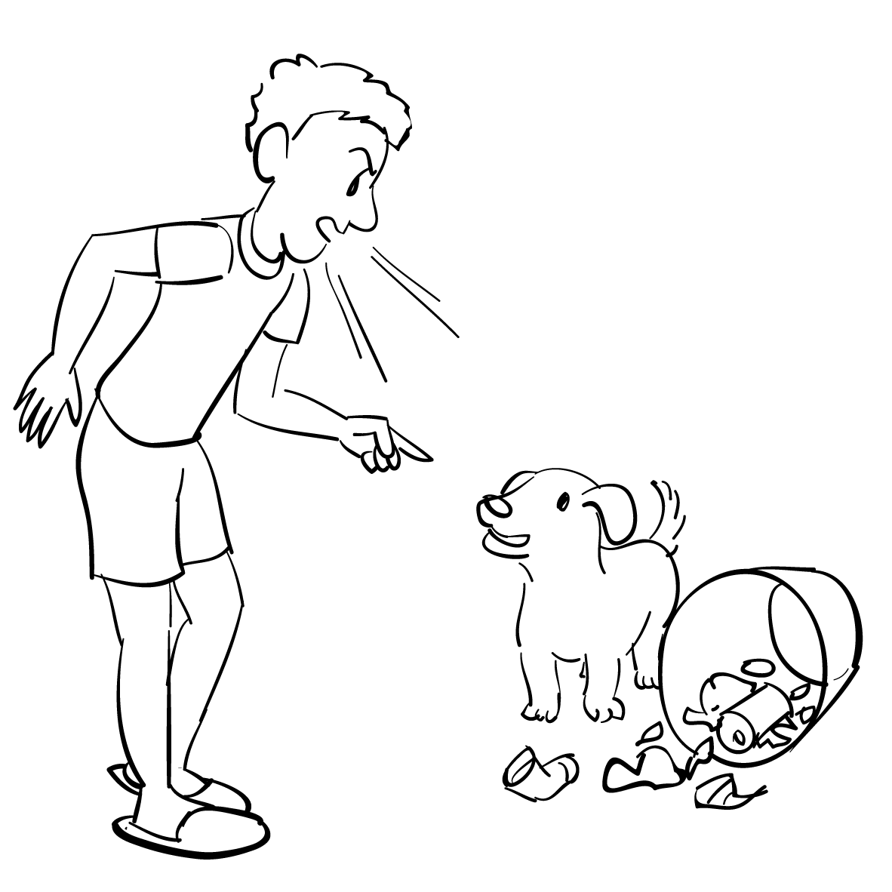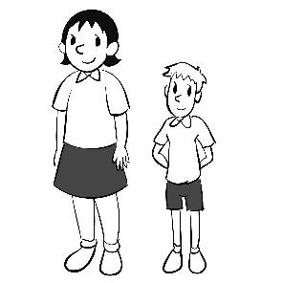
1. ______ 2. ______
（二）問答：每題請聽錄音機所播出的英語句子，再從試題上各選項中，選出一個最適合的回答或回應（每題播放兩次）。
- (A) That’s the spirit! (B) Thanks. The TV was too loud.
(C) I don’t have feelings for you! (D) I’m sorry that you’re not friends anymore.
- (A) I’m fine, thanks. (B) He was scolded for failing the math test.
(C) I think the math test was easy. (D) He is kind and patient.
- (A) That’s why I never drink coffee after 5 p.m. (B) Yeah, it usually helps me to get to sleep.
(C) Right. It’s time for me to catch some Z’s. (D) I usually go to bed before 11 p.m.
- (A) That’s why I don’t want to make friends with him.
(B) In fact, he is good at disguising his feelings.
(C) He really needs to learn to control his temper.
(D) I guess people don’t like him for a reason.
- (A) I agree. Smoking has very little effect on our health.
(B) Without a doubt, smoking has many benefits.
(C) Yes, scientists have proved there’s a link between the two.
(D) Right. Smoking makes it possible for you to stay healthy.
（三）簡短會話：每題請聽錄音機所播出的一段對話和相關問題，再從試題上各選項中，選出一個最適合的答案（每題播放一次）。
- (A) Where to stay during their trip. (B) What to do after graduation.
(C) A chance to gain work experience. (D) An interesting TV program.
- (A) Asking the woman to contribute to charity.
(B) Asking the woman to lend him some money.
(C) Thanking the woman for her contribution.
(D) Giving the woman 500 NT dollars.
- (A) They met for the first time at the party.
(B) They did not expect to see each other at the party.
(C) They were invited to the party by the same person.
(D) They were not surprised to see each other at the party.
- 文意字彙 10%
 | The bad weather spoiled our camping trip. (選出與畫底線的單字意義最相近的字)
 | (A) confused | (B) expected | (C) ruined | (D) pretended
 | The scientist’s hard work _____ to the success of the project. He is honored for his great achievements.
 | (A) teased | (B) stuck | (C) contributed | (D) disguised
 | Many people _____ to feel nervous when they are in a new environment.
 | (A) link | (B) stuff | (C) witness | (D) tend
 | The public are waiting for the government’s _____ to the food safety problem.
 | (A) reaction | (B) appetite | (C) frequency | (D) cuisine
 | The singer’s performance was _____. The audience enjoyed it and shouted with excitement.
 | (A) furious | (B) terrific | (C) tense | (D) frequent
- 綜合選擇 20%
 | Brian bought lilies rather _____ roses for his girlfriend. Lilies are her favorite flower.
 | (A) than | (B) as | (C) to | (D) for
 | In order _____ the first train, I got up early this morning.
 | (A) to not miss | (B) not to miss | (C) missing not | (D) not missing
 | _____ much fast food is not good for your health.
 | (A) To eating | (B) By eating | (C) Eat | (D) Eating
 | I have always wanted to visit London _____ is a beautiful city in England.
 | (A) it | (B) that | (C) , that | (D) , which
 | Jessica’s Japanese is not _____ her English.
 | (A) better | (B) good than | (C) as good as | (D) as better as
 | Larry sprained his ankle and had difficulty _____.
 | (A) walking | (B) walked | (C) walk | (D) in walk
 | This house is less _____ than that one.
 | (A) bigger | (B) big | (C) as big as | (D) so big that
 | Here _____ for your family.
 | (A) is it a cake | (B) it a cake is | (C) a cake is | (D) is a cake
 | I had trouble _____ the foreigner’s Chinese.
 | (A) understanding | (B) understand | (C) understands | (D) understood
 | Eric is a kind person. He is always willing to _____ people who are in need.
 | (A) helping | (B) helps | (C) help | (D) helped
- 克漏字 20%
Food plays an important role in any travel experience. _(26)_, when people visit a foreign country, sometimes they do not dare to try the local food the host has prepared for them. The exotic dish may _(27)_ a delicacy by the locals, but it may seem weird for the visitors. Nevertheless, trying foreign food not only gives visitors a chance to experience a foreign culture but also allows them to show respect _(28)_ the host. Therefore, it is advised that they take a bite of the food _(29)_ to them. The following are three _(30)_ for travelers who do not dare to try foreign food. First, do not ask _(31)_ before you try it. It is very likely that the food you consider weird is actually delicious. It is the thought _(32)_ stops you from eating the food. Second, instead of filling your plate _(33)_ a lot of food, take a small helping first. _(34)_, take a sip of your drink when you eat something you don’t like. The drink can help _(35)_ rid of the unpleasant taste.
 | (A) Otherwise | (B) As a result | (C) However | (D) In their presence
 | (A) consider to be | (B) be regarded | (C) think about | (D) be thought of as
 | (A) with | (B) for | (C) at | (D) in
 | (A) that served | (B) is served | (C) served | (D) has served
 | (A) tips | (B) traits | (C) punishments | (D) crews
 | (A) what is the food | (B) what the food is | (C) the food what is | (D) is what the food
 | (A) that | (B) and | (C) it | (D) so
 | (A) of | (B) for | (C) in | (D) with
 | (A) As a matter of fact | (B) Last but not least | (C) On the one hand | (D) First of all
 | (A) getting | (B) and get | (C) gets | (D) get
- 對話 10%
- Justin: You know Jack, right?
Tracy: Yes. __________ Everybody likes him.
Justin: Wow! He must be very popular at school.
(A) I am a careful and punctual person. | (B) He was just kidding.
(C) He is a confident and outgoing person. | (D) I didn’t feel well today.
- Cindy: Since you are now in Sri Lanka, you should try the famous spicy pineapple curry.
Rachael: __________
Cindy: Great. You’ll love it.
(A) Come on! Just try some. | (B) Sure. Why not?
(C) Help yourself to some more. | (D) Right. You might like it.
- Oscar: Welcome to my party. Help yourself to some snacks over there.
Johnnie: __________ They look delicious.
(A) I can help you later. | (B) OK, I will.
(C) I don’t care for snacks. | (D) Enjoy yourself.
- Hudson: I’m going to the supermarket. __________
Fannie: It would be great if you could buy me a bottle of milk.
(A) Is there anything you need? | (B) Is it available now?
(C) Can you tell me where it is? | (D) Should I drive there?
- Ken: You don’t seem well. What happened?
Jay: I broke my leg, and I can’t walk on my own. __________
Ken: No problem. I’ll drive you there right away.
(A) Can you bring me some food? | (B) Would you let me drive your car?
(C) Would you leave me alone, please? | (D) Can you take me to the hospital?
- 非選擇題：請作答於答案卷。

___________
選擇題
- 文意字彙 18%
- Peter spent a large a t of money on his new house.
- You should be c s about what you say; otherwise, you may offend other people.
- As the country’s economic situation gets worse, there is growing a y about unemployment.
- Although Laura was on a diet, she couldn’t resist the t n to eat a piece of pizza.
- The Internet is a useful s e of information. Many people look for the information they need through it.
- The man d ed the cake into eight pieces and gave each child a piece.
- The big smile on Vincent’s face i es that he is very happy. His favorite baseball team just won the championship.
- Dan works for a travel program. His job provides him with the o _y to travel around the world.
- Larry is shy. His p y makes it difficult for him to make new friends.
- 填空式翻譯（每格只填一個字） 12%
- Grace不小心把咖啡灑在襯衫上。
Grace spilled coffee on her shirt ______ a .
- 你為什麼要拒絕一份這麼棒的工作？
Why did you ______ ______ such a fantastic job?
- David沒有試圖掩蓋他的錯誤；相反的，他說出事實。
David didn’t try to ______ ______ his mistake. Instead, he told the truth.

