請將答案劃記在電腦答案卡上(否則不予計分), 共20題; 並劃上座號，劃記不清者或未畫座號者酌扣總分5分!
- 素養題 25%/@5
(1)
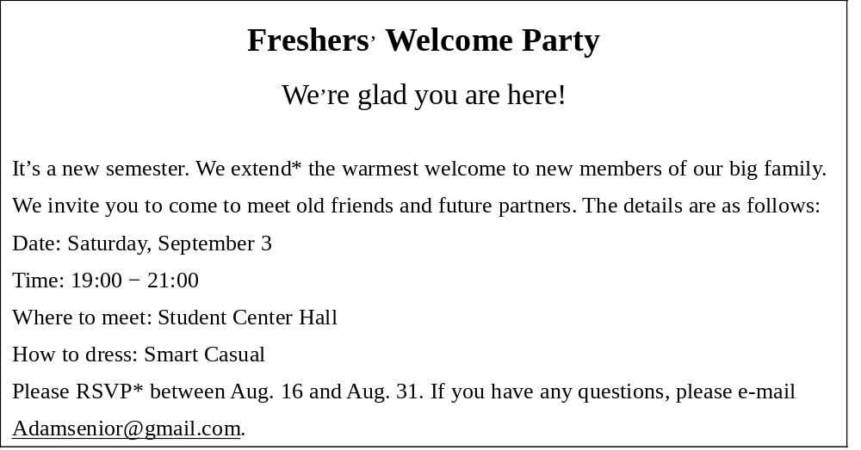
*extend vs. 給予 *RSVP 請回覆
1.Whom is the party being held for?
(A) Job-seekers. (B) Teachers. (C) New students. (D) Graduates.
2. On what date can a student sign up if he or she wants to attend the party?
(A) August 12. (B) August 26. (C) September 1. (D) September 3.
3. Which of the following is a good choice for a student to wear to the party?
(A) A black suit. (B) A silk hat. (C) A pair of jeans. (D) An evening dress.

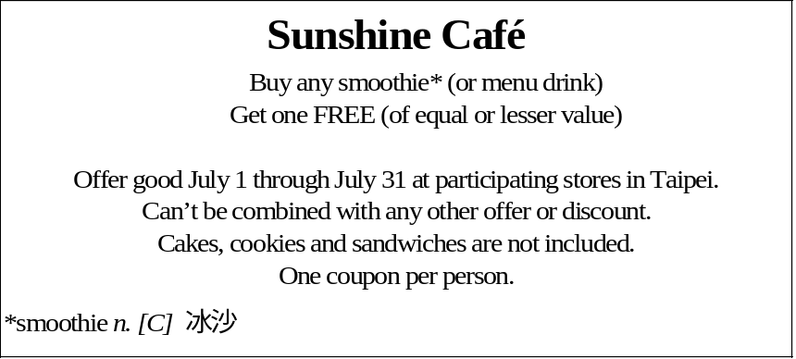
4. Henry bought a cup of black tea and it cost him NT$80. Which of the following items
could he get for free?
(A) An NT$95 smoothie. (B)An NT$90 large coffee.
(C) An NT$80 sandwich. (D) An NT$60 small coffee.
5. What can we infer from the passage above?
(A) Sunshine café doesn’t offer cakes and cookies.Sunshine
(B) Café has many chain stores in Taiwan.
(C) This coupon is designed for summer promotion.
(D) Smoothies are the most popular products in Sunshine Café.

- 閱讀測驗 75%/@5
(1) On the first day of high school, I noticed there were a lot of clubs looking for new members. I checked out a few, but the one that caught my attention was the drama club. I had never acted before, but I always wanted to try it. So, even though I was a bit shy, I signed up, and I’m glad I did!
The club’s first show of the year was a musical called “Guys and Dolls.” I auditioned* for the lead role. I didn’t expect to get it. I thought I would try out, and they would give me a smaller part instead. But, to my surprise, I won the role! In the coming several weeks, we had rehearsals* every day after school. It was hard work, memorizing all those lines, songs, and dance moves. It paid off, though. Our performance got great reviews from everyone who came to see it. There was even an article in the local paper. The writer said that I was the best young acting talent he had seen in years. Now I’m thinking acting might not just be a hobby for me. It could actually be my future career!
*audition vi. 試演 *rehearsal n. [C] 排演 * talent n.才華
6. What is the main idea of this story?
(A) The author had no idea which club to join on the first day of high school.
(B) The author had always been very interested in giving acting a try.
(C) The author got the lead role in a musical called “Guys and Dolls.”
(D) The author joined the drama club and had a successful performance.
7. Which of the following about the author is NOT true?
(A) He worked very hard to memorize all the lines and songs.
(B) He had never thought that he was able to get the lead role.
(C) He had some acting experiences before joining the drama club.
(D) He decided to join the drama club on the first day of high school.
8. What happened to the author after his first performance?
(A) He felt so tired that he wanted to take a long rest.
(B) He considered making a living as an actor.
(C) He decided to quit the drama club and focus on his studies.
(D) He was seriously injured and had to stay in a hospital.
(2) There is a famous saying that goes, “Don’t judge a book by its cover.” That’s true, but many people do not follow the above saying. They judge people based on what they look like. I am a good example of that. I used to be really overweight, and some people made fun of me because of my weight. They called me names like “Fatty” and “Piggy.” I knew they were being very unkind, but I just tried to ignore them. However, one day I read an article about being overweight. The author wrote about all the health problems that can result from this. So in the end, I decided I really should try to lose some weight. The most important thing, though, is that I did this for myself, not to please other people. We should never judge others based on their appearance. Only you can decide what you want to do with your body.
9. What does “that” in line 3 mean?
(A) Don’t judge a book by its cover. (B) Many people made their own decisions.
(C) People judged me by my appearance. (D) I worked hard to lose weight.
10. According to the passage, which of the following is NOT true?
(A) The author was overweight.
(B) Some people said unkind words to the author.
(C) After seeing news on TV, the author tried to lose some weight.
(D) The author didn’t pay attention to negative words from others.
(3) Fables are short stories that contain something meaningful and teach readers a lesson. The following is an inspiring story of kindness.
A long time ago, a lion was lying on the ground in the forest. He lay his head on his
paws and started to fall asleep. Suddenly, a little mouse ran across his nose. Because the mouse
had accidentally interrupted his nap, the lion got irritated with the tiny creature. He laid his
huge paws on the little mouse and got ready to kill her.
The little mouse begged the lion not to kill her. “Please let me go. I will help you in return
some day.” The lion was surprised at what the little mouse said. Never did he believe that a
mouse could help him. However, he was feeling generous so he let the mouse go.
A few days later, the lion was trapped in a hunter’s net while following his prey. The lion
roared angrily in the net. The little mouse heard the noise and knew that the lion was in trouble.
She quickly found him and bit the net that trapped the lion. Soon, the lion was free.
“You didn’t believe that I would help you.” Said the little mouse. “Now you know that even a small creature like me can get an important job done.”
* inspiring 具啟發性的 * paw 手掌 * accidentally 無意間地
* interrupt 中斷 * prey 獵物 * roar 吼叫
11. What is the main idea of this reading?
(A) The lion treated the mouse badly. (B) A little mouse can save a lion.
(C) Kindness will pay off someday. (D) The kindness of the mouse saved the lion free.
12. According to the reading, which of the following is true?
(A) The little mouse made the lion fall into the trap.
(B) The lion got out of the net without any help.
(C) The lion thougt that the mouse couldn’t satisfy (滿足) his hunger.
(D) Because of the lion’s kindness, the little mouse repaid him.
13. What does the word “irritated” mean in the second paragraph?
(A) Angry. (B) Excited (C) Tired (D) Delightful.
14. Where is this reading most likely taken from?
(A) A comic book. (B) A story book.
(C) A scientific journal. (D) A newspaper.
15. Which of the following sentences about the mouse is NOT true?
(A) The mouse kept her promise and save the lion.
(B) The mouse used the same tools to cut the lion.
(C) The mouse woke the lion up by chance.
(D) The mouse heard the sound of the lion and helped him.
(4)
December 15th,2000
Dear Alice,
I’m really sorry I haven’t written. The holidays are the busiest time of the year for me at the store. We bought a new car last month because my husband has started a new job. He has also given up smoking. I’m really happy about that. The children are a lot bigger than when you saw them. I think Tommy is going to be the tallest one in the family very soon. Helen always studies hard, and she is one of the best students in her class.
How’s everything with you? Do you have any plans to visit us? I’m hoping I can see you soon.

Sincerely yours,
Sarah

16. Why did Sarah and her husband buy a new car?
(A) They want to visit Alice. (B) Sarah is expecting a new baby.
(C) Sarah is very busy at her store. (D) Her husband has started a new job.
17. How many children does Sarah have?
(A) One (B) Two (C) Three (D) Four
18. When is the busiest time of the year for Sarah at store?
(A) The holidays. (B) Summer
(B) Her birthday. (D) Her pregnancy.
19. Who has given up smoking?
(A) Helen. (B) Alice’s husband.
(C) Tommy. (D) Sarah’s husband.
20. When did Sarah write this letter?
(A) Last month. (B) December 15th,2000.
(C) Novermver 15th, 2000. (D) December 15th, 1999.

